Application Pack
SIMS Data Officer
Job reference SIMDAT0218

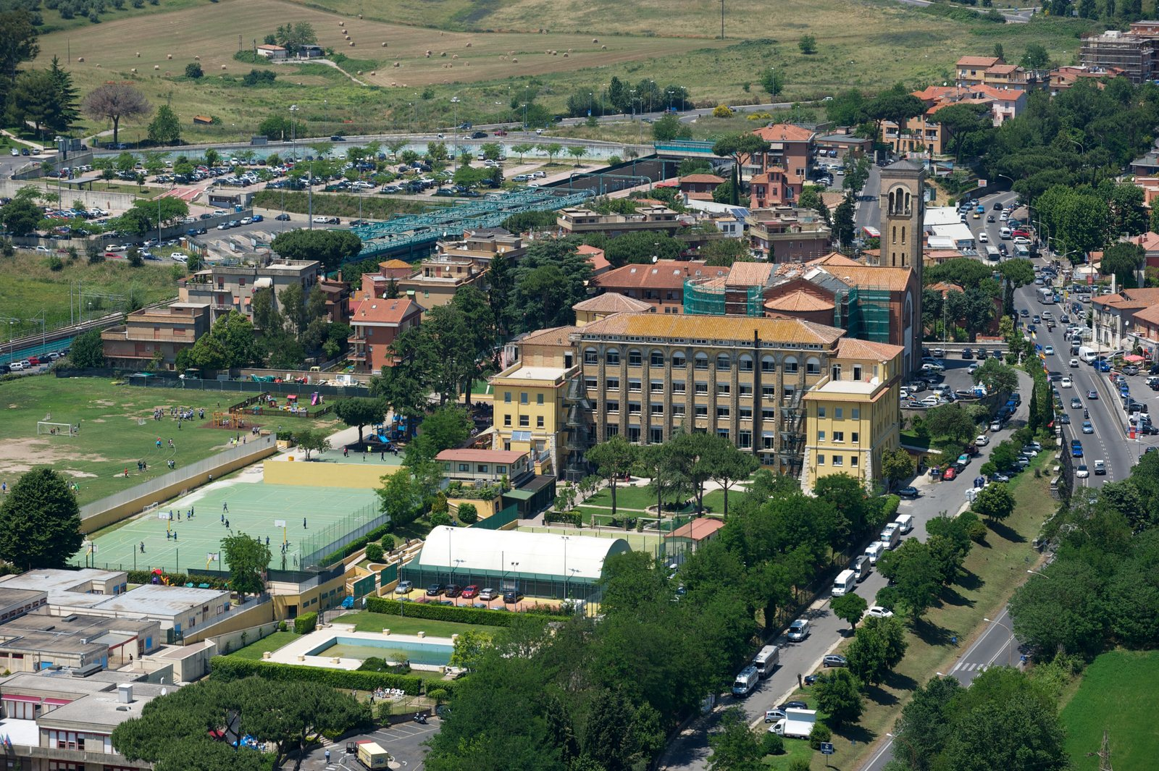

Message from the Principal, Martyn Hales
Welcome to St George’s British International School.
Since the foundation of the school in 1958, we have had a clear vision of what we hope to achieve for our students. We want our Georgians to reach the highest academic standards through being analytical, critical and compassionate thinkers so they can access the world’s best universities. We want them to be able to relate their classroom experience to the world outside so they become informed, active participants in local and world affairs. We want them to be truly international in their outlook, respectful of other cultures and attitudes, and conscious of their shared humanity. We want them to be confident leaders, ready to take a risk and make a difference in the challenging 21st century world they will inherit.
Our website and the pages that follow will help you to understand more about us and all we do to provide our students with a world-class education. I am delighted that you are considering working at our school.
Martyn Hales
Principal
St. George's British International School

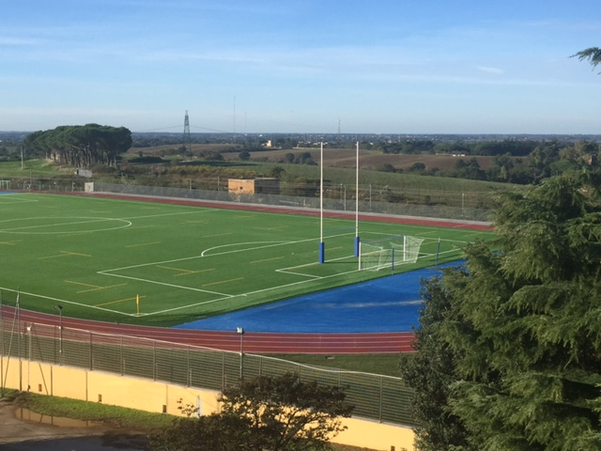

St George’s British International School is one of Europe’s leading British-curriculum schools with a recent excellent ISI inspection report. It is co-educational, non-selective and offers a broad and successful academic programme. The school, founded in 1958, has a spacious 14-acre site and is located north of the city. St George’s is an International member of HMC, an executive member of COBIS, and is a member of ECIS, CIS and AGBIS.
Although the school follows a strong British curriculum, it is international in many other aspects: it has been offering the IB diploma programme since 1996 and its pupils represent over 70 nationalities. A wide range of subjects is taught to GCSE/IGCSE level prior to the sixth form and in the IB programme over 25 subjects are offered. Teachers are highly qualified and participate in pastoral care and guidance through a tutorial system, with specialised advice given on University entrance. Emphasis is on academic excellence and external examinations results are strong. All Year 13 students follow the IB Diploma programme; in 2017, 72 students at St George’s passed the full Diploma achieving an average score of 36.1 (well above the World Average). Alumni of the school are currently studying at some of the world’s leading universities including Oxford, Cambridge, UCL, Imperial, Bristol, Durham, Edinburgh, Yale, MIT, Berkeley, McGill, the Bocconi and La Sapienza.

The school’s learning facilities include fully-equipped classrooms, seven science laboratories, two dedicated teaching rooms for Information Technology, a specialist Design and Technology area and a Music Department with a sound-proof room. The work produced by the English Language, Music and Art departments is exceptional and regularly wins prizes. The school’s excellent sports facilities include a new generation all weather rugby pitch, floodlit astro-turf soccer pitch, a cross-country trail, tennis, basketball and volleyball courts, a fully equipped sports centre and an all-weather multipurpose sports area. Specialised learning facilities include SEN (Special Education Needs) and EAL (English as an additional language). A wide-range of trips are organised both in Italy and abroad.

Vacancy Details

Core Purpose

This is a key role within the School with overall responsibility for MIS (both in terms of tracking and interpretation).

The two core functions are:
- to ensure that SIMS is used effectively to support and monitor progress throughout the School; and
- to guarantee the accuracy of operational MIS processes (such as attendance).

The candidate will ideally:

- Have at least 2 years’ experience working in a similar role, preferably in a UK school;
- Be highly organised with outstanding IT skills and the proven ability to analyse complex data;
- Have a profound understanding of pupil performance measurement (from Key Stage 1 – Key Stage 5) and School MIS systems and communication tools;
- Be capable of designing and developing user friendly reports which quickly identify issues for senior management and effectively support the continuous raising of standards across all age groups;
- Present MIS data for a variety of parties (including the Principal, COBIS, ISI and the School’s governors) tailored to their unique requirements, including external benchmarks where appropriate;
- Advise and assist in School target setting;
- Allocate and maintain student timetables and grouping records, in accordance with the school timetable and under the instruction of the appropriate Senior Leadership Team (SLT) representative.

A job description will be forwarded to all interested candidates.

How to Apply

Closing date for applications | 16/02/2018
Interview date | From week beginning 19/02/2018
Start date | March 1st or as soon as possible
Job reference number | SIMDAT0218

Short listing will commence immediately after the closing date.

Please complete and the application form available at http://www.stgeorge.school.it/Employment, continuing on a separate sheet if necessary, and email it to jobs@stgeorge.school.it, inserting the job reference SIMDAT0218 in the title of the email.

Our preference is for you to complete and submit the application form electronically. If this is not possible, then please use black ink for handwritten applications. Please do not submit a CV or send certificates or testimonials at this stage.

Please note that, as well as a face-to-face or Skype interview, the selection process may include another form of assessment (e.g. administrative test, demonstration of practical skill, a presentation etc.) if relevant.

Shortlisted candidates will have references taken up prior to interview.
Conditional Offer of Appointment

Any offer to a successful candidate will be conditional upon the following:

verification of identity, qualifications and professional status;

a safeguarding check;

receipt of at least two satisfactory references (one of which should be from your current or most recent employer);

verification of medical fitness (completion of a medical declaration).

Salary

The successful candidate will receive a salary and benefits that are highly competitive in the international sector and consistent with the status that St George’s holds as an HMC school.

The post’s conditions of service will follow those of an administrative member of staff.

