February 2018

Dear Prospective Applicant,

May I first of all thank you for showing interest in this post and I hope that after reading the material included, you wish to apply.

Tottington High School is a successful school in the north of Bury serving various townships. Please visit our main school website as well as read our latest Ofsted report to get ‘a feel’ for our school.

Our staff are very committed to ensuring the best quality education for our young people and I know that the successful applicant will see this is an excellent opportunity to gain experience in this permanent post.

We are seeking to appoint from 1st September 2018, two teachers of Mathematics to work within our Mathematics Faculty teaching in both Key Stage 3 & 4. We currently have eight full time Mathematics teachers.

This is a good opportunity for someone to work in a vibrant and professional environment helping to making a difference to the prospects of young people.

Applicants will find a job description and person specification in the application pack.

I hope after having reading information about our school that you feel Tottington High will suit your ambitions and skills.

Deadline for applications is noon on Tuesday 27th February 2018 and interviews will be conducted in the week following.

Head of Science Mr Paul Wilkonson is available for any queries on following email: pwilkinson@tottingtonhighsch.co.uk

Yours sincerely,
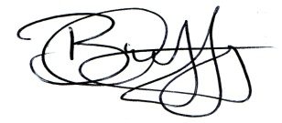
Mr. Brian Duffy
Headteacher

