Belmont Infant School
Head Teacher
Information Pack

Together we make a difference

Belmont Infant School
Rusper Road
Wood Green N22 6RA
0208 888 7140
admin@belmont-inf.haringey.sch.uk
www.belmontinfants.org

Together we make a difference
Welcome to our school 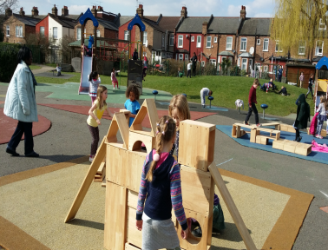
Dear Applicant,
We are delighted that you have shown an interest in becoming the Head teacher at Belmont Infant School. We are seeking a leader who can support, motivate and inspire staff and can communicate a clear vision and direction for the school. Will help children enjoy their learning while realising their full potential. Has a commitment to inclusivity and can work well in partnership with parents, governors, the wider community and local schools.
We are a vibrant and diverse school, with a highly motivated staff team. Our Governors and parents are supportive and committed. We are very privileged to work in partnership with Belmont Junior and The Vale School. Our school is a happy environment where children are encouraged to have fun whilst learning. Members of the wider community make a valuable contribution to school life helping our children learn about the world around them.
You are actively encouraged to visit the school before applying. Governors will be delighted to show you around and answer any questions you may have. Please contact the school office on 0208 888 7140 to arrange your visit.
We look forward to receiving you application by Monday 5th March 2018. Interviews will take place the week commencing 12th March 2018.

We look forward to meeting you,

Yours sincerely
Dan Rosenberg
Chair of Governors

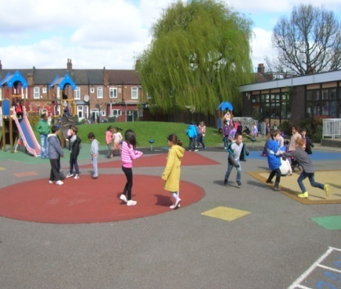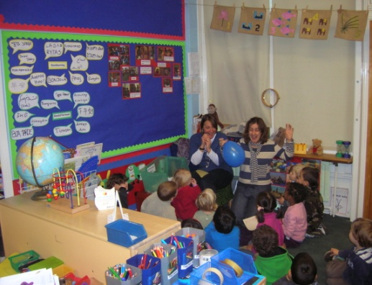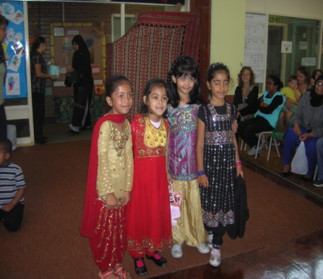

Together we make a difference
Information about our school
Belmont Infant School is situated in a pleasant and quiet environment. We have plenty of green space and play areas for our children to enjoy. We value highly our richly diverse community and we offer a caring, inclusive ethos where each child is valued as an individual and encouraged to be the best they can.
There is a hard working, dedicated and caring staff that is always looking for ways to enrich the curriculum to build on the children's natural desire to explore their world and develop a love for learning.
Our children "respond well to a rich and stimulating internal and outdoor environment. Children make ood progress due to the care that is taken to plan for their individual needs and interests." (Ofsted report May 2013)

The Vale School
The Vale scheme offers full time mainstream inclusion for children with physical disabilities. Vale students are supported by an experienced team of therapists, support staff and teacher in order to enable them to access and participate in all areas of the curriculum. The partnership between Belmont and the Vale is very strong and has successfully existed for over twenty five years. The Vale brings something very special to Belmont which has resulted in a caring school with an understanding and awareness of others which is quite unique.

We aim to:-
- To nurture the whole child and provide a happy, secure and exciting learning environment.
- To provide high standards of quality educational provision across the curriculum.
- To have high expectations of our children. Our teaching aims to develop our children’s social, emotional, intellectual & physical capabilities and their spiritual awareness.
- To support children in learning to value themselves and each other and to work towards becoming happy and useful members of the community.
- To encourage all children to express their views and opinions, confident in the knowledge that they are listened to and taken seriously.
- To maintain our commitment to the inclusion of pupils with physical disabilities in partnership with The Vale Special School.
- To celebrate the richness of the diversity of cultures within our school and value highly the contribution each community brings to the life of the school.
- To eliminate discrimination based on race, sex, family groupings, class, disability or religion and to recognise Bilingualism as a positive asset to the whole school.
- To work in partnership with the Governing Body and Haringey Council in all aspects of school development. Implementing the Government’s vision to embed the 5 strands of Every Child matters.
- To work closely with the Junior School.

I love the school and I wish he could stay here. The teachers are kind, easy to approach and talk to. I appreciate the extra help my son has received in the school. I have felt supported from the start.
Parent – March 17
Together we make a difference

Ofsted
Our school was inspected in October 2017 and was judged to be a GOOD school.
“Staff are highly motivated and fully committed to the school and pupils. As a result, pupils are happy and confident.”
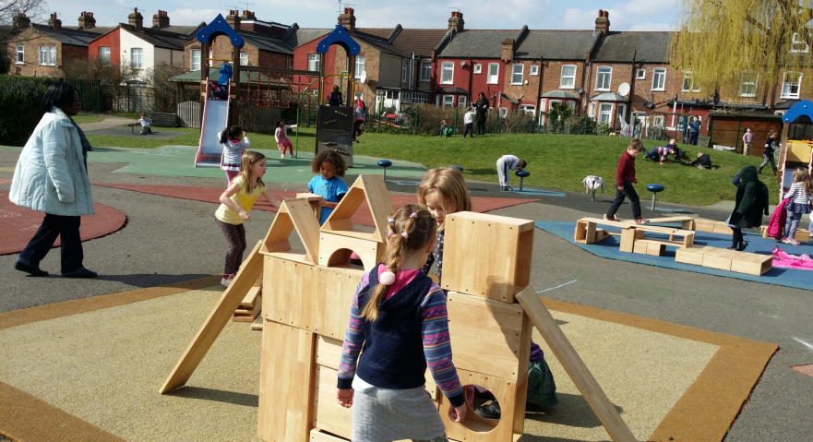
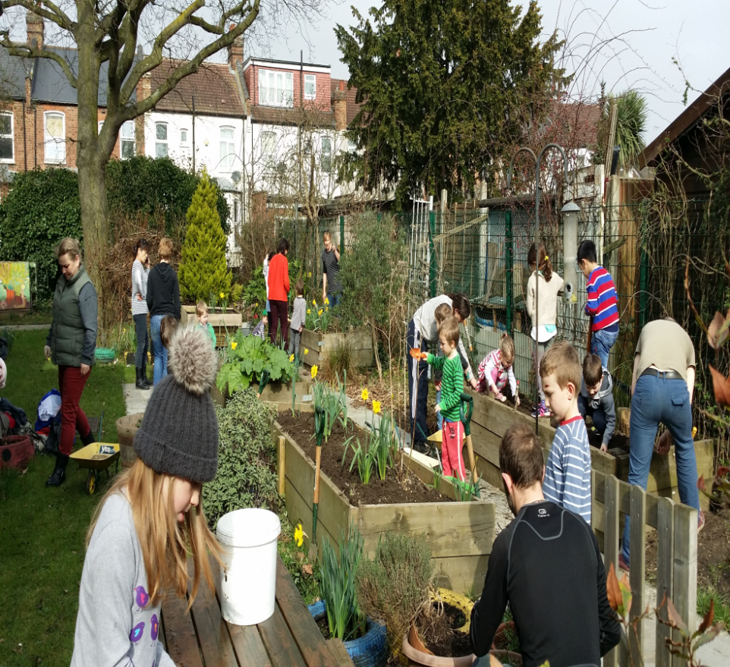

Together we make a difference
Job – Description – Head teacher
Duties
This job description is subject to the general conditions of service for a Head teacher as set out in the current school Teachers’ Pay and Conditions Document. This job description is based on the National Standards of excellence for Head Teachers (2015).
Main Purpose
The Head teacher will provide professional leadership, vision and strategic direction for the school in order to maintain and develop the conditions which enable pupils and teachers to achieve effective learning so that the school’s aims and objectives are implemented in accordance with the policies of the governing body and national and local education strategy.
Key Accountabilities
Qualities and Knowledge
- Hold and articulate clear values and moral purpose, focused on providing a world class education for the pupils they serve.
- Demonstrate optimistic personal behaviour, positive relationships and attitudes towards their pupils and staff, towards parents, governors and members of the local community.
- Lead by example- with integrity, creativity, resilience, and clarity – drawing on their own qualifications, expertise and skills, and that of those around them.
- Sustain wide, current knowledge and understanding of education and school systems locally, nationally and globally, and pursue continuous professional development.
- Work with political and financial astuteness, within a clear set of principles centred on the school’s vision, ably translating local and national policy into the school’s context.
- Communicate compellingly the school’s vision and drive the strategic leadership, empowering all pupils and staff to excel.

Pupils and Staff
- Demand ambitious standards for all pupils, overcoming disadvantage and advancing equality, instilling a strong sense of accountability in staff for the impact of their work on pupils’ outcomes.
- Secure excellent teaching through an analytical understanding of how pupils learn and of the core features of successful classroom practice and curriculum design, leading to rich curriculum opportunities and pupils’ well-being.
- Establish an educational culture of ‘open classrooms’ as a basis for sharing best practice within and between schools, drawing on and conducting relevant research and robust data analysis.
- Create an ethos within which all staff are motivated and supported to develop their own skills and subject knowledge, and to support each other.
- Identify emerging talents, coaching current and aspiring leaders in a climate where excellence is the standard, leading to clear succession planning.
- Hold all staff to account for their professional conduct and practice.
Systems and process
- Ensure that the school’s systems, organisation and processes are well considered, efficient and fit for purpose, upholding the principles of transparency, integrity and probity.
- Provide a safe, calm and well- ordered environment for all pupils and staff, focused on safeguarding pupils and developing their exemplary behaviour in school and in the wider society.
- Establish rigorous, fair and transparent systems and measures for managing the performance of all staff, addressing any under-performance, supporting staff to improve and valuing excellent practice.
- Welcome strong governance and actively support the governing body to understand its role and deliver its functions effectively- in particular its functions to set school strategy and hold the head teacher to account for pupil, staff and financial performance.
- Exercise strategic, curriculum-led financial planning to ensure the equitable deployment of budgets and resources, in the best interests of pupils’ achievements and the school’s sustainability.
- Distribute leadership throughout the organisation, forging teams of colleagues who have distinct roles and responsibilities and hold each other to account for their decision making.
The self-improving school system
- Create outward-facing schools which work with other schools and organisations- in a climate of mutual challenge- to champion best practice and secure excellent achievements for all pupils.
- Develop effective relationships with fellow professionals and colleagues in other public services to improve academic and social outcomes for all pupils.
- Work well and collaboratively with our linked junior school in the best interests of the children and local community.
- Challenge educational orthodoxies in the best interests of achieving excellence, harnessing the findings of well evidenced research to frame self-regulating and self- improving schools.
- Shape the current and future quality of the teaching profession through high quality training and sustained professional development for all staff.
- Model entrepreneurial and innovative approaches to school improvement, leadership and governance, confident of the vital contribution of internal and external accountability.
- Inspire and influence others-within and beyond schools- to believe in the fundamental importance of education in young people’s lives and to promote the value of education.

Accountable for
Leadership of all teaching and support staff, with specific performance management responsibility for members of the senior leadership team.
Accountable to
The Governing Body and Local Authority
Together we make a difference
Person Specification
E/D: Essential/Desirable Criteria
Criteria |  | E/D
Qualifications | Qualified Teacher status | E
 | Degree level qualification | E
 | Completed NPQH | D
 | Further post-graduate study | D
 | A record of recent and relevant in-service training | E
Experience | Proven successful leadership at senior level in an infant or primary school | E
 | Experience of working in mainstream inner city settings, including in good and outstanding schools | D
 | Experience of working effectively with the school community and external partners. | E
Qualities and knowledge | Evidence of the ability to promote a positive, sensitive and caring ethos and pride in the school and its physical environment together with high standards of achievement and behaviour. | E
 | Ability to innovate and find creative solutions, and to communicate a vision to inspire and motivate all stakeholders | E
 | Proven track record of the ability to raise the academic and personal achievement of all pupils. | E
 | The ability to set, communicate, encourage and expect high expectations for all members of the school community, including parents. | E
 | Excellent interpersonal and communications skills, both oral and written | E
 | Be prepared to make a direct contribution to the broader life of the school. | E
Pupils and Staff | Knowledge and understanding of how to raise standards of learning across the school and a proven track record in doing so. | E
 | Excellent knowledge of the current major curriculum issues, recent educational developments and legislative changes, together with and understanding of their significance for the leadership of an infant school | E
 | Ability to use, analyse and monitor pupil assessment data to identify needs and trends in order to promote an appropriate level of challenge to all pupils. | E
 | Demonstrate a commitment to providing choice and flexibility in learning to meet the needs of every child to ensure that every child achieves her/his best. | E
 | An ability to identify and promote excellence and challenge poor performance across the school. | E
 | A proven commitment to an inclusive education which addresses the needs of all the learners in a diverse community. | E
 | A clear vision for consistent systems and procedures which bring about firm but fair behaviour management. | E
 | Evidence of establishing a culture of creativity and imaginative expression amongst staff and pupils. | E
Systems and Process | The ability to use performance management and line management to secure accountability and improve performance. | E
 | Proven track record in working collaboratively and building, leading empowering and developing effective teams. | E
 | Evidence of the ability both to delegate and work in collaboration. | E
 | The ability to prioritise tasks, make informed decisions and implement them in a flexible manner. | E
 | An understanding of managing finance efficiently in accordance with benchmarking, financial management and best value principles. | D
 | Evidence of a commitment to developing and sustaining a safe, secure and healthy school environment, in accordance with child protection and safeguarding legislation. | E
 | Experience of creating, implementing and maintaining new systems and structures in a school environment. | E
The self- improving School system | A willingness to engage the school community in the systematic and rigorous self and external evaluation of the work of the school, using a wide range of views to better understand the strengths and weaknesses of the school. | E
 | Proven ability in working with a range of stakeholders, including pupils, staff, parents, governors, the LA and the wider community. | E
 | Experience of developing and managing good communication systems, chairing meetings effectively and working in partnership with other agencies. | E
 | A vision for governor, parent, and community involvement in the life of the school. | E
 | A commitment to continuing CPD for oneself and for all members of the school community. | E
 | An unwavering commitment to acknowledge, celebrate and foster respect for the richness and diversity of the school’s communities. | E
Caring and Nurturing | A commitment to the idea that attainment is only one part of every child’s personal development and a willingness to embed this into the school’s culture. | E

