Mercia School
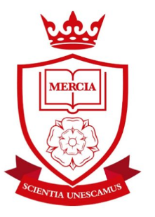
Carter Knowle Road, Nether Edge, Sheffield

Teacher of Mathematics
MPS
We are seeking to appoint an outstanding teacher of mathematics.

- Do you believe every child can succeed at mathematics?
- Are you an inspirational teacher of mathematics?
- Do you believe in a traditional approach to teaching and a mastery curriculum?
- Are you an energetic person who is dedicated to the life chances of young people?

Commencement Date: 1 September 2018

At Mercia School, mathematics will be:

- Exceptionally challenging for all pupils, no matter their ability or need.
- Taught in a traditional way that gives pupils time to practise and master content.
- A subject that raises aspiration so all pupils have a successful career and a happy life.
- Preparing pupils for the challenges at GCSE and A-level, from day one.

Your role will be to teach excellent lessons, develop a mastery curriculum, promote a love of mathematics and commit yourself to the vision of the school.

We welcome applications from talented, ambitious individuals who can dedicate themselves to the implementation of the school’s vision.

If you do not believe in the ethos and mission of Mercia School, please do not apply.

www.merciaschool.com
‘Let us be united by knowledge’

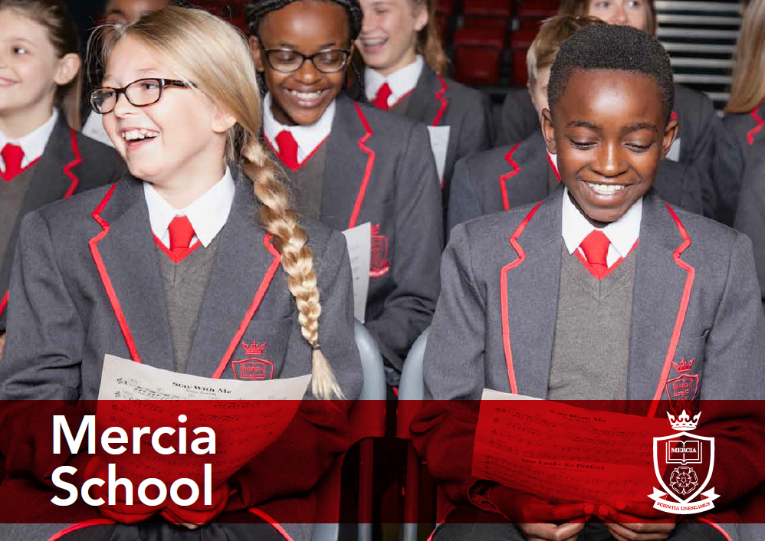

At Mercia School we will offer an education that is traditional and academically rigorous. It is our belief that all pupils, whatever their background, have a right to a culturally rich education. We strive to ensure all pupils can access the very best universities in the land, or a valuable alternative.
To apply, please send a covering letter (no more than 3 sides in Calibri font size 12) along with your competed application form to shodkinson@ecgbert.sheffield.sch.uk
Please include answers to these questions within your letter:
- Why do you want to teach mathematics at Mercia School?
- How would you fit into our unique ethos?

                - Please email any enquiries about this post to shodkinson@ecgbert.sheffield.sch.uk

Closing date: Wednesday 21 March 2018

www.merciaschool.com
‘Let us be united by knowledge’

