

**‘Let us be united by knowledge’**

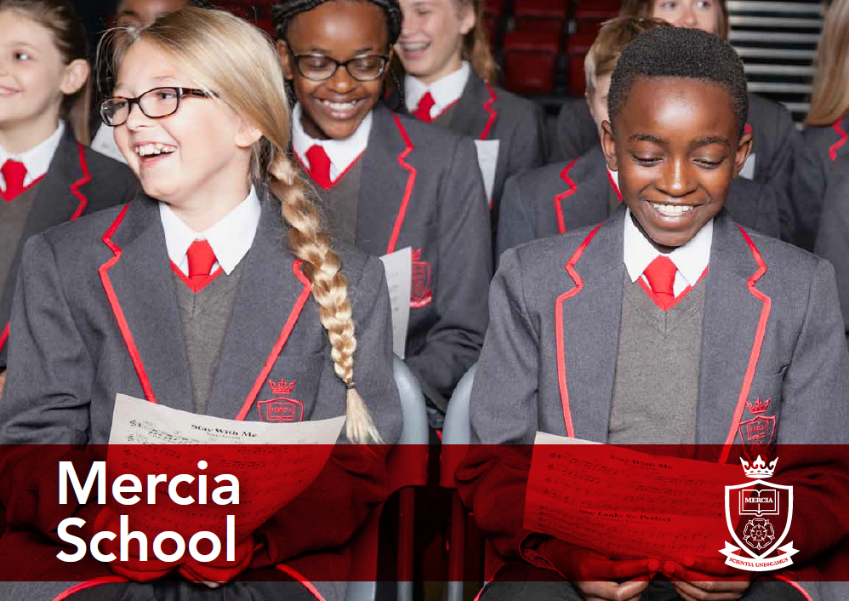

Teacher of Mathematics Information Pack

School Information

Job Description

Person Specification



Contents:

* Information about the Mercia Learning Trust
* Letter from the Headteacher
* Advert
* Job Description
* Person Specification



**‘Let us be united by knowledge’**

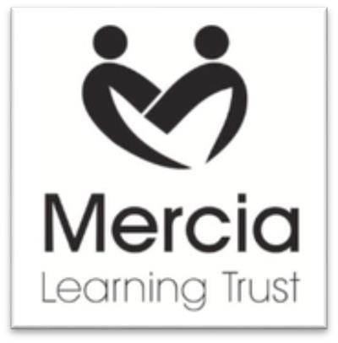

**THE MERCIA LEARNING TRUST**

The Mercia Learning Trust, established in January 2014, currently comprises: Mercia School, King Ecgbert School, Newfield School, Totley Primary School, Valley Park Community Primary School and The Nether Edge Primary School.

The mission of the Trust is to provide an outstanding education for pupils from 0-19. We are passionate that all our pupils should see their time at school as happy and fulfilling, with their potential developed to the utmost. Our approach is founded on partnership working — binding together our schools, parents and their communities.

At all Mercia Learning Trust schools our pupils will benefit from:

* A fully inclusive approach, maximising the attainment and achievement of every pupil
* A broad and balanced curriculum, with high quality teaching that responds to individual needs
* Promotion of resilience and self-reliance in our learners, thus enabling them to meet the challenges and opportunities of the changing world
* Support to develop and maintain positive well-being in all aspects of life
* High standards of orderly behaviour rooted in strong moral values
* Continual investment in the professional development of all our staff, as the foundation of our offer to pupils

For more information, please visit our website: [www.mercialearningtrust.co.uk](http://www.mercialearningtrust.co.uk)



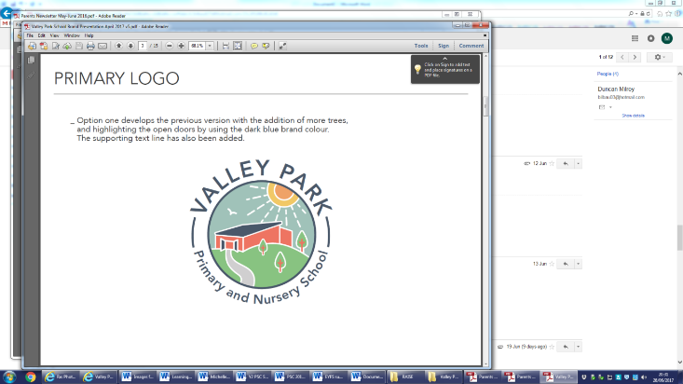  



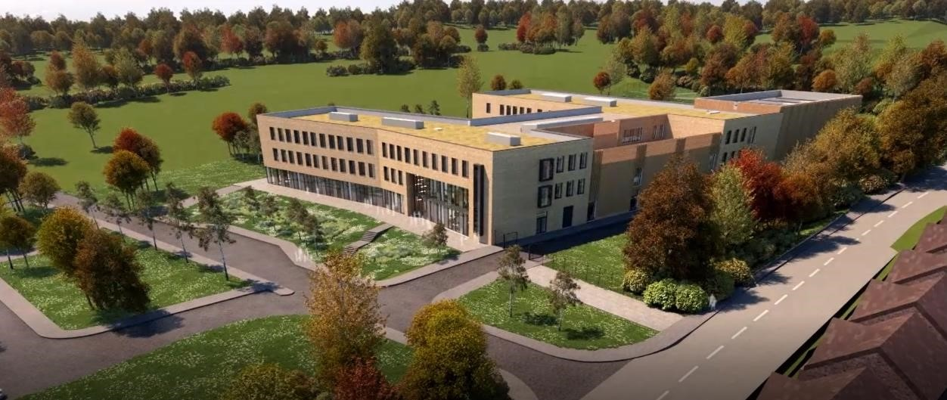

Dear Applicant

Mercia School is a brand new 11-18 school that will serve the south-west of Sheffield. The school will open in September 2018 with 120 Year 7 pupils and grow incrementally for 7 years. Mercia School is part of the Mercia Learning Trust, a local and ambitious Trust that is dedicated to improving the life chances and careers of its pupils and professionals.

Mercia School will provide all pupils, no matter their background or starting point, a rich and demanding education that will inspire. Mercia School will be different. The curriculum will be purely academic with a focus on acquisition of knowledge at its heart. Pupils will receive high levels of challenge in their studies and be supported to achieve accelerated progress. We will set the highest aspirations for our pupils so they can achieve their individual potential and personal ambition.

Mercia School will be a traditional school, following the practices of the very best schools in the land. In essence, Mercia School will share the traits of elite schools, however, we will be a non-selective comprehensive school. We will drive social mobility and achievement for all.

Mercia School will expect that teachers teach from the front with excellent subject knowledge. Our classrooms will be arranged in rows with pupils learning things by heart. We will cherish our teachers’ passion for developing their craft and specialism by ensuring they have time and energy to be reflective. CPD and a transparent team approach to improving practice will ensure we achieve our ambitions together.

Underpinning the ambitious curriculum and teaching will be a consistent discipline approach. Behaviour at the school will be of the highest standard. We will employ a firm approach to behaviour, systematically supported by the senior staff. This will enable our teachers to prioritise the planning and teaching of subject knowledge. We will also have a rich culture of celebration, supported through a traditional house system model, that will highlight and celebrate exceptional performance and excellence in all its forms.

As Headteacher, I am excited about the prospect of leading my team into the new school. It is imperative that I have a team of teaching staff and senior leaders that are truly excellent in the classroom and fully committed to building a world-class school for its community.

I am seeking a highly skilled and talented individual, with a thirst to learn, to serve as the school’s teacher of mathematics. You will have a chance to build something incredibly special in the Mathematics department and beyond, working with the talented Mr Adam Brown, the head of department – this is a once in a career opportunity. You will be required to work harder than you have ever done before with unrivalled passion, as we shape our world- class school. You will be ambitious and have a hunger to be the best you can be.

You will love teaching and be excited at the prospect of a high teaching commitment, as we deliver truly excellent and challenging lessons for our pupils. As teacher of mathematics, you must absolutely believe that every pupil is entitled to a first-class education, no matter their background or ability, achieved through the acquisition of core knowledge.

If this letter has filled you with excitement and you believe you are the person I am looking for to join our movement, I would welcome your application.

Mercia Learning Trust is committed to providing high quality support, training and opportunities for your professional development.  The opportunity for learning and development for both teaching and support staff are such that there has never been a more exciting time to join our fantastic schools.

Mercia School is committed to safeguarding and promoting the welfare of pupils and expects all staff and volunteers to share this commitment. Successful candidates will need to undertake an Enhanced Disclosure via the DBS and/or provide police checks from other countries, where appropriate. Mercia School is an equal opportunities employer.



**Dean F Webster**

**Headteacher Mercia School**

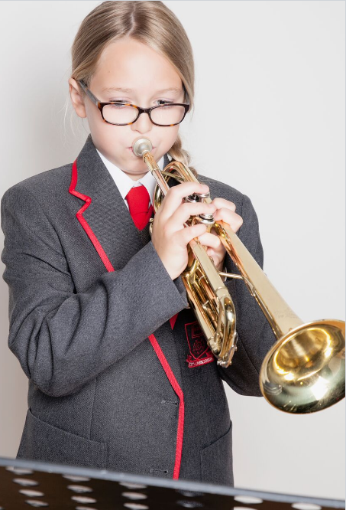

**‘Let us be united by knowledge’**

**Mercia School**



**Teacher of Mathematics**

**MPS**

**Commencement Date: 1 September 2018**

We are seeking to appoint an outstanding teacher of mathematics

**At Mercia School, mathematics will be:**

- Exceptionally challenging for all pupils, no matter their ability or need.

- Taught in a traditional way that gives pupils time to practice and master content.

- A subject that raises aspiration so all pupils have a successful career and a happy life.

- Preparing pupils for the challenges at GCSE and A-level, from day one.

Your role will be to teach excellent lessons, develop a mastery curriculum, promote a love of mathematics and commit yourself to the vision of the school.

**We welcome applications from talented, ambitious individuals who can dedicate themselves to the implementation of the school’s vision. Please email completed application forms or any enquiries about this post to shodkinson@ecgbert.sheffield.sch.uk**

If you do not believe in the ethos and mission of Mercia School, please do not apply.

[www.merciaschool.com](http://www.merciaschool.com)

**Closing date for applications: Wednesday 21 March 2018**

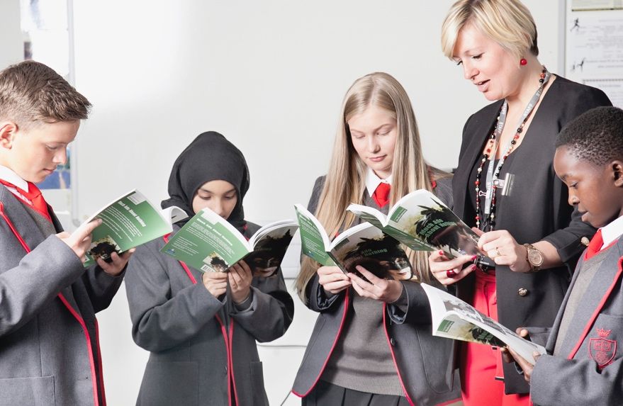

**‘Let us be united by knowledge’**

**Job Description**



|  |  |
| --- | --- |
| Post title: | **Teacher of Mathematics** |
| Responsible to: | Head of Mathematics |
| Purpose of the role: | * To teach designated pupils and undertake associated pastoral and administrative duties as well as other general responsibilities, having full regard for the school’s unique ethos, aims and policies. * To undertake tasks related to the development of the mathematics curriculum and the wider school. * To deliver the vision of Mercia School without fear or favour, particularly through exemplary teaching of mathematics. This will relate predominantly to the successful delivery of a knowledge rich curriculum taught through traditional, didactic pedagogical approaches. * To drive the standards agenda in mathematics so that every pupil aspires to be the best they can be. * To implement excellent teaching and learning strategies to ensure every student achieves at the highest possible level in mathematics. * To ensure teaching and learning in mathematics is first-class and in line with the Mercia School Teaching and Learning policy, namely a knowledge-based approach with a focus on mastery in mathematics. * To collaborate with the Head of Mathematics in designing a curriculum that is challenging and inspiring. * To consistently drive high standards and expectations throughout the school generally. * To build effective networks and partnerships that are pertinent to mathematics, so that Mercia School is innovative whilst staying true to its core values. |
| CORE DUTIES | |
| Teaching and Learning | * To ensure units of work in mathematics are challenging and have an abundance of knowledge, which pupils learn off by heart. * To plan schemes of work for pupils in co-operation with the Head of Department in order to ensure that all pupils are taught to the same exceptional standard. * To plan work matched to the individual needs of pupils and within the school’s agreed policy and schemes of work, so that all pupils and groups of pupils achieve equally well in mathematics. * To produce written records of such planning in accordance with school policy and the instructions of the Head of Department. * To monitor and react to developments in terms of mathematical pedagogy and research. * To teach excellent lessons that are in line with the Mercia School Teaching and Learning policy. * To teach mathematics with passion and a reflective attitude. * To be abreast of assessments/examinations at GCSE and A-level so that the curriculum is relevant in mathematics from Year 7 and beyond. * To assess and record pupils’ achievements and progress within the statutory requirements and school’s assessment policy and report to parents. * To teach pupils according to their individual needs, including the planning and assessment of work in line with agreed policies of the school. * To contribute to the provision of a safe and secure learning environment. |
| Professional | * To actively promote the school within Sheffield and nationally. This will include participation in national mathematical competitions and events. * To contribute to the school liaison and publicity activities. * To pursue the aims of the school in a positive manner and promote the school’s knowledge-centric ethos. * To work co-operatively within a whole staff team to achieve continuous improvement with a relentless drive to ensure teaching and learning is of the highest quality. * To consistently implement and maintain the school’s policy on discipline and behaviour. * To support the school’s endeavours to meet the needs of its community. * To participate in the school’s performance management process. * To contribute to meetings, discussions and management systems necessary to ensure the co-ordination of the work of the school as a whole. * To contribute to the ideas within and the implementation of the School Improvement Plan. |
| OTHER SPECIFIC DUTIES | |
|  | * To take part in personal professional development. * To observe, without fail, dedicated duties as determined by the Leadership Team. * To participate in staff observations as a part of day-to-day practice. This will include regularly being observed by colleagues and vice versa. * To proudly contribute to an open, honest and candid school climate. We expect candor from all, no exceptions. * To participate in Family Lunchevery day, relishing the opportunity to spend quality time with all of our pupils. * To be a committed and excellent form tutor, delivering rich reading, PHSE and fulfilling pastoral duties in line with school policy. * To have an unrelenting commitment to the cause, as shown by exemplary attendance and completion of our longer school day. * To take part in our House system, as directed by the Headteacher. * Any other delegated roles, as directed by the Headteacher. |
| The specific responsibilities of the post will be further determined according to the expertise and experience of the successful candidate. | |
| The school will endeavour to make any necessary reasonable adjustments to the job and working environment to enable access to employment opportunities for disabled job applications or continued employment for an employee who develops a disabling condition.  This job description is current at the date as shown, but in conjunction with the post holder, may be changed by the Headteacher to reflect or anticipate changes in the role which are commensurate with the grade and job title.  March 2018 | |

**Person Specification**



|  |  |  |
| --- | --- | --- |
| Post title: | Teacher of Mathematics | |
| Qualifications and Training | * Degree in mathematics (or other quantitative subject) is essential. * Qualified teacher status essential – suitable for an NQT. * Recent and relevant professional development relating to knowledge-based curricula is desirable. | Application form and interview |
| Skills and  Knowledge | * Must have highly effective communication skills which engage pupils, parents, staff, governors and the wider community. * Must be able to use traditional pedagogical approaches appropriate to the teaching of mathematics to the highest level. * The ability to teach in a didactic way is essential, giving pupils exceptional knowledge in mathematics is vital. A desire and will to change practice as requested is essential. | Application form, interview and references |
| Experience | * Teaching mathematics to a full range of age and ability within a secondary school. * Knowledge of current initiatives relating to achievement and inclusion in mathematics is desirable. * Track record as a successful classroom practitioner (Ofsted criteria) across the secondary school age and ability range. * We welcome existing subject examiners; however, this is not essential. Please be aware that all teachers at Mercia School will become examiners in their subject area. | Application form, interview and references |
| Personal  Qualities | * Must be able to demonstrate the ability to take initiative, lead, motivate, inspire and support the full range of stakeholders to achieve excellence. * Must be ambitious for self and others, showing a powerful commitment to continuous improvement and raising standards within a knowledge-based curriculum. * Must be resilient and optimistic, having a relentless focus on achieving the best for our pupils and being prepared to develop creative strategies to achieve this. * Must be able to show evidence of an alignment with the values of Mercia School both in words and behaviours. Knowledge will be at the heart of everything we do. If this does not excite you, please do not apply. | Application form, interview and references |



**‘Let us be united by knowledge’**