Dear Candidate

Head Teacher for September 2018

On behalf of the governing body at Old Bexley CE Primary School may we thank you for your interest in the post of Head Teacher at this school.

We recognise that you are trying to choose a school that is right for you as much as we are trying to select a candidate who can work together with the whole school community and lead the staff team into an exciting future. In this pack you will find information about the post which we hope you will find helpful.

Old Bexley CE Primary School is a founding member of the Amadeus Primary Academies Trust, a local MAT of successful schools. Old Bexley CE Primary School is a welcoming and attractive school with a deep rooted Christian community ethos. We are looking for the right person who can help to build on the current achievements of the school who will be key to taking the school forward to the next and exciting stage of development.

If you would like to discuss the post or have other questions you are most welcome to telephone or visit the school. Please contact Mrs Dawn Carroll by telephone on 01322527981 or via email at dcarroll@oldbexley.bexley.sch.uk.

The closing date for applications is noon on Monday 5th March. Please ensure that your application is posted to the school addressed to Peter Wilson, CEO and marked CONFIDENTIAL HT. The interviews are planned to take place on Monday 19th and Tuesday 20th March. We would be grateful if you would please also include a clerical reference. We ask that your supporting letter should be no more than 1,200 words.

If you share our excitement and feel that you meet the criteria we would very much like to hear from you.

Good luck!

Yours sincerely
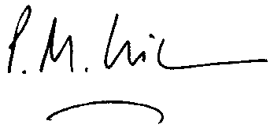

Julie Bowen

Revd Julie Bowen
Chair of Governors
Old Bexley CE Primary School

Peter Wilson
CEO
Amadeus Primary Academies Trust

