23 February 2018

Dear Applicant,

Thank you for your interest in the position of Teacher of Science (maternity) at Ormiston Chadwick Academy.

Ormiston Chadwick Academy, or OCA as we fondly call it, opened on the 1st September 2014. Since opening, we have had an exceptional journey. Our results last summer put us not only at the top of the borough for progress and attainment, but in the top 5% of schools in the country (Top 100) for the new government measure Progress 8. Ofsted recently recognised this during a Section 5 visit in December 2016. We were judged as ‘Outstanding’ for overall effectiveness.

This did not happen by magic, it is because I have committed, loyal, wonderful staff that go ‘above and beyond’ for our pupils. We serve a community with a very high proportion of disadvantaged students; half of all our students attract Pupil Premium funding. Staff who come and work for us are committed to making a difference to the lives of these young people, the work here is fast paced but extremely rewarding.

I am looking for a dynamic individual, a teacher who will go that extra mile and inspire confidence and ambition in every child in their classroom and form. We have a very strong and loyal community and the ability to relate well to parents and carers is a necessity. We put a lot of emphasis into staff training, including an excellent NQT programme. Every staff member is encouraged to develop their skills throughout their time with us.

The Science department are a strong team with a range of experience. The school’s specialism is science and we like to encourage as many of our pupils as possible to continue studying science at A-Level and beyond.

If you feel that this is the type of school where you could help make the difference, I would love to hear from you.

Yours Sincerely,
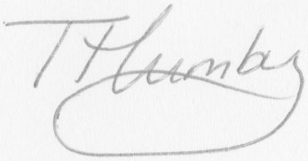
Tuesday Humby
Principal

