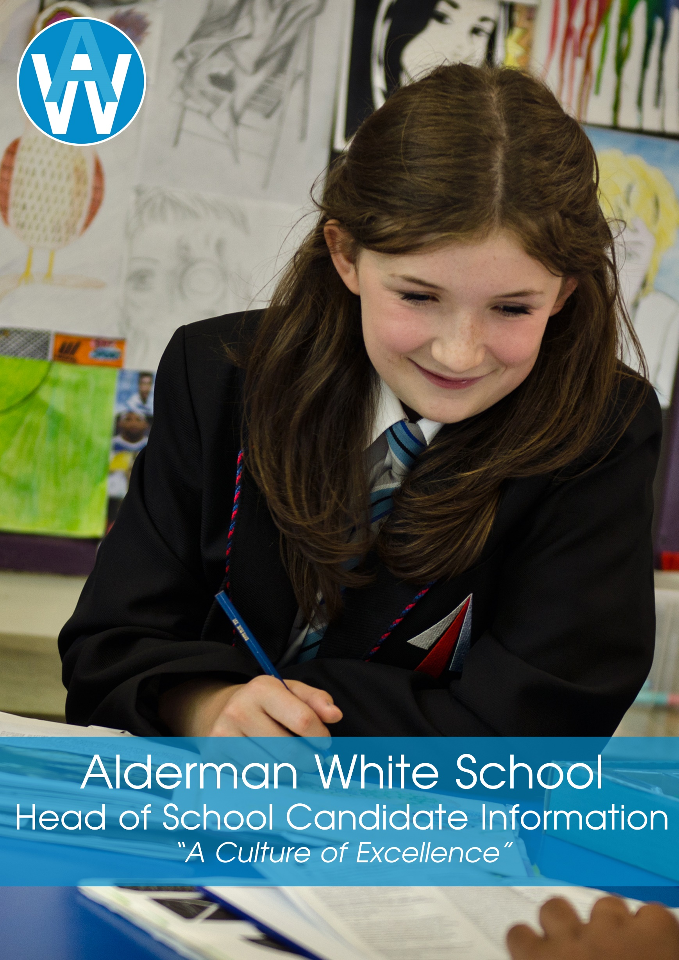

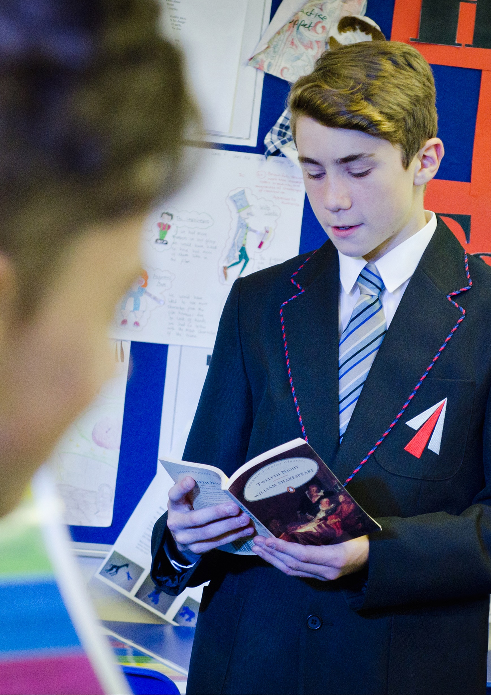**WELCOME**

Dear Applicant,

I am delighted that you are interested in the position of Head of School at Alderman White School, part of the White Hills Park Federation Trust.

Following the promotion of our current Head, we are looking forward to securing an outstanding candidate who will lead the school to its next stage of development. Having achieved a well-deserved Good judgement at the last inspection, and with achievement on a secure upward trend, this is an exciting time to be leading the school.

Alderman White School is a friendly, thriving and stimulating place to work and study. Our students are well behaved and motivated. We have excellent support from parents and the community, and a talented and positive staff team. We set high aims for every student and provide high-quality pastoral care and support for our most vulnerable students.

Alderman White School offers outstanding enrichment opportunities for students, with an enviable range of productions, musical events, and visits and exchanges all over the UK and beyond. Through the Language College offer, we are a centre for excellence in the teaching of a wide range of languages to our students and the wider community. In recent times, the Confucius classroom has enabled the school to develop links with China and introduce the teaching of Mandarin.

Alderman White School plays a central role in the White Hills Park Federation Trust. We are a small multi-academy trust with strong values, and also a strong vision and ambitious plans to develop and grow. As the Head of School, you would play a crucial role in these plans, to the benefit of the Trust, but also to Alderman White School and your own career development. We have a strong and supportive Board of Directors, who work with us to promote and improve our schools.

As our new Head of School, you will be someone who is making rapid progress in their career, who has shown that they can thrive under the challenges of leadership and is ready to move to a new level. You will have a clear vision and sense of purpose. You will work well as part of our Trust team, but be single-minded in your desire to succeed for Alderman White School.

We are very proud of what we have to offer you and hope you can see the potential for you in this opportunity. We warmly welcome you to have a pre-application visit to the school, or an informal discussion with me over the telephone. Details are available in the pack.

I hope that reading the details of the post will inspire you to find out more, and I look forward to receiving your application,

Yours,

Paul Heery

Executive Principal

**BACKGROUND INFORMATION**

**The White Hills Park Federation Trust**

The White Hills Park Federation Trust is a small Multi-Academy Trust, located on the western fringes of Nottingham. Formed in 2012, it currently comprises Alderman White School, Bramcote College 11-16 School, and Bramcote College 6th Form. Although the schools work closely together and share resources and support services, each school retains its own character, identity and autonomy.

We are located within close proximity to the M1 and A52, and within easy reach of Nottingham City Centre as well as rural Nottinghamshire and Derbyshire, including the Peak District National Park.

We work very closely with other local schools, particularly our feeder primary schools, with whom we share a formal collaboration. All the schools in the Trust were inspected in 2017, and all were judged good.

Through the work of the Trust, we aim to build a culture of excellence, enabling our students to fulfil their potential and become responsible, positive citizens, founded on our INSPIRE values of:

* Integrity
* Nurture
* Success
* Perseverance
* Innovation
* Responsibility
* Engagement

**Alderman White School**

Alderman White School is a successful and inclusive school with a record of good progress, excellent student behaviour and a wide range of enrichment activities. In recent years, the school has gone from strength to strength and enjoys growing student numbers and an excellent reputation in the local community.

We have retained our distinct identity as a specialist language school, with students benefitting from a range of languages taught both as part of the mainstream curriculum and of the extensive community programme including the Saturday family learning classes. We organise exchanges to Germany and visits to many locations, including France and Spain. We have established a Confucius Classroom, in partnership with the Confucius Institute at the University of Nottingham, enabling our students to learn Mandarin, and to benefit from cultural exchanges with schools in China. We have a proud tradition of music and drama, and strong relationships with parents and our local community.

The school is served by five main primary schools, with a significant number of students from several other primaries within a wider geographical area. There is a high level of co-operation and contact within our 'family' and the school engages with many activities within the wider community.

**APPLICATION DETAILS**

Dear Applicant

You must complete the application form fully and give details of all employment, training and gaps in employment since leaving secondary school to the present day. Any additional information, which you wish to bring to the notice of the selection panel should be included in your letter of application (supporting statement). Please ensure that you take each of the criteria on the person specification and say why and how you meet these criteria in your letter of application.

We look forward to receiving your application.

|  |  |
| --- | --- |
| **The Selection Process**:  Shortlisting meeting:   * Monday, 19th March 2018   Interviews will be held on:   * Day 1 Tuesday, 27th March 2018 * Day 2 Wednesday, 28th March 2018 | Pre-application visits are welcomed by appointment as follows:   * Friday, 9th March 2018 from 1.30 pm onwards * Monday, 12th March 2018 any time * Wednesday, 14th March 2018 from 11.00 am onwards * Thursday, 15th March 2018 any time   To arrange a visit, please contact  Karen Sims, PA to the Executive Principal  on 0115 9078111 or [karen.sims@whpfederation.org](mailto:karen.sims@whpfederation.org) |

**References** must cover the previous five years employment and please provide an email address for your referees so that we can contact them.

**The closing date** for applications is **9.00 am** on **Monday, 19th March 2018.**

Please email your completed application form and letter of application (no longer than 2 sides of A4, Arial font size 11) to Karen Sims, PA to the Executive Principal – [karen.sims@whpfederation.org](mailto:karen.sims@whpfederation.org). CV’s will not be accepted.

**SAFEGUARDING**

The White Hills Park Federation Trust is an equal opportunities employer and is committed to safeguarding and protecting the welfare of children. The successful candidate will be required to undergo an enhanced Disclosure and Barring Service (DBS) clearance and checks will be made with past employers.