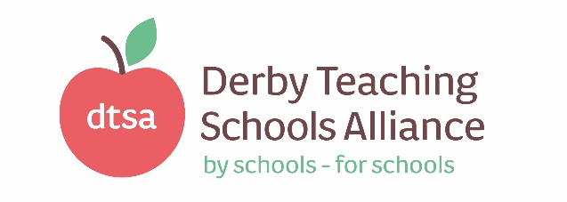
Director of Derby Teaching Schools Alliance

Job title: Director of Derby Teaching Schools Alliance

Responsible for: The strategic and operational day to day running and business

development of Derby Teaching Schools Alliance

Employer: DTSA Charitable Company

Responsible to: The Chair of DTSA Executive Board
Salary: L20 – 24 (£62,833 to £69,330 per year), pension arrangements and contributions to be discussed
Hours: Full Time
Holidays: Teachers Terms and Conditions apply
Contract type: Permanent
Reports to: Chair of DTSA Executive Board
Base: Chellaston Academy, Derby
Job description:
- Core Role

  - Supply direction and development of Derby Teaching Schools Alliance (DTSA), including its commercial functions across Secondary, Primary and Special sectors.
  - Collaborate and negotiate at a strategic and operational level with local and national partners in order to share expertise and bring positive benefits to the DTSA.
  - Maintain and develop the Alliance’s vision of collaboration, creativity and high aspirations for learners of all ages and abilities, ensuring it meets its aims and key delivery targets, realising all potential for growth.
  - Directly influence and support the raising of standards across partner schools, through school to school support, specific bid related work and the commercial programmes.
  - Ensure that all provision is quality controlled so that any future inspection or monitoring will result in an ‘outstanding’ judgment for the provision.
- Strategic duties and responsibilities
  - Create and strategically develop the DTSA to meet the key performance indicators and needs of schools within the Alliance.
  - Secure the commitment of the wider community of the DTSA, by developing and maintaining effective partnerships with, for example; schools, MATs, Governors’ Partnership, other agencies, local dioceses, the Local Authority, National College, higher education institutions, Department for Education and the private and voluntary sector.
  - Provide advice and guidance to the Executive Board and the three advisory groups to support effective decisions on policy and outcomes of service delivery.
  - Liaise closely with staff in schools within the Alliance and broader partnerships where appropriate.
  - Liaise with established local partnerships and networks to translate the vision into agreed objectives and operational plans which will promote and sustain improvement.
  - Evaluate DTSA performance against key indicators, identifying success and the priorities for continuous improvement.
  - Ensure that the range, quality and use of all available resources (human and financial) is monitored, evaluated and reviewed to provide value for money.
  - Provide for the Executive Board and to other interested partners, quarterly financial feedback or reports which indicate how any income has been expended.
  - Ensure partner accountabilities and quality assurance measures are clearly defined, understood and agreed and are subject to rigorous review and evaluation.
  - Develop and present a coherent, understandable and accurate account of the DTSA performance, against key indicators and/or funding criteria, to a range of audiences, including grant returns to the DfE.
  - Contribute to the development of the broader education system by for example, sharing effective practice and collaborating with others to raise standards.

- Operational Management
  - Produce and implement clear, evidence-based improvement plans and policies for the development of the core work streams for the Teaching School Alliance.
  - Lead a range of initiatives and services linked to the commercial, bid funded and traded work of the Alliance including national delivery areas and performance indicators.
  - Undertake regular audits of the strategies, experience, knowledge, challenges and needs across the Alliance and geographical area, analysing the results to feed into management information.

  - Lead and manage the administration team and contracts/performance of others commissioned to do work on behalf of the Alliance.
  - Broker and commission services and resources to enable the Alliance to fulfill its objectives.
  - Ensure the Alliance has an effective website with an online directory of support services and skills, contributed by Alliance schools and other partners across the geographical area.
  - Design, with partners and colleagues, the Teaching School Alliance prospectus and annual delivery programme.
  - Ensure a range of marketing and social networking tools are used to promote and celebrate the work of the Teaching School Alliance.
  - Secure and maintain the relationship with other Teaching School Alliances to ensure a balanced offer, joint working and a good alignment of practice and leadership development in response to audited and/or data led need.
  - Create monitoring measures and criteria to monitor effectiveness in meeting KPIs.
  - Ensure Alliance business and action plans secure best value.

