
Ralph Thoresby School
Information for candidates

Teacher of Computer Science/iMedia
Salary Range

£22,466 to £38,250

Ralph Thoresby School
Holtdale Approach
Leeds
LS16 7RX

Telephone: 0113 3979911
Email: dmaw@ralphthoresby.com
Fax: 0113 2613132

Headteacher: Mr Will Carr

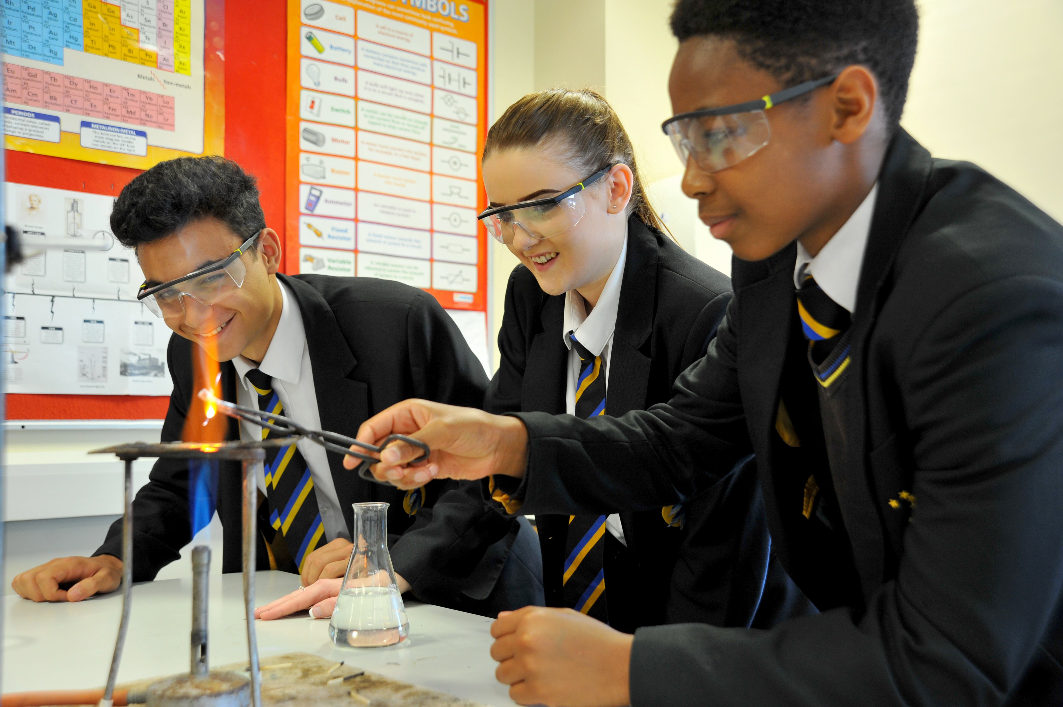
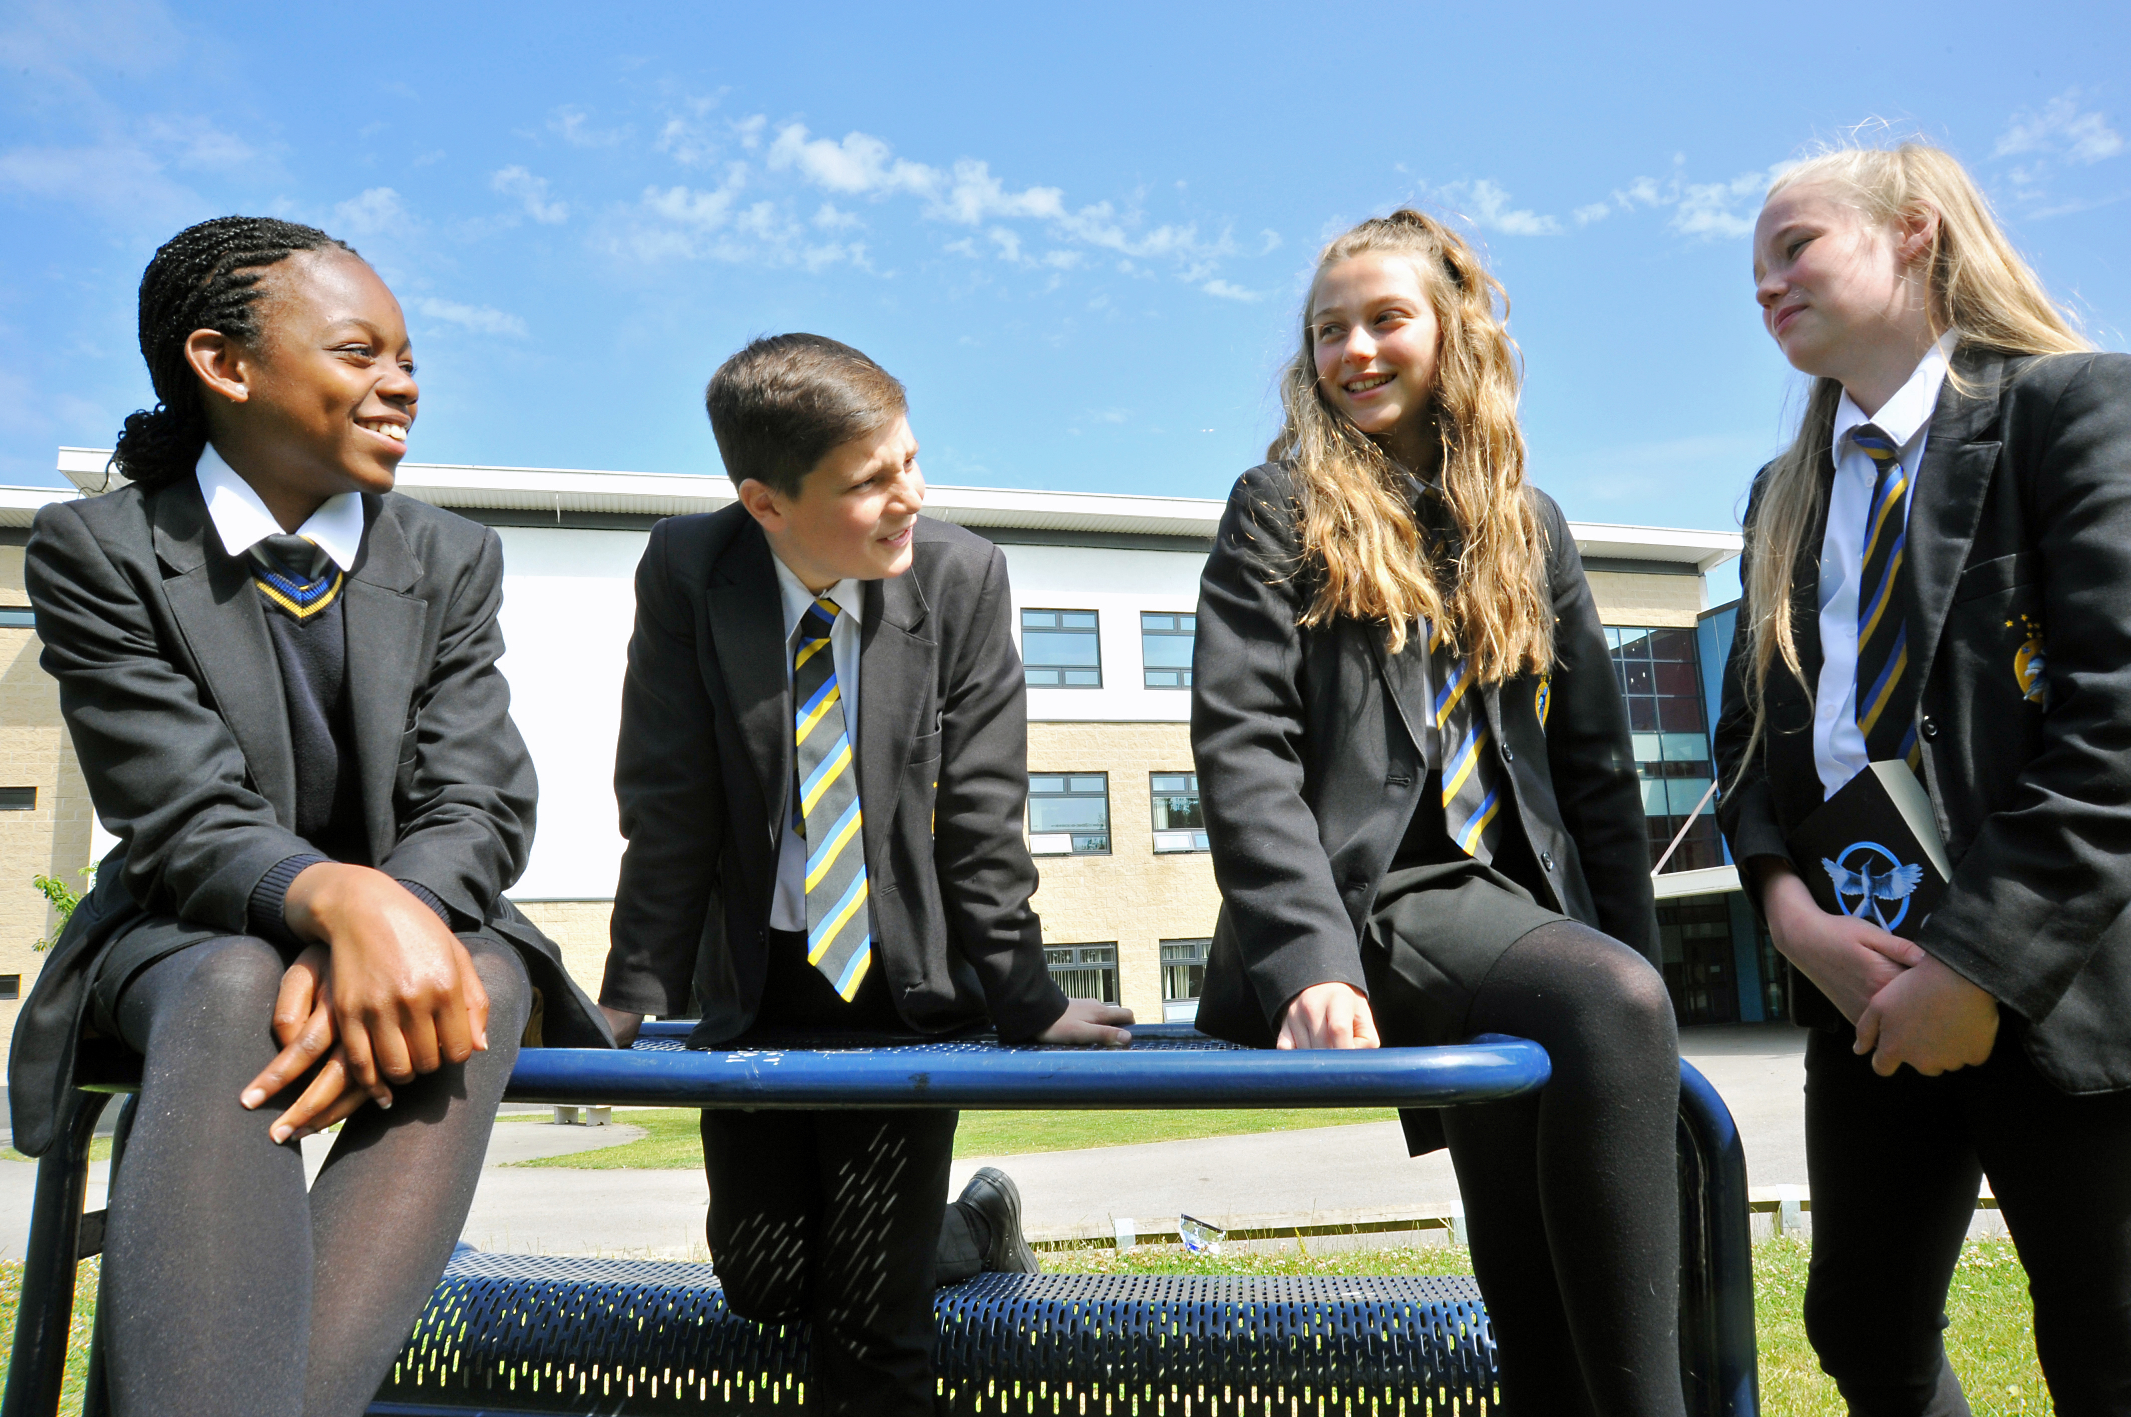

Contents
Page | Item
3 | Letter from the Headteacher
4 | The Selection Process
5 | Information For Candidates
6 | Job Description
9 | Personal Specification
10 | Beliefs, aims and expectations

March 2018

Dear Candidate,

Thank you for expressing an interest in applying for the post of Teacher of Computer Science/iMedia at Ralph Thoresby School.
This is an exciting time to be joining Ralph Thoresby School. The school is on an upward curve and has recently been judged GOOD by Ofsted in all key areas. Exam results are consistently strong at both GCSE and A Level. Students make good progress ‘as a result of good and sometimes outstanding teaching’ (Ofsted). We are keen to continue the significant improvements made in recent years while working together – ‘Morale in the school is high and there is a culture of high expectations supported by all staff’ (Ofsted).

The School is a mixed comprehensive community school with 977 students on role. 30% of our students come from ethnic minority backgrounds and we have a resource provision for physically and visually impaired students which really adds to the positive and harmonious atmosphere around school. Our superb, modern school building further enhances the atmosphere and supports students’ learning. The atmosphere around school is always positive – ‘The school is a calm and purposeful place. Students are pleasant, polite and courteous’ (Ofsted).

We have an excellent 6th form partnership arrangement with Lawnswood School (another GOOD local school) and together we offer post-16 provision to rival the best in the city – ‘Students make exceptional progress due to high quality teaching and strong student commitment to do well’ (Ofsted). In addition, we are a Trust school in partnership with several of our local partner Primary schools. Our vision is to create a high performing learning community in the North Leeds locality for children aged between 6 months and 19 years. ‘Partnership working is strong’ (Ofsted).

Our school motto is ‘ambition and achievement for all’. We firmly believe in giving all students the opportunity to achieve their very best regardless of the circumstances in which they find themselves.

We are excited about the future here at Ralph Thoresby and, having read the information included in this pack, I hope you feel you can play an important part and submit an application. Please also ensure that you visit our website which will give you an insight into the work of the school. I look forward to welcoming you to the school as a candidate in the near future.

Yours faithfully,



Mr Will Carr (Headteacher)

NQT’s are welcome to apply

THE SELECTION PROCESS

How to Apply

Thank you for taking time to read and digest our information. If you wish to apply for the post of Teacher of Computer Science/iMedia at Ralph Thoresby School, then you should:

- Complete fully the enclosed application form, ensuring all details are accurate and all declarations are signed. Please ensure you enclose two professional referees with one being your current employer (with email addresses if possible). Do not enclose additional CVs.

- Support your application with a covering letter (2 sides A4 Arial 11.5 point, maximum) detailing how your experience and qualifications fit the role of Teacher of Computing.

- Submit your letter and application form on hardcopy to be received by 12 noon on Monday 19th March 2018.

Please address all return mail to;
Mrs D Maw
PA to the Headteacher and Senior Leadership Team
Ralph Thoresby School
Holtdale Approach
Leeds
LS16 7RX
________________________________________

Timetable for the selection process

- Post advertised in TES and Leeds CC Bulletin: Friday 2nd March 2018
- Closing date for applications: Monday 19th March 2018, no later than 12:00 noon
- Short listing: Tuesday 20th March 2018
- Invitation to interview by telephone: Tuesday 20th March 2018
- Confirmation by email: Tuesday 20th March 2018
- Reference requested: Tuesday 20th March 2018
- Selection day scheduled: Friday 23rd March 2018
Information for Candidates for the Post of Teacher of Computer Science/iMedia

Staffing
The Computer Science/iMedia department at Ralph Thoresby is made up of 1 full specialist teacher, as well as five non-specialists. The team is highly supportive of each other and works collaboratively in both planning and delivery of the curriculum. Recent quality assurance data shows that the quality of teaching is consistently outstanding in the department and that significant steps have been taken to ensure that students receive a high quality education in all lessons throughout the department. However, the team is currently in a position to develop even further, and this is why we are looking to appoint an outstanding computer science teacher at this time, to add additional capacity to a rapidly developing department. The successful candidate will inspire and enthuse students to be the very best they can be, as well as demonstrate the ability to work effectively within the science department and the whole staff team.

Accommodation and Resourcing
All Computer Science/iMedia teaching takes place in a suite of 4 dedicated computer suites, which provide an outstanding environment for quality teaching and learning to take place. Collaborative planning is being developed to ensure that excellent resources are available for learners of all ages and abilities. The department prides itself on being paperless; all resources, student work submissions, marking and feedback occur on the school VLE platform, Moodle.

Courses and Qualifications
All students at Key Stage 3 study computer science for 2 hours per fortnight, and follow a programme of study which meets the National Curriculum expectations for the subject. These units are designed to cover the essential knowledge and skills that we believe are necessary to fully equip students for their studies at Key Stage 4.

At Key Stage 4, students can opt to study Eduqas GCSE Computer Science or OCR Cambridge Nationals in Creative iMedia. These qualifications are taught over 5 lessons per fortnight. These options are popular choices, with group sizes growing year upon year. In 2017, results in both Computer Science and Creative iMedia were amongst the strongest in the school and the department is keen to consolidate and where possible, improve these results going forward.

Post 16 students can follow a vocational route and study OCR Cambridge Technicals in Digital Media. This course has been well received by our students, with numbers growing year upon year. A Level Computer Science is offered within our sixth form partnership at Lawnswood School.

This new post of Teacher of Computer Science and iMedia at Ralph Thoresby offers an excellent opportunity for an enthusiastic, passionate and dedicated teacher to work within a developing team, at a very positive time for both the school and the department.

Ralph Thoresby School

Job Description

Job Title: Teacher of Computer Science/iMedia

This job description will be reviewed annually and may be subject to amendment or modification at any time after consultation with the post holder. It is not a comprehensive statement of procedures and tasks, but sets out the main expectations of the School in relation to the post holder’s professional responsibilities and duties, including the provision of high quality teaching and learning across the School and the pastoral care of the students in their charge.

Elements of this job description and changes to it may be negotiated at the request of either the Headteacher or the incumbent of the post.
Accountable to: | Head of Department | Line Managing: | N/A
Post type: | Permanent | Salary/Grade: | MPS/UPS
Liaising with: | Parents/carers, school staff and students

Safer Recruitment Statement:
We are committed to safeguarding and promoting the welfare of children and young people and we expect all staff and volunteers to share this commitment. This post requires Enhanced Disclosure (CRB).

Every member of staff is required to:
- Work towards and promote the vision, beliefs, aims and expectations outlined in the School Improvement Plan
- Support and contribute to the achievement of every child’s outcomes
- Support and contribute to the safeguarding of all students
- Undertake professional development activities to enhance personal development and performance
- Maintain high personal professional standards of attendance, punctuality, appearance, conduct and positive relations with students, parents and staff.

All teaching staff are required to:
- Plan, develop and deliver high quality lessons and courses within the broad, balanced, relevant and differentiated subject curriculum using a variety of approaches, to continuously enhance teaching and learning.
- Monitor student progress, keeping records that include assessment outcomes and targets set at regular intervals in line with school policy, to enable all students to achieve their full potential.
- Work consistently at and beyond the professional standards set out in the 'School Teachers’ Pay and Conditions Documents' for the level at which you are employed i.e. Core, Post Threshold or Excellent.
- Implement relevant policies, procedures and improvement plans.
- Fully participate, as requested, in the processes of self-evaluation and improvement planning.
- Fully implement all policies in relation to effective learning, student rewards and managing behaviour to ensure there is a well ordered and disciplined teaching and learning environment within their own specific learning space and across the whole school
- Contribute to the safeguarding and promotion of the welfare and personal care of all students with regard to the Safeguarding and Child Protection Procedures.
Teaching and Learning
- Manage student learning through effective teaching in accordance with the Department’s schemes of work.
- Ensure continuity, progression and cohesiveness in all teaching.
- Use a variety of methods and approaches (including differentiation) to match the needs of each student to ensure that all students are able to access the curriculum and make at least their expected progress
- Set homework regularly (in accordance with the School homework policy) to consolidate and extend learning and encourage students to take responsibility for their own learning.
- Work with EAL/SEN staff and support staff (including prior discussion and joint planning) in order to benefit from their specialist knowledge and to maximise their effectiveness within lessons.
- Support individual learning, including more able students, by planning work with appropriate challenge and monitoring and reviewing student outcomes regularly.
- Set clear and precise learning objectives and define criteria for success for each lesson.
- Work effectively as a member of the Department team to improve the quality of teaching and learning by contributing to the Department Improvement Plan and implementing and monitoring change.
- Implement new initiatives at school, local or national level by adapting classroom procedures accordingly, monitoring progress and reflecting on pedagogical outcomes.
- Set high expectations for all students to deepen their knowledge and understanding and to maximise their achievement.
- Use positive management of behaviour in an environment of mutual respect that allows students to feel safe and secure and promotes their self-esteem.
Monitoring, Assessment, Recording, Reporting, and Accountability
- Be responsible for the processes of assessment, recording and reporting for the students in
their charge.
- Track student progress effectively, monitoring achievement against targets set and taking appropriate action to improve student outcomes.
- Assess students’ work systematically and use the results to inform future planning, teaching and curriculum development.
- Contribute towards the implementation of IEPs as detailed in the current Code of Practice particularly the planning and recording of appropriate actions and outcomes related to set targets.
- Be familiar with statutory assessment and reporting procedures and present informative, helpful and accurate reports to parents.
- Keep an accurate register of students for each lesson. Unexplained absences or patterns of absence should be reported immediately in accordance with the School policy.
Subject Knowledge and Understanding
- Have a thorough and up-to-date knowledge and understanding of the National Curriculum programmes of study, level descriptors and specifications for examination courses.
- Keep up-to-date with research and developments in pedagogy in the relevant subject area.
- Contribute to the effective use of subject resources, including evaluation of new materials and equipment.
- Use up-to-date technology to enhance delivery of, and student access to, the subject.
Professional Standards and Development
- Work in accordance with the 2012 Teachers’ Standards
- Be a role model to students through personal presentation and professional conduct.
- Arrive in class, on or before the start of the lesson, and begin and end lessons on time.
- Be familiar with the School and Department handbooks and Departmental Portfolio contents and support all the School’s policies, e.g. those on Health and Safety, Citizenship, Literacy, Numeracy and ICT.
- Establish effective working relationships with professional colleagues and associate staff.
- Be courteous at all times to all colleagues and students and visitors to the school.
- Be involved in extra-curricular activities such as making a contribution to after-school clubs and visits.
- Maintain a working knowledge and understanding of teachers’ professional duties as set out in the School Teachers’ Pay and Conditions document, and teachers’ legal liabilities and responsibilities relating to all current legislation.
- Liaise effectively with parents/carers and other agencies with responsibility for students’ education and welfare.
- Be aware of the role of the Governing Body of the School and support it in performing its duties.
- Be familiar with and implement the current SEN Code of Practice, DDA and Access to Work. Consider the needs of all students within lessons (and implement specialist advice) especially those who: have SEN; are more able; are not yet fluent in English.

Continuing Professional development
      - Take responsibility for personal professional development, keeping up-to-date with research and developments in teaching pedagogy and changes in the School Curriculum.
      - Undertake any necessary professional development as identified in the School Improvement Plan taking full advantage of any relevant training and development available.
      - Maintain a professional learning portfolio of evidence to support the Appraisal process including the incorporation of targets related to leadership, evaluating and improving own practice.
      - Effectively manage own time when dealing with the wide range of day-to-day and long term demands of the post.
Additional Duties
- Contribute to the life of the Ralph Thoresby School community, and to support its ethos and policies.
- Undertake any other duties as reasonably required by the Headteacher.

Compiled by: | W Carr | Date: | March 2018

Ralph Thoresby School
Person Specification
Job Title: Teacher of Computer Science/iMedia

 |  | Essential | Desirable |  | Evidence
 | Qualifications & Experience | - Qualified Teacher Status (QTS) and good Honours degree relevant to teaching Computer Science/iMedia (NB: All original certification will be checked on the selection day, including proof of passing the DfE Professional Skills tests [Numeracy & Literacy] if appropriate)  - Outstanding classroom practice that inspires students and adds value to their progress  - Proven track record of having impact on students’ outcomes in current post/teaching practice school | - Further formal Professional Development |  | Application form, letter & references
 | Skills & Knowledge | - Substantial knowledge and understanding of developments in the teaching and learning of Computer Science/iMedia.  - Ability to relate to teaching staff, other professionals, parents, students and Governors.  - Experience of new technologies to support teaching and learning.  - Ability to use data effectively to monitor student progress  - Ability to work as a member of a team and /or independently | - Ability to work collaboratively across the team to develop high quality teaching and learning |  | Letter, references & selection process
 | Personal qualities and skills | - Enthusiastic, sensitive, flexible, hard working with a sense of humour and ability to remain calm  - High level skills of communication, time management and prioritisation  - Ability to keep confidences  - Excellent interpersonal skills and organisational skills  - Ability to support and challenge  - Ability to inspire, motivate and influence others | - Ability to ask for help if required  - Concern for the welfare of all members of the school community |  | Letter, references & selection process
 | Special Requirements | - Excellent punctuality and attendance record  - Willingness to participate in the extra-curricular life of the school |  |  | References & selection process


Beliefs, aims and expectations
At Ralph Thoresby School we BELIEVE in:
- High expectations for all.
- Excellence in all we do.
- Determination and resilience.
Respect and tolerance.
- Creativity and independent learning.

At Ralph Thoresby School we AIM to:
- Achieve success in all areas of school life.
- Ensure that all students enjoy school and are fully engaged in learning.
- Create an inspiring place to learn where all students are safe and well supported.
- Be fully inclusive and committed to opportunity for all.
- Prepare students for life through strong links with local businesses and excellent career development.
- Build strong community links, including with parents and carers.
- Develop confident, articulate and responsible young citizens.
- Create an ethos of mutual support and encouragement amongst our students.
- Promote values of tolerance and respect.

Our EXPECTATIONS are:
For Students:
- To arrive at school on time every day, correctly dressed, ready to learn and ready to work hard.
- Calm, polite and considerate behaviour towards all others.
- To aim high, be committed and make the most of your ability.
- To take responsibility for your learning – be an active learner.
- To always uphold school values, aims and expectations.

For Staff and Governors:
- To be positive, professional role models in promoting school values, aims and expectations.
- To be committed to student achievement and demand the best from our students.
- To develop an engaging curriculum and deliver consistently excellent lessons.
- To demonstrate and encourage independence and leadership.
- To treat everyone with dignity, building relationships rooted in mutual respect.

For Parents / Carers:
- To support your children in achieving their goals.
- To fully support school staff, policies and initiatives.
- To encourage students to achieve their potential.
- To take an active role in your child’s learning, attending school events wherever possible.
- To ensure that your child attends school and arrives on time every day, fully equipped and ready to learn.

