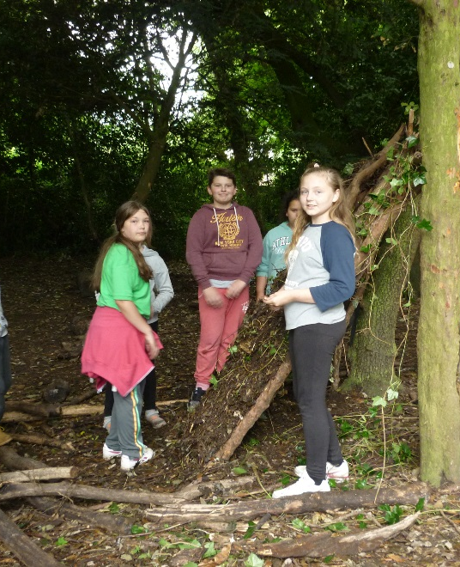
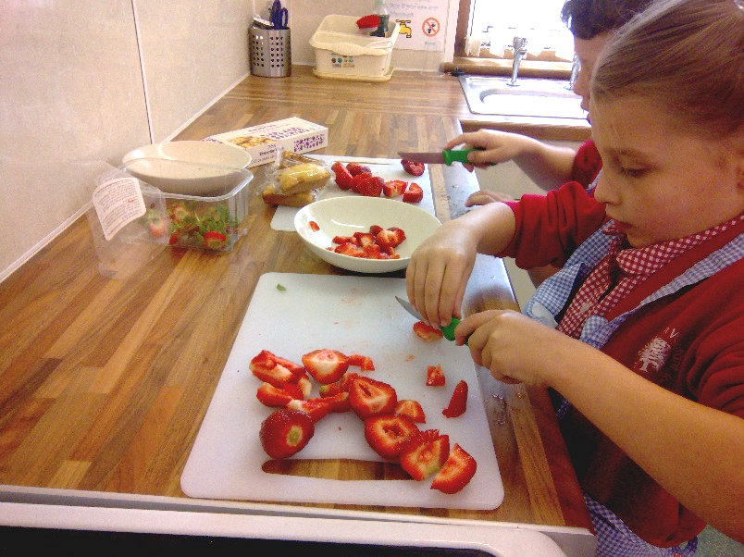

www.swaffhamjuniorschool.com
www.dneat.org

CONTENTS

- Letter from the Chair of the Local Governing Body
- Letter from the outgoing Head Teacher
- Headteacher – Swaffham Church of England Primary Academy (advert)

- Headteacher Selection Criteria/Person Specification
- Headteacher Job Description
- An overview of Swaffham Church of England Junior Academy
- Key Leads and responsibilities
- Classes and Staffing
- Curriculum
- About Swaffham/How to Find Us/Getting in Touch
- The Diocese of Norwich Education and Academies Trust (DNEAT)
- What are the benefits of being part of DNEAT?
- DNEAT Model of Learning-Centred Leadership

Letter from the Chair of the Local Governing Body
Swaffham Church of England Junior Academy
Brandon Road
Swaffham
PE37 7EA

March 2018

Dear Prospective Head Teacher,

Swaffham C.E. Junior is an academy that we, as local governors, are proud to be associated with. Visitors regularly tell us how delightful the children are! Whilst we recognise that some have challenging behaviours, our children always create the right impression when we take them on trips or have visitors in school - they really are our greatest asset! We are situated in a town of about 7,000, and are the only academy in Swaffham with KS2 pupils. We currently have two forms of entry although there will be an opportunity for the successful candidate to capitalise on exciting prospects for growth.

Our Head Teacher is leaving the school after almost 10 years. I have been working with the school for a similar length of time and it’s fair to say that we have had a little bit of a rollercoaster ride, but we are all confident we are heading in the right direction! She is leaving us on excellent terms for a Head Teacher position in a larger, Primary School. We recognise this move as an opportunity for all, not only for Miss McCarthy but for our school community.

Do you think you can help us continue our momentum towards improved standards and accelerated progress? Do you want to develop your career with a school that’s absolutely committed to the children and their needs? Do you relish the joy and challenge of headship in equal abundance? Can you support and inspire our existing and established team? If so we would love to welcome you on board. For our part I can assure you that you will be welcomed by a friendly and open group of people who have a heart for the community and are well used to receiving and acting upon feedback and ideas in a positive way.

I am constantly impressed by the “can-do” nature of our staff. ‘Teamwork, Challenge and Respect’ are the three words we think best describe our Ethos. We have additional in-school support in place for the development of teaching and learning, and a dedicated full time Student and Family Support Worker. Our Breakfast Club and intervention groups are funded in part by our Pupil Premium allocation, and we have seen the progress and results for disadvantaged children improve dramatically over the last three years.

If you are still interested, but undecided, then perhaps our location might help! Swaffham sits on the edge of the beautiful Breckland countryside, and is within easy reach of the spectacular Norfolk coast, and the Norfolk Broads National Park.

Yours sincerely,

Darren Wynne
Chair of the Local Governing Body
Letter from the Headteacher
Swaffham Church of England Junior Academy
Brandon Road
Swaffham
PE37 7EA

March 2018

Dear Prospective Candidate,

I was talked into coming and having a look around Swaffham Junior School just over ten years ago. Something about it tugged me in and has held me here, until now. I would never have envisaged myself staying in one post for this long before, and that in itself is an indicator of how much I have enjoyed working with our children and members of staff. I consider myself very privileged to have had the opportunity to build some fantastic relationships with children and adults, which I will treasure and remember forever.

Life at Swaffham has been full of joy and challenge over that time but we’ve continued to work hard and over the last three years, with the support of our local governing body and DNEAT, have ensured that sufficient and in many cases accelerated progress has been made across the school. Children join us significantly below national expectations and diminish the difference on where they should be as they move through the school; our results for disadvantaged children are particularly strong.

But Swaffham provides much more than an academic education. The social and emotional growth of our children as they move from year to year is clear to see. We have many examples of pupils who struggled significantly with their behaviour when they joined us, but thanks to their hard work, and the combined efforts of school staff and their families, they now stand tall and proud within their year groups, functioning effectively as learners with strong personal character and resilience.

I am going to find leaving SJA very hard. I am moving on for two reasons. I feel I have played my role in the SJA journey as far as I can, and it’s time for someone new with a different set of skills to lead SJA on the next leg of its journey and having originally trained to teach infants many years ago, it’s now time for me to follow my heart back to a Primary School.

We really do live and breathe our three Core Values, RESPECT, CHALLENGE and TEAMWORK, as evidenced by our recent ‘Good’ SIAMS inspection. Leading SJA is an honour, and I am absolutely sure that whoever leads SJA through the next phase of its journey will feel as blessed as I do to be a part of the Swaffham C.E. Junior Academy community.

Yours sincerely,

Tracey McCarthy
Headteacher

The Advert
Headteacher – Swaffham Church of England Primary Academy
NOR: 222
Salary scale: L12 – 18
These are exciting times at Swaffham. We are on a quest to secure good status in our first inspection as an academy and require a highly motivated and skilled individual to lead the way in a thriving community that cannot wait to work with you!
We are seeking to appoint someone with the:
- character to ensure that personal virtues and organisational values enhance outcomes
- passion to focus relentlessly on what’s best for pupils in their context
- initiative to promote new and innovative ideas whilst sustaining what already works
- ability to develop outstanding educational provision that results in outstanding outcomes
- willingness to understand what the team has to offer and get the best from them
- ambition to capitalise on exciting prospects for growth
- vision to cultivate collaborative relationships with other academies in the Diocese of Norwich Education and Academies Trust (DNEAT) whilst establishing Swaffham as a beacon of distinctiveness and excellence
We can offer you:
- peer to peer networking, collaboration, challenge and support
- geographically focussed development opportunities within a south western hub of academies including dedicated support from a key professional
- the security of working in a climate of shared accountability
- investment in your professional development and future career
- opportunities to contribute to the development of a growing organisation and trust-wide improvement initiatives
- access to a suite of core services that enable you to focus more on leading, teaching and learning
- a research-based approach to academy improvement that builds capacity from within
- a values-led approach that underpins the attitudes and behaviour of individuals and the family of Church academies
Don’t miss the opportunity to find out more by reading our information pack and visiting our website. We strongly encourage potential candidates to visit the school to experience what it has to offer. Please contact Jackie Purple on 01760 721831 to arrange a visit.

Closing date: Sunday 25th March 2018

Interviews: Thursday 26th and Friday 27th April 2018

Take up post: 1st September 2018
Please download the application form and information pack from this webpage. Return completed applications to: headship@epm.co.uk

Swaffham Church of England Junior Academy

Headteacher Selection Criteria/Person Specification
Qualification, Experience and Professional Development
- Qualified teacher status with practical understanding of the National Curriculum and assessment arrangements and current national developments.
- Relevant further leadership and management qualifications. (The NPQH or equivalent is desirable)
- Evidence of further appropriate professional development (In-Service Training).
- Evidence of impactful leadership and management within the primary age range.
- Evidence of successful teaching within the primary age range, with smooth transitions.

Academy Specific Knowledge and Professional Competencies
To demonstrate the capacity and commitment to:
- Raise achievement and expectations – and thus give this rural community pride and confidence in its academy
- Further nurture a strong sense of ‘team’, harmony and a genuinely shared vision for the academy’s future
- Promote a rich curriculum which engages all pupils and staff, and enthuses their commitment to learning
- Reach out to parents and the community as partners in the children’s learning and in the life of the academy
- Lead the development of this academy as an inclusive church school, drawing on its heritage, distinctive contribution and service to its community
- Collaborative working with other schools within and beyond the Academy Trust to contribute to an effective school-improvement network
- Articulate a clear and coherent vision for growth
- Promote the welfare and safeguarding of children
- Promote, implement and monitor equal opportunities across all aspects of the academy

Generic Knowledge and Professional Competencies
Applicants must be able to demonstrate their competency against the National Standards of Excellence for Headteachers (2015). The Trustees and Local Governors will use these as a check to ensure that their selection process is sufficiently comprehensive, covering all of the key areas of headship:

- Qualities and knowledge
  - Hold and articulate clear values and moral purpose, focused on providing a world class education for the pupils they serve.
  - Demonstrate optimistic personal behaviour, positive relationships and attitudes towards their pupils and staff, and towards parents, governors and members of the local community.
  - Lead by example - with integrity, creativity, resilience, and clarity - drawing on their own scholarship, expertise and skills, and that of those around them.
  - Sustain wide, current knowledge and understanding of education and school systems locally, nationally and globally, and pursue continuous professional development.
  - Work with political and financial astuteness, within a clear set of principles centred on the school’s vision, ably translating local and national policy into the school’s context.
  - Communicate compellingly the school’s vision and drive the strategic leadership, empowering all pupils and staff to excel.

- Pupils and staff
  - Demand ambitious standards for all pupils, overcoming disadvantage and advancing equality, instilling a strong sense of accountability in staff for the impact of their work on pupils’ outcomes.
  - Secure excellent teaching through an analytical understanding of how pupils learn and of the core features of successful classroom practice and curriculum design, leading to rich curriculum opportunities and pupils’ well-being.
  - Establish an educational culture of ‘open classrooms’ as a basis for sharing best practice within and between schools, drawing on and conducting relevant research and robust data analysis.
  - Create an ethos within which all staff are motivated and supported to develop their own skills and subject knowledge, and to support each other.
  - Identify emerging talents, coaching current and aspiring leaders in a climate where excellence is the standard, leading to clear succession planning.
  - Hold all staff to account for their professional conduct and practice.

- Systems and process
  - Ensure that the school’s systems, organisation and processes are well considered, efficient and fit for purpose, upholding the principles of transparency, integrity and probity.
  - Provide a safe, calm and well-ordered environment for all pupils and staff, focused on safeguarding pupils and developing their exemplary behaviour in school and in the wider society.
  - Establish rigorous, fair and transparent systems and measures for managing the performance of all staff, addressing any under-performance, supporting staff to improve and valuing excellent practice.
  - Welcome strong governance and actively support the governing board to understand its role and deliver its functions effectively – in particular its functions to set school strategy and hold the headteacher to account for pupil, staff and financial performance.
  - Exercise strategic, curriculum-led financial planning to ensure the equitable deployment of budgets and resources, in the best interests of pupils’ achievements and the school’s sustainability.
  - Distribute leadership throughout the organisation, forging teams of colleagues who have distinct roles and responsibilities and hold each other to account for their decision making.

- The self-improving school system
  - Create outward-facing schools which work with other schools and organisations - in a climate of mutual challenge - to champion best practice and secure excellent achievements for all pupils.
  - Develop effective relationships with fellow professionals and colleagues in other public services to improve academic and social outcomes for all pupils.
  - Challenge educational orthodoxies in the best interests of achieving excellence, harnessing the findings of well evidenced research to frame self-regulating and self-improving schools.
  - Shape the current and future quality of the teaching profession through high quality training and sustained professional development for all staff.
  - Model entrepreneurial and innovative approaches to school improvement, leadership and governance, confident of the vital contribution of internal and external accountability.
  - Inspire and influence others - within and beyond schools - to believe in the fundamental importance of education in young people’s lives and to promote the value of education.

Personal Qualities
Applicants must be able to demonstrate the following general attributes:
- Commitment to high standards of achievement
- Excellent communication, interpersonal and organisational skills
- Calmness to diffuse conflict and inspire optimism
- Adaptability and creativity
- Enjoys a rapport with children and parents
- Clarity of thought to prioritise, plan and organise self and others
- Commitment and integrity
- Confidence to empower others
- Enthusiasm, perseverance and resilience
- Rises to challenge and takes the initiative
- Personal impact and presence
- Insight to innovate and manage change for positive impact
- Sense of humour
- Commitment to well-being of staff and self
- Sympathetic to the aims, values, ethos and distinctiveness of Church of England schools and academies

We are committed to safer recruitment practices and to safeguarding and promoting the welfare of all children. We expect all staff and volunteers to share this commitment. This post is subject to an enhanced Criminal Records check.

We strongly encourage potential candidates to visit the school to experience what it has to offer. Please contact Jackie Purple on: 01760 721831 to arrange a visit.

Closing date: Sunday 25th March 2018

Interviews: Thursday 26th and Friday 27th April 2018

Taking up post: 1st September 2018

Please download the application form and information pack from this webpage.
Return completed applications to headship@epm.co.uk

Swaffham Church of England Junior Academy
Headteacher Job Description

The Headteacher will carry out his/her professional duties in accordance with and subject to the National Conditions of Employment for Headteachers and the School Government Regulations and the National Standards for Headteachers.

The Headteacher will be responsible to the Diocese of Norwich Education and Academies Trust (DNEAT) and the Peterhouse Church of England Academy Local Governing Body for the conduct, management and administration of the academy, subject to any policies which the Department for Education, DNEAT and the Governors may make.
The job description is subject to annual review.

Section A: Role outline
- Lead and manage the academy effectively and efficiently ensuring the highest possible quality of education and range of educational opportunities for all pupils.
- Provide clear vision and positive, incisive and purposeful leadership with strategic direction to ensure high standards of achievement for all.
- Promote the ethos, vision and values of the Diocese of Norwich Education and Academies Trust (DNEAT) and contribute positively to wider school improvement developments within the Trust
- Ensure that resources are efficiently and effectively used to achieve the academy’s aims and objectives.
- Lead a culture that promotes excellence, equality and high expectations.
- Evaluate the academy’s performance to identify the priorities for continuous improvement and raising standards.
- Manage the day-to-day organisation and administration of academy.
- Lead and develop the academy’s identity and character as a Church of England school, strengthening its distinctive offering and working closely and proactively with the local church.
- Have overall responsibility for safeguarding.

Section B: Specific responsibilities

- Leadership and management of staff and the organisation

- Create a shared vision and strategic plan which inspires and motivates pupils, staff, governors and all members of the academy community.
- Adopt a strong, caring and flexible leadership style which will both influence and motivate staff and pupils to achieve their potential.
- Set a climate of high performance within the academy where each individual member of the team is encouraged, supported and developed to deliver outstanding results for our pupils and children.
- Manage the academy’s financial and human resources effectively and efficiently to achieve the academy’s educational goals and priorities.
- Recruit, retain and deploy staff appropriately and manage their workload to achieve the vision and goals of the academy.
- Implement successful performance management processes with all staff ensuring effective arrangements for appropriate, accurate and timely management information to enable continuous evaluation of performance and satisfy relevant external bodies.
- Manage and organise the academy environment efficiently and effectively to ensure that it meets the needs of the curriculum and health and safety regulations.
- Ensure that all the facilities always provide a safe, clean and welcoming environment for pupils, staff, parents and other visitors.
- Attend to the well-being of all staff and oneself through example and exercising of duty of care.
- Play an active part in DNEAT’s Headteacher Regional Alliance and collaborative working across the Trust
2. Learning and teaching
- Ensure high standards of teaching, leading to highest standards of achievement for all pupils regardless of needs through high expectations and an inclusive creative curriculum.
- Ensure a consistent and continuous focus on pupils’ achievement, using data and benchmarks to monitor progress in every child’s learning.
- Ensure the academy continues to develop as a pupil and family focused community using innovative and creative approaches to meet the needs of all pupils, children and families.
- Ensure that learning is at the centre of strategic planning and resource management.
- Ensure a culture and ethos of challenge and support where all pupils can achieve success and become engaged in their own learning.
- Maintain strategies which secure high standards of behaviour and attendance.
- Monitor, evaluate and review classroom practice and promote improvement strategies.
- Challenge under performance at all levels and ensure effective corrective action and follow up.
3. Finance, accountability and governance
- Responsibility for overseeing the production of the annual budget and financial strategy for approval by the Local Governing Body and Academy Trust.
- Provide a clear and accurate account of academy performance to the Local Governing Body and all other audiences including parents/carers, OFSTED and the Academy Trust.
- Ensure compliance with child protection, safeguarding, health and safety and other statutory requirements.
- Ensure that all those who have specific responsibilities regarding the operation of the academy, in any aspect of teaching and learning, legal compliance and safeguarding are clear on their responsibilities.
4. Wider stakeholder and community management
- Carry the confidence of the Academy Trust and involve them at a strategic level with relevant local and regional education groups and forums.
- Build a culture and curriculum which takes account of the richness and diversity of the academy and its communities celebrating and championing the academy as a Church school.
- Ensure learning experiences for pupils are linked into and integrated with the wider community.
- Collaborate with other agencies in providing for the academic, spiritual, moral, social, emotional and cultural well-being of pupils and their families.
- Create and maintain an effective partnership with parents and carers to support and improve children’s achievement and personal development.
- Ensure that the successes of the academy are shared with the community to reinforce our position at the heart of the community.
- Co-operate and work with relevant agencies to protect children.
- Have an understanding of working within a range of socio-economic communities and the challenges that doing so brings to the role.

(An overview) Swaffham Church of England Junior Academy is a smaller than average Junior school, with 220 children on roll; we converted to academy status on 1st February 2015, and are part of the Diocese of Norwich Education Academies Trust (DNEAT).

We have experienced steady growth over the past nine years, and have eight classes (two in each year group), having chosen to establish a parallel class structure early in September 2015 (with just 181 children on roll) in order to help meet the needs of our pupils, and to support staff in doing this.

We focus on developing our pedagogy and practice (for teachers and support staff), particularly around the Teachers’ Standards and draft Support Staff Standards. We have used peer support and mentoring, and in 2014 we appointed a part-time teacher to our Leadership Team with responsibility for developing learning and teaching throughout the school.

We are located in a lovely little market town – however, our deprivation factor is 0.27, which is higher than the national average…we support a number of families struggling to manage historical trauma; in particular attachment related issues. We have taken a proactive approach to meeting the varied needs of our community and families, and in 2015 appointed a full-time Student and Family Support Worker with a background in counselling, and many years’ experience of working for Children’s Services. In 2016 we established our Student and Family Support Team (SAFS team), led by our full-time Deputy Head Teacher – who also has responsibility for the impact of our Pupil Premium spending. We are part of the DNEAT mental health strategy group.

- Our school deprivation indicator is 0.27, which is higher than the national average;
- Our percentage of children in receipt of Pupil Premium funding has consistently been around 35% each year (currently 41%), which is higher than the national average;
- The percentage of children with EAL is rising for the school (2014 = 5%; 2015 = 6%;
- 2016 = 7%; currently 14%), but is lower than the national average;
- The percentage of children on our SEND register is higher than the national average, currently at 22%;
- Our current Y3, 4, 5 and 6 cohorts have all started KS2 significantly below the national average (Sig- on Raiseonline).

The main focus areas for our Single Change Plan (School development plan) during the current academic year are:
- Developing leadership across the school;
- Developing the quality of learning, teaching and assessment across the school;
- Student and family support.

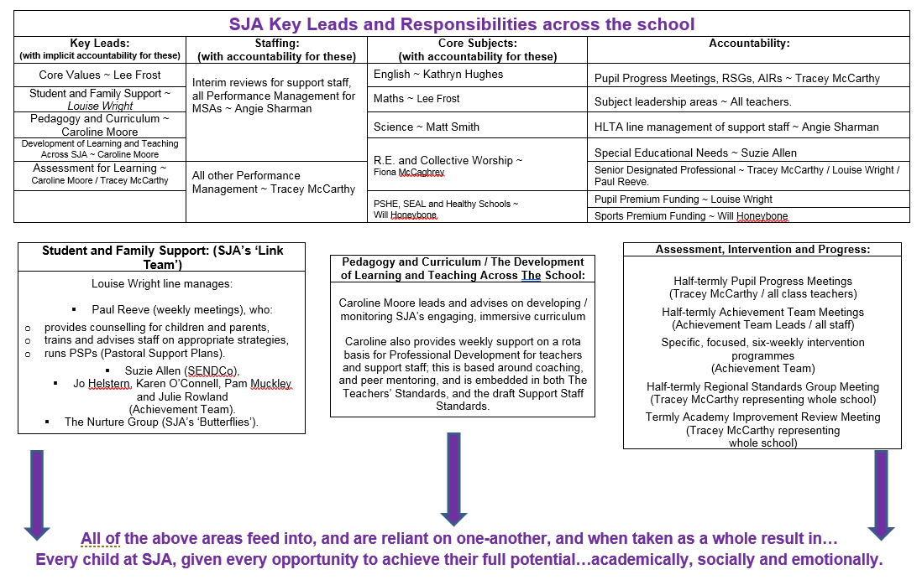

Classes and Staffing
at Swaffham Church of England Junior Academy
For information on our Leadership Team, please refer to the ‘SJA Key Leads and Responsibilities across the school’ document.

Year 3: | Blickling Class | Sandringham Class
Number on roll: | 30 children | 30 children
Teachers: | Mr. Will Honeybone | Mrs. Fiona McCaghrey
Support Staff:  (mornings only) | Mrs. Pam Muckley | Mrs. Karen O.Connell  Mr. Des Lloyd

Year 4: | Mannington Class | Walsingham Class
Number on roll: | 30 children | 29 children
Teachers: | Mrs. Kathryn Hughes | Mrs. Katherine Davies
Support Staff:  (mornings only) | Mrs. Rebecca Alderton-McLeod | Mrs. Linda Powley

Year 5: | Holkham Class | Oxburgh Class
Number on roll: | 26 children | 29 children
Teachers: | Mr. Simeon Grundy (NQT) | Mr. Lee Frost
Support Staff:  (mornings only) | Mrs. Julie Rowland | Mrs. Angie Sharman

Year 6: | Houghton Class | Felbrigg Class
Number on roll: | 22 children | 23 children
Teachers: | Mr. Matt Smith (0.6 part-time) and  Mrs. Charlotte Whitfield (0.6 part-time). | Miss Louise Wright
Support Staff:  (mornings only) | Mrs. Jo Gagen  Mrs. Nicholle Smart (1:1) | Mrs. Jo Helstern  Mrs. Sadie Garrod (1:1)  Mrs. Nicholle Smart (1:1 afternoons only)

In addition, we have the following roles and staffing:
Student and Family Support Team: | Admin: | Lunchtime Staff: | Premises Staff:
- Student and Family Support Worker (also trained as Designated Lead for Safeguarding):  Mr. Paul Reeve;  - Achievement Team, working on interventions throughout the afternoons:  Mrs. Karen O’Connell,  Mrs. Pam Muckley,  Mrs. Julie Rowland and Mrs. Jo Helstern;  - S.J.A.’s ‘Butterflies’ Nurture Group during the afternoons:  - Mrs. Sadie Garrod and Mrs. Becky McLeod.  - Breakfast Club, from 8am to 8.30am Monday to Friday:  Mrs. Karen O’Connell, Mrs. Jo Helstern,  Mrs. Nicholle Smart. | - School Secretary:  Mrs. Jackie Purple;  - Finance and Admin:  Mrs. Jo Gagen. | - Play Leader:  Mrs. Pam Muckley;  - Midday Supervisory Assistants:  Mrs. Linda Powley, Mrs. Lynda McHardy,  Mrs. Ewa Parkes, Mrs. Margaret Reader,  Mrs. Becky McLeod, Mrs. Karen Hunt (1:1). | - Caretaker:  Mr. Nick Vince;  - Cleaners:  Mrs. Tansy Creed, Mrs. Rachel Dale, Mrs. Deborah Trodoff.

The Curriculum
at Swaffham Church of England Junior Academy

We run whole school themes so that all school members can immerse themselves in the topic. Where appropriate we link themes to all areas of the curriculum to enable our pupils to make links between their learning.
These are the themes/topics for the 2017-2018 academic year:
Autumn Term: Asian Legacies
Spring Term: Rise of the Machines
Summer Term: Mission to Mars
This link will give you an overview of our curriculum for the 2017-2018 and 2018-2019 academic years:

2017-2019 Curriculum map

We have a more comprehensive map in school which we use to plan effectively, if you would like to see this document you are more than welcome to ask via the school office.

The following are the curriculum maps and vision statements for each individual subject for the 2017-2018 academic year:

Art overview 2017-2018
Calculation policy as of July 2017
Computing overview 2017-2018
DT overview 2017-2018
English overview 2017-2018
Geography overview 2017-2018
History overview 2017-2018
Languages overview 2017-2018
Maths overview 2017-2018
Music overview 2017-2018
PE overview 2017-2018
PSHE and Skills for Life overview 2017-2018
RE overview 2017-2018
Science overview 2017-2018

We also believe every child should have access to a range of cross-curricular opportunities throughout their time at SJA, please look at our entitlement list.

If you would like any further information on our curriculum, please contact the school office.

SWAFFHAM

Swaffham is an Historic Market Town in Norfolk, situated in the West of the County. To the north rolling Norfolk countryside eases towards renowned Norfolk beaches and to the south, beautiful countryside dominated by farmland joins the Breckland Landscape, an area of international significance for its rare heathland landscape.

The town is well served by road. Bus routes leave the market square and connect the town with Norwich and also Gt Yarmouth and Lowestoft in the East. To the west the same Bus service terminates in Peterborough. Peterborough Rail station is on the east coast main line.

Swaffham is benefiting from an extensive building program on a former brownfield site. Houses are being built by two local building companies and prices compare favourably to those in other areas in the South of the County.
Still not sure? Get in touch and let us show you
what more Swaffham Junior Academy and Norfolk
can offer!

Photo Credits - Award winning Norfolk Photographer Gary Pearson.

How To Find Us:
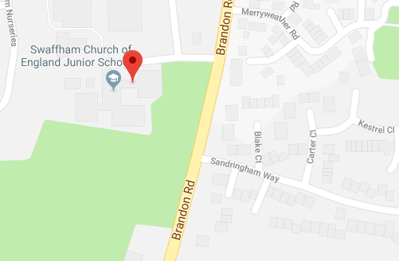

Getting in Touch:

Headteacher: Miss T McCarthy
Chair of Governors: Mr D Wynne
Address:
Swaffham Church of England Junior Academy, Brandon Road, Swaffham, Norfolk PE37 7EA
Email: office@swaffhamjunior.norfolk.sch.uk
Academy Website: www.swaffhamjuniorschool.com
Trust Website: www.dneat.org
Telephone: 01760 721831
Fax: 01760 722747

The Diocese of Norwich Education and Academies Trust
(DNEAT)

Vision: The Trust aims to serve its community by providing an education of the highest quality within the context of Christian belief and practice. The Trust is driven by the moral purpose of making a significant difference to the outcomes of young people in order to best prepare them for their next stage of education and adult life. The Trust is focused on transforming young people’s lives and therefore life chances by providing the perfect balance between excellent education and uncompromising pastoral care.
The Trust seeks to develop with its academies ‘a system of continuous improvement and innovation that is simultaneously bottom-up, top-down and sideways’ and through which it ‘cultivates a culture of purposeful learning that is neither tightly controlled nor too loose’ (Michael Fullen).
DNEAT is not simply a holding body for a series of largely autonomous units. Instead it creates opportunities for academies to learn from and support each other through: shared purpose, shared leadership, shared systems, shared resources and shared accountability.

DNEAT enables individual academies to work together in order to:
promote and sustain a culture of high expectation, rapid improvement and interdependency.

DNEAT ensures that:
autonomy does not lead to isolation, diversity does not become a barrier to collaboration and accountability does not rely exclusively upon regulation.

Swaffham Junior is part of this family of academies.

This year our priorities are to:
- Continue to raise standards
in reading, writing and maths and make sure that all children make as much progress as possible

- Develop our workforce
via excellent training, and by identifying and sharing talent and best practice

- Improving the way we communicate
with our academies at every level
More detailed information about how this will be achieved can be found in the DNEAT Strategic Change Plan (available for reference at interview).

What are the benefits of being part of DNEAT?

- Doing things right
Trust governance:
- Ensuring compliance with recognised governance practices and frameworks
- Development and dissemination of Trust Core Policies
- Small Schools Review response
- Clerking support and quality assurance
- Provision of Governor Improvement Associates
- Facilitating Academy Improvement Reviews
- Development of GovernorHub as a resource and a repository for the MAT

Local governance:
- Annual timetable of meetings, and resources (agenda/designed governor resources/templates/skills/self-assessment) to support local governors
- Development of Critical Guide to Questioning
- Quality assurance visits and reports
- Training – standard offer plus specific face to face training
- Chair of Governors’ termly forum
- Bespoke support to each local governing body
- PEX/Complaints/Grievance Panels including clerking and support

Performance Management:
- Leading process of Headteacher Performance including write up of review and quality assurance across the Trust
- Teachers’ appraisal data capture and statutory reporting to Trustees and Unions

- Staying safe
- A cycle of safeguarding audits
- Health and Safety audits
- General Data Protection Requirement (GDPR) updates and training
- Rapid response to safety issues
- Support for HR concerns and liaison with EPM
- Finance support and budget management

- Improving together
Quality and Accountability:
- Academies Group Executive Principal bespoke support and challenge
- Termly, quality assured Academy Improvement Review
- Annual Effectiveness Review (led by Ofsted inspector)
- Leadership capacity reviews as needed
- Quality Assurance of Local Governing Body function

Improvement and Development:
- Assess to DNEAT ‘tools’ (Single Change Plan format, Operational Overview format, Head teacher’s report/SEF format, SOAP)
- Regular Ofsted updates
- Support before, during and after Ofsted inspection (and SIAMS inspection)
- Comprehensive Continuing Professional Development programme (100 events) to include moderation of work opportunities for all year groups
- Annual Staff CPD event
- Annual Support Staff CPD event
- Senior and middle leader networks (heads, deputies, SendCos, Subject leads, Early Years Leads)
- Head teacher Regional Alliance
- Brokerage and subsidy of Better to Best offer (linked to regional priorities)
- Externally brokered Pupil Premium Reviews and Impact Assessments
- Externally commissioned Trust wide GL Assessments
- Bespoke Trust wide opportunities (Shirley Clarke – Assessment for Learning)
- Assessment and data analysis support
- HMI project
- Involvement in Strategic School Improvement Funded projects
- Trust wide celebrations – The Big Sing

And that’s not all!

DNEAT Model of Learning-Centred Leadership

Principal Foundation:
- DNEATs approach to improvement is driven by Christian mission, values and principles. This brings purpose to leadership at all levels across the organisation, including within and beyond individual academies.
- DNEAT expects leaders to exhibit the character required to be ‘servant’ leaders within their community for the benefit of the children in their care; whereby Christian distinctiveness becomes the principle foundation of their work in improving outcomes and raising standards.
- In order to maximize the influence and impact of its leaders DNEAT promotes a model of learning-centred leadership. This provides a relevant and sharply focussed framework for values-led improvement.

Learning-centred leadership:
DNEAT expects that leadership across the Trust will involve a strong commitment and concern for pupils’ learning. Expressed another way, what is distinctive about school leadership, compared to the leadership of other organisations is that it is centrally concerned with improving pupils’ developments and achievements.

Research tells us that school leadership has significant effects on student learning, second only to the effects of the quality of the curriculum and teachers’ instruction. Leadership is therefore most powerful and potent when it focuses on developing pupils’ learning and strengthening teaching. This is why the idea of learning-centred leadership is so important.

DNEAT will therefore establish, promote and support a climate of high achievement through learning-centred leadership by enabling leaders to make excellent decisions about:

- What is taught (curriculum)
- How it is taught (pedagogy)
- How it is assessed (formative and summative assessment)
- How learning is delivered and resourced (organisation)

Although Headteachers can draw on others for this process they must be seen to be confident about these issues and their implications. If learning is at the centre of the school’s purpose they need to know what is happening within classes and among individual pupils and ensure the efforts of all staff are focused on pupil learning. In order to create the right capacity for Headteachers to make this their primary function DNEAT will strip away as far as it is able, other leadership responsibilities delegated through the Education Reform Act of 1988 which introduced Local Management of Schools (LMS); for example, by introducing efficiencies through the procurement of external services such as HR, joint-purchasing and back-office finance functions.

DNEAT will also seek to recruit and develop leaders who have knowledge of and technical excellence in teaching and can provide themselves, or recognise and encourage skills in others, for learning and assessment. This priority will underpin other ways of working, such as through the support and challenge provided by the AGEPs. It will dominate the way they communicate, the way they collect and review data, respond to staff development issues and shape the culture and structure of the academies they work with. In effect, they will model the learning-centred leadership we expect of those who lead our academies.

DNEAT will enable school leaders to work with and through others to influence teachers’ practice through learning-centred leadership. In doing so, DNEAT will promote three powerful tactics for leaders to use:

- Modelling
- Monitoring
- Dialogue

These represent the essential methodology required to successfully implement whole school decisions to improve the curriculum, pedagogy, assessment, their organisation and delivery.

Finally, DNEAT will systematically seek through its succession planning strategy, to identify, develop and utilise leadership talent in a way that builds capacity, competence and character through servant and learning-centred leadership. It therefore seek to recruit and grow individuals who understand that:

- Leadership is contextualised because where they are affects what they do as a leader. There is no one way to be successful in all situations. Outstanding leadership is exquisitely sensitive to the context.

- Leadership is collaborative because we need leaders who can work together and learn with one another in order to share effective practices both in and beyond their academy.

- Leadership is distributed because we think about leadership rather than just the leader. Belief in the power of one has given way to the belief in the power and reach of everyone.

- Leadership is about providing a sense of direction to know where you are going. Good leaders ‘see ahead’, ‘see behind’, ‘see above’, ‘see below’, ‘see beside’, ‘see beyond’ and significantly ‘see it through’ (Henry Mintzberg 2003). They are aware of what is happening outside the school which will have implications for what goes on inside it and are capable of implementing change even when it is difficult to do so.

