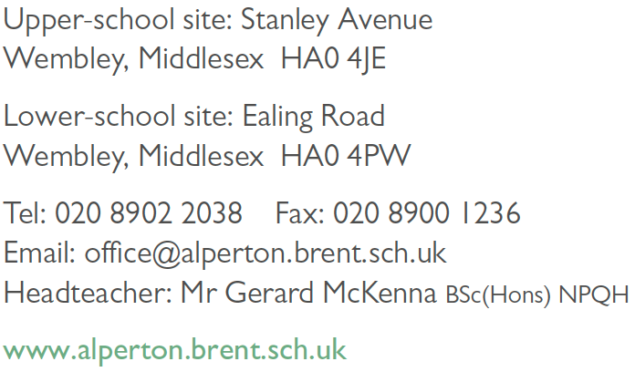
Aspire | Commit | Succeed

APPLICATION FOR A TEACHING APPOINTMENT

Job Title
Secondary Subject
How did you hear about this vacancy?
Please return form to: | hr@alperton.brent.sch.uk
When could you take up duties if appointed?

Alperton Community School does not accept CVs alone, they will only be considered as part of the additional information on a fully completed application form. We are unable to provide feedback to applicants who are not shortlisted for interview. If you do not hear from us within 14 days of the closing date, please assume that you have been unsuccessful on this occasion.

Part A – PERSONAL DETAILS
Title
First Name
Surname
Address
Postcode
Telephone number
Email address
If applicable, do you need a work permit to work in this country?
YES | NO | N/A
If you have a work permit, please state if there are any limitations / conditions / expiry date on the work permit.
National Insurance Number
Please indicate if you have a disability you want the school to take into account
YES | NO
Please outline what assistance (if any) you need during the recruitment and selection process
Date of recognition as qualified teacher by the DfE
DfE No.
GTC No.
Have you successfully completed a period of induction / probation?
YES | NO
If yes, with which authority?
Date of completion of induction / probation?

Part B – EDUCATION AND TRAINING
1. Secondary Education
Details of secondary / further education. Please list all schools, colleges, etc. which you have attended.
Name of establishment | Qualification gained | Grade | Dates
 |  |  | From | To

Please continue on a separate sheet if necessary. You will be asked to provide original proof of relevant qualifications if you are interviewed.

2. Higher Education / Teaching Qualifications
Details of higher education / teaching qualifications. Please list all colleges, universities etc. which you have attended.
Name of establishment  (school, university, etc) | Qualification gained & Subject | Grade/ Class | Dates
 |  |  | From | To

3. Higher Education / Teaching Qualifications
Name of Professional Body | Was membership gained by examination | Membership grade | Date

4. Relevant In-Service Courses
Please give details of all relevant in-service courses attended.
Courses | Qualifications gained | Dates

Part C – EMPLOYMENT
1. Present or most recent employment
Name and address of employer
Postcode
Telephone number
Post Held
Date started |  | Until
Basic salary
Other allowances
Key roles/Achievements
Reason for leaving

2. Full Employment history

Please continue on a separate sheet if necessary.

Name and address of employer (including telephone number) | Date of employment |  | Position | Salary | Reason for leaving

Have you ever been dismissed by an employer?
YES | NO
Details

Part D – KNOWLEDGE, EXPERIENCE AND SKILLS

Use this section to show how you meet all of the shortlisting criteria for the job as set out in the person specification, drawing on all aspects of your education, training and experience, including paid or unpaid employment, voluntary work, and home responsibilities. Shortlisting will be conducted only on the basis of written applications. It is therefore essential that all applicants, both internal and external, should complete this section of the application form. Please continue on a separate sheet if necessary.
Part D – KNOWLEDGE, EXPERIENCE AND SKILLS

Part C – REFEREES (Please note that references will be requested prior to your interview, unless stated otherwise)
Please give names and addresses of two referees who can provide employment references. One referee should be your current Headteacher / Line Manager.
REFEREE 1 |  |  | REFEREE 2
Name |  |  | Name
Position |  |  | Position
Organisation |  |  | Organisation
Address |  |  | Address
Tel. No. |  |  | Tel. No.
Email |  |  | Email
Please tick this box if you do not wish the school to approach your present employer until, and if, a firm offer of employment has been made. The school normally takes up references if you have been shortlisted. Please note that we reserve the right to approach any of your previous employers for references if necessary.
CRIMINAL CONVICTIONS
By law, spent convictions must be disclosed. Would you please give details of any criminal convictions (not including minor traffic offences), if you have no convictions please write ‘NONE’.
DECLARATION
I hereby declare that I have understood and complied with the requirements laid down in the previous paragraph and I agree that the information given on this form may be used for registered purposes under the Data Protection Act, 1984. I have also understood and complied with the provisions concerning the disclosure or criminal convictions.

Failure to disclose information or providing deliberate false information to support your application or canvassing, directly or indirectly, anyone likely to be involved in the appointment process will disqualify you from appointment or if appointed will render you liable to dismissal without notice.
Name
Signature
Date

Aspire | Commit | Succeed

CONFIDENTIAL

ADDITIONAL DECLARATION OF INFORMATION

PERSONAL DETAILS
A check on the possible existence and content of a criminal record will normally be requested from the Criminal Records Bureau after a person has been selected for appointment to this post. Refusal to agree to a check being made could disqualify you from being considered for the appointment.

You are therefore asked to sign the statement on this document to confirm your agreement, if you are selected for the appointment, to a check being made on any criminal record applicable to you.

Under the Rehabilitation of Offenders Act 1974, you have the right not to disclose details of 'spent' convictions. However, because we are a school and you will be working in an environment with children and young people we are allowed to ask about these offences. The Rehabilitation of Offenders Act 1974 (Exceptions) Order 1975 (as amended) sets out details of all jobs to which this applies and the job you have applied for is included in that list.

Please give details of ALL convictions, cautions, bindovers, reprimands, or warnings (whether spent or not).

DISCLOSURE AND BARRING SERVICE (DBS)
The Disclosure and Barring Service is an executive agency of the Home Office and helps employers check records which were previously held by the police, the Department of Health and the Department for Children, Schools and Families. Different levels of disclosure can be provided, according to the type of work applied for.

The job for which you have applied will necessitate an Enhanced and Barred DBS check. These are for positions with a greater degree of contact with children or certain vulnerable adults, like social workers and teachers, for example. They contain all the information given on a Standard Disclosure plus relevant non-conviction information held at local levels.

Have you ever been subject to any sort of investigation by an employer?

YES | NO

If you have answered 'yes' to this question, please give details on a separate sheet. Please supply details of activities involving contact with children and vulnerable adults outside the work environment (e.g. sports coach, scout leader, etc.). Please continue on a separate sheet if necessary.

DECLARATION
I agree, if I am selected for this appointment, to an application being made to the Disclosure and Barring Service (DBS) for an Enhanced and Barred Disclosure concerning myself. I also consent to ACS carrying out other appropriate checks with the DBS if it so wishes.
Name (please print)
Signature | Date

