***Handcross*** *is a* [*village*](https://en.wikipedia.org/wiki/Village) *of approximately 1,500 people in the* [*Mid Sussex*](https://en.wikipedia.org/wiki/Mid_Sussex) *District of* [*West Sussex*](https://en.wikipedia.org/wiki/West_Sussex)*. It is 4.2 miles from Crawley and is well connected for all major transport links to London and the South Coast.*

|  |  |
| --- | --- |
|  | 🞂Handcross  A brief overview of the village. |
|  | Image result for handcross village  Image result for handcross village  Handcross has two public houses. The Red Lion (High Street), which was refurbished in 2010 in contemporary style and offers gastropub food.  The Royal Oak[]](https://en.wikipedia.org/wiki/Handcross#cite_note-3) (Horsham Road), which is a more traditional "English" pub, offering home cooked food and cask ales.  Handcross also boasts a Social club, serving the community. There is a vibrant church community at St Mary’s in Slaugham with a sister chruch in Staplefield. These offer a variety of services in support of the community of Handcross and surronding villages.  [Image result for st mary's church slaugham](http://www.google.co.uk/url?sa=i&rct=j&q=&esrc=s&source=images&cd=&cad=rja&uact=8&ved=2ahUKEwiEiu3m687ZAhUC-aQKHbt0CNUQjRx6BAgAEAY&url=http://www.geograph.org.uk/photo/3051118&psig=AOvVaw29abne7gBSZK1J0rJuGSQ0&ust=1520121427598322)  Handcross Primary School, situated at the northern end of the village recently underwent extensive building works to increase capacity. The school has become an 8 class school with land adjacent the school currently being acquired to allow for expansion of the outside play space and the possibility for further expansion to the school premises depending on future demand.  [Image result for map of handcross,](http://www.google.co.uk/url?sa=i&rct=j&q=&esrc=s&source=images&cd=&cad=rja&uact=8&ved=2ahUKEwjbuqWc7s7ZAhWPDuwKHdd-BxIQjRx6BAgAEAY&url=http://www.turkey-visit.com/map/united-kingdom/crawley-map.asp&psig=AOvVaw3k8MHwCtOkk4jiHXwZmstO&ust=1520122004839673)  The school serves the communities of Handcross, Pease Pottage and the South of Crawley,  There is a great deal of expansion within Handcross and Pease Pottage which would have an impact on the demand for school places in the future.  Handcross is currently in the process of building 21 new homes on the adjacent land to the west of the school. There are a further 8 homes completed at the northerly edge of the village.  Pease Pottage has an estate of 95 new houses currently under construction with permission for a new neighbourhood of 600 houses currently at the planning stage for land adjacent to the service station. This large development is expected to include shops, a community building, a new Hospice site and a primary school of up to 1 form entry. |
|  |  |
|  |  |
|  |  |
|  |  |
|  |  |
|  |  |
|  |  |
|  |  |
|  |  |
|  |  |
|  |  |
|  |  |
|  |  |
|  |  |
|  |  |
|  |  |
|  |  |
|  |  |
|  |  |
|  |  |
|  |  |
|  |  |
|  |  |
|  |  |
|  |  |
|  |  |

*The village is situated on the A23 from London to Brighton and was well known as a rest stop for coaches in the early 1800’s. The Red Lion Pub was the original coaching inn and remains to this day. In 1883 a locomotive was named after the village. It also gained notoriety in 1906 when a coach crash on Handcross Hill left 10 dead and 24 injured. It can boast a long history of horticultural excellence with two of the best gardens in the South of England located within the village boundary.*

*Nymans Gardens is owned and managed by the National Trust. It is set in 30 acres of stunning parkland and is located next to the High Street within walking distance of the school. There is a stunning formal garden area surrounding the ruins of the old manor house. The gardens are open year round and offer excellent enrichment activities for the children.*

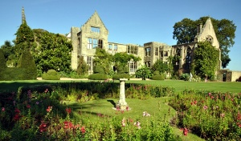

*High Beeches Gardens lies to the North of the Village and has 20 acres of water gardens set in an undulating valley.*

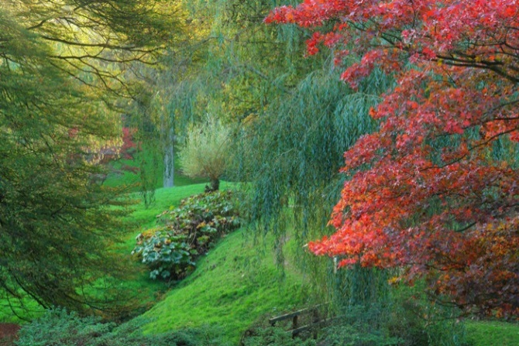

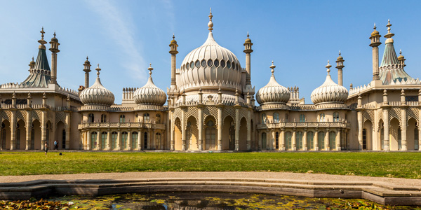

***Located close to excellent shopping and recreational facilities in Crawley, Horsham and Haywards Heath. There are plenty of opportunities to enjoy the theatre, fine dining and sporting activities.***

***Brighton is a 40 minute drive away and has a host of extra attractions including concert venues, an extensive night life and a worldwide reputation for celebrating different cultures and lifestyles****.*

*There are two public houses in the village.*

*The Red Lion in the High Street which was refurbished in 2010 and offers gastropub food in a contemporary environment.*

*The Royal Oak on the Horsham Road offers more traditional pub food and cask ales in a more relaxed environment.*

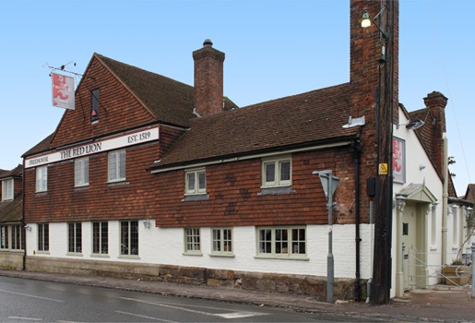

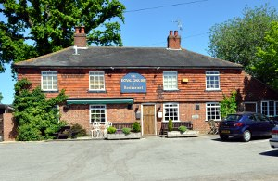

[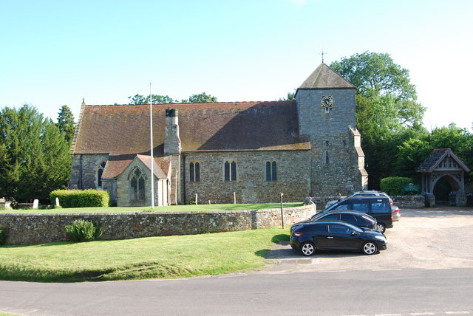](http://www.google.co.uk/url?sa=i&rct=j&q=&esrc=s&source=images&cd=&cad=rja&uact=8&ved=2ahUKEwiEiu3m687ZAhUC-aQKHbt0CNUQjRx6BAgAEAY&url=http://www.geograph.org.uk/photo/3051118&psig=AOvVaw29abne7gBSZK1J0rJuGSQ0&ust=1520121427598322)

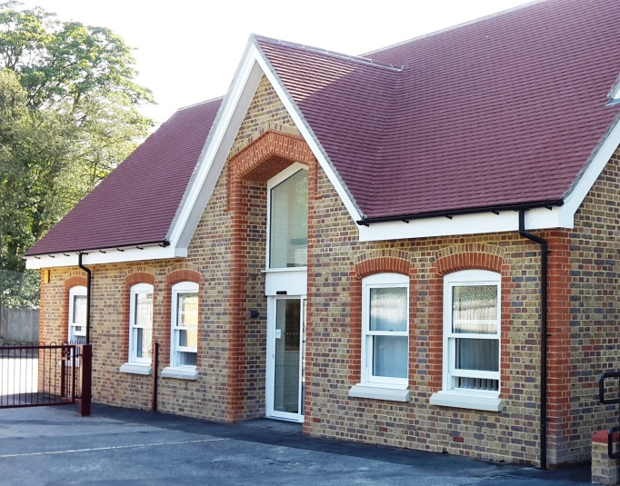

*The village has a Social Club, offering a large hall for community events as well as a petanque club, junior and senior football clubs and many other activities.*

*St Mary’s Church in Slaugham, has a vibrant and active congregation offering a number of services to the community including, families in need, baby and toddler groups and social care for the elderly.*

*Handcross Primary School, situated at the Northern end of the Village, recently underwent extensive building works to improve the school site and increase capacity. The school has acquired land adjacent to the school to allow for the expansion of the outside play space and the possibility of further expansion to the school premises depending on possible increased demand.*

*The school serves the communities of Handcross, Pease Pottage and the Southern end of Crawley.*

*There is a great deal of expansion within the school catchment area. There is a development of 21 homes currently being built on the southern boundary of the school. A further 8 homes have just been completed within 2 miles of the school.*

*Pease Pottage has 95 homes currently under construction with a new neighbourhood of 600 homes planned just outside the village next to junction 11. This new neighbourhood will include shopping and community facilities including a new purpose build Hospice.*

*The Governing Body view these developments as opportunities to consider further expansion of the school in line with demand.*

