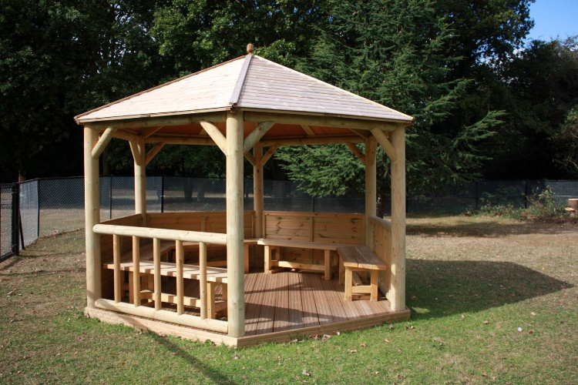
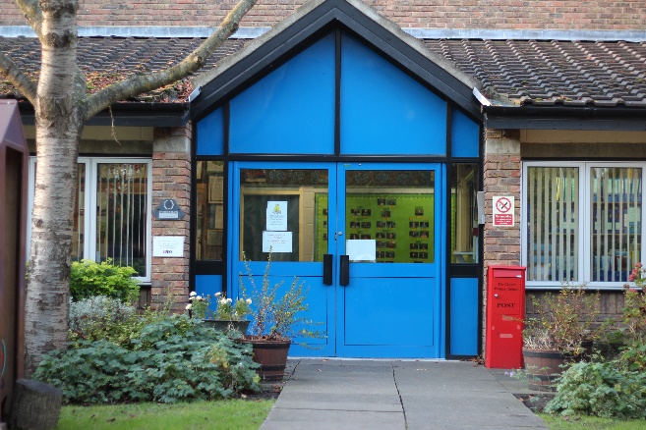
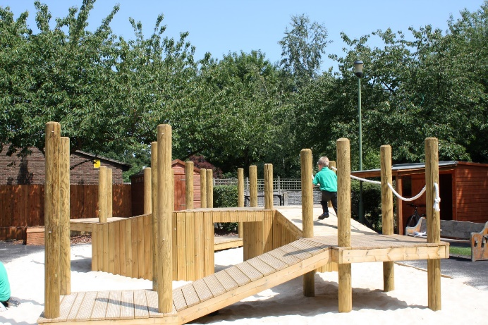
Headteacher
Recruitment Pack
Closing Date: midnight on Sunday 25th March 2018
Interviews: Wednesday 18th April 2018
Start: 1st September 2018 (Autumn Term)

Contents Page

Letter from the Chair of Governors 3

Advert 4

Job Description 5

Person Specification 8

March 2018
Dear Applicant
Thank you very much for expressing an interest in the post of Headteacher at The Cedars Primary School.
Our current Headteacher, Lesley Julian, will be leaving at the end of this academic year, after eighteen very successful years, leading and shaping the school into the outstanding, special learning environment it is today.
The Governors have worked very closely with the outgoing Headteacher to create a genuine partnership and Ofsted have recognised the supportive yet challenging relationship that now exists.
The Governing Body is now seeking an inspirational and ambitious leader who can build upon these successes, develop our school still further and share the passion for learning that we instil in our pupils.
The person specification included in this pack provides a comprehensive list of qualities we are looking for in a candidate but essentially we wish to appoint someone with a nurturing approach and the ability to work in a diplomatic and sensitive way that inspires confidence.
Further information about the school is available on the school website at www.cedars.hounslow.sch.uk and information about visiting the school is given in the recruitment pack.
Shortlisting is scheduled for Wednesday 28th March and those called for interview will be contacted as early as possible after this date. References will be requested prior to interview.
There will be a range of tasks and activities to undertake and you will be given information about these if you are invited to interview.
On behalf of the Governors of The Cedars Primary School, thank you again for your interest in our school and we look forward to hearing from you.
Yours sincerely
Anna Ballantyne
Chair of Governors

‘a special school for special children’
The Cedars Primary School
Cranford, Hounslow, West London
Required for September 2018
Headteacher
Leadership Scale L18 – L24
£63,985 - £71,736
An enhancement might be considered for the right candidate, if necessary

The Cedars Primary School is a special school for primary aged pupils with social, emotional or mental health difficulties (SEMH) situated in green belt land in Cranford, to the west of Hounslow, bordered by the M4 and close to Heathrow Airport.
The school received its 4th consecutive Outstanding grade from Ofsted in June 2017. The inspectors stated that:

“The school is a welcoming and inspiring community, underpinned by the passion to secure the very best outcomes for pupils. Leaders and staff are equally committed to providing pupils with the highest standard of education. Together, staff work as a cohesive team to achieve this goal. Governors contribute well to the efforts to drive further improvements through a careful balance of support and challenge.”

Following the retirement of the current post holder, the Governing Body is seeking to appoint an inspirational, visionary and dynamic Headteacher who will lead the school through its next period of opportunity, growth and development.
The successful candidate will:
• Have high expectations of children, their achievements and behaviour
• Have the vision and the skills required to be an instigator of innovative developments as well as the ability to implement, refine and shape these.
• Be able to lead and inspire a committed and hard-working team to achieve and maintain excellent practice
• Be an excellent communicator in a wide range of settings, working with individual families and local communities
• Have experience of working with children who display challenging behaviour, either in mainstream or special settings
- Be fully committed to the inclusion of children with SEN in education and society as a whole
• Be subject to an Enhanced Criminal Record Bureau check.

Closing Date for the receipt of completed applications: Midnight on Sunday 25 March
Shortlisting will take place on Wednesday 28th March
Interviews are scheduled to take place: Wednesday 18 April

Visits to the school are welcomed and can be arranged by emailing the School Business Manager, MadeleineTrowles on mtrowles.313@lgflmail.org
Click apply now for application forms. Completed applications must be sent to mtrowles.313@lgflmail.org

Our school is proud of its commitment to safeguarding and promoting the welfare of children and expects all staff and volunteers to share this commitment. Appointment to this post is subject to an Enhanced DBS disclosure. We are an equal opportunities employer.

The Cedars Primary School

Headteacher Job Description

The appointment is subject to the current conditions of employment for Headteachers contained in the School Teachers’ Pay and Conditions Document, the National Standards of Excellence for Headteachers (2015) and any other current educational legislation as required in various Education Acts.
This Job Description sets out the scope, duties, responsibilities and working practices that the successful applicant will be required to undertake, discharge and demonstrate on an ongoing basis.

Main Purpose of the Role
- To lead and manage a primary special school for children with social, emotional and mental health difficulties (SEMH).
- To work with the Governing Body and Senior Management Team to develop a collaborative school vision that embraces excellence, high standards and inclusion.
- To work with the Senior Management and Middle Management teams to translate that vision into a development and implementation plan.
- To provide professional, operational and strategic leadership across all aspects of the school

Key Responsibilities
- Secure excellent teaching to achieve high standards of learning and attainment
- Hold all staff to account for their professional conduct and practice by establishing secure robust performance management systems
- Foster an open, transparent and equitable culture
- Ensure there is clear responsibility for internal organisation, management and control of the school
- Manage finance and resources astutely to maximise their use and value
- Ensure that there is financial probity and that robust HR procedures are in place
- Develop and sustain effective relationships with the Governing Body, to ensure effective governance of the school and the discharge of GB responsibilities
- Build and maintain effective relationships with parents and all members of the school and wider community
- Create an outward- facing school, working with other schools, organisations and partners to champion best practice and collaborative networks
- Ensure inclusion, diversity and access for a range of pupils, having regard to the school’s admission criteria

Qualities & Knowledge
- Hold and articulate clear values and moral purpose, focused on providing an outstanding education for children with SEN
- Have experience of dealing with children with challenging behaviour and have a thorough understanding of the techniques to use for physical restraint and the law surrounding that
- Demonstrate optimistic personal behaviour, positive relationships and attitudes towards pupils, staff, parents, governors and members of the local community.
- Lead by example - with integrity, creativity, resilience, and clarity - drawing on their own scholarship, expertise and skills, and that of those around them.
- Knowledge and understanding of education and school systems locally, nationally and globally, and pursue continuous professional development
- Work with political and financial astuteness, within a clear set of principles centred on the school’s vision, ably translating local and national policy into the school’s context.
- Communicate compellingly the school’s vision and drive the strategic leadership, empowering all pupils and staff to excel.

Pupils & Staff
- Demand ambitious standards for all pupils, overcoming disadvantage and advancing equality, instilling a strong sense of accountability in staff for the impact of their work on pupils’ outcomes.
- Secure excellent teaching through an analytical understanding of how pupils learn and of the core features of successful classroom practice and curriculum design, leading to rich curriculum opportunities and pupils’ well-being.
- Establish an educational culture of ‘open classrooms’ as a basis for sharing best practice within and between schools, drawing on and conducting relevant research and robust data analysis.
- Create an ethos within which all staff are motivated and supported to develop their own skills and subject knowledge, and to support each other.
- Identify emerging talents, coaching current and aspiring leaders in a climate where excellence is the standard, leading to clear succession planning.
- Ensure the delivery of INSET, Induction and NQT programmes are effective and impact on school outcomes
- Hold all staff to account for their professional conduct and practice.

Systems & Processes
- Ensure that the school’s systems, organisation and processes are well considered, efficient and fit for purpose, upholding the principles of transparency, integrity and probity.
- Provide a safe, calm and well-ordered environment for all pupils and staff, focused on safeguarding pupils and developing their exemplary behaviour in school and in wider society.
- Establish rigorous, fair and transparent systems and measures for managing the performance of all staff, addressing any under-performance, supporting staff to improve and valuing excellent practice.
- Welcome strong governance and actively support the governing board to understand its role and deliver its functions effectively – in particular its functions to set school strategy and hold the Headteacher to account for pupil, staff and financial performance.
- Exercise strategic, curriculum-led financial planning to ensure the equitable deployment of budgets and resources, in the best interests of pupils’ achievements and the school’s sustainability.
- Distribute leadership throughout the organisation, forging teams of colleagues who have distinct roles and responsibilities and hold each other to account for their decision making.

The Self-Improving School
- Create an outward-facing school which works with other schools and organisations - in a climate of mutual challenge - to champion best practice and secure excellent achievements for all pupils.
- Develop effective relationships with fellow professionals and colleagues in other public services to improve academic and social outcomes for all pupils.
- Challenge educational orthodoxies in the best interests of achieving excellence, harnessing the findings of well evidenced research to frame self-regulating and self-improving schools.
- Shape the current and future quality of the teaching profession through high quality training and sustained professional development for all staff.
- Model entrepreneurial and innovative approaches to school improvement, leadership and governance, confident of the vital contribution of internal and external accountability.
- Inspire and influence others - within and beyond the school - to believe in the fundamental importance of education in young people’s lives and to promote the value of education.

The Cedars Primary School

Headteacher Person Specification

This person specification defines the type of person required, and describes the essential and desirable skills, knowledge, qualifications, specific conditions and competencies required to undertake the duties of the job description.

Items marked as ‘E’ (Essential) must be demonstrated on the application form and/or at interview, as indicated below. Failure to do so is likely to result in the application in question being omitted from a short list for interview. You should ensure that you provide supporting evidence of how you meet the criteria through reference to work or other relevant experience.

Items marked as ‘D’ (Desirable) may form the basis for selection and should be demonstrated if possible in the application form (’A’) and / or at interview (‘I’) as indicated below.

Selection decisions will be based on the criteria outlined below. At each stage of the process an assessment will be made by the appointment panel to determine how far the criteria have been met.

Outline of Key Abilities
To provide the effective, professional leadership and management of The Cedars Primary School to achieve continued outstanding success:

• Leadership and management of children’s attainment and progress
• Leadership and management of staff
• Leadership and management of the national curriculum
• Leadership of learning and teaching and attitudes to learning
• Strategic leadership of safeguarding and child protection
• Financial and resources leadership and management
• Management and control of risk
• Management of resources and premises

Key:
E - Essential D - Desirable A - Application Form I - Interview Process

Qualifications |  | E | D | A | I
1. | Qualified Teacher Status | ✓ |  | ✓
2. | Additional SEN qualification |  | ✓ | ✓
3. | Successful recent leadership experience as a Headteacher, Deputy Headteacher of equivalent | ✓ |  | ✓
4. | Evidence of further relevant professional development e.g. NPQH, MA or similar |  | ✓ | ✓
Knowledge & Understanding  Able to evidence and apply up to date secure knowledge and understanding of: |  | E | D | A | I
1. | Current and updated knowledge of the National Education Agenda, curriculum frameworks and Ofsted frameworks within which the school operates | ✓ |  | ✓ | ✓
2. | Knowledge of school evaluation and school development planning to secure effective teaching and learning and raising standards | ✓ |  | ✓ | ✓
3. | Knowledge of how to use a range of tools and performance data to monitor, evaluate, support and track pupil progress, attainment and achievement | ✓ |  | ✓ | ✓
4. | Knowledge and understanding of what makes an effective school and how to use a range of strategies to achieve continuing school improvement and pupil progress | ✓ |  | ✓ | ✓
5. | Have a range of effective teaching and management methods for children with SEMH | ✓ |  | ✓
6. | ‘Working together to safeguard children’ and ‘Keeping Children Safe in Education’ and current and updated knowledge of all safeguarding practices and procedures | ✓ |  | ✓ | ✓
Skills |  | E | D | A | I
1. | Work on own initiative, prioritise own workload and that of others. Anticipate and meet deadlines around the school’s priorities and timescales. | ✓ |  | ✓ | ✓
2. | Work closely with the Governing Body and all stakeholders to lead on the strategic direction and development whilst creating and communicating a compelling effective vision |  | ✓ | ✓
3. | Communicate clearly, effectively, calmly and professionally in the English language, both verbally and in writing with all children and adults | ✓ |  | ✓ | ✓
4. | High level of numeracy and financial understanding plus an aptitude/willingness to develop this skill and knowledge base | ✓ |  | ✓ | ✓
5. | Accurate interpretation and the effective use of comparative data in raising whole school standards through analysis and evaluation of pupil data, target setting, assessment for learning and pupil tracking. Ability to clearly and effectively communicate the results of any comparative data to a range of different audiences in simple terms. | ✓ |  | ✓ | ✓
6. | Positively manage a variety of challenging people in a calm and professional manner and to successfully build constructive relationships with colleagues, parents, other educational establishments and external agencies and the ability to foster an open, transparent and equitable culture within the school community | ✓ |  | ✓ | ✓
7. | Excellent change management skills ensuring that continuous improvement is embedded across the school | ✓ |  | ✓ | ✓
8. | The ability to influence external partners, acknowledge difference and resolve conflict. | ✓ |  | ✓ | ✓
9. | Effective leadership skills including the ability to: carry out strategic planning; involve, inspire, motivate and unite others; and be able to articulate a vision and direction for the school and translate such vision into coherent, achievable effective outcomes. | ✓ |  | ✓ | ✓
10. | Effective management skills to include: strategic financial management and human resources; people management skills to include delegation coordinating, monitoring and evaluating all aspects of performance successfully. | ✓ |  | ✓ | ✓
Proven successful experience of: |  | E | D | A | I
1. | Significant practical classroom experience in a special needs school or unit with a track record of outstanding, creative teaching | ✓ |  | ✓ | ✓
2. | Challenging underperformance at all levels and ensuring effective corrective action and follow up | ✓ |  | ✓ | ✓
3. | Working effectively in partnership with parents, carers, outside agencies and other schools | ✓ |  | ✓ | ✓
4. | Leading and managing change within an education setting | ✓ |  | ✓ | ✓
Personal Attributes & Professional Values |  | E | D | A | I
1. | Consistently demonstrate the professional behaviours and values expected by virtue of being a person in a position of responsibility and trust | ✓ |  | ✓ | ✓
2. | Be positive, self-motivated, creative, robust and resilient | ✓ |  | ✓ | ✓
3. | The ability to manage oneself, including time management, professional direction and development and an ability to work effectively, as part of a team, at all times including challenging circumstances. | ✓ |  | ✓ | ✓
4. | Ability to establish and promote a safe, secure and healthy learning environment for students and staff. Ability to promote a healthy work-life balance for staff and oneself. | ✓ |  |  | ✓
5. | Excellent interpersonal skills and the ability to relate to people with understanding, humour and tact; to communicate effectively with a wide range of potential audiences and to listen and understand the point of view and opinions of other people. | ✓ |  | ✓ | ✓
6. | A genuine concern to secure the educational progress of pupils irrespective of their ability, sexual orientation or ethnic, cultural or social background | ✓ |  | ✓
7. | Suitable to work with children and able to always maintain appropriate professional boundaries between oneself and children and other work colleagues | ✓ |  | ✓

