**

*“Aiming High. Reaching Our Potential”*



Skidby CE (VC) Primary School

Headteacher Recruitment Pack

March 2018

**Letter from the Chair of Governors**

Dear Prospective Headteacher,

On behalf of the members of the governing body, staff, parents and PFA, may I thank you for your interest in the post of Headteacher for Skidby Church of England VC Primary School. I trust you will find this pack helps you make an informed decision about the role and the huge potential our unique school offers.

Ofsted judged the school to be good as did SIAMS. However within the last year the school has risen to a number of challenges seeing these as opportunities rather than threats. Rapid change benefiting both pupils and a dedicated hardworking team of staff has been achieved within a framework of mutual respect, collective ownership of change and high expectations of all.

Governors, staff, parents and pupils are seeking an inspirational, far sighted and innovative leader to build on current successes; ensure the school is outward facing and provides a safe, happy and stimulating learning environment where children aim high, learn to love and love to learn.

**The successful candidate will:**

* lead an outward facing, vibrant school at the heart of this rural community
* have a proven track record of good leadership and sound communication skills
* be creative and inspirational to further develop the potential for maximising outside resources to enhance and extend wider learning
* inspire, nurture/challenge all pupils and staff to realise their full potential
* be fully committed to ongoing staff development for all, to move the school from good and aspire to outstanding
* maintain and strengthen links with governors, parents, the church and wider community
* support, promote and fully embed our Christian value base

**We offer:**

* a warm supportive and friendly environment with happy children who feel safe, feel listened to and encouraged to make good progress academically and become confident well rounded young people.
* the support of a hardworking staff team and governors who embrace change and are excited about the opportunities ensuring all pupils make good progress and achieve their full potential.

This is an important and exciting step in your career. You are most welcome and encouraged to visit us and see the school in action, meet the pupils and see their learning for yourself.

I look forward to receiving your application by the closing date.

Kate Makepeace

Chair of Governor

Skidby Church of England (Voluntary Controlled) Primary School

**Welcome to our School**



**About Our School**

* At Skidby we have high expectations of our children and set challenging targets for them.
* Every child is encouraged to reach their full potential and we recognise that every child is special and has their own contributions to make.
* Our staff are dedicated, hardworking, experienced and provide a safe, calm and caring atmosphere in school. They foster a hardworking ethos based on an enjoyment of learning within a stable environment.
* Governors are committed to continuously developing staff and have specifically set aside funding within our budget to support the Headteacher and colleagues to improve and grow.
* We expect a great deal from our children and they do not disappoint us. We are pleased to offer a varied selection of enrichment and enhancement opportunities and possess excellent links with our local and diocesan communities.
* We have an aspiration for all our children that through their school journey they will fulfil their academic potential and become successful lifelong learners whilst developing in a nurturing Christian environment.
* In addition, we endeavour that our children will possess high levels of both social and emotional intelligence so that they are well placed to succeed and thrive in the future, becoming active and productive members of society.
* We recognise that parents play an important role in the education of their children and as such, we welcome your support and co-operation in making your child’s time at Skidby CE enjoyable.
* Serving a rural based community provides a wealth of creative opportunities to develop learning both within and outside the classroom

**Parents and Friends Association (PFA)**

Skidby School is fortunate to have a very active PFA. It is a registered charity run by parents and friends of the school. It was set up to organise social and fun activities for the children which in turn provides funding for ‘extras’ that the school budget cannot provide. These ‘extras’ range from simply buying new books for the library to mammoth fundraising activities to help finance larger projects for example, updating technology or transforming a school play area. Skidby is a very small primary school with limited funding and without the PFA fundraising it would be extremely hard to maintain a fulfilled learning environment for our pupils.

**What do the pupils like about Skidby School?**

# **Our Diocese**

York Diocesan Board of Education supports 125 Church of England schools and academies in the area from the Humber to the Tees. We have a dedicated team of professionals who offer a wide range of expertise and can help schools access further assistance.

The Education team aims to:

* Be available as a ‘one-stop shop’ for pastoral and professional support
* Work with a range of agencies to promote school improvement
* Promote excellence and Christian distinctiveness
* Provide and facilitate professional development and governor training
* Help schools and academies network, collaborate together and share best practice
* Offer a Total Property Management scheme in association with DBE Services Ltd
* Guide schools on matters concerning trusts
* Work with schools exploring Academy conversion
* Advise in the appointment of staff, especially Headteachers
* Support Headteacher appraisal
* Represent Church of England education to the wider church community and more widely to the public
* Maintain contact with the local authorities and the Regional Schools Commissioners

*The Rt Revd Paul Ferguson, Bishop of Whitby and Chair of the Diocesan Board of Education*

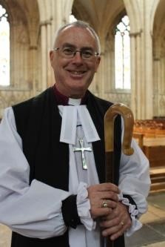 “Our schools and academies are a vital part of the mission of the Church of England in the Diocese of York. Staff and governors are strongly committed to their communities, and in many cases the influence of church schools can only be described as transformative.

We strive to offer our young people the very best in every aspect of education, including encouraging them to mature spiritually and to understand how faith informs good relationships and responsible citizenship. We aim for our schools to be places where the love of God in Christ is truly reflected. If these aims and values resonate with you, we hope that you will consider applying to come to Skidby CE Primary School to lead our schools into the next phase of their life.”

*Andrew Smith, Diocesan Director of Education*

"As a diocese, we are here to help celebrate and strengthen the Christian ethos in our schools. We understand that each school is unique and our aim is to get to know our schools on an individual basis in order to foster the local parish and community links as far as possible.

As such, our Education Team offers a range of support to our headteachers from both a school distinctiveness and effectiveness point of view, as well as providing a range of training and development opportunities for staff and governors to access over the course of each year. In a rapidly changing educational landscape, we are more and more involved in wider school development, particularly as schools change from one school status to another. I do hope that you feel able to apply for the position of Headteacher of Skidby VC Primary School and we would look forward to welcoming you as part of our diocesan family here in the Diocese of York.”

**Skidby and the surrounding area**

Skidby is a small conservation village and civil parish in the East Riding of Yorkshire, situated some 6 miles north-west of Hull city centre and 5 miles south of Beverley.

Skidby lies in a mainly rural area with several working farms and is also a commuter village for workers in Hull and Cottingham, given the easy links to the A63/M62 west, the A1079 to York, and the A164 to the Humber Bridge and the south. According to the 2011 UK census, Skidby parish had a population of 1,284. The village has a well-used Village Hall and a flourishing pub.

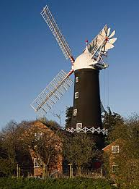

Skidby Mill is a working four-sailed tower windmill, the last working mill in East Yorkshire. It is set in an acre of land and has magnificent views over the Wolds. The mill is unusual in still having all its original outbuildings around the courtyard. Some of these buildings have been converted to form the Museum of East Riding Rural Life

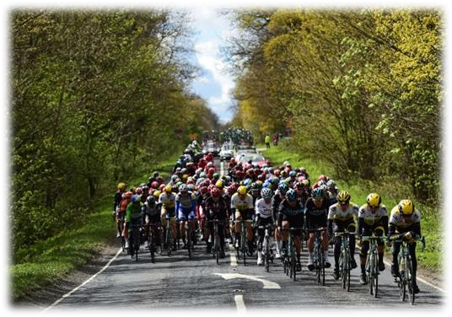

This year the Tour de Yorkshire cycle race will pass through the centre of the village past its Medieval Church. The school is planning a rapturous welcome.

St. Michael’s Church, Skidby is in the fortunate position of being in the centre of the village and therefore easily accessible. It is a Grade 2* listed building. There has been a church on the site since 1227, though the present building dates from the 16th century.

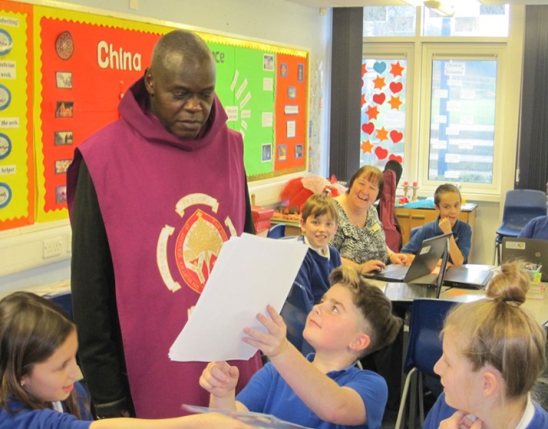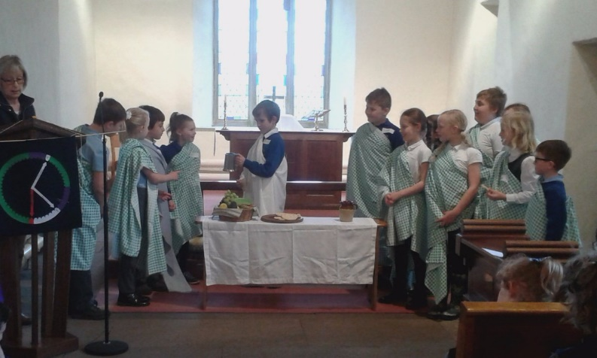

Class 3 debate the role of animals in circus entertainment

Learning about the Last Supper

An important visitor to our school

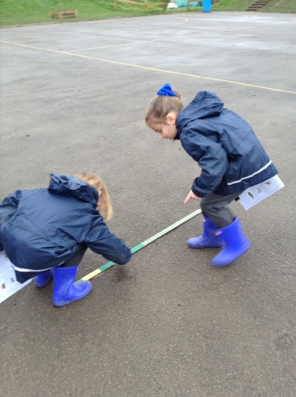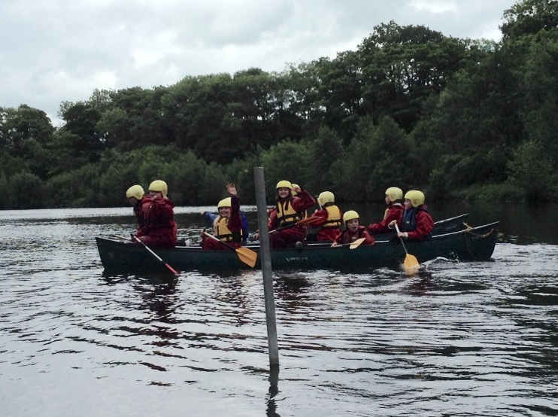

Class 1 children measure out the length of animals

The 2017 Residential Visit

Class 2 looking “super” at their Super Hero Day

**Headteacher Job Description**

## Purpose

* To provide vision, leadership and direction for the school
* With the Governing Body, to be responsible for creating and maintaining an effective learning environment which is engaging and fulfilling for all pupils, promoting the highest possible standards, and fostering the continual improvement of the quality of learning offered by the school
* To preserve and develop the Christian ethos of the school

**Accountable to**

* The Governing Body of the School

## Accountable for

* The standards, progress and well-being of all pupils
* Investing in staff through continuing professional development to drive change
* Effective and efficient management of all the resources of the school
* Contributing to teaching of pupils for the equivalent of one day per week

**Key Tasks**

## Overall

* To treat everyone fairly and equitably, with dignity and respect.
* To create and maintain a shared school culture and positive climate that motivates pupils, staff and all other members of the school community
* To nurture all children and create a culture of high expectations and aspirations that lead to excellent learning
* To promote effective relationships with all pupils, staff, governors, parents, other schools, the local community, the Local Authority and other external bodies

## Leadership and management

* To ensure that parents, pupils, staff and governors share and are committed to the school’s vision of excellence
* To be an agent for change through aspirational leadership.
* To be responsible for the effective day-to-day leadership, management, organisation and administration of the school, modelling work-life balance and managing the workload of others
* To ensure that the school achieves its curriculum and pastoral aims through the implementation of effective improvement planning
* To ensure the rigorous implementation of well-focused improvement plans, based on robust self-evaluation
* Working with other staff and governors, create and implement appropriate policies and procedures that raise standards, especially in reading, writing, mathematics and behaviour**.**

## Governance

* To work with the Governing Body to enable it to meet its responsibilities and present to it, on a regular basis, an accurate account of the school’s performance
* To advise the Governing Body on the formulation of policies and their implementation, to ensure the

enhancement of the quality of learning in an efficient and cost effective manner

## The curriculum

* To ensure that statutory requirements for the curriculum are met, that curriculum provision is appropriate and relevant to the needs of all pupils and provides equality of opportunity for all
* To secure a broad and balanced curriculum that successfully promotes spiritual, moral, social and cultural learning and assists pupils in preparing for life in modern Britain
* To ensure that the curriculum promotes and sustains a thirst for knowledge and understanding and a love of learning, and challenges pupils to ensure they make excellent progress

## Behaviour and safety

* To secure effective safeguarding procedures that ensure the safe recruitment of all staff and the safety of all pupils, including in respect of e-safety
* To establish a positive ethos throughout the school so that pupils take pride in their school, their work and their behaviour

## The quality of teaching and learning

* To recognise good/outstanding teaching and learning and be able to communicate this effectively to all staff and governors
* To ensure that effective teaching strategies are matched closely to pupils’ needs, including the most and least able, so that all pupils learn well in lessons
* To ensure that teaching is appropriate to the age and ability of all pupils and provides challenge, progression and high expectation to enable all pupils to achieve at the highest level
* To ensure that effective monitoring and evaluation of the quality of teaching, attainment and progress are used to improve learning
* Through the effective management of Pupil Premium funding, ensure that disadvantaged pupils achieve at least as well as their peers and those with Special Educational Needs and Disabilities are given every opportunity to do the same
* To ensure that teaching helps to develop a culture of excellence, where the highest achievement in academic work is recognised, especially when supporting the achievement of the most able

## The achievement of pupils

* To ensure that the curriculum and pastoral aims are achieved through the effective implementation of the School Development Plan
* To ensure that assessment information is effectively used to improve teaching and learning so that all pupils make or exceed expected progress
* To ensure that parents and carers are regularly provided with sufficient information to understand how well their children are doing and what they can do to help improve learning
* Ensure that there are successful strategies for engaging with all parents to the benefit of all pupils

## Early Years provision

* To ensure that children in the Early Years are safe and happy and achieve well
* To ensure that teaching nurtures, engages and motivates children and is based on accurate assessment of children’s learning needs and development
* To ensure that all children are well prepared for Year 1 and subsequent education

## As a Church school

* To articulate confidently, support and promote a vision for the school rooted in distinctively Christian values
* To ensure that arrangements for religious education and collective worship meet statutory requirements
* To work closely with the local Churches and the Diocese to promote an understanding of the

Christian faith and respect for other faiths and cultures

The Selection Panel will be looking for evidence that the candidate has demonstrated their ability to fulfil the following criteria through the **A**pplication, **R**eferences or **I**nterview.

|  |  |  |  |  |  |
| --- | --- | --- | --- | --- | --- |
| **Headteacher Specification** | **E**  ssential | **D**  esirable | **A**  pplication | **R**  eferences | **I**  nterview |
| **Qualifications and Experience** |  |  |  |  |  |
| Qualified Teacher Status | **E** |  | **A** |  |  |
| Has NPQH qualification |  | **D** | **A** |  |  |
| Recent experience as a senior leader | **E** |  | **A** | **R** | **I** |
| **Qualities and Knowledge** |  |  |  |  |  |
| Knowledge and understanding of the curriculum across the appropriate age range | **E** |  | **A** |  | **I** |
| Commitment to maintaining and developing the Christian ethos of the school and promoting an understanding of other faiths and cultures | **E** |  |  |  | **I** |
| Demonstrate positive relationships and attitudes towards their pupils and staff, and towards parents, governors and members of the local community | **E** |  |  | **R** | **I** |
| Lead by example driving the strategic leadership, empowering all pupils and staff to excel | **E** |  |  | **R** |  |
| Sustain wide, current knowledge and understanding of education and school systems locally, nationally and globally |  | **D** | **A** |  |  |
| **Pupils and Staff** |  |  |  |  |  |
| Demand ambitious standards for all pupils, overcoming disadvantage and advancing equality, instilling a strong sense of accountability in staff for the impact of their work on pupils’ outcomes | **E** |  | **A** | **R** |  |
| Develop pupils’ learning, independence and resilience recognising the need for all pupils to enjoy school in order to  become confident and enquiring learners | **E** |  |  |  | **I** |
| Create a learning culture within which all staff are motivated and supported to develop their own skills and subject knowledge, and to support each other | **E** |  |  |  | **I** |

|  |  |  |  |  |  |
| --- | --- | --- | --- | --- | --- |
| Identify emerging talents, coaching current and aspiring leaders in a climate where excellence is the standard, leading to clear succession planning | **E** |  | **A** |  | **I** |
| **Systems and Processes** |  |  |  |  |  |
| Maintain a safe, calm and well-ordered environment for all pupils and staff, and developing their exemplary behaviour | **E** |  |  |  | **I** |
| Establish rigorous, fair and transparent systems and measures for managing the performance of all staff | **E** |  | **A** |  | **I** |
| Welcome strong governance and actively support the Governing Body to understand its role and deliver its functions effectively | **E** |  |  |  | **I** |
| Exercise strategic, curriculum-led financial planning to ensure the equitable deployment of budgets and resources | **E** |  | **A** |  | **I** |
| **Self-Improving School Systems** |  |  |  |  |  |
| Maintain an outward-facing school which works with other schools and organisations - in a climate of mutual challenge - to champion best practice and secure excellent achievements for all pupils | **E** |  | **A** |  | **I** |
| Develop and maintain positive relationships with the local parish, school cluster, diocese, and the Local Authority | **E** |  | **A** |  | **I** |
| Shape the current and future quality of the teaching profession through high quality training and sustained professional development for all staff | **E** |  |  | **R** | **I** |
| **Safeguarding** |  |  |  |  |  |
| Demonstrate a commitment to safeguarding and the welfare of children and young people | **E** |  |  |  | **I** |
| Ability to form and maintain appropriate relationships and personal boundaries | **E** |  |  | **R** | **I** |
| Emotional resilience in working with challenging behaviours | **E** |  |  | **R** | **I** |
| Appropriate use of authority and discipline | **E** |  |  | **R** | **I** |

This school is committed to safeguarding and promoting the welfare of all children and staff.

The appointment is subject to the receipt of a satisfactory enhanced DBS disclosure.

**Key information:** The School

Skidby Church of England Primary School  
Main Street

Skidby

HU16 5TX

Phone: 01482 846169

Fax: 01482 847278

Email: [skidby@eastriding.gov.uk](mailto:skidby@eastriding.gov.uk)

Website: <https://skidbyprimaryschool.org.uk>

Number on the Roll: 71 (January 2018)

**The Post**

Headteacher Group: Group 1

Post: Full time, permanent (0.8 Headteacher with 0.2 Teaching commitment)

National Leadership Pay Scale: L12 – L18 (£51,639 – £59,857)

## The Recruitment Process

Application forms are available at [www.eastriding.gov.uk/jobs](http://www.eastriding.gov.uk/jobs)

To arrange to visit the school Please ring Sam Grady on 01482 846169

Closing date: Wednesday 28th March 2018

Shortlisting: Thursday 5th April 2018

Interviews: Tuesday 24th April 2018 (in school) AND

Wednesday 25th April 2018 (off-site)

Start date: 1 September 2018



