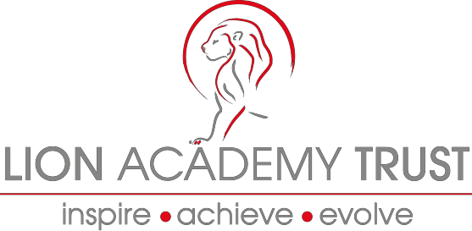

Lion Academy Trust
Information and Application Pack
New Qualified Teachers:

Main Payscale
Location: London, Essex, Northamptonshire

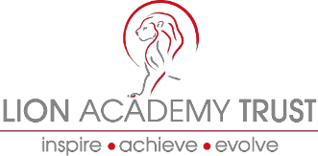
Dear Candidate

Teacher. Thank you for the interest you have shown in the post of Newly Qualified

Lion Academy Trust is now looking to recruit outstanding, enthusiastic, innovative and committed NQTs to work across all phases

Our schools are fully inclusive and serves a diverse cultural community. Staff from the school support and network with each other through shared planning, INSET and good practice, to ensure that all pupils in our school receive outstanding education and grow into well-rounded individuals.

The Trust enjoys a strongly innovative and productive partnership with Google and uses cutting edge information technology to educate our future decision makers, leaders and innovators!

- Are you excited by innovation and challenge, energised by opportunities to develop and share your practice, whilst being supported by our friendly team of Senior Leaders, colleagues and high quality mentoring from our pool of SLE teachers?
- Would you welcome the opportunity to learn from the team you will become a member of and the children you will work with? If the answer is ‘Yes’ then we would like to hear from you!

We offer a bespoke package of training to our NQTs which includes:

• One-week induction in the Summer Term
• Taught sessions and Peer Observations
• Modelled/ Team Teaching
• Cross school visits
• Mentoring by Lead Practitioner & Senior Leadership Team
• Detailed one year NQT Induction programme

All our teachers are provided with a work devices and access to other necessary resources. In addition to PPA and NQT release time where there is a need additional non-contact days each term for planning and assessment moderation.

Our NQTs begin on Main Scale 1 and for outstanding candidates we will be looking to appoint from the Summer Term and consideration will be given to a starting salary at M2.

If our NQT offer is what you are looking for and you feel you have the necessary skills to contribute to our continuing successful journey we would love to hear from you.

Yours sincerely Justin James
Chief Executive Officer

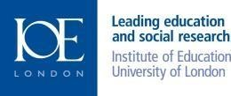
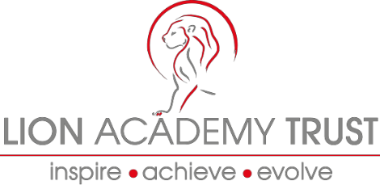
The Lion Academy Trust is a non-profit making educational charity with over twenty years of experience in running schools in and around London and is growing to meet the demand of schools in need of support nationally, through our two new hubs in Essex and Northamptonshire.

The Lion Academy Trust is a sponsor of schools in need of a structural and education change to how they operate for the benefit of their pupils and local communities. Successful candidates need to share our no excuses and have an inherent belief that all children, irrespective of context or background have the right to an outstanding education and can succeed.

If you are looking to become a Newly Qualified Teacher in an organisation that has a proven track record of promoting staff with the right skills, attitude and disposition into senior leadership posts, we offer support to enable you to improve your teaching and learning practice by being reflective practitioners, taking part in professional development and practice opportunities and taking ownership of your professional development in order to aspire and achieve outstanding outcomes for all pupils.

The successful candidate will also work closely with colleagues, subject leaders in the planning development and delivery of an effective curriculum, ensuring that our pupils have the best possible education and school experience.

We support a range of school improvement services including brokering support from our Specialist Leaders of Education to assist other schools.

We run a series of internal networks including NQTs, subject leaders, EYFS leaders, SEN and Inclusion leaders. Alongside our internal programmes

Lion Academy Trust have high expectations, ambitious and hardworking staff and above all happy and enthusiastic children with a thirst for learning.

We are seeking committed, positive and ambitious candidates who are:

- Innovative, creative and strategic thinkers;
- Resilient and confident teachers with a passion for working at all tiers of a school and organisation;
- Able to lead, motivate, challenge and inspire whole school communities;
- Able to demonstrate an ability to teach and model the highest possible standards of learning and teaching;
- Dynamic and enthusiastic with the vision and energy to help lead schools to excellence;
- Friendly and approachable with excellent communication skills and a passion for teaching

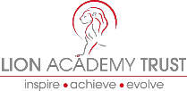

Our Schools

At Barclay Primary School, Sybourn Primary School, Brook House Primary School, Maple Grove Primary School, Leigh Beck Junior School and Thomas Gamuel Primary School, we believe that all children and students have a right to have an excellent education in order to give them the best life chances irrespective of race, colour, creed or circumstance. We have high aspirations for our children, staff and communities. At the heart of our schools, are dedicated staff teams who are committed to being part of schools that enable all staff and students to make outstanding progress.

We believe that obstacles and barriers both real and perceived can be overcome by clear, strategic and targeted support that creates culture change based on sharing good and outstanding practice, collegiality, and a relentless pursuit of excellence. This underpins our high expectations and action and drives all the staff to provide opportunities for our children in order for them to reach the highest possible levels of attainment and achieve exceptionally well in all walks of life.

We believe that outstanding teaching and learning must be central to every decision made and every development introduced.

We are inclusive, caring schools where every child matters, we recognise that all children have talents and abilities to celebrate, and part of our role is to help children to discover these. We challenge and develop our children to become curious, autonomous learners who are inspired and stimulated through a rich and varied curriculum that is appropriate to individual needs. We develop children’s learning skills and by setting high expectations and exacting standards, we prepare our children to flourish, have high self-esteem and self-belief.

We believe that teacher learning and continued professional development is central to our success. Teachers will be given opportunity and challenged to continuously improve practice.

Teachers will be supported to:
- Adapt to changing demographics and environments
- Facilitate and lead outstanding learning opportunities and experiences for children
- Become outstanding teachers and learning must be central to every decision made and every development introduced.

As a Trust, we are committed to ensuring that we train, develop and recruit outstanding professionals so that we provide only the best for all our pupils. Through our links with quality tertiary providers we have access to the most up to date research and training that is at the forefront of educational development and transformation. Through effective use of this professional and leadership development we are able to provide learning journeys for aspiring professionals at all levels to develop into outstanding practitioners and leaders within our school.

We are on the journey towards being schools that continually develop and provide high quality education to our local communities and become a group of strong self-sustainable and self-sufficient institutions working and contributing within the Lion Academy Trust.

The Lion Academy Trust believes that access to outstanding education is a right for all our children and young people.

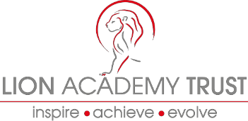
We aim to work closely with our parents, other schools and organisations, building partnerships, which benefit, not only our children, but others in the wider community, both on a local, national and global level.

How to apply
To apply please forward:

- A completed Application Form
- Application monitoring form

Candidates who are invited to interview will have a further opportunity to explore the content and context of these responses.

Please send your completed application by email to: recruitment@lionacademytrust.net

Recruitment process
The recruitment process:

We will treat all enquiries, formal and informal in confidence. Potential applicants are welcome to visit the Schools within the trust.
Candidates will have the opportunity to spend time with key people involved in the school.

The closing date for applications is 27th April 2018 at 12 noon.
A selection of candidates will be invited for interview on 8th May 2018.

Alternatively, find out more information and download an application pack from
the Lion Academy Trust Website www.lionacademytrust.net

