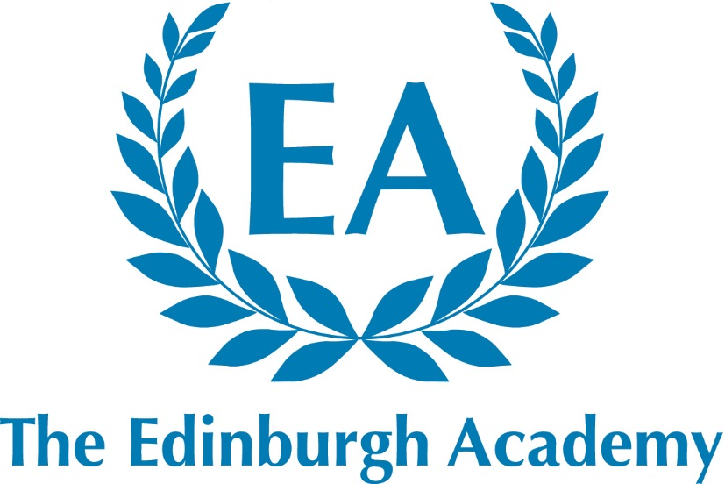

42 Henderson Row
Edinburgh
EH3 5BL

Fully co-educational

HMC
Independent Co-educational Day Schools

Senior School: 586 pupils aged 11 –18
Junior School: 388 pupils aged 5 –11
Nursery: 92 pupils aged 2 – 5

Teacher of German with French (Maternity Cover)
Part-time 0.6 – 0.7fte

Required for August 2018

The Edinburgh Academy

Introduction

The Edinburgh Academy is an academically selective, independent, co-educational day school for pupils aged 5 -18 years with a reputation for being caring and friendly. It aims to provide co-educational excellence with a first-class all-round education to those of intellectual promise and academic potential, regardless of background, race or creed. The Edinburgh Academy aims to be forward-looking and progressive but also greatly values its long held traditions. Although the School is not academically exclusive, the ability range of pupils is well above the national average. Great emphasis is placed on the pursuit of co-curricular interests alongside academic studies for all our pupils. The School has a strong reputation for individual attention and excellence in its pastoral care and co-curricular provision. The School consists of a Senior School containing approximately 590 pupils and a Junior School containing approximately 390 pupils, and we have a Nursery department of around 100 pupils. The School is a member of HMC. The Edinburgh Academy moved to full co-education across the whole school in 2008. Previously girls were only admitted in the Sixth Form (S5 and S6).

The School’s Place in Edinburgh

The School was founded in 1824 and has been regarded as a leading educational establishment within the City of Edinburgh and across Scotland ever since. Original Directors included the leading literary names of their age such as Sir Walter Scott. Robert Louis Stevenson and James Clerk Maxwell were also pupils at the School.

The Senior School occupies a site in Henderson Row, less than a mile from Princes Street and at the northern limits of the Georgian ‘New Town’, of which it was designed to be a part. The buildings include an iconic school hall and the James Clerk Maxwell Science Centre, which was completed in November 2006. The Edinburgh Academy is a highly regarded school within the local community, across Edinburgh and beyond. Staff and pupils take great pride in this reputation, and the commitment from all is evident in the continuing success and progress of the School. The Edinburgh Academy is committed to sharing its facilities with the local community and has established a series of projects that provides the use of its estates and premises for the public good.

Further details about the School and its resources can be found on the School website - www.edinburghacademy.org.uk

Classes and Assembly
7ths (S6) and 6ths (S5) classes are organised by tutor groups studying either Highers, Advanced Highers or GCE A-level. Across the Senior School no teaching group consists of more than 24 pupils and many are substantially smaller. A School Assembly is held at 8.50am each morning, and is attended by the whole school. School Services for the whole school are held on several occasions during the session.

Exam Results
The Edinburgh Academy uses both English and Scottish examination boards. Nearly all subjects now present SQA National 5 and Advanced Higher examinations. Each year, a significant number of our 7ths (S6) have conditional places at very competitively sought universities on the basis of their Advanced Higher/A-level and Higher results.

Yearly academic results can be found on the School website.

Games and Activities
At the Edinburgh Academy, sport offers opportunities at all levels. The PE curriculum is varied, encompassing a wide variety of team games and individual sports. The School runs teams in a large number of major and minor sports and encourages pupils to represent the School at one or more sports at any age group.

In Music, there are about 20 performing groups including orchestras, choirs, wind bands, a big band and several chamber groups.

In Drama, there are usually three or four main productions each year. There is a fully active LAMDA qualification schedule in acting, reading for performance, mime, public speaking and Musical Theatre in place. This occurs at break time and lunchtimes. In addition, the Drama and Music department liaise to produce an annual musical, with potential to increase this.

All pupils currently join the CCF or The Duke of Edinburgh’s Award in 4ths (S3).

All members of staff are expected to play a full part in supporting the co-curricular life of the School.

Part-time Teacher of German with French (Maternity Cover)

The Post

We are looking to appoint an exceptional part-time German teacher, with experience of teaching across the full age and ability range. We anticipate this post will be between 0.6 - 0.7fte. Applicants should be passionate about Modern Foreign Languages, with excellent subject knowledge and committed to ensuring success for all.

Duties and Responsibilities:

We welcome applications from well-qualified men and women who are graduates with relevant teaching qualifications. The successful candidates should be able to teach German at least up to Higher level as well as teach French up to S2 Level.

In line with all members of the department, successful applicants will be expected to:
- keep abreast of changes in national exams/courses
- take an active role in promoting languages throughout the School
- work closely with other members of the Modern Languages department, including the German Language assistant.
- give regular, informative feedback to students on their progress
- have excellent organisational skills
- have consistently high expectations of students and yourself
- have excellent communication and ICT skills
- have a keen interest in development and sharing of effective teaching and learning strategies in Languages.
- have a commitment to fresh and exciting methods of delivering the curriculum
- be fully involved in the life of the School as a whole, to promote languages and cultural awareness

Duties and responsibilities associated with all teachers at the Edinburgh Academy are:

- To plan, prepare and teach lessons to all assigned pupils according to their educational needs.
- To assess, record and report on the progress of the pupils within the guidelines written in the Staff Handbook.
- To engage with the wider School Curriculum in a manner which is consistent with the ethos of the School.
- To carry out such administrative and other routine tasks as are outlined in the Staff Handbook.
- To demonstrate a commitment to both individual professional development and to the developing curriculum in the School.
- To carry out any other duties and to assume any other responsibilities as the Rector shall from time-to-time reasonably request.
- To play a full part in the co-curricular life of the School.

Short-listed candidates will be asked to plan and teach a lesson.

Reporting

The successful applicant will report to the Head of Department on all aspects of classroom management, timetabling, teaching and learning, reporting and pupil discipline. The successful applicant will report to the Deputy Rectors on matters of whole school commitments, professional development and personal absence.

Remuneration Package

The Edinburgh Academy pay scale shadows the national scale for teachers and promoted posts, but also offers a special supplement in recognition of the extra contributions made by teachers out with their classroom duties. This supplement is currently 8% addition to national scales. The successful candidate will be entitled to join the Scottish Public Pension’s Agency’s Teachers’ Superannuation Scheme. The terms and conditions may be discussed at interview.

Availability

The appointment is available from August 2018 and we anticipate it will run for one academic year.

Applications

Applications are welcome from well-qualified graduates for this post of Teacher of German and French.

Candidates should complete all sections of the application form, which should be emailed to rectorsoffice@edinburghacademy.org.uk

Candidates are welcome, if they wish, to send a copy of their curriculum vitae, including full details of qualifications and experience, and/or a covering letter explaining why they think they are particularly suited to the role and how it may fit in with future aspirations. However, please note that this is entirely optional and the short listing for interview will be based on the application form. The appointment will be made without regard to gender or ethnic origin. Further details are available from the Rector’s Office – 0131 624 4911 rectorsoffice@edinburghacademy.org.uk

The closing date for application is Friday 20th April.

Conditions of Appointment

The appointment will be subject to satisfactory references, verification of identity and proof of qualifications, and to a satisfactory medical screening.

Child Protection

The Edinburgh Academy is committed to safeguarding and promoting the welfare of children, and applicants must be willing to undergo child protection screening appropriate to the post, including checks with past employers and PVG Disclosure Scotland.

Equal Opportunities

The School is an Equal Opportunities employer, and welcomes applications for this post from appropriately qualified persons regardless of age, disability, gender, race or sexual orientation.

Barry Welsh
Rector
March 2018

