Red Hall Primary
What our children want from their new Headteacher
_______________________________________________

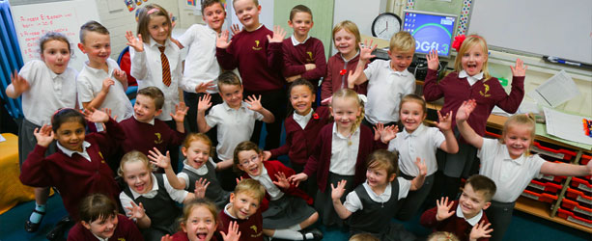
Our School Council were asked what qualities they would like for their new Headteacher.
The findings from their discussions are below:
“kind” | “keeps calm under pressure”
“caring” | “helpful”
“a good leader” | “keeps to their schedule”
“a good teacher” | “confident”
“clever” | “brave”
“good at communication” | “organised”
“good at taking assemblies” | “respectful”
“a good role model” | “encouraging”
“friendly, with a strong personality” | “understanding”
“has lots of ideas” | “against bullying”

