Sherwood Park School

Website:
www.sherwoodpark.org.uk

Sherwood Park Campus
Streeters Lane
Wallington
Surrey
SM6 7NP

Tel: +44 (0)20 8773 9930
Email: office@sherwoodpark.org.uk

Sherwood Hill Campus
Stanley Park Road
Carshalton
Surrey
SM5 3HW

Tel: +44 (0)20 8669 7832

Headteacher: Mr Simon Vines B.A. (Hons), PGCE

Embedded Map information:
Sherwood Park School
<iframe src="https://www.google.com/maps/embed?pb=!1m18!1m12!1m3!1d2490.789542289008!2d-0.13958673415172068!3d51.370165579612916!2m3!1f0!2f0!3f0!3m2!1i1024!2i768!4f13.1!3m3!1m2!1s0x4876070b07724c29%3A0x6bed5238143711fb!2sStreeters+Ln%2C+Wallington+SM6+7NP!5e0!3m2!1sen!2suk!4v1521022080982" width="600" height="450" frameborder="0" style="border:0" allowfullscreen></iframe>
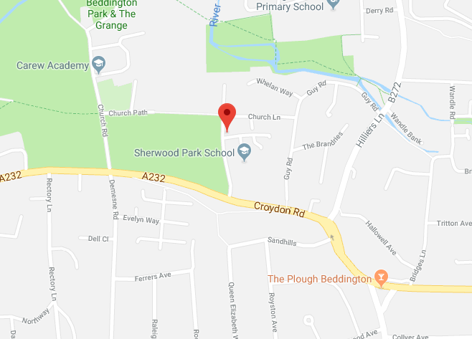
Sherwood Hill
<iframe src="https://www.google.com/maps/embed?pb=!1m18!1m12!1m3!1d2491.5430821001632!2d-0.15871043415223576!3d51.35631212961064!2m3!1f0!2f0!3f0!3m2!1i1024!2i768!4f13.1!3m3!1m2!1s0x4876078e1545a1db%3A0xbe84c9c5776bac98!2sStanley+Park+Rd%2C+Carshalton+SM5+3HW!5e0!3m2!1sen!2suk!4v1521022181118" width="600" height="450" frameborder="0" style="border:0" allowfullscreen></iframe>
