March 27th 2018

Dear Applicant

Assistant Head Teacher Post – For September 2018
Thank you for requesting details for the Assistant Head Teacher post at Samuel Pepys School. I am pleased to enclose an application form together with a range of documents to offer you a greater understanding of our school. Please find attached:
- Job description
- Person specification
- Keeping Children Safe in Education: information for all school and college staff
Please also visit our website www.samuelpepysschool.co.uk
You are invited to look around the school and meet pupils and staff on Wednesday 25th April at 2.00pm. Please contact the school office to confirm your attendance. We expect prospective applicants to visit the school before submitting their application.
Your completed application form should be returned to the school via email by 9.00am on Monday 30th April. Shortlisting applicants will be called for an interview on Friday 4thMay.
Please refer to the job description and person specification when preparing your letter and include any roles, interests or personal experiences that you feel support your application. Please note that a CV is not acceptable.
If you require any further information please do not hesitate to get in touch. I hope that you will feel that your enthusiasm, skills and commitment to teaching match the high expectations that we have at Samuel Pepys School and we look forward to receiving your application.
Yours sincerely,
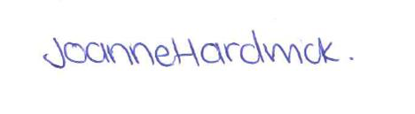
Joanne Hardwick
Head Teacher
head@samuelpepys.cambs.sch.uk

