Brentwood County High School
A Specialist Science, Maths and Computing School

Brentwood County High School
Appointment of Head of School
Information for Candidates
March 2018

Brentwood County High School
A Specialist Science, Maths and Computing School

Contents

Page Title Page Number
About Our school 3
- Location
- Community
School History 4
Facilities 5
School Structure 6
Staffing Structure of BCHS 7
Key School Statistics 8
GCSE Results Data 9
A-Level Results Data 10
School Map 11

Brentwood County High School
A Specialist Science, Maths and Computing School

About Our School
Location
Brentwood is situated in the southwest of Essex and is a pleasant, busy town conveniently situated for London, the surrounding countryside and villages. The borough has a total area of around 15,310 hectares and a population of around 79,000.
Brentwood is located within the Metropolitan Green Belt, with the heart of the town only minutes away from pleasant woods, commons and rights of way. The borough has over 3,000 acres of woodland, three country parks, a large amount of farmland and a number of very attractive villages within its borders, yet it is only 18 miles from London.
Road and rail connections are excellent with the M25, A12 and A127 trunk roads within the borough and convenient, fast rail links with London and East Anglia. Stansted, London City and Southend airports are all a 30 to 40 minute drive away.
Some 38% of Brentwood’s housing is owner-occupied, higher than the national average. Much of the older housing has been renovated and there are few areas of poor quality housing in the borough. Brentwood is an affluent town with more than 50% of the resident workforce commuting out of the borough to work, particularly into London.
Community
Brentwood County High School is a school committed to engaging with our local community. At entry level of the school we are involved in community projects, support local charities and work in partnership with all those within our community.
Staff work with students on community fundraising projects, most recently the Word Challenge and national events such as Children in Need and Sport Relief.
We offer a programme of Saturday Master Classes focusing on Maths, Science, ICT, PE and Technology giving primary school pupils additional learning opportunities.

Brentwood County High School
A Specialist Science, Maths and Computing School

School History
In 1876 a private school for girls was opened in Queen's Road, Brentwood. Some forty years later this was taken over by Essex County Council and Brentwood County High School opened with fifty-four students.
In 1927 the school moved to its current site on Shenfield Common and extensions were added in 1937 to provide accommodation for 450 girls.
The school celebrated its Golden Jubilee in 1963 and then in 1965 plans were laid to convert it from a girls' grammar school into a mixed comprehensive school which, after extensive building works, happened in September 1978.
Since then, continued growth and success have seen the student numbers increase to more than 1100 and the number of teaching staff to more than 68.
Although our school today is very different from the one created so long ago, we have preserved many of the traditions on which the school was built, while also developing new principles to meet the demands of the modern world as we progress through the 21st Century.
The school year 2013-2014 saw the official centenary year of our school.
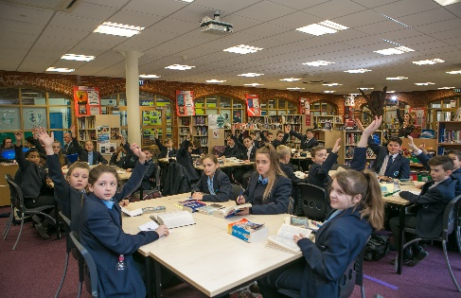
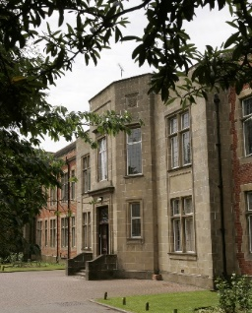
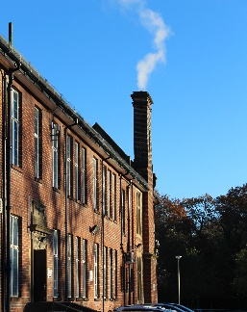
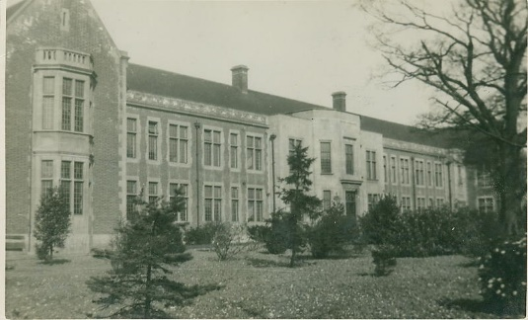
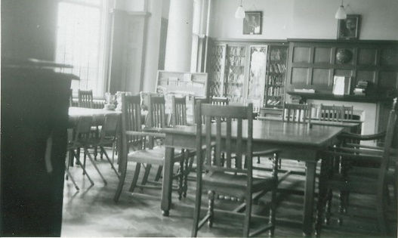
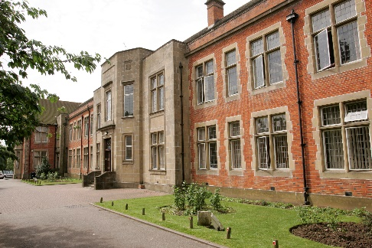

Brentwood County High School
A Specialist Science, Maths and Computing School

Facilities
The school is on a single site and consists of a mixture of the old grammar school buildings, more modern extensions completed in 1975 and 1995 and most recently a new block completed in 2000. The swimming pool was enclosed in 2002. It is set in pleasant grounds, which include hard play areas and a playing field. There is also access to a large playing field almost opposite the school.
As well as the general purpose classrooms there are twelve science laboratories, a suite of language rooms, a mathematics building, art studios, design and technology workshops, swimming pool, a drama hall, two drama studios and a suite of Sixth Form rooms. The Sixth Form Common Room has recently been refurbished and extended.
There is a well-stocked library resource centre with computers and study facilities. There are seven computer suites equipped with networked computers, in addition to computers in faculties and departments throughout the school. There is a specialised graphic design area within the Technology Faculty, incorporating video input, scanner and digitisers. Students have access to the internet on all curriculum workstations.
In 2018 there are plans to demolish one of the older buildings and replace with a new state of the art building as well as plans for refurbishment of the remaining buildings. The project will be managed by the Chief Operations Officer of the Osborne Co-operative Academy Trust.
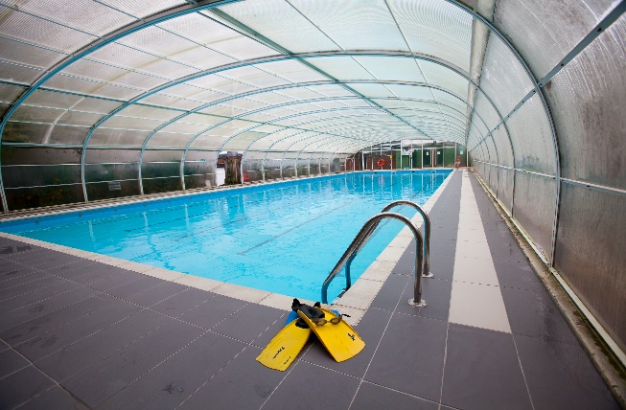
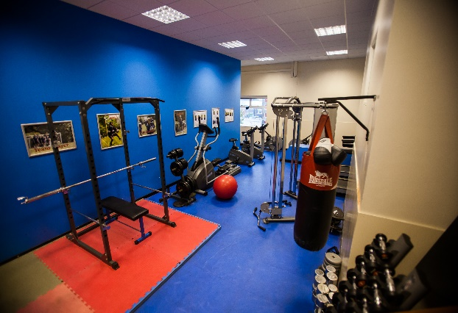
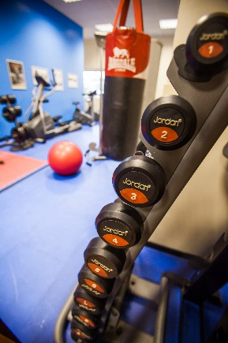
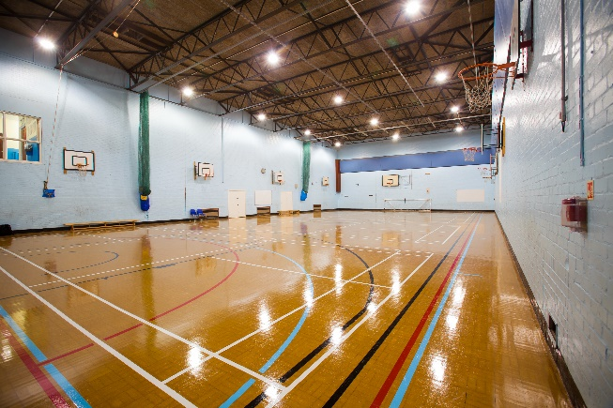
Brentwood County High School
A Specialist Science, Maths and Computing School

School Structure

Our school is a large organisation, with around 1117 young people served by around 150 staff.
Our students are aged 11 on entry and leave at age 18 (or in some cases 19 if they repeat a year in the sixth form).
The school's Senior Leadership Team line manage all parts of the school, covering academic, pastoral and administrative. All staff ultimately report to the Executive Headteacher, Mrs. A Hughes. The management of the school by the Executive Headteacher and her staff is overseen at a strategic level by the school's Local Governing Body. At the end of the last academic year, the Trust set up a Progress Board as an active response to the RI Ofsted judgement in June 2017.
The Progress Board is an interim measure to accelerate school improvement. The Trust Board will review the school progress in the Summer Term 2018 and decide when it is appropriate to re-constitute the Local Governing Body.
The members of our Local Governing Body are drawn from all sections of the community. We have a wide range of expertise, experience at senior levels within the private sector, current and former public servants and elected representatives. Our breadth of experience allows the Local Governing Body to perform the important task of acting as both critical friend and ambassadors for the school.

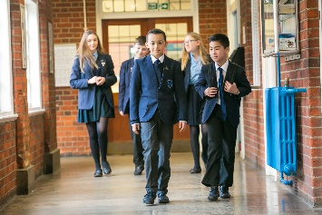
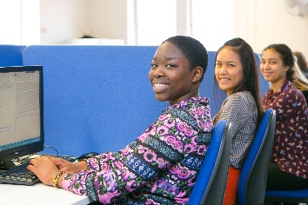
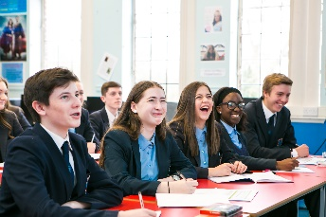
Brentwood County High School
A Specialist Science, Maths and Computing School

Staffing Structure of BCHS
Lead role | Structure | Role | Number of
Leadership Team | Executive Head  Head of School  Deputy Head Teacher  Assistant Head Teacher  Assistant Head Teacher  Assistant Head Teacher  Assistant Head Teacher | Achievement  Teaching and Learning  Pastoral  Curriculum and Disadvantaged Students  Data (St Clere’s 3 days) | 1  1  1  1  1  1  1
Senior Leaders | Director of Learning | Academic | 5
Teachers with Responsibilities | Lead Teachers (and those with responsibilities) |  | 27
Teachers | Department Teachers |  | 41
SEND | SENCO  Department SENCO |  | 1  1
Cover Supervisor |  |  | 3
Teaching Assistants |  |  | 13
Midday Assistants |  |  | 4
Student Wellbeing |  |  | 1
Safeguarding Officer |  |  | 1
Administration |  |  | 27
Technicians |  |  | 8
Site Team |  |  | 4
Catering |  |  | 12

Brentwood County High School
A Specialist Science, Maths and Computing School

Key School Statistics
Type of school | Academy
Age range | 11-18/19 Non-Selective
Specialism | Science, Maths and Computing
Number of students | 1117
Number in Sixth Form | 116
% of students with SEN | 15 %
% of FSM | 8.8 %
% Ethnic Minority Students | 17 %
GCSE results | *
A Level results | **
Last Ofsted | 3-4 May 2017: Requires Improvement
Number of teaching staff | 96
Number of support staff | 73
PAN for September 2018 | 210 (Year 7)  210 (Sixth Form)
Applications for 2018 entry | 116

*Please page 9 for GCSE results
**Please see page 10 for A-Level results

Brentwood County High School
A Specialist Science, Maths and Computing School

GCSE Results Data

BCHS Year 11 Data Summary & Targets |  | Target 2017 | 2017 ResultY11 | Ntnl. | Target 2018 | 2018 Y10 Sum 17 GCSE Est | 2018 Y11 | 2018 Y11
 |  |  |  | 2017 |  |  | Dec 17 GCSE Est | Feb 18 GCSE Est (184)
KS4 | (E&M 4+) | - | 64% | 63% | 70% | 69% | 77% | 78%
 | E&M 5+ | 46% | 40% | 42% | 50% | 49% | 51% | 52%
 | Attainment 8 | 51 | 40.7 | 46 | 50 | 49.8 | 48.6 | 50.2
 | Progress 8 (est.) | >0 | -0.54 | 0 | >0.1 | -0.88 | 0.16 | 0.26
 | Ebacc Entered | - | 77% | 35% | 39% | 38% | 39% | 41%
 | Ebacc Achieve | - | 24% | 24% | 26% | 26% | 17% | 17%
KS4 Eng | Grade 4-9 | 75% | 75% | 70% | 87% | 75% | 87% | 88%
 | Grade 5-9 | 58% | 54% | 56% | 69% | 59% | 65% | 67%
 | Grade 7-9 | - | 15% | tbc | 23% | tbc | 21% | 22%
 | Subject Progress | - | -0.38 | 0 | >0.1 | 0.29 | 0.11 | 0.12
KS4 Ma | Grade 4-9 | 77% | 72% | 69% | 78% | 82% | 81% | 81%
 | Grade 5-9 | 58% | 50% | 48% | 60% | 61% | 61% | 62%
 | Grade 7-9 | - | 16% | tbc | 23% | tbc | 15% | 16%
 | Subject Progress | - | -0.09 | 0 | >0.1 | 0.29 | 0.34 | 0.32

Brentwood County High School
A Specialist Science, Maths and Computing School

A-Level Results Data
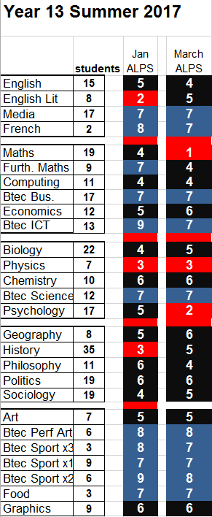
Brentwood County High School
A Specialist Science, Maths and Computing School

School Map

Brentwood County High School
Shenfield Common
Seven Arches Road
Brentwood
Essex
CM14 4JF
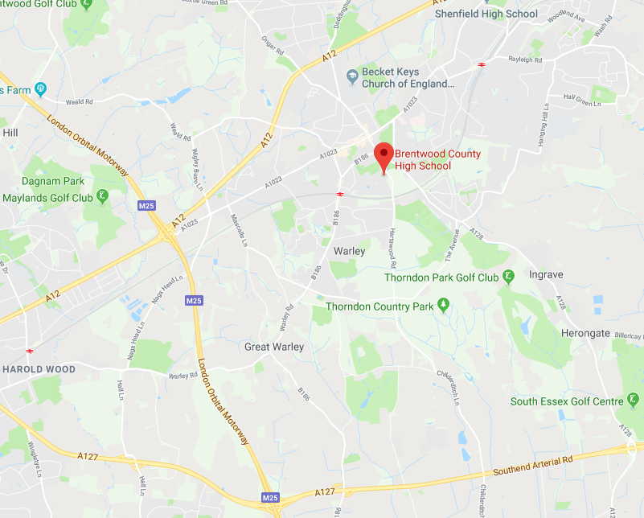
01277 238 900

