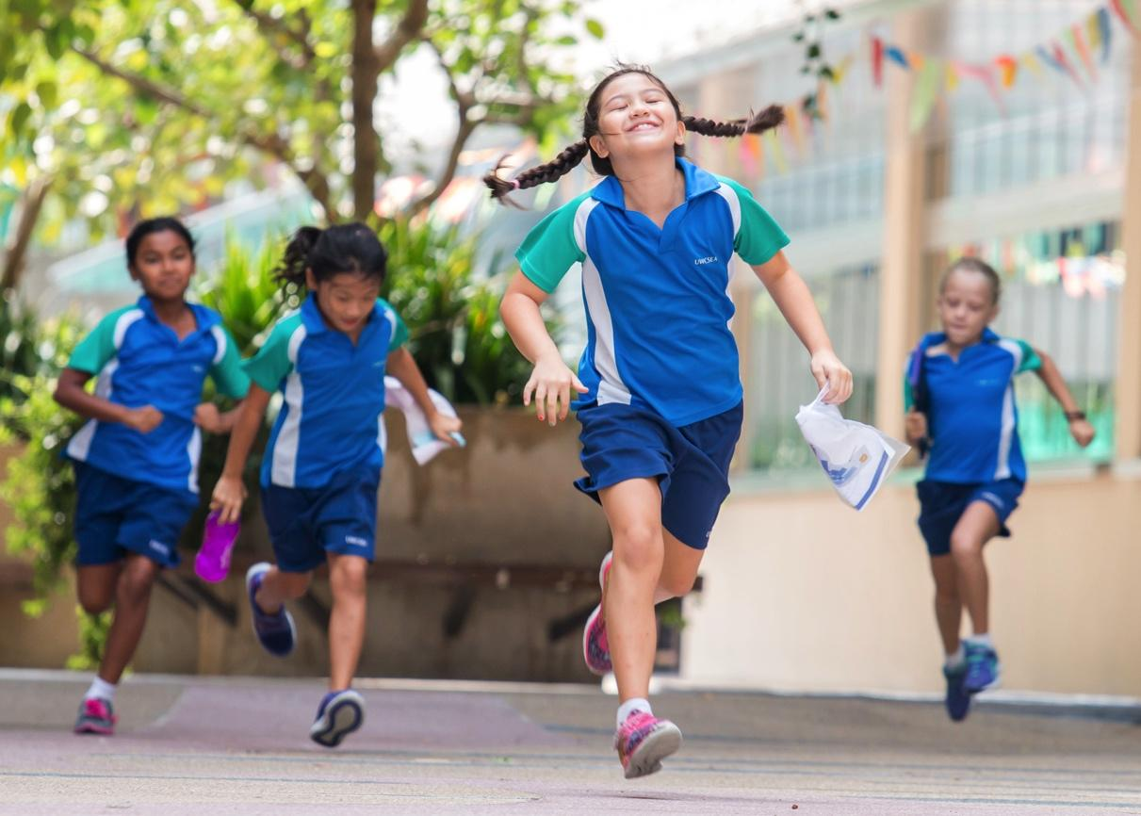

Vice Principal of Primary School
East Campus

Education
like no other
The Post
UWCSEA has a vacancy for August 2018 (but will consider a January 2019 start for the right candidate) at its East Campus for a Vice Principal of Primary School. The Vice Principal is one of the pedagogical leaders within the Junior School. The Vice Principal, working with other members of the Primary Leadership Team, is responsible to the Principal of Primary School for the learning programme in the Primary School.
The Vice Principal has shared responsibility for the quality of learning and for the recruitment and professional practice of its personnel. The Vice Principal will also work as a member of the East Campus Leadership Team to ensure unity of purpose within the Campus and the College as a whole.
The Context
UWCSEA welcomes applications from all qualified candidates. UWC South East Asia is committed to safeguarding our students and protecting them from harm. In keeping with the expectation that all staff and volunteers share this commitment, those applying for a position at the College must be willing to undergo employment background checks and screening appropriate to the post.
If you have a strong sense of adventure and an exceptional level of commitment to teaching and learning, UWCSEA might be the perfect next step for you. Here are some reasons why:
- You can be part of the College at an exciting time in its development. The implementation of our bespoke College-wide curriculum, the integration of technology into teaching and learning, and a significant focus on educating for ethical dispositions are just some of the exciting initiatives our staff are currently involved in.
- As a non-profit organisation, we invest a percentage of income into scholarships for approximately 100 students each year. These scholars come from a wide variety of cultural and socio-economic backgrounds. You can teach and learn from these exceptional students.
- Our academic results are outstanding, but our focus on holistic education means teachers are involved in all aspects of the programme. At UWCSEA you can take students trekking in the Himalayas or kayaking in Thailand, building houses in Cambodia or skiing in Switzerland. Equally, you can support them in making real connections with the local community, working with children with multiple disabilities or teaching life skills to domestic workers who have been the victims of violence. All our students and teachers, from Kindergarten 1 to Grade 12 are involved in our activities, outdoor education and service programmes.
- We provide a professional learning programme that brings international experts to the school and supports teachers in their professional learning journey.
Person specification
- A degree and professional teaching qualification is essential: a higher degree is desirable
- Knowledge of international curricula, concept based teaching, learning and assessment
- Proven ability to develop and lead talented staff and high achieving students in an International School context
- Passion for international education
- Understanding of leadership to improve teaching and learning
- Awareness of current issues and trends in education
- Understanding of the principles of organizational culture and behaviour
- Honesty, integrity, compassion, and a good sense of humour
- Ability to develop a sense of community and generate trust with all constituent groups
- Strong organizational and proven problem-solving skills
- Excellent self-management skills
- Understanding of the place of technology within the school environment
- Fluency in English and excellent communication skills: written, spoken and in presentations
- Academic expectations include enthusiastic participation in Professional Learning, both that which is mandated by the College and that which is identified by the teacher.
- Teachers should be willing and eager to participate in the five key elements of a UWCSEA education: Academic; Personal & Social Education; Service; Activities; Outdoor Education.
- On average the College expects a yearly contribution of two sessions per week in each season to Activities and/or Service.
- The College expects that teachers will participate enthusiastically in the curricular Outdoor Education experiences which are relevant to their students and will also occasionally volunteer for holiday Outdoor Education trips.
- Applicants should be enthusiastic about teaching within a multi-cultural environment.
- Flexibility of approach, a collaborative style and a good sense of humour are essential.

Responsibilities
The main focus for the VP Primary School is to ensure that the pastoral and curricular needs of the students and teachers are met, and to assist the Principal in creating and maintaining a spirit within the Primary School that supports students to be happy and perform at their very best. The VP Primary School will work with and support the Heads of Grade to develop and manage the staff and students within their Grades.
- Assisting the Principal with the implementation of the College mission, ethos and values, throughout the school.
- Assisting in the annual process of recruitment
- Developing and communicating the Strategic Plan
- Assisting staff with pastoral needs, including discipline issues
- Developing and ensuring the quality of our UWCSEA curriculum
- Assisting staff with curricular needs, including implementation of new initiatives
- Monitoring the quality of all Junior School expeditions
- Monitoring the quality of teaching and learning
- Supporting the Professional Learning Programme (PLP)
- Coordinating the Junior School components of on-campus events
- Working with the Principal to ensure that there is continual professional learning for teachers
- Deputising for the Principal in his/her absence

Logistics (in collaboration with the Principal)
- Liaising with the Timetable Manager in the production of the Junior School timetable.
- Contribute to the compilation of the Academic Calendar
- Collaboration with the Principal in the organising of School Orientation Evenings and assuring input of pastoral care into presentations.
- Creation and management of duty roster for teachers and teacher assistants
- Ensuring evacuation procedures are up-to-date, adequate to the school’s needs and are communicated to all concerned.

Administrative
- Making sure student records are kept up to date and inclusions such as file notes are completed and followed up.
- Coordinating reports, including guidance on timing and assistance with checking and distribution and follow-up with staff.
- Supervision of the Junior School Office secretaries in terms of responsibilities and time management.
- Ensuring that curriculum policies and documentation are updated regularly and made accessible to all Junior School staff.

About UWCSEA
UWC mission
The UWC movement makes education a force to unite people, nations and cultures for peace and a sustainable future.
UWCSEA educational goal
We educate individuals to embrace challenge and take responsibility for shaping a better world.
UWCSEA ambition
UWCSEA will be a leader in international education. We will have a worldwide reputation for providing a challenging, holistic, values-based education with an emphasis upon academic achievement, service to others, environmental stewardship, teamwork and leadership.
UWCSEA community member profile
The UWCSEA learning programme provides a breadth of opportunity that enables learners to develop the qualities and skills of the UWCSEA profile. The profile is derived from our mission and supported by current research in education. Through the development of these skills and qualities, members of our community lead by example, embrace challenge and take responsibility for shaping a better world. While each quality and skill is identified separately, they are interconnected and impact each other.
Qualities
- Commitment to care
- Principled
- Resilient
- Self-aware
Skills
- Critical thinker
- Creative
- Collaborative
- Communicator
- Self-manager

The UWC movement – a history
“I regard it as the foremost task of education to insure the survival of these qualities: an enterprising curiosity, an undefeatable spirit, tenacity in pursuit, readiness for sensible self denial, and above all, compassion.” - Kurt Hahn
The UWC movement was founded in 1962 by Kurt Hahn, a German educator, whose ideas were crystallised by the destruction he witnessed during the first and second World Wars. In 1958 Hahn was inspired by the cooperation between former adversaries he witnessed at a NATO Staff Conference. He was convinced that education should prepare young people for a life with service, leadership and meaningful action at its heart. By educating young people from around the world together, he thought that future conflicts could be prevented. From this belief in the power of education to change the world, the UWC movement was born, with a mission to make education a force to unite people, nations and cultures for peace and a sustainable future.
Today, there are 17 UWC schools and colleges around the world, with UWCSEA in Singapore the largest of these. As well as providing an international education for young people living in Singapore, each year the UWC movement and UWCSEA provide scholarships for more than 100 students from all over the world to attend UWCSEA. In the words of Nelson Mandela, Former Honorary President, UWC International: “The striking thing about the United World Colleges is that they embrace the entire world across all divides of race, history, culture, wealth, religion, economic status and political belief.”
The first UWCSEA campus on Dover Road was opened in 1971 by then Prime Minister, Lee Kuan Yew, under the name of Singapore International School. In the late 1990s, the Dover Campus gradually expanded its age range from a secondary school to include primary and kindergarten students. Today, it has grown to a school of 3,000 students from Kindergarten–Grade 12. Opened in 2008, the purpose-built East Campus has grown to more than 2,500 students from Kindergarten–Grade 12.
UWCSEA students
Students at UWCSEA are selected through a process that takes a holistic view. Previous school reports and references, as well as the student’s potential to contribute, support and participate fully in the life of the College are all taken into account. Where appropriate, entry tests and English language assessments are required.
The 5,591 students currently enrolled at the College represent 100 nationalities and speak 56 different first languages.
Student numbers 2017/2018
School | Dover Campus | East Campus | Whole College
Infant School (K1–G1) | 288 | 327 | 615
Junior School (G2–5) | 673 | 676 | 1349
Middle School (G6–8) | 783 | 607 | 1390
High School (G9–12) | 1277 | 960 | 2237
Boarders (G8–12) | 178 | 164 | 342

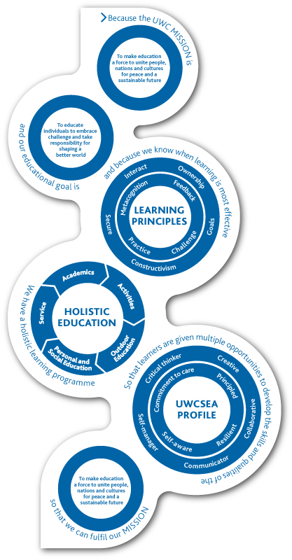
The UWCSEA learning programme
The UWCSEA learning programme has the UWC mission as both our inspiration and our goal.
With our mission and educational goal as starting points, and basing our practice on learning principles that tell us when learning is most effective, we have developed a holistic learning programme, consisting of five elements: academics, activities, outdoor education, personal and social education and service. Through this programme, students develop the skills and qualities of the UWCSEA profile, while help them to fulfil the UWC mission to make education a force to unite people, nations and culture for peace and a sustainable future.

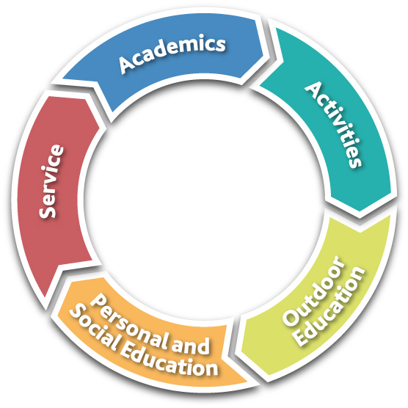
Academics
At UWCSEA, students experience the joy of intellectual engagement and the satisfaction of scholarly pursuit. Through the academic element of the programme, they gain an understanding of the connections between individual subjects and how to solve complex problems using different approaches.
UWCSEA is an IB World School, offering the IB Diploma Programme in Grades 11 and 12. Our K–12 academic curriculum is shaped by our mission and educational goal and guided by the UWCSEA profile and learning principles. Learning goals in languages, mathematics, sciences, the Arts, humanities, technology and physical education build logically through each grade, preparing students for the next academic challenge. UWCSEA offers the (I)GCSE programme in Grades 9 and 10, with students who enter in Grade 10 taking a Foundation IB (FIB) course.
Activities
The College offers an extensive Activities programme to students from Grade 2 onwards. More than 900 activity events take place across both campuses each week. The programme is divided into sports, arts (dance, drama, music and visual arts), leadership, clubs and special interests. It is designed to provide students with opportunities to explore new interests, develop their strengths and pursue their passions. Activities invigorate the life of the College by bringing students together for creative, athletic, leadership and other endeavours.
Outdoor Education
The opportunities for learning at UWCSEA extend far beyond the classroom as students take on experiential challenges that build resilience, collaboration and leadership. Our Outdoor Education programme offers an incremental progression of age-appropriate experiences to students across the K–12 curriculum. Whether going on a forest adventure in Malaysia in Grade 3 or trekking in Nepal in Grade 9, students develop confidence in their physical abilities and emotional resilience to withstand difficult situations.
Personal and Social Education
There are opportunities for personal and social development in all elements of the UWCSEA learning programme, but the importance of this aspect of the student experience is recognised by our dedicated Personal and Social Education (PSE) programme. The PSE programme supports students in dealing with the personal and social challenges that all young people face. From younger students identifying and celebrating mastery of new skills to Grade 12 students using their self-knowledge to select their path after graduation, the PSE programme is a dedicated time for students to explore their identity and place in the world.
Service
The Service programme empowers students to become aware, able and active contributors to the community. Students become involved in College service, where they offer a service to other members of the school community; in local service, where they connect with members of the Singapore community; and in global service, which incorporates Global Concerns (GC) projects, the Initiative for Peace and our extensive Gap Year programme. GC is a dynamic initiative enabling students to put their ideals into action by working to support causes and communities through direct links with partner organisations outside Singapore.
The greatest impact of the Service programme is on our students, as they put their ideals and values into action and grow as compassionate people and active agents of change.
The Benefits
Along with a very competitive package, UWCSEA offers the incredibly high rewards that come from working with remarkable young people in a climate of innovation, collaboration and collegiality. Furthermore, the College offers outstanding levels of professional learning; we not uncommonly hear from new teachers that they have learnt more with us than at any other stage in their careers. Opportunities include structured internal courses, a self-driven Professional Learning Programme, support for further studies, an emphasis on conceptually-based teaching and learning, and specific foci that we adapt to our own context, such as, Reggio, Reading and Writing Workshop, IB courses, Philosophy for Children.
Teachers arriving from overseas will be provided with relocation support, housing allowance, medical insurance and repatriation support at the end of contract. It should be noted that the medical insurance is provided within industry-standard limits.
Teachers arriving from overseas may be entitled to tuition fee exemption for up to (3) children at the College, subject to evaluation of available places at the time of offer and/or the existing HR benefits package. Teachers’ children are subject to the same admission standards as all other applicants. It should be noted that provision for learning support is limited in scope.

