# C:\Documents and Settings\LUCY\Local Settings\Temporary Internet Files\Content.IE5\382L8ZSV\logo_colour[1].gifSt Mary’s CE Primary School

**‘Nurturing Success’**

*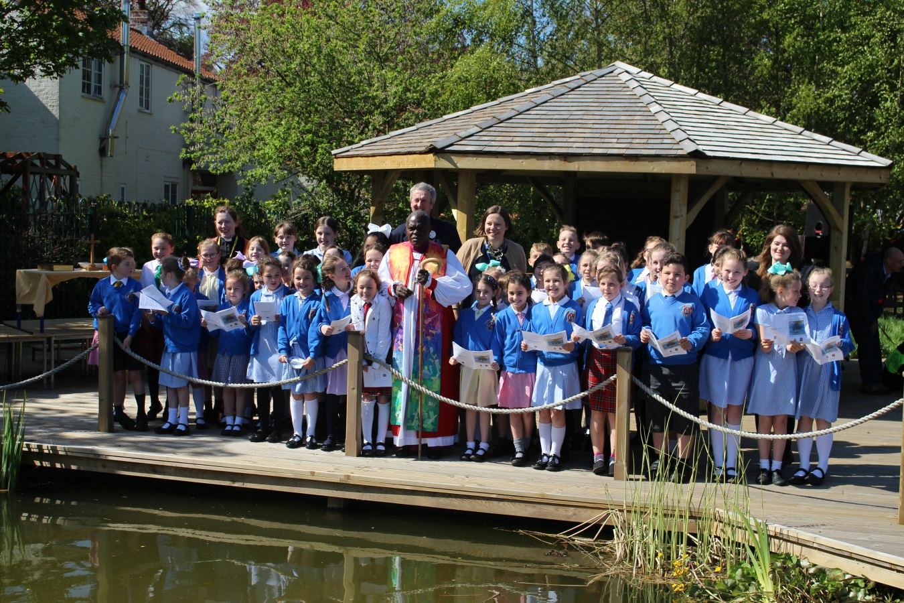*

# 

# 

# Headteacher Recruitment Pack

# April 2018

# C:\Documents and Settings\LUCY\Local Settings\Temporary Internet Files\Content.IE5\382L8ZSV\logo_colour[1].gifSt Mary’s CE Primary School

**From the Chair of Governors**

Dear Applicant,

On behalf of all members of the school community I would like to thank you for your interest in applying for the post of Headteacher at St Mary’s. I hope that this pack and our website will give you a feel for our wonderful school and that it will encourage you to apply for this exciting and rewarding position.

Our current Headteacher has been appointed as a School Improvement Advisor to the Local Authority and we are seeking to recruit an inspirational and dynamic successor who has the vision and skills to build upon the school’s success. They will be supported by an enthusiastic highly skilled staff, supportive parents and an active governing body.

St Mary’s is a school where everyone feels valued, we are welcoming and friendly with happy children eager to learn. We aim to offer a broad education rooted in the school’s Christian ethos and are proud of our strong links with the local church.

If you are considering applying I would encourage you to visit the school to see the pupils and staff at work. Please contact Mr Ali Kemp, the school business manager via email to arrange a visit - [a.kemp@stmarysbeverley.eriding.net](mailto:a.kemp@stmarysbeverley.eriding.net). If you feel that this might be the school for you to lead then we would love to hear from you.

Yours faithfully

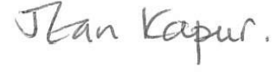

Mrs Jean Kapur

# C:\Documents and Settings\LUCY\Local Settings\Temporary Internet Files\Content.IE5\382L8ZSV\logo_colour[1].gifSt Mary’s CE Primary School

**Welcome to our School**

Our mission at St Mary’s is to provide the highest quality education for every child, enabling them to fulfil their potential in a safe and friendly school community underpinned by Christian values. We want children to develop as confident, articulate and happy individuals who will love learning throughout their lives.

This mission is underpinned by six key Christian values which were chosen by our school community as being particularly relevant to St Mary’s School. Our values are:

* **Respect**
* **Friendship**
* **Trust**
* **Perseverance**
* **Wisdom**
* **Hope**

Throughout the school day, we think about these values and try to live by them.

The school has a special relationship with St Mary’s Church which both sides value and support. We have regular school services in church and weekly visits from the vicar. In addition we have church-school clubs and a worship committee led by the children (with a little help from the vicar and RE coordinator).

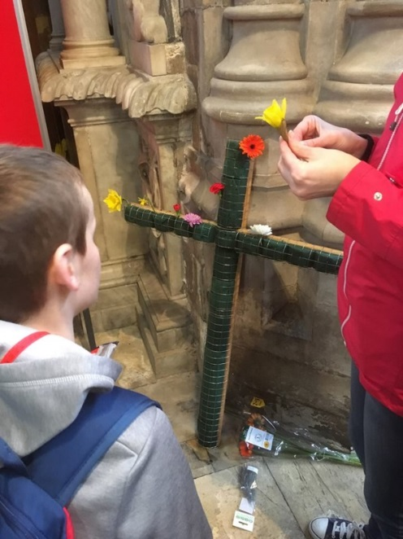

This is a cross made by the children during the last Easter service.

# C:\Documents and Settings\LUCY\Local Settings\Temporary Internet Files\Content.IE5\382L8ZSV\logo_colour[1].gifSt Mary’s CE Primary School

**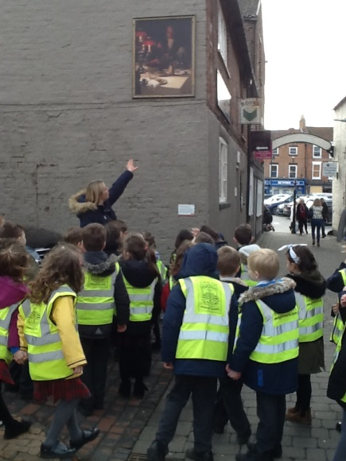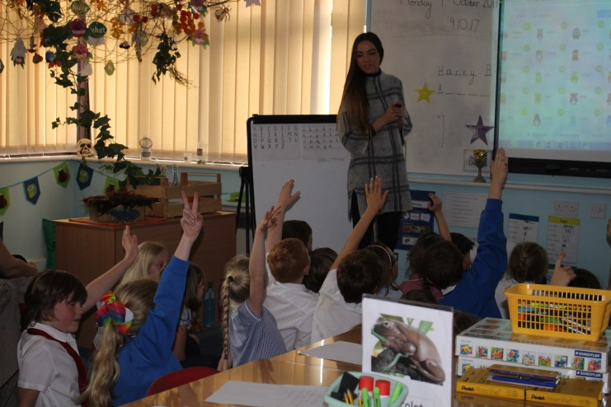**

**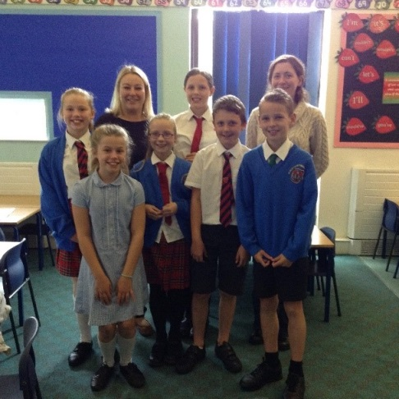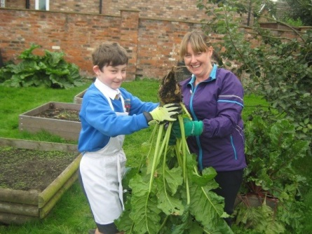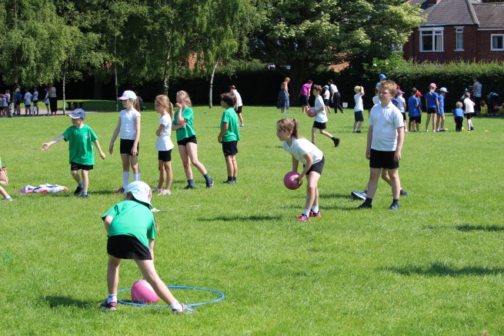**

Children and staff were asked what qualities they hoped for in their new Headteacher

Children said:

|  |  |  |
| --- | --- | --- |
| Respectful to everyone | Kind | Clever |
| Fairness | Happy | Aware of safety |
| Funny | Friendly | Good judgement |
| Determination | Give children choice | Confident |
| Nice | Keep children safe | Trustworthy |
| Be fun but firm | Perseverance | Understanding |
| Expects children to show respect and do good work | Sporty | Patient |

Staff said:

|  |  |  |
| --- | --- | --- |
| Someone with presence | Leads by example | Strong leader |
| Supportive and approachable | Continues to move the school forward | Firm but fair |
| Enable the children to achieve their best….for a successful future | Take an interest in all children and staff | Places a high importance on the well-being of staff and children |

# C:\Documents and Settings\LUCY\Local Settings\Temporary Internet Files\Content.IE5\382L8ZSV\logo_colour[1].gifSt Mary’s CE Primary School

**Letter from the Diocese**

York Diocesan Board of Education supports 125 Church of England schools and academies in the area from the Humber to the Tees. We have a dedicated team of professionals who offer a wide range of expertise and can help schools access further assistance.

The Education team aims to:

* Be available as a ‘one-stop shop’ for pastoral and professional support;
* Work with a range of agencies to promote school improvement;
* Promote excellence and Christian distinctiveness;
* Provide and facilitate professional development and governor training;
* Help schools and academies network, collaborate together and share best practice;
* Offer a Total Property Management scheme in association with DBE Services Ltd;
* Guide schools on matters concerning trusts;
* Work with schools exploring Academy conversion;
* Advise in the appointment of staff, especially Headteachers;
* Support Headteacher appraisal;
* Represent Church of England education to the wider church community and more widely to the public;
* Maintain contact with the local authorities and the Regional Schools Commissioners.

|  |
| --- |
| *The Rt Revd Paul Ferguson, Bishop of Whitby and Chair of the Diocesan Board of Education, said:*  “Our schools and academies are a vital part of the mission of the Church of England in the Diocese of York. Staff and governors are strongly committed to their communities, and in many cases the influence of church schools can only be described as transformative.  We strive to offer our young people the very best in every aspect of education, including encouraging them to mature spiritually and to understand how faith informs good relationships and responsible citizenship. We aim for our schools to be places where the love of God in Christ is truly reflected.  If these aims and values resonate with you, we hope that you will consider applying to come to St Mary’s VC Primary School, Beverley to lead our school into the next phase of its life”. |

|  |
| --- |
| *Andrew Smith, Diocesan Director of Education, said:*  ”As a diocese, we are here to help celebrate and strengthen the Christian ethos in our schools. We understand that each school is unique and our aim is to get to know our schools on an individual basis in order to foster the local parish and community links as far as possible.  As such, our Education Team offers a range of support to our headteachers from both a school distinctiveness and effectiveness point of view, as well as providing a range of training and development opportunities for staff and governors to access over the course of each year. In a rapidly changing educational landscape, we are more and more involved in wider school development, particularly as schools change from one school status to another.  I do hope that you feel able to apply for the position of Headteacher of St Mary’s VC Primary School, Beverley and we would look forward to welcoming you as part of our diocesan family here in the Diocese of York”. |

# C:\Documents and Settings\LUCY\Local Settings\Temporary Internet Files\Content.IE5\382L8ZSV\logo_colour[1].gifSt Mary’s CE Primary School

**Headteacher Job Description**

**Purpose**

* To provide vision, leadership and direction for the school
* With the governing body, to be responsible for creating and maintaining an effective learning environment which is engaging and fulfilling for all pupils, promoting the highest possible standards, and fostering the continuous improvement of the quality of learning offered by the school
* To preserve and develop the Christian ethos of the school

**Accountable to**

* The governing body of the school

**Accountable for**

* The standards, progress and well-being of all pupils and all staff
* For all the resources of the school

**Key Tasks**

**Overall**

* To treat everyone fairly and equitably, with dignity and respect so as to create and maintain a shared school culture and positive climate that motivates pupils, staff and all other members of the school community.
* To nurture all children and to create a culture of high expectations and aspirations that lead to excellent learning
* To promote effective relationships with all pupils, staff, governors, parents, other schools, the local community, the Local Authority, the Diocese and other external bodies to enhance the positive image of the school and the development of the education system as a whole.

**Leadership and management**

* Working with all stakeholders, create a vision for the school that provides direction for all aspects of the life of the school
* To ensure that pupils, parents, staff and governors are committed to the school’s vision of excellence
* To be responsible for the day-to-day management, organisation and administration of the school, modelling effective work life balance and encouraging staff to reach their full potential
* To ensure the rigorous implementation of well-focused improvement plans, based on robust self-evaluation particularly in reading, writing and mathematics
* To monitor and evaluate standards of teaching, learning resource usage and management effectiveness and implement appropriate strategies for change

**Governance:**

* To work with the governing body to enable it to meet its responsibilities and present to it, on a regular basis, an accurate account of the school’s performance

**The curriculum**

* To work with governors, to ensure that the statutory requirements for the curriculum are met so that curriculum provision is appropriate and relevant to the needs of all learners, providing equality of learning opportunity for all
* To secure a broad and balanced curriculum that has a positive impact on the behaviour and learning of all pupils, contributing to their physical well-being and their social, moral, spiritual and cultural development.
* To ensure that the curriculum promotes and sustains a thirst for knowledge and understanding and a love of learning

**Behaviour and safety**

* To establish and maintain the policies and procedures that ensure the safety of all pupils, staff members and visitors to the site
* To establish a positive ethos throughout the school so that pupils take pride in their school, their work and their behaviour
* To maintain a culture where respect for others and courtesy are the norm.

**The quality of teaching and learning**

* To ensure that teaching in all classes is good or better so that learning over time for all groups, is good or better
* To provide support, guidance and challenge to all staff so that they provide the very best for all pupils
* To understand what good/outstanding teaching and learning looks like and be able to communicate this effectively to all staff and governors
* Ensure effective monitoring and evaluation of the learning of all cohorts, groups and individual pupils so that they achieve as well as possible
* To ensure that teaching helps to develop a culture of scholastic excellence, where the highest achievement in academic work is recognised, especially when supporting the achievement of the most able

**The achievement of pupils**

* To ensure that all pupils achieve well, so that the proportions making or exceeding expected progress are close to, or above, national figures
* To ensure that parents and carers are regularly provided with sufficient information to understand how well their children are doing and what they can do to help improve learning
* Ensure that there are successful strategies for engaging with parents to the benefit of all pupils

**Early Years provision**

* To ensure that children in the Early Years are safe and happy and achieve well
* To ensure that the provision for Early Years is highly effective
* To ensure that all children are well prepared for Year 1 and subsequent education

**As a Church school**

* To confidently articulate, support and promote a vision for the school rooted in distinctively Christian values
* To articulate an explicitly Christian vision that impacts positively upon standards of achievement, the distinctively Christian character of the school and the well-being of the whole school community
* To work closely with the local Churches and the Diocese to promote an understanding of the Christian faith and respect for other faiths and cultures.

# C:\Documents and Settings\LUCY\Local Settings\Temporary Internet Files\Content.IE5\382L8ZSV\logo_colour[1].gifSt Mary’s CE Primary School

The selection panel will be looking for evidence that the candidate has demonstrated their ability to fulfil the following criteria through the Application, References and Interview.

|  |  |  |
| --- | --- | --- |
| **Headteacher Specification** | **Essential (E) or**  **Desirable (D)** | **Application (A), Interview (I), Reference (R)** |
| Qualifications and Experience |  |  |
| Qualified teacher status.  NPQH qualification  Successful senior leadership experience. | E  D  E | A  A  A, I, R |
| Qualities and knowledge |  |  |
| To confidently articulate, support and promote the vision of the school which is rooted in distinctive Christian Values.  Demonstrate optimistic personal behaviour, positive relationships and attitudes towards their pupils and staff, and towards parents, governors and members of the local community.  Lead by example - with vision, integrity, creativity, resilience, and clarity - drawing on their own scholarship, expertise and skills, and that of those around them.  Work with political and financial astuteness within a clear set of principles centred on the school’s vision, ably translating local and national policy into the school’s context.  Drive the strategic leadership, empowering all pupils and staff to excel. | E  E  E  E  E | A, I, R  A, I, R  A, I, R  A, I, R  A, I, R |
| Pupils and staff |  |  |
| Expect ambitious standards for all pupils, overcoming disadvantage and advancing equality, instilling a strong sense of accountability in staff for the impact of their work on pupils’ outcomes.  Secure excellent teaching through an analytical understanding of how pupils learn and of the core features of successful classroom practice and curriculum design, leading to rich curriculum opportunities and pupils’ well-being.  Maintain the educational culture of ‘open classrooms’ as a basis for sharing best practice within and between schools.  Create an ethos within which all staff are motivated and supported to develop their own skills and subject knowledge, and to support each other.  Hold all staff to account for their professional conduct and practice.  Develop pupils’ learning, independence and resilience recognising the need for all pupils to enjoy school in order to become confident and enquiring learners | E  E  E  E  E  E | A, I, R  A, I, R  A, I, R  A, I, R  A, I, R  A, I, R |
| Systems and process |  |  |
| Ensure that the school’s systems, organisation and processes are well considered, efficient and fit for purpose, upholding the principles of transparency and integrity.  Ensure that a safe, calm and well-ordered environment for all pupils and staff is provided, focused on safeguarding pupils and developing their exemplary behaviour in school and in the wider society.  Continue the rigorous, fair and transparent systems and measures for managing the performance of all staff, addressing any under-performance, supporting staff to improve and valuing excellent practice.  Welcome strong governance and actively support the governing board to understand its role and deliver its functions effectively – in particular its functions to set school strategy and hold the head teacher to account for pupil, staff and financial performance.  Exercise strategic, curriculum-led financial planning to ensure the equitable deployment of budgets and resources, in the best interests of pupils’ achievements and the school’s sustainability.  Distribute leadership throughout the organisation, with teams of colleagues who have distinct roles and responsibilities and hold each other to account. | E  E  E  E  E  E | A, I, R  A, I, R  A, I, R  A, I, R  A, I, R  A, I, R |
| The self-improving school system |  |  |
| Work with other schools and organisations, in a climate of mutual challenge, to champion best practice and secure excellent achievement for all pupils.  Shape the current and future quality of the teaching profession through high quality training and sustained professional development for all staff.  Encourage innovative and sustainable approaches to school improvement, leadership and governance.  Inspire and influence others to believe in the fundamental importance of education in young people’s lives and to promote the value of education.  To continue to work closely with the local Church and the Diocese to promote an understanding of the Christian faith and respect for other faiths and cultures. | E  E  E  E  E | A, I, R  A, I, R  A, I, R  A, I, R  A, I, R |
| Safeguarding |  |  |
| Demonstrate a commitment to safeguarding and the welfare of pupils and staff.  Form and maintain appropriate relationships and personal boundaries.  Possess emotional resilience in working with challenging behaviours.  Use appropriate authority and discipline. | E  E  E  E | A, I, R  A, I, R  A, I, R  A, I, R |

# C:\Documents and Settings\LUCY\Local Settings\Temporary Internet Files\Content.IE5\382L8ZSV\logo_colour[1].gifSt Mary’s CE Primary School

**Staffing Structure**

# C:\Documents and Settings\LUCY\Local Settings\Temporary Internet Files\Content.IE5\382L8ZSV\logo_colour[1].gifSt Mary’s CE Primary School

**The School and its Context**

St Mary’s CE School is a large primary school which draws its pupils from across the East Yorkshire market town of Beverley.

Beverley lies on the edge of the beautiful Wolds countryside, is within easy reach of the Yorkshire Coast and has a thriving and characterful town centre. The town hosts a range of festivals, sporting and community events throughout the year, such as the Festival of Christmas and Tour De Yorkshire Cycle race which the school actively support.

The town is a popular residential choice and was ranked by the Sunday Times Newspaper as being within the ‘top ten best places to live’ in the North East in 2018.

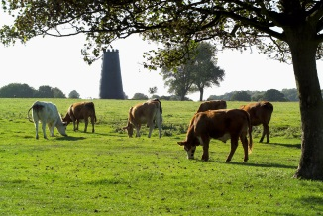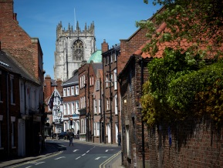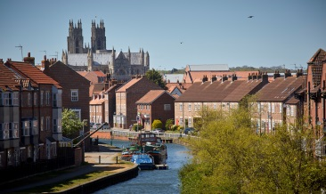

Beverley is in easy commuting distance of Hull (10 miles) and York (30 Miles). The town sits on the rail network and enjoys a direct rail service to London, via Hull Trains. Leeds, Sheffield and Manchester can be easily reached by rail from the town.

The school itself is situated just to the north of the town, approximately a 15 minute walk from the town centre and St Mary’s Church. It sits on a site of over 4 acres which includes a school playing field and outside learning area.

**School Contact Details**

St Mary’s CE (VC) Primary School

Eden Road

Beverley

East Riding of Yorkshire

HU17 7HD

Telephone: 01482 868149

Email: [stmarysbeverley.primary@eastriding.gov.uk](mailto:stmarysbeverley.primary@eastriding.gov.uk)

Website: [www.stmaryscofe-beverley.co.uk](http://www.stmaryscofe-beverley.co.uk)

Number on roll: 396 (October 2017)

Headteacher Group: Group 3, L15 - L21 (£55,600 - £64,417)

Last Ofsted report: Good (Nov 2013)

Last SIAMS Report: Outstanding (June 2014)

# C:\Documents and Settings\LUCY\Local Settings\Temporary Internet Files\Content.IE5\382L8ZSV\logo_colour[1].gifSt Mary’s CE Primary School

**The Recruitment Process**

Application forms are available at [www.eastriding.gov.uk/jobs](http://www.eastriding.gov.uk/jobs)

To arrange to visit the school, please contact Mr Ali Kemp on [a.kemp@stmarysbeverley.eriding.net](mailto:a.kemp@stmarysbeverley.eriding.net)

Closing date: Thursday 10th May 2018 12:00pm

Shortlisting: Monday 14th May 2018

Interviews: Monday 21st May 2018 (in school)

Tuesday 22nd May 2018 (off site)

Start date: 1st September 2018, or as soon as possible thereafter

Kind thanks to VHEY for use of their Beverley images in this pack