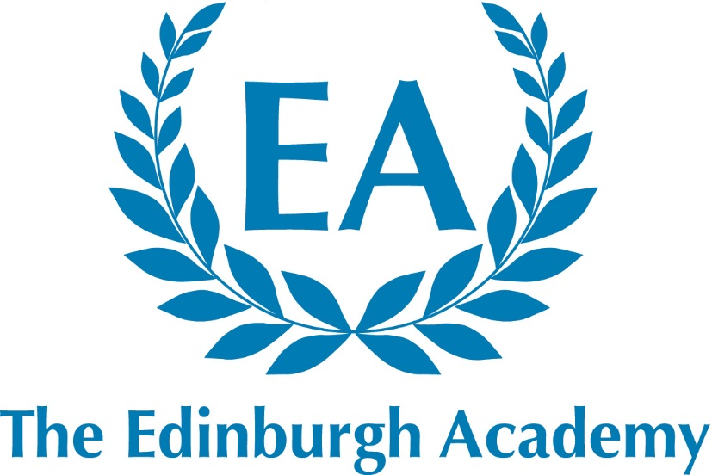

42 Henderson Row
Edinburgh
EH3 5BL

Fully co-educational

HMC
Independent Co-educational Day Schools

Senior School: 586 pupils aged 11 –18
Junior School: 388 pupils aged 5 –11
Nursery: 92 pupils aged 2 – 5

Teacher of Music
Senior School
Required for August 2018
The Edinburgh Academy
Introduction

The Edinburgh Academy is an academically selective, independent, co-educational day school for pupils aged 5 -18 years with a reputation for being caring and friendly. It aims to provide co-educational excellence with a first-class all-round education to those of intellectual promise and academic potential, regardless of background, race or creed. The Edinburgh Academy aims to be forward-looking and progressive but also greatly values its long held traditions. Although the School is not academically exclusive, the ability range of pupils is well above the national average. Great emphasis is placed on the pursuit of co-curricular interests alongside academic studies for all our pupils. The School has a strong reputation for individual attention and excellence in its pastoral care and co-curricular provision. The School consists of a Senior School containing approximately 590 pupils and a Junior School containing approximately 390 pupils, and we have a Nursery department of around 100 pupils. The School is a member of HMC. The Edinburgh Academy moved to full co-education across the whole school in 2008. Previously girls were only admitted in the Sixth Form (S5 and S6).

The School’s Place in Edinburgh

The School was founded in 1824 and has been regarded as a leading educational establishment within the City of Edinburgh and across Scotland ever since. Original Directors included the leading literary names of their age such as Sir Walter Scott. Robert Louis Stevenson and James Clerk Maxwell were also pupils at the School. The Senior School occupies a site in Henderson Row, less than a mile from Princes Street and at the northern limits of the Georgian ‘New Town’, of which it was designed to be a part.

Further details about the School and its resources can be found on the School website - www.edinburghacademy.org.uk

Classes and Assembly
7ths (S6) and 6ths (S5) classes are organised by tutor groups studying either Highers, Advanced Highers or GCE A-level. Across the Senior School no teaching group consists of more than 24 pupils and many are substantially smaller. A School Assembly is held at 8.50am each morning, and is attended by the whole school. School Services for the whole school are held on several occasions during the session.

Exam Results
The Edinburgh Academy uses both English and Scottish examination boards. Nearly all subjects now present SQA National 5 and Advanced Higher examinations. Each year, a significant number of our 7ths (S6) have conditional places at very competitively sought universities on the basis of their Advanced Higher/A-level and Higher results. Yearly academic results can be found on the School website.

Games and Activities
At the Edinburgh Academy, sport offers opportunities at all levels. The PE curriculum is varied, encompassing a wide variety of team games and individual sports. The School runs teams in a large number of major and minor sports and encourages pupils to represent the School at one or more sports at any age group.

In Music, there are about 20 performing groups including orchestras, choirs, wind bands, a big band and several chamber groups.

In Drama, there are usually three or four main productions each year. There is a fully active LAMDA qualification schedule in acting, reading for performance, mime, public speaking and Musical Theatre in place.

All members of staff are expected to play a full part in supporting the co-curricular life of the School.

Teacher of Music
Job Description

An exceptional opportunity exists for a talented, energetic and enthusiastic Teacher of Music to take an active and visible role in working within our thriving Music department, based in our Senior School. The post would be suitable for a qualified teacher who will have a good degree from a recognised university, experience of working with children or young people, and, most likely, a post-graduate teaching qualification.

In addition to delegated leadership given of school and community based music groups, we seek a proven ability to work as a member of a team, and to contribute to the wider life of the School is also desirable.

Music Department Details

The reputation of the Edinburgh Academy Music department is widely known to be outstanding, leading in standards achieved not just in the City of Edinburgh but across Scotland and the UK. Success of our Chamber Choir in national competitions is just one part of a highly varied music programme that stretches across all ages in School as well as including community involvement in choral concerts of the highest standards.

We have a fine team of instrumental instructors who help to ensure a high standard of music-making in three orchestras, two concert bands and a Big Band, along with a number of other smaller ensembles and chamber groups. There are also opportunities for solo performance in a regular series of lunchtime concerts and an annual Soloists Competition and many pupils sit Associated Board and Trinity Music Exams (across all Grades) during the autumn, spring and summer diets. Pupils are also encouraged to make, and lead, music independently, with a particular focus being the celebrated annual Division Music Competition. In recent years, a biennial music tour abroad has been offered. There are annual concerts in the Queen’s Hall and the Usher Hall.

Staff
In the Senior School, the Director of Music and his colleagues oversee class/academic teaching and choir-training, in addition to some instrumental ensemble responsibility. A full-time Head of Strings and Head of Wind work at both Senior and Junior schools, as do most of the twenty-two part-time singing and instrumental instructors, some of whom also run instrumental ensembles.

Curriculum offered
Music is taught as a class subject in each year of the School, with the opportunity to study for GCSE, Higher and Advanced Higher in the senior years.

Departmental development
A weekly departmental meeting is timetabled to plan and take forward new teaching and learning initiatives, to plan for upcoming musical events and to monitor pupil progress. A recent development has been our move from AS and A-level to SQA Higher and Advanced Higher Music, keeping us in line with the whole school change of curriculum in that direction. A current development area is how we can focus on our highest ability musicians to stretch them beyond the limits of the SQA syllabi.

Accommodation and resources
We enjoy a purpose-built Music School, with a fine recital room and a second large rehearsal room, a Music Library (in which is housed a range of Apple computers), a Keyboard Studio and nine good-sized teaching/practice rooms (each of which contains a piano). There is a pipe organ in the Hall, five grand pianos, a harpsichord, four electric pianos and a wide range of percussion equipment including three pedal timpani. We also have a large number of guitars and tuned percussion instruments for class use. Instruments of all kinds are available for pupils to hire in their early stages of learning.

Short-listed candidates will be asked to take a Primary 7/S1 Choir rehearsal and teach a lesson on a given topic.

In addition to the help and ensuring the smooth-running of ensembles; some academic provision of Certificate teaching is afforded to those (who are able) outwith the school timetable at a time mutually agreed between Parents and the Department. The Edinburgh Academy Choral Society (140 singers approx.) rehearse, during term time, on a Wednesday evening and give two concerts per session; one Winter Concert in December, and another, with the School Choir, in the Summer term. Music staff also offer pupils weekly Music Theory Classes and some practice and guidance for the Associated Board Aural Tests across all grades. There may be other times throughout the year where additional rehearsals for performances both in and out of school is required.

The Post

We welcome applications from well-qualified men and women who are graduates with relevant teaching qualifications. The successful candidate should be able to teach Music from Primary 7 (Geits) up to Advanced Higher level.

In line with all members of the department, the successful applicant will be expected to:
- Have strong, secure keyboard skills.
- Keep abreast of changes in national exams/courses.
- Take an active role in promoting Music throughout the School and beyond.
- Work closely with other members of the Music department.
- Give regular, informative feedback to students on their progress.
- Have excellent organisational skills.
- Have consistently high expectations of students and yourself.
- Have excellent communication and ICT skills.
- Have a keen interest in development and sharing of effective teaching and learning strategies in Music.
- Have a commitment to fresh and exciting methods of delivering the curriculum.
- Have a confident singing voice.
- Be fully involved in the life of the School as a whole.

Duties and responsibilities associated with all teachers at the Edinburgh Academy are:

- To plan, prepare and teach lessons to all assigned pupils according to their educational needs.
- To assess, record and report on the progress of the pupils within the guidelines written in the Staff Handbook.
- To engage with the wider School Curriculum in a manner which is consistent with the ethos of the School.
- To carry out such administrative and other routine tasks as are outlined in the Staff Handbook.
- To demonstrate a commitment to both individual professional development and to the developing curriculum in the School.
- To carry out any other duties and to assume any other responsibilities as the Rector shall from time-to-time reasonably request.
- To be conscious at all times of the importance of the external image of the School and to act in a professional and constructive manner with pupils, parents and external agencies.
- To play a full part in the co-curricular life of the School.

Reporting

The Teacher of Music will report to the Head of Department on all aspects of classroom management, timetabling, teaching and learning, reporting and pupil discipline. The Teacher of Music will report to the Senior Deputy Rector on matters of whole school commitments, professional development and personal absence.

Remuneration Package

The Academy pay scale shadows the national scale for teachers and promoted posts, but also offers a special supplement in recognition of the extra contributions made by teachers out with their classroom duties. The Academy supplement, in common with all teaching positions, currently runs at an 8% addition to national scale points.

The successful candidate will be entitled to join the Scottish Public Pension’s Agency’s teachers’ superannuation scheme.

The terms and conditions may be discussed at interview

Applications

Applications are welcome from well-qualified graduates for this post of Teacher of Music.

Candidates should complete all sections of the enclosed application form, which can be emailed in the first instance but a signed hard copy must be sent to the Rector at the School address. Applications without the signed declaration on the final page will not be accepted.

Candidates are welcome, if they wish, to send a copy of their curriculum vitae, including full details of qualifications and experience, and/or a covering letter explaining why they think they are particularly suited to the role and how it may fit in with future aspirations. However, please note that this is entirely optional and the shortlisting for interview will be based on the application form.

Further details are available from the Rector’s Office – 0131 624 4911 rectorsoffice@edinburghacademy.org.uk

The closing date for application is Friday 18th May 2018.

Availability

The appointment is available from August 2018.

Conditions of Appointment

The appointment will be subject to satisfactory references, verification of identity and proof of qualifications, and to a satisfactory medical screening.

Child Protection

The Edinburgh Academy is committed to safeguarding and promoting the welfare of children, and applicants must be willing to undergo child protection screening appropriate to the post, including checks with past employers and PVG Disclosure Scotland.

Equal Opportunities

The School is an Equal Opportunities employer, and welcomes applications for this post from appropriately qualified persons regardless of age, disability, gender, race or sexual orientation.

Barry Welsh
Rector
April 2018

