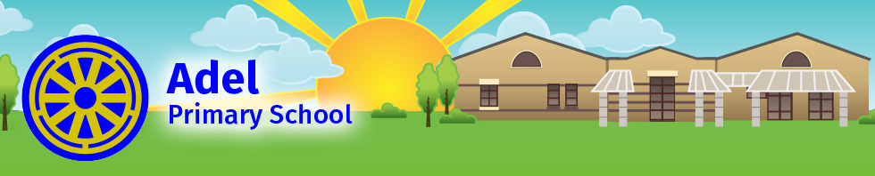

Headteacher Application Pack
May-June 2018

Contents
- Letter from our Chair of Governors
- Letter from our School Council
- About Adel Primary School and its surrounding area
- Aim of our School
- Key Information
- Selection Process

Please ensure that you have also downloaded the following documents:
- Job Description
- Person Specification
- Application Form

Letter from our Chair of Governors

Dear Applicant
On behalf of the Governing Body I am writing to thank you for
your interest in the position of Headteacher at Adel Primary School.
We hope you find the enclosed information useful.

Our current Headteacher has led a dedicated, talented and committed school staff which secured a ‘Good’ Ofsted report for the school in January 2017. With the current post holder moving on to new opportunities the Governors are seeking to appoint a Headteacher with vision and energy who can embrace and build on our many successes and achievements.

Adel Primary School’s aim is ‘For every child to thrive in our safe
and caring environment and enjoy a stimulating learning journey’
and our teaching and support staff show great care, determination and commitment to its pupils and the community we serve. Our teaching and support staff is a vibrant balance of experience and innovation with recent recruits working alongside staff of many years service. The children are a delight, with excellent behaviour and conduct and I continue to be impressed with their confidence, love of learning and their engagement in all the school has to offer. We have a supportive Governing Body and an active Parent Association known as “APPA”.

I hope you will enjoy reading the information in this pack and on
our website http://www.adelprimary.org.uk and it makes you feel
that you’d like to be part of our wonderful school community.

Once again, thank you for your interest in Adel Primary School.
I look forward to meeting with those candidates invited for interview.

Yours Sincerely

Debra Gardner
Chair of Governors

Dear Future Headteacher,

As you know our Headteacher is leaving and we are looking for another fabulous person to lead our school.

At Adel Primary School we have lot of kind and caring people and we are proud to be pupils here. In this letter we would like to tell you what we like about our school and what we want our new Headteacher to be.

The teachers make subjects fun and exciting and they also give us challenges which we exceed in completing. They help and listen to our ideas and also if we have a problem they will try to sort it out straight away. They encourage us to be Effective Adel Learners so that we can be the best we can.

We love going on educational and residential visits to fun and exciting places with our class mates. Our friends at Adel make us happy and we respect and are kind to everyone so we all feel safe and have someone to play with at playtime.

We have a Celebration Assembly every Friday and all the teachers give out Star Pupil Awards (a certificate for when you’ve succeeded in a particular area)!

We really like Mrs Parkinson, our present Headteacher, because she is only strict when she needs to be. We like that she is interactive and involved with us, by saying hello in the morning and coming outside at playtimes. She helps make Adel a happy place and has organised for us to have a trim trail built to make playtimes more exciting.

We would like our new Headteacher to keep all the good things we have but bring new ideas as well. We think it is important that you are polite, kind and caring and also interactive, as we don’t want you to stay in your office all the time.

If you would like to be our new Headteacher we hope you will keep our school a happy and fun place to come. We are all looking forward to meeting and welcoming you when you visit.

Yours faithfully,

The School Council

About Adel Primary School
and its surrounding area

Adel Primary School is located in Adel, Leeds and falls under the local authority of Leeds. We are a one-form entry school which opened in 1992, and currently have 250 pupils aged 3-11 years on role.

We also run our own very successful Out of School Club, offering places before and after school to our pupils.

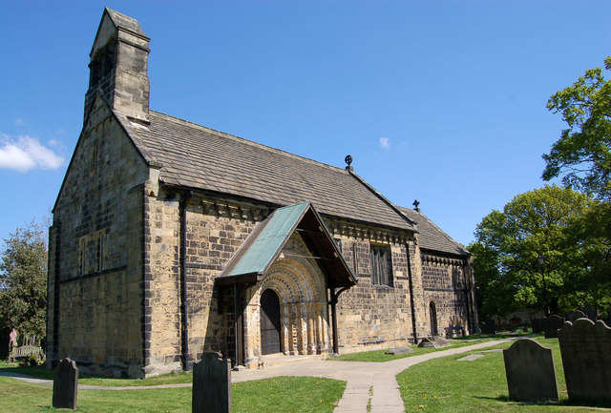
Adel is a mainly residential area in the North of Leeds. It is situated between Cookridge, Holt Park, Weetwood and Alwoodley and has a distinctive countryside feel. Adel has two primary schools, Adel Primary School and St John the Baptist Primary School.

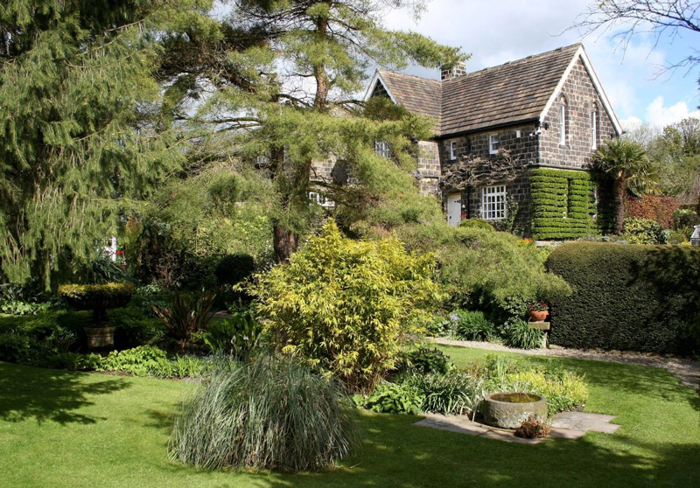
Close to Adel Church is York Gate, an old farmhouse with a landscaped garden and a pavement maze in the driveway. The gardens are open to the public on regular occasions.

Also close to the church is the Adel Memorial Hall and sports ground. The hall is home to a number of thriving Sports groups including the Bowmen of Adel and also Adel Players, an amateur dramatics group that puts on three productions a year. Adel is also home to Headingley Golf club, the oldest golf club in Leeds; Adel Methodist Church and Adel Quaker Meeting House, dating from 1868.

For inspiring experiences, Leeds won't disappoint, with impressive historical ruins, glorious art displays and an extensive programme at the city's many theatres. Leeds also boasts the internationally acclaimed Opera North and Northern Ballet, the UKs only opera and ballet companies outside London.

Venture slightly further afield and you will be able to visit Harewood House, Harrogate, York and the delights of the Yorkshire Dales.

AIM OF OUR SCHOOL

‘For every child to thrive in our safe and caring environment and enjoy a stimulating learning journey.’

OBJECTIVES TO ACHIEVE OUR AIM:

- To encourage children to develop independence, showing
responsibility and respect.

- To support children’s ability to work together successfully.

- To celebrate and respect diversity, and promote global citizenship.

- To work together with families, Governors and the local community.

- To equip children with the skills, knowledge and confidence to keep themselves safe.

- To constantly have high expectations for all children in all that they do.

- To provide a secure environment where children can explore,
question, make mistakes and develop perseverance.

Key Information (2016/17)
Age range |  | 3 – 11 years
School Group Size |  | 2
Co-educational or single sex |  | Co-educational
Location |  | Tile Lane, Adel, Leeds  LS16 8DY
Type of school |  | Community School
Management structure |  | Headteacher, Deputy Head, Assistant Head
Number of Teaching Staff |  | 13
Number of children on roll |  | 230
Average class size |  | 30
Attendance 2016-17 |  | 96.8%
% of pupils on FSM  (past 6 years) |  | 11%
% of pupils SEN support |  | 8%
% of pupils SEN statement/  EHC plan |  | 1.6%
% of pupils EAL |  | 14%
Key Stage 1 Results 2017 |  | % at ARE | % Greater Depth
 | Reading | 83 | 43.3
 | Writing | 77 | 30
 | Maths | 83 | 30
Key Stage 2  Results 2017 |  | % at ARE | % Greater Depth
 | Reading | 83 | 37
 | Writing | 87 | 30
 | Maths | 90 | 53
 | SPAG | 90 | 60

Selection Process
School Visit
We would expect applicants to make a school visit and we have scheduled Monday 21st May 2018 at 12 noon to 1.30pm or 2.00pm to 3.30pm and Tuesday 22nd May 2018 at 9.30 to 11.00am or 11.30am to 1.00pm for this.
Please contact our School Business Manager Laura Haigh to confirm which session you would like to attend on 0113 230 1116 or by email at l.haigh@adelprimary.org.uk.

Application Process
Please complete the application form with supporting information, detailing your personal qualities and unique attributes that will set you apart as the exceptional leader we are looking for. This should relate to the person specification and job description detailed in the application pack.

Application Closing Date
12.00 noon on Friday 8th June 2018.
Email applications (including all relevant attachments and enclosures) should be sent to l.haigh@adelprimary.org.uk.
Short listed applicants will be invited to attend interviews by 20th June 2018. If you have not heard from us by this time, your application has not been successful on this occasion.

Safeguarding
We are committed to safeguarding and promoting the welfare of children and young people and expect all staff and volunteers to share this commitment. This post is subject to an enhanced Disclosure and Barring Service (DBS) check. Reference checks will be performed prior to interview.

Interviews
Interviews will take place over two days on 25th and 26th June 2018.
All shortlisted candidates will be invited to interview on the first day,
with candidates who impress the interviewing panel being invited back for a second day.

Please confirm your availability to attend both days of interview in your application.

Appointment Timescales
The school intends to appoint our new Headteacher on 26th June 2018 to start 01 January 2019.

Pay Scale
The school is in Group 2 and the pay scale for this post is L15 to L21.

Contact Information
Adel Primary School, Tile Lane, Adel, Leeds LS16 8DY
Tel: 0113 230 1116
Email: l.haigh@adelprimary.org.uk

