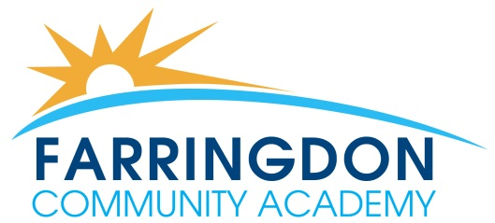

Academy Information

Farringdon Community Academy is a mixed 11 – 16 Academy which serves the communities in the South of the city. We are dedicated to improving the lives of young people within our community.

Our Vision

All students, irrespective of background, acquire the skills for life, take pride in what they do, who they are, and in their community, and become confident, respectable and upstanding citizens.

Our Values

- Respect
- Resilience
- Endeavour
- High aspirations and attainment
- High standards and expectations

Our Academy community is founded on the key values of respect, resilience, endeavour, high aspirations and attainment, high standards and expectations. These values permeate all aspects of Academy life and apply in equal measure to staff, students and governors.

We are an inclusive Academy which recognises the equality of each individual and their right to thrive within our community and we will support all our students through an inspiring curriculum which meets the needs of all.

It is an exciting time to be joining our school as we embark on our journey to outstanding. Whether you are applying to join our fantastic teaching team or our wonderful support team, you are becoming part of a community in which all people and their skills are valued.

You can find out more about our school by looking at our website (www.farringdonschool.co.uk) and reading the latest edition of our award-winning student newspaper The “Farra News”. You can also follow us on Twitter (@Farra School) and Facebook (@Farringdonca).

