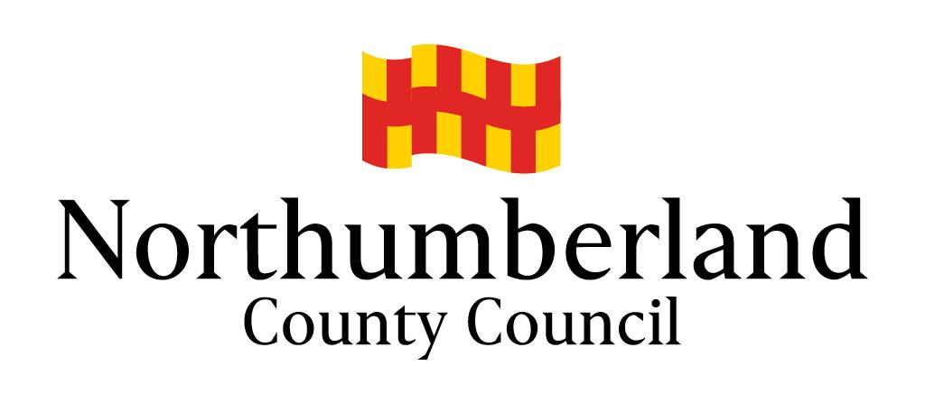
Holy Trinity CE First School

Headship application pack – Contents
- Letter from Chair of Governors

- School Information

- Guide for applicants

- Job Description and Person Specification

- Working and Living in Northumberland

- Working Together to Support Schools and Parishes

- Schools and Consultation with the Boards of Education

- Church Schools in the Newcastle Diocese Historical Perspective

- The Berwick partnership of schools

- Equality in Employment Policy

- Criminal Records Policy

- Immigration, Asylum and Nationality Act 2006

- Application Form

- Criminal Records Declaration Form

- Childcare Disqualification Form

