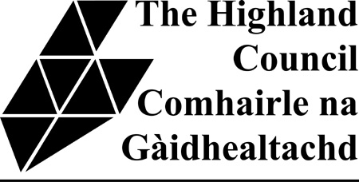

PRIMARY
Principal Teacher, Isle of Muck Primary School
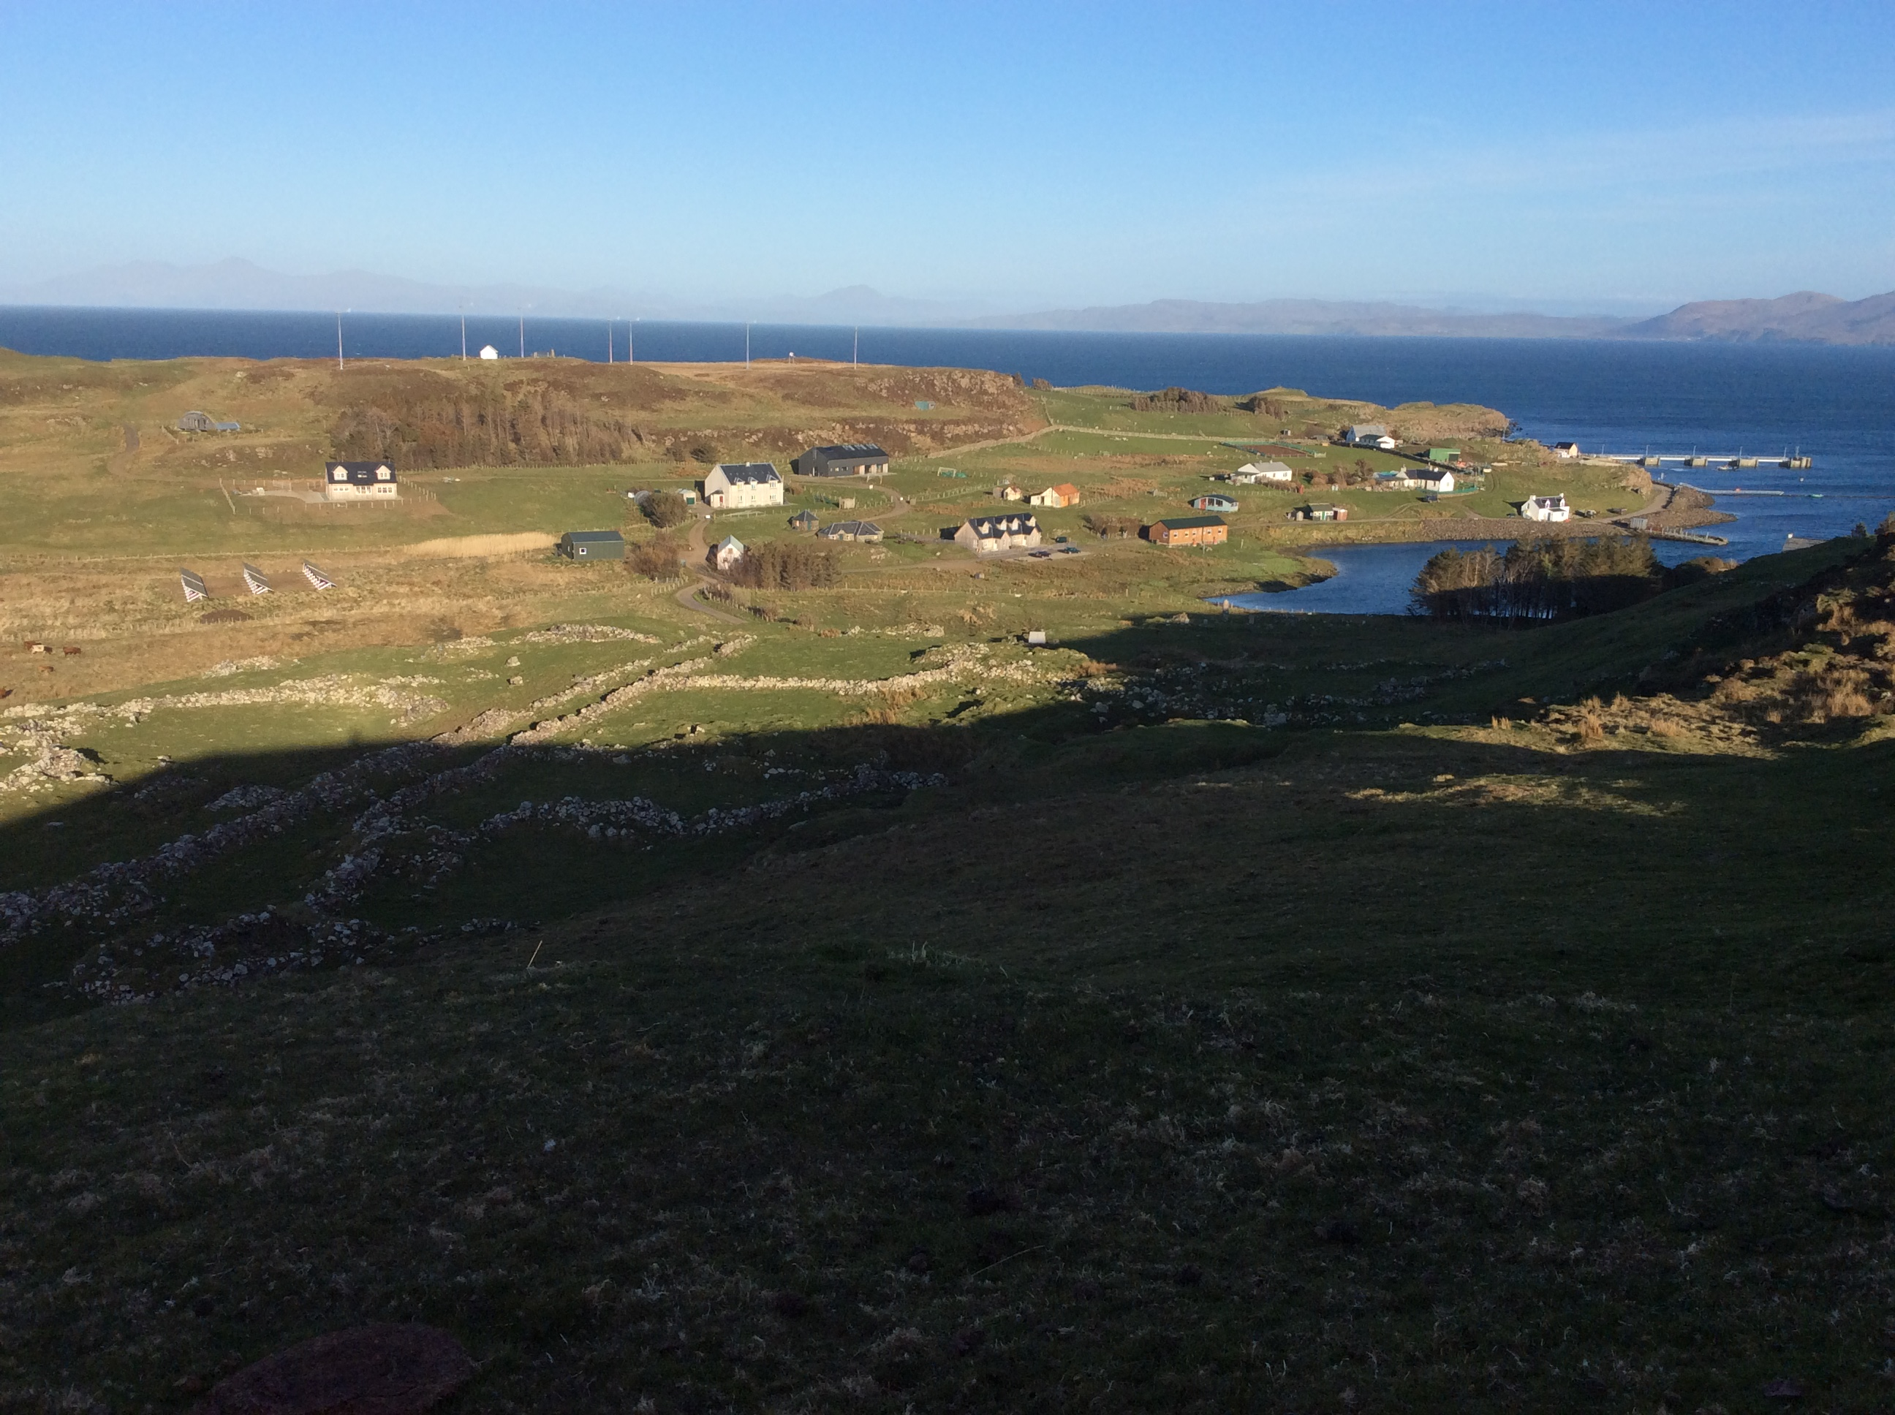

Muck is the smallest of the Small Isles, a group of islands situated to the south of Skye on the west coast of Scotland in one of the most remote and beautiful parts of the UK. It has a small but thriving population of around 40.

Electricity is supplied by the island’s recently-installed renewable energy scheme, based on wind and solar power. Internet access is through a fast and reliable broadband service, provided by a community interest company based in the Small Isles. The GP practice is based on the Isle of Skye, and a GP visits the island fortnightly for routine consultations. A Community Nurse is also based on the island, as well as a First Responder team in case of emergencies.

The island is ideal for nature lovers with many species of birds, including corncrakes and puffins and other resident animals such as otters and seals. Muck enjoys stunning views of the mainland and the other Small Isles as well as Skye and the Outer Hebrides.

The community is renowned for its hospitality, and puts on many events during the year in the Community Hall. Recently, residents and visitors have enjoyed performances from a travelling theatre group, traditional and modern musicians, art exhibitions and sporting activities and, of course, several ceilidhs. Visiting specialists occasionally provide workshops for the benefit of the children. The primary school is an important focus for the people of Muck and is central to community life on the island.

Muck Primary School is situated near the ferry terminal on the Isle of Muck in a building that replaced the old school in 1993. The school has a light, airy classroom, with the nursery sharing the space. There is an art room/library, kitchen, school office and a very popular outdoor classroom. The anticipated roll for August 2018 is 9, with 6 pupils in the Primary 1-7 class (current range from P2 – P5), and 3 nursery pupils.

To view the Muck Primary School blog, please go to https://muckprimaryschool.wordpress.com/
For more information on Muck, go to www.isleofmuck.com/

Parents are willing volunteers in the school’s activities, putting on several events each year in partnership with the school and keenly supporting the children’s day-to-day learning.

We are seeking a dynamic and committed Primary Teacher who is fully registered with the General Teaching Council for Scotland for this wonderful professional opportunity. Whilst experience in a promoted post is desirable, this is not essential.

A school flat is provided for rental, with views of Ardnamurchan. The flat has 3 bedrooms, a kitchen, sitting room and bathroom, and is located above the School. The flat is in good order throughout, and has double glazing and central heating. Most windows within the flat have been replaced during 2018.

The salary for the post is £41, 418, plus Higher Rate Remote Allowance, currently £2635 per annum, and Distant Islands Allowance, currently £2094 per annum. The schools are managed by a Head Teacher. The duties required of the Principal Teacher can be found in the Job Specification document.

Further information may be obtained from Andrew Murray, Head Teacher (Tel No. 01687 482424) or Don Esson, Quality Improvement Manager (Tel No. 01478 613697)

Application can be made online at https://www.myjobscotland.gov.uk/home/

Applications from Gaelic Speakers are encouraged.

Prior to confirming appointment, we will require successful candidates to become members of the Protecting Vulnerable Groups (PVG) Scheme

The council has a comprehensive relocation package which may be available to the successful candidate. 

