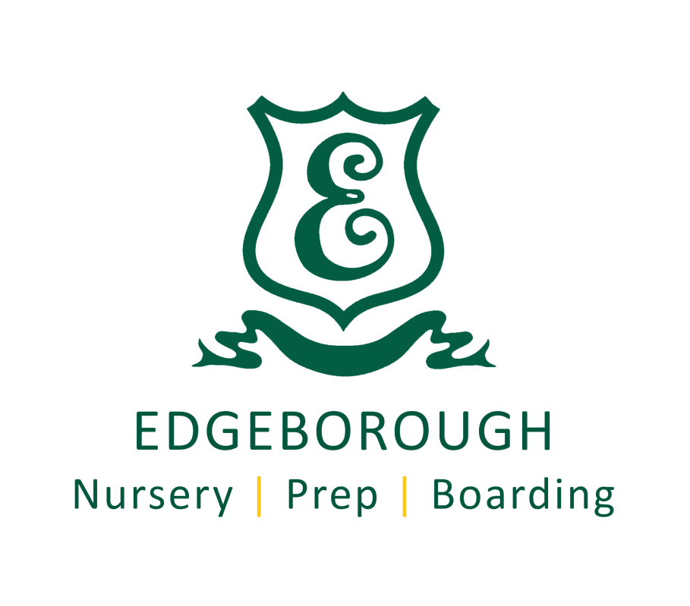

Edgeborough

Application Details for the post of:

Head of Early Years

Start Date: Jan 2019

General Information:

Edgeborough Preparatory School

Edgeborough School, Frensham, Farnham, Surrey, GU10 3AH

Contact: Mrs Gill Dixon, Head’s PA.
Email: gillian.dixon@edgeborough.co.uk
Web site www.edgeborough.co.uk
Tel 01252 792495
Head: Mr Daniel J W Thornburn

Pupils: 318 boys and girls

Edgeborough is a Charitable Trust established for Educational purposes.

The Application Procedure

The closing date for applications is: 22/06/18

Interviews will take place in the weeks commencing: 25/06/18 or 02/07/18

On the day of Interview candidates will be given the opportunity to:

- Lead an activity or session in the Nursery.
- Discuss the post with the Headmaster and Interim Head of Nursery.
- See around the school.
- Meet other staff.

Why Teach at Edgeborough?

Edgeborough is one of Surrey’s top prep schools and is a fantastic environment in which to work. The staff room is a warm, friendly and vibrant place with everyone pulling together in their quest to keep Edgeborough right at the forefront of prep school education in the UK.

There are approximately 320 children aged 2 – 13, the huge majority of whom go on to some of the country’s leading independent senior schools. These include Wellington, Charterhouse, Canford, Cranleigh, Bradfield College, RGS Guildford, Winchester, St Swithun’s, St Catherine’s Bramley, Guildford High School, Lord Wandsworth College, Radley, Marlborough and Eton. Most of the pupils make excellent use of the school’s weekly and flexi boarding facilities.

The school is extremely well resourced both in terms of buildings and equipment. Facilities include Sports Hall; Theatre; Music, Art, CDT and Dance studios; state of the art Science and ICT facilities; Swimming Pool; outstanding Playing Fields and a large Astro-turf.

The school is set in 50 acres of wonderful, rolling Surrey countryside in Frensham near Farnham.
Pupils are very well behaved, courteous and supportive of the school’s Christian ethos.
Any new member of staff will be joining an exceptionally strong and well organised team of teaching and non-teaching staff.

Opportunities
- The Edgeborough scale for remuneration of its teachers is generous and above the national scale.
- Children of teachers who fulfil all other usual entry requirements and to whom places are offered can be educated at reduced fees. This reduction is means tested and can be up to a maximum of 75%.
- The school enjoys outstanding facilities and is very well resourced.
- Small classes of well-behaved children with supportive parents.
- All staff have the opportunity (and indeed are required!) to continue with their professional development while at Edgeborough.
- Opportunities to take part in sporting and extracurricular trips.
- Lunch is provided free of charge when duties are performed, as is tea and coffee.

The Nursery at Edgeborough

The Nursery is an integral part of the school, sharing the beautiful grounds whilst situated in its own exclusive house and gardens. The Nursery is very well equipped and has a large and safe garden for outdoor play, the use of a hall for drama, music and dance and spacious classrooms.

The Nursery provides a secure and relaxed environment for children to begin their school life. We place an emphasis on a happy family atmosphere which fosters all-round development and a balanced education of a high standard.

Children usually join the Nursery from the age of two and then move on to Reception in the September after their 4th birthday.

Job Title: Head of Early Years (EYFS)

Responsible to: The Head / Deputy Head Academic
Permanent / Temporary Permanent – There is one year probationary period.
Part time or Full time Full Time 0800-1800 Monday-Friday, during term time.

The Head of Early Years, being a managerial position in the school, should be prepared to work as appropriate outside normal school hours in order to successfully fulfil the requirements of the role.

All staff attend INSET Training days and a small number of special school events e.g. parents evenings/open days etc.
Remuneration
On Edgeborough Scale (See above). The appointee will be placed on the scale according to experience and qualifications.

Main Responsibilities:
General outline:
The Head of Early Years will work in partnership with the Head, the Edgeborough Leadership Team (ELT) and the Head of Years 1 & 2 to ensure the highest quality education and achievement for all of its pupils in the EYFS.

The main responsibilities for this post are:

- To lead and develop outstanding practice in EYFS

- To support, develop and coach teaching and learning across the EYFS

- To lead and co-ordinate assessment across EYFS, maximising pupil and parental engagement

The Head of Early Years will also have key accountabilities for:

- Knowledge and understanding of

  - What constitutes exceptional quality in EYFS educational provision, the characteristics of effective Early Years settings and strategies for raising young pupils’ achievement.

  - How to promote pupils’ spiritual, moral, social and cultural development and good behaviour through effective management and leadership.

- Strategic leadership

  - Help develop a highly effective school with a positive, “can do” culture.

  - Maintain an ethos and provide educational vision and direction to secure effective teaching, successful learning and achievement by pupils in the Early Years.

  - Present a coherent and accurate account of pupil performance and other Early Years self-evaluation evidence in a form appropriate to a range of audiences including governors, Ofsted, the ISI and others to enable them to play their part effectively.

- Planning and setting expectations

  - Assist the Head and ELT in leading and managing the creation and implementation of an EYFS strategic plan with particular emphasis on improving the quality of teaching by identifying priorities and targets to ensure pupils achieve high standards.

- Teaching and planning pupil learning

  - Work in partnership with the ELT to ensure the implementation of a climate and code of conduct to promote and secure outstanding teaching, effective learning, exceptional standards of achievement, good behaviour and discipline throughout the EYFS.

  - Work in partnership with the ELT to monitor and evaluate the quality of teaching and standards of learning and achievement of pupils in EYFS, including those with special education or linguistic needs, in order to set and meet challenging, realistic targets for improvement.

- Assessment and evaluation in EYFS

  - To work with the ELT to monitor, evaluate and review the effects of policies, priorities and targets of the school in practice and take action as necessary.

  - To contribute to the EYFS Self Evaluation Form.

  - Work with other lead professionals to ensure pupils’ prior attainment data is captured using appropriate information technology resources and apply comparative data to establish benchmarks and set targets for improvement.

- Relationship with parents and the wider community

  - To support families with the induction and wellbeing of their child when they arrive in Early Years.

  - Ensure parents are well informed about their child’s attainment and progress.

  - To develop an effective partnership with parents and help them understand how they can support their child’s learning and personal development.

  - Develop effective relationships with the community, especially other local providers, to extend the curriculum and to enhance teaching and learning.

- Managing and developing staff and other adults

    - Maximise the contribution of EYFS staff to improve the quality of education provided and standards achieved and ensure that constructive working relationships are formed between staff and pupils.

    - Lead professional development of staff through example, creating a strong team.

    - Support the provision of high quality professional development by methods such as coaching and drawing on other sources of expertise where appropriate.

    - Mentor trainee and newly qualified teachers and support the induction of any new staff in EYFS.

- Managing resources

    - Manage, monitor and review the range, quality and quantity of all available resources in order to improve pupils’ achievements, ensure efficiency and secure value for money.

- Managing personal performance and development

    - Participate in arrangements for appraisals and take responsibility for personal professional development.
    - Prioritise and manage own time effectively.

    - Work under pressure and to deadlines.

    - Sustain their personal motivation and that of other staff in the EYFS.

- Other duties and responsibilities

  - To ensure the safeguarding of pupils.

  - Other duties the Head may from time to time ask the post holder to perform.
  - Take on specific tasks related to the day to day administration and organisation of the school.
  - Participate fully in the wider life of the school.

Other Information:
Disclosure type – Enhanced
Note: This Job Description covers the main duties and responsibilities of the job. The appointee may be asked to carry out other activities commensurate with this Job Description from time to time.

Date Job Description reviewed: | June 2018
Line Manager Name: | Daniel Thornburn, Head of Edgeborough

Edgeborough School

Person Specification

Job Title: Head of Early Years

 |  |  | Assessment
Experience | - Experience of working with children of relevant age in a learning environment.  - Experience of assisting with the assessment, recording and reporting of pupils’ progress.  - Experience of working with and enjoying some element of responsibility in a team. |  | Application Form / Interview
Skills and Abilities | - The desire and capability to be both an outstanding teacher and manager.  - An understanding of young children.  - Enthusiasm.  - A willingness to become a part of the school community – some activities may take place outside school hours.  - Abilities to perform tasks outlined in the job description.  - Can use ICT effectively to support learning and methods of working.  - A confident and effective communicator.  - Good understanding of child development, learning processes and factors that affect how pupils learn.  - Ability to relate well to children and adults, and to build positive working relationships.  - Work constructively as part of a team, understanding classroom roles and responsibilities and your own position within these.  - Confidence and competence when managing the learning and behaviour of an individual, a small or large group, or whole class.  - Ability to develop high quality learning resources.  - Have a working knowledge of (or the desire to gain such knowledge of) relevant policies / codes of practice / legislation.  - Knowledge of strategies and principles of inclusion.  - Willingness to work in support of the ethos of the school. |  | Application Form / Interview
Qualifications and Training | - Demonstrable and strong working knowledge of Statutory framework for the Early Years Foundation Stage  - Relevant teaching qualification – Degree, QTS, Early Years Professional Status, EYFS Teacher Status or other suitable Early Years qualification at Level 6 or above. |  | Application Form / Interview
Other Factors | - Commitment to working with young people.  - Desire to improve own practice / knowledge through self-evaluation and learning from others.  - Police check |  | Interview  DBS / Police Check
Date Person Specification reviewed: |  | June 2018
Line Manager Name: |  | Daniel Thornburn, Head of Edgeborough

Edgeborough School is committed to safeguarding and promoting the welfare of children and young people. Applicants must be willing to undergo child protection screening, including checks with past employers and the Disclosure and Barring Service.

