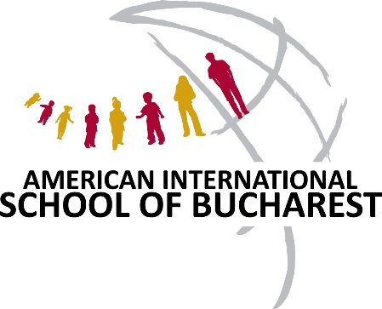
The American International School of Bucharest, Romania
Seeks a PYP Elementary Teacher
Commencing August 2018

Experienced PYP teacher is needed for the Elementary School
Successful candidate will have:
• A Recognized teaching qualification
• PYP experience and training
• Prior experience using the reader’s and writer’s workshop
• An ability to successfully balance the written curriculum and student agency
• Strong collaborative skills
• Experience with elementary age students
• Ability to differentiate teaching and effectively integrate technology
• Experience in a multi-cultural setting
• Mother tongue English or an equivalent level of fluency is required.

TERMS OF EMPLOYMENT & CONTRACT
- This position receives a highly competitive, tax-free salary and comprehensive benefits package; the initial appointment will be for a two-year period, to be renewed annually thereafter.

APPLICATION
All applicants should submit a letter of application addressed to the Director, Dr. Robert Brindley, a current résumé, two testimonials, and at least two confidential referees on our school online job application form.
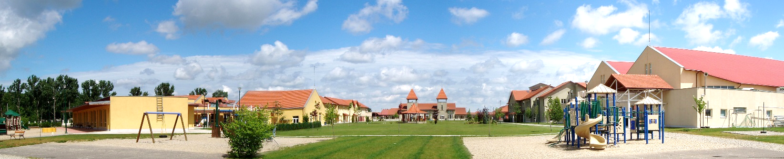
The school reserves the right to appoint an applicant at any stage if a highly qualified person applies.

The School
AISB was founded in 1962 by the American Embassy to serve the children of Diplomats living in Bucharest at the time. From its humble beginnings, teaching only six students in a garage, AISB’s growth over the last 55 years has been extraordinary. We now have over 250 faculty and staff members who provide an excellent international education to 950 students in Early Childhood 2 through Grade 12. With 60 nationalities represented, we host a wonderfully rich and diverse community on our ten-hectare, purpose-built campus with state-of-the-art facilities. AISB maintains a comprehensive website, containing numerous documents and reports, which potential applicants will find useful at http://www.aisb.ro/.

Campus and Facilities
Our campus covers ten hectares (about 27 acres), and offers state of the art facilities to our students, including a performing arts theater/auditorium, library & media center, three computer labs, cafeteria, gymnasiums and extensive sports facilities. The campus is located in the Baneasa forest area, approximately 10 km from the center of Bucharest and 13 km from the Henri Coanda International Airport.

Curriculum and Accreditation
AISB is accredited by the New England Association of Schools and Colleges (NEASC) and the Council of International Schools (CIS) for grades EC2-12, and is authorized by the International Baccalaureate (IB) organization to offer the IB Primary Years, Middle Years and Diploma Programmes. AISB is a member of Central and Eastern European Schools Association (CEESA), based in Warsaw, Poland; College Board, the Educational Records Bureau (ERB); and Council of Support and Advancement of Education (CASE). AISB is affiliated with and receives grant support from the U.S. Department of State's Office of Overseas Schools (A/SO), Washington, D.C. AISB is also recognized by the Romanian Ministry of Education.

Faculty
AISB is committed to high standards of achievement, as exemplified by a highly qualified faculty who have continuous access to current instructional materials and teaching strategies. AISB faculty and staff come from a multitude of countries including USA, Canada, New Zealand, Australia, UK, France, Spain, Romania and Ireland; the school actively supports and encourages the professional growth of its faculty and staff. Teachers enjoy an excellent benefits package and savings potential. Bucharest is a safe and interesting place to live with a fascinating history and cultural heritage. Most faculty tend to stay for multiple contracts.

The Student Body
AISB has a richly diversified population of approximately 830 students, with 56 nationalities attending the school from Early Childhood 2 through Grade 12. Romanians comprise approximately 30% of the student population, North Americans 16%, Israelis 11%, Germans and Koreans 6% each, British 4% and the remainder from Europe, Asia, Africa, Middle East, Australia, and South and Central America. The average class size is twenty students.

Active Parental Support
The AISB community enjoys the support of a very enthusiastic and hands-on Parent and Teacher Organization that supports the education of AISB students by fostering relationships among the school, parents, and teachers, activities and communication between different parts of our community. The PTO organizes and participates in numerous events during the year, such as the Harvest Festival, Festival of Lights, International Festival, Auction Gala, and Terry Fox Run, among others, as well as creating links between the parent community and the school.

The School Board of Trustees
The Board of Trustees is the governing body of the school. It exists to ensure that our students receive the best education, that our teachers have all the resources to teach and benefit from a constructive working environment, and that the school budget is well funded to support our Mission, Vision and Values. The AISB Board of Trustees has ten voting members. The Chair is appointed by the American Ambassador from among the senior officers of the US Embassy. The Board generally meets once a month to oversee and ensure school governance, school policy and to set strategic direction.

The Country and City
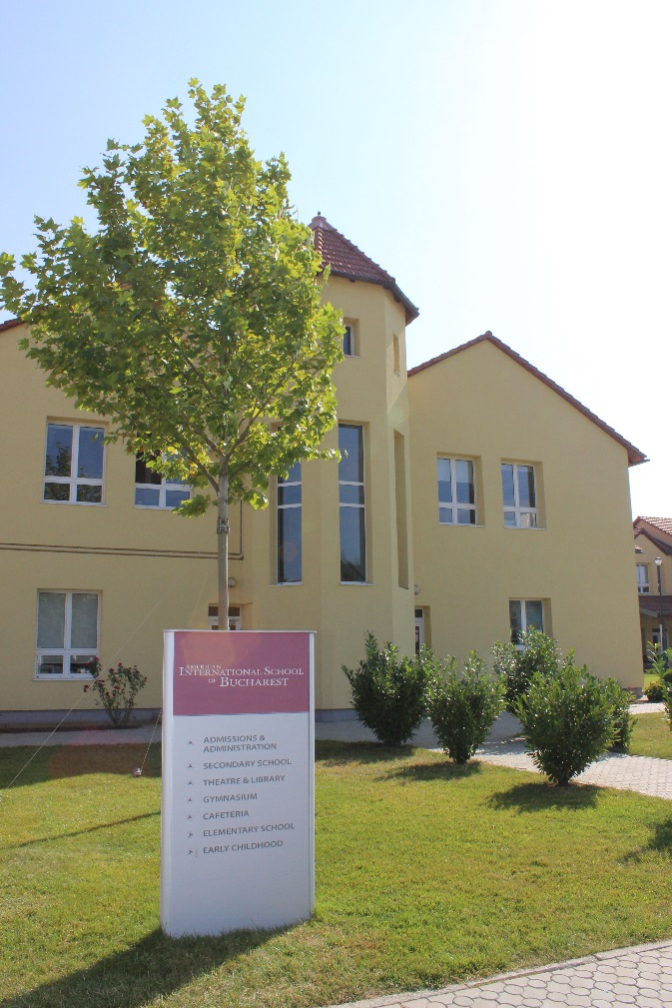
Location: (Southeastern) Central Europe
Time Zone: Seven hours ahead of U.S. Eastern Standard Time (GMT + 2)
Area: 92,043 sq. miles (238,391 sq. km) - a little larger than the state of Minnesota
Population: 19,942,000 (March 2014)
Largest cities: Bucharest (1,883,400), Cluj Napoca (324,600), Timisoara (319,300), Iasi (290,400), Constanta (283,900), Craiova (269,500), Brasov (253,200), Galati (249,400), Ploiesti (2209,900), Oradea (196,400). Romania's population lives in 320 cities and towns and 12,956 villages.
Main Ethnic Groups: Romanian 84%, Hungarian 6.1%, Roma 3.1%,German 0.2%, Ukrainian 0.2%
Religions: Christian Orthodox 81%, Roman Catholic 4.3%,
Official Language: Romanian
Currency: Leu (RON) (plural Lei)
Capital: Bucharest (București)

Romania is situated in the southeastern part of Central Europe and shares borders with Hungary to the northwest, Serbia to the southwest, Bulgaria to the south, the Black Sea to the southeast, Ukraine to the east and to the north, and the Republic of Moldova to the east. Roughly the size of Oregon, Romania is the second largest country in the area, after Poland. Bucharest — the capital city of Romania — is located at the same latitude with the cities of Portland - Oregon; Montreal - Canada; Venice - Italy; and Bordeaux - France. Romania's territory features splendid mountains, beautiful rolling hills, fertile plains and numerous rivers and lakes. The Carpathian Mountains traverse the center of the country bordered on both sides by foothills and finally the great plains of the outer rim. Forests cover over one quarter of the country and the fauna is one of the richest in Europe including bears, deer, lynx, chamois and wolves. The legendary Danube River ends its eight-country journey at the Black Sea, after forming one of the largest and most bio-diverse wetlands in the world, the Danube Delta. About a third of the country consists of the Carpathian Mountains (also known as the Transylvanian Alps). Another third is hills and plateaus, rich with orchards and vineyards. The final third is a fertile plain, largely devoted to agriculture.

Climate
Because of its position on the southeastern portion of the European continent, Romania has a climate which ranges from temperate to continental. The average annual temperature is 11 °C (51.8 °F) in the south and middle-south and 8 °C (46.4 °F) in northeast. In Bucharest, the temperature ranges from average low −5 °C (23 °F) in January to average high 29 °C (84.2 °F) in July and August, with average temperatures of −3 °C (26.6 °F) in January and 23 °C (73.4 °F) in July and August. Spring is pleasant with cool mornings and nights and warm days. Summer is quite warm, with extended sunny days. The hottest areas in summer are the lowlands in southern and eastern Romania where 37.7 °C (100 °F) is often reached in July and August. Temperatures are always cooler in the mountains. Autumn is dry and cool, with fields and trees producing colorful foliage, much like New England. Winters can be cold, especially in the mountains. While not the rule, abundant snowfalls may occur throughout the country, from December to mid-March.

