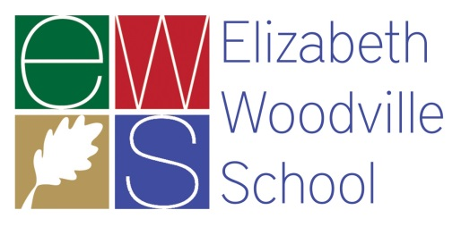
ENGLISH TEACHER

Come and join our forward looking, student-focused, energetic team – we work hard, but we work smart and we always work together. We are well resourced, with a wealth of material prepared in-house for the new specifications, and we are always looking to improve and ‘raise the bar’. We need you to help us move forward with your drive, attention to detail, and contagious love of English which makes your lessons the highlight of every students day.

We believe that all staff and pupils should be treated with respect and have built a culture based on respect for each other, resilience to meet new challenges and take responsibility for our actions and our learning.

There are new and exciting challenges daily in education, and as an English specialist you will be acutely aware of this. In English at EWS, students are challenged from the beginning of Year 7 to work with, and gain inspiration from, a wide range of the world’s most enduring texts, and we keep this level of challenge high as our students - a vibrant and dynamic body of engaging young people – work with us towards their GCSEs and A Levels in English Language and English Literature.

Visits to the school are encouraged - to arrange a visit please contact Shazeen Robson, English Learning Leader at shazeen.robson@ewsacademy.org.uk
There are many attractive benefits to working at EWS, including:

* On-site parking
* Rural location
* On site Nursery
* Swimming pool/gym membership
* Dedicated NQT support including your own subject mentor, school NQT coach and reduced teaching timetable
* Joining the network of TOVE Learning Trust schools and the SWAN Teaching School Alliance, gaining access to local curriculum networks along with a wide range of opportunities for continued professional development at all levels.

Rated as a good school by Ofsted in May 2014, Elizabeth Woodville School is a high-achieving comprehensive school across two sites serving many villages and the fringes of both Northampton and Milton Keynes. EWS joined Tove Learning Trust in 2016, whose vision is to ensure all pupils are provided with outstanding educational experiences that lead to outstanding outcomes. The school is ambitious and well managed with an inspiring learning environment for both students and staff.

Closing date: 19 March 2018 – midday - Please submit a supporting statement along with your application form (No CV’s).

The governors of Elizabeth Woodville School and the Trustees of Tove Learning Trust are committed to safeguarding and promoting the welfare of children, young people and vulnerable adults and expect all staff and volunteers to share this commitment. Successful candidates must be willing to undergo Enhanced DBS and other checks appropriate to the post. Tove Learning Trust is an equal opportunities employer.

