The British School in Colombo

APPOINTMENT OF DEPUTY HEAD (Academic) - SENIOR SCHOOL
With effect from January 2019

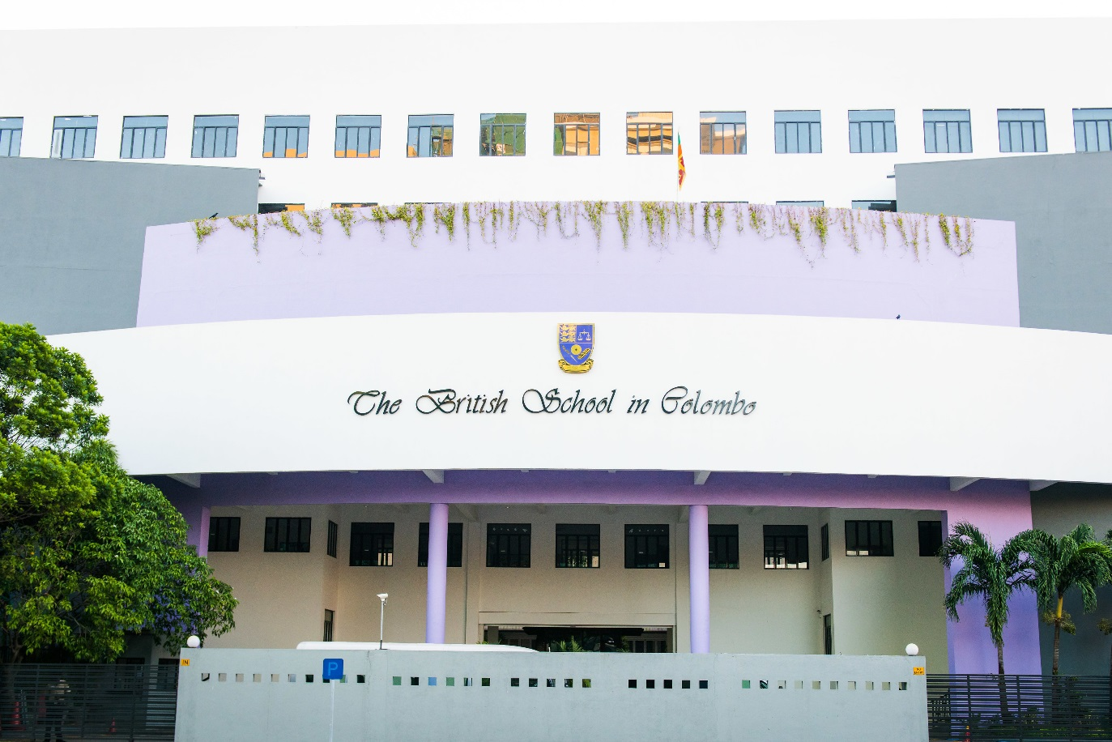

Welcome from the Principal
Dr John Scarth

Dear Colleagues,

The British School in Colombo is one of the leading British schools in the subcontinent and has an enviable reputation for providing high quality education in a caring, nurturing environment. We are now seeking an outstanding educationalist to lead our Senior section of the school. The current Deputy Principal (Head of Senior School) has been with the school for 15 years and is now assuming the role of Director of Alumni Relations.

Sri Lanka has come out of a period of conflict and the sense of optimism in the country is reflected in the school. We are excited about our future and this will be an exciting place to work and develop professionally in the coming years. There will be challenge and rewards here for teachers at all stages of their careers.

We realize that school leaders will apply to BSC for a number of possible reasons. However, what is the case is that successful teachers here usually have a number of things in common. First and foremost, they are enthusiastic and flexible. People need to be willing to rise to a challenge of adapting both culturally and socially to a new and very different environment. Of course, Colombo provides a wonderful base from which to explore and travel both Sri Lanka and the wonderful richness of south and east Asia. However, successful teachers also recognize that the school provides an outstanding opportunity for them to develop professionally through not only their own work but by helping others to develop professionally too.

Education is vitally important in Sri Lanka and therefore, school leaders are held in very high esteem. Within our community, it is vital to be enthusiastic about teaching and learning and to recognize that successful teaching is a collaborative activity.

Successful expatriate staff at BSC appreciate that the school is an independent, fee-paying school and parents take a strong interest in the progress of their children. Anywhere in the world teaching is a difficult job: it is no different at BSC. We recognize that leading teaching at BSC is as demanding as it is rewarding. All colleagues need to go the extra mile, whether that it for academic work or for extra-curricular activities. Dedication and commitment are expected. The rewards are considerable: successful teachers enjoy teaching some of the most enthusiastic students anywhere, parents are extremely appreciative and respectful and school colleagues provide excellent companionship and support.

Colombo is a somewhat chaotic and busy city, with a hot and humid tropical climate. Nevertheless, it is a culturally and socially vibrant place, boasting a wide range of cuisine and it is a wonderful centre from which to explore the sub-continent and South East Asia.

Before applying to any international school it is important to think carefully about whether the environment is right for you: this is no different in Colombo. From having worked in a number of different international schools, I am certain that those who arrive in this wonderful city with their eyes open and a willingness to take full advantage of what Sri Lanka has to offer, will thoroughly enjoy their stay and, like many of my colleagues, will wish to remain in the area for much longer than an initial contract.

I recommend that you take a little time to read the Information for Candidates below and visit our website www.britishschool.lk.

We are also active on social media, so please take a look at our Facebook page: www.facebook.com/pg/BSColomboLK

Photographs of school life can be found on flickr: www.flickr.com/bscolombolk

And follow us on Twitter: @BSColomboLK

I look forward to hearing from you soon.

My best wishes,

Dr John Scarth
Principal

OVERVIEW

The British School in Colombo is an independent, co-educational day school which follows the National Curriculum for England. The school serves an international pupil body with some 53 different nationalities although the majority of children are of Sri Lankan origin. The school employs both local and expatriate teachers. There are currently 1400 pupils on roll with 650 in the Senior School.

The school is housed in modern, purpose-built accommodation with dedicated facilities for science, computer science, art, music drama and sport. All classrooms and offices are air-conditioned. The professionally equipped Auditorium is used for assemblies and productions throughout the year. The school has installed a robust wifi network with plans to introduce Bring Your Own Device (BYOD) from August 2019. The school is oversubscribed with waiting lists in most year groups.

Focussed on the principles of holistic education, child-centred excellence and inclusivity, the Senior School sets out to provide a broad educational experience in which all pupils are prepared for a successful and healthy future founded on mutual respect, self-discipline and a love of learning. It is a school where students can experience many opportunities and develop confidence in a challenging and inspirational environment.

The Deputy Principal (Head of Senior School) works closely with the Deputy Principal (Head of Junior School) to ensure continuity of learning, close co-operation between staff and the implementation of one school ethos.

ORGANISATION

Deputy Principal/Head of Senior School
Principal
Deputy Head
(Academic)

Deputy Head
(Pastoral)

Year Leaders and Key Stage Leaders
Heads of Department

Subject Teachers
Form Tutors

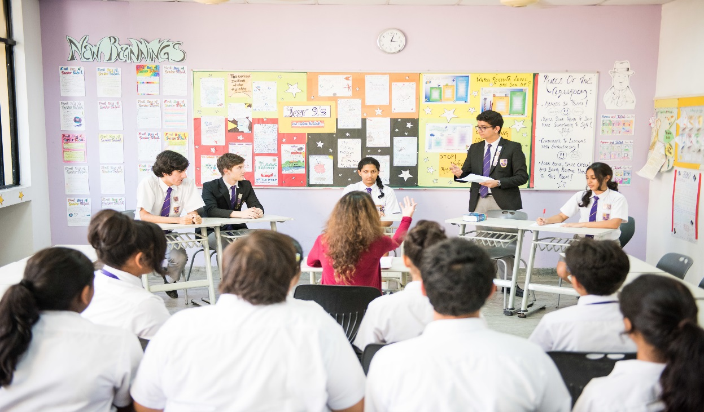

There are currently 75 full and part time academic, sports and learning support staff. There are 4 classes in each year group, with a maximum of 25 pupils in each class.

The Deputy Head (Academic) leads the heads of department and subject teachers whilst the Deputy Head (Pastoral) leads the Key Stage leaders, Year leaders and Form Tutors.

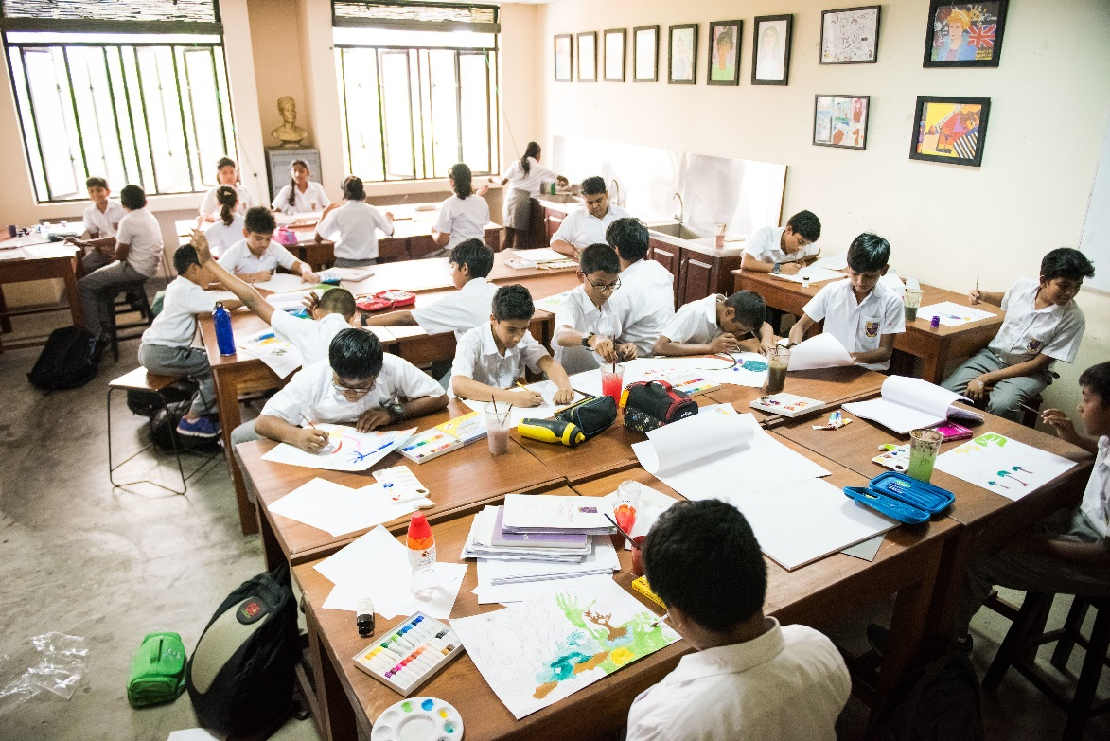
ACADEMIC STANDARDS

The National Curriculum for England is followed throughout the Senior School with adjustments to take account of our Sri Lankan setting and the international context.

The Deputy Head (Academic) tracks the progress of each child with termly reports to parents providing good information on progress and achievement.

Students are entered for Cambridge IGCSE and A levels examinations. Results are good and enable most students to enter the universities of their first choice around the world.

Examination Results 2018

A Level 2018
% A* - E | 98%
A* - B | 59%
A* - A | 35%

IGCSE 2018
A* - C | 84%
A* - B | 72%

SCHOOL EVENTS

A full programme of curricular and extra-curricular events is compiled each term and published to parents through the Parent Portal on Engage. Pupils and parents particularly value the various whole-school days such as Book Week, UN Day, Languages Day and Science Week which are annual events designed to extend and enrich the curriculum.

All teachers participate in the after school provision for pupils and there are currently over 50 different sports and activities on offer.

The school is committed to a strong home-school partnership and there is a proactive and thriving Parents’ Teachers Association. This includes parent representatives from all year groups and organises many social events whilst also raising money for charitable causes and additional school resources.

JOB DESCRIPTION FOR DEPUTY HEAD (Academic) - SENIOR SCHOOL

Purpose of Job:
To support the Head of Senior School to deliver the vision of the school through high quality, engaging and fulfilling education across all age groups.

Responsible to:
The Deputy Principal (Head of Senior School)

Responsible for:
Teaching and Learning in the Senior School

Employment duties:
To undertake duties as described within the Contract of Employment and any other reasonable duties as requested by the Principal and Deputy Principal (Head of Senior School)

Key Areas of Responsibility:

AIMS
To support the Principal and Deputy Principal (Head of Senior School) in sustaining the essential vision of the School through:
- Developing and improving the quality of education offered to the pupils in the school through the promotion of the highest possible standards of education, equality of opportunity, and an environment which is conducive to excellence in learning and teaching;
- Promoting the ethos of the school through participation in the construction and implementation of the school development plan and in relevant curriculum committees.

GENERAL
- To implement the school’s agreed policies;
- To maintain effective discipline through implementation of the school’s agreed procedures;
- To monitor standards of teaching and learning within departments in order to ensure the highest quality of provision and learning for all pupils;
- To cultivate and develop departmental self-review so as to ensure good progress in standards of teaching and learning;
- To keep up-to-date with educational reform and policy by ensuring an awareness of education initiatives and their usefulness;
- To inform and liaise with the Head and where necessary present information regarding new developments to staff and Heads of Departments;
- To attend all staff meetings, Head of Department meetings, Senior Leadership/Management team meetings and Mock Review meetings;
- To oversee the formulation of school and departmental development plans (reviews and updates);
- To chair Curriculum Development meetings and discuss any proposals resulting from these meetings with the Headmistress, updating the curriculum policy annually;
- To promote the general care of the school by demonstrating awareness of what is needed and responding as necessary;
- To take assembly in the absence of the Head of School, shared with the Deputy Head (Pastoral);
- To teach in a given subject.
CHILD PROTECTION
- To promote and safeguard the welfare of children and young persons for whom you are responsible and with whom you come into contact;
- To maintain good order and discipline among the pupils and safeguard their health and safety both when they are on the School Premises and when they are engaged in authorized school activities elsewhere;
- To be the Deputy Designated Person responsible for matters relating to child protection and welfare in the absence of the Designated Person (the Deputy Head Pastoral).
ASSESSMENT, RECORDING and REPORTING
- To be responsible for whole school monitoring and development of assessment, recording, reporting and target setting, including updating the Assessment Policy;
- To maximize the use of the school information management system (Engage) to improve the recording and the communication of information;
- To be responsible for baseline-testing and value-added data (collecting, collating and disseminating);
- To generate ideas for the improvement of the School Management Information System and oversee its use for pupil tracking and reporting;

TEACHING AND LEARNING
- To monitor standards of teaching and learning within departments, and to ensure that schemes of work and department handbooks are updated by Heads of Department;
- To plan and implement initiatives for the development of teaching and learning;
- To work with the Director of Technology to develop the use of technology in classrooms;
- To oversee the departmental and school self-review procedures;
- To formally meet HoDs on a regular basis to monitor standards within departments;
- To implement an ongoing programme of observation to ensure high standards of teaching and learning and to promote the sharing of best practice;
- To ensure that the academic needs of individual pupils referred by Form Teachers or Heads of Departments, are met and, where necessary, to develop a plan of action for a particular pupil;
- To review and update the Teaching and Learning Policy and other related policies as required.
TIMETABLE AND STAFFING
- To build the timetable AND to ensure that it enables the best quality teaching and learning to take place;
- To review academic staff requirements in relation to the timetable
- To organise and/ or deliver INSET for staff where relevant;
- To develop and oversee the Induction programme for new staff, in conjunction with the Head of Senior School and the Deputy Head (Pastoral);
- To oversee the Induction for new pupils;
- To attend INSET training and external courses to ensure continuing professional development.
LINE MANAGEMENT
- To line manage all Heads of Department;
- To participate in the appointment of staff to departments and support the Head of Department in the drawing up of their specific job descriptions;
- To promote development and training opportunities for all departments;
- To take an appropriate part in the school’s appraisal process;

The Deputy Head (Academic) may also be required to undertake such other comparable duties as the Principal or Deputy Principal (Head of Senior School) requires from time to time.

PERSON SPECIFICATION FOR DEPUTY HEAD (Academic) - SENIOR SCHOOL)

Person Specification

Qualifications

• a high quality degree;

• a formal teaching qualification at least 8 years teaching experience;

• a previous management role of significance;

• experience of overseas teaching or of teaching international students an advantage.

Skills and Experience

• the capability and experience of teaching expertly and confidently within the Senior age range;

• a willingness to accommodate the needs of students with a variety of linguistic ability is essential;

• confidence with new technologies, including social media, being able to pick up new procedures and routines quickly; particularly in respect of the school database and the development of the Parent Portal;

• effective and efficient administrative skills;

• relevant experience of leadership;

• an ability to deal professionally and effectively with parents;

• excellent skills with new technologies and social media.

Personal Attributes

The successful applicant should:

• be a passionate about education

• have excellent interpersonal skills and have the ability to work both as part of a team whilst also providing excellent leadership to a team of teachers;

• be generous in spirit – the role is likely to require hard work and a professional attitude
to the commitment required in an international school;

• be able to communicate fluently and accurately in spoken and written English;

• demonstrate foresight and good judgement in the execution of managerial tasks;

• be confident in handling students at both ends of the academic spectrum;

• be confident in handling parents with tact and diplomacy;

• be flexible in outlook and amenable to change.

