|  |  |  |
| --- | --- | --- |
|  |  |  |
|  | INFORMATION PACK 2018/19 **TEACHER OF MATHEMATICS**  CONTENTS  1. THE ADVERTISED POST  2. PERSON SPECIFICATION  3. THE SECONDARY SCHOOL AND HND DAY  4. WORKING CONDITIONS |  |
|  |  |  |

Cambridge House Community College is a thriving British school with around 1600 students from Nursery to HND, located around 15 minutes from the centre of Valencia. The school has excellent teaching facilities, friendly, hardworking and supportive colleagues and cheerful, high-achieving students. Favourable conditions of service and help with relocation are available.

We wish to recruit an enthusiastic, dynamic specialist teacher of HND Hospitality Management and A Level Travel and Tourism in our expanding school. The successful applicant will be able to teach across the HND Hospitality Management curriculum, as well as contributing to the teaching of the HND Business and HND Sports Management courses also offered at our school. We are looking for someone to join a successful and experienced department who has a passion for developing high quality teaching and learning which ensures excellent student progress and engagement. Applicants must have an entitlement to live and work in the European Union. For details about our school please visit our website [www.cambridgehouse.es](http://www.cambridgehouse.es)

Interested in enjoying a positive teaching experience in Spain? Please send your CV, a photo and a letter in support of your application to Chris Walsh: [chris.walsh@cambridgehouse.es](mailto:chris.walsh@cambridgehouse.es)

# Start date: As soon as possible or January 2019

# SPECIALIST TEACHER OF HND HOSPITALITY MANAGEMENT AND A LEVEL TRAVEL AND TOURISM

CLOSING DATE: 4th oct 2018

Cambridge House is committed to safeguarding and promoting the welfare of children and young people and expects all staff to share this commitment. Successful applicants will be expected to have undertaken an Enhanced Disclosure via the DBS process and/or local police checks.



|  |  |  |  |  |  |  |  |  |  |  |  |
| --- | --- | --- | --- | --- | --- | --- | --- | --- | --- | --- | --- |
| |  |  |  | | --- | --- | --- | |  | ESSENTIAL | DESIRABLE | | QUALIFICATIONS  KNOWLEDGE & EXPERIENCE | * A first degree in Hospitality Management or a relevant degree. * A P.G.C.E. or equivalent Teacher Education qualification. * Secure subject knowledge to teach across the secondary age and ability range, up to and including HND * Experience of teaching Hospitality Management at HND level * A clear philosophy on student achievement. * An ability to challenge all students to achieve excellent progress, appropriate to their needs. * An ability to contribute meaningfully to the pastoral welfare of students in your care. * An up to date knowledge of current educational developments. | * Experience teaching second language learners. * Willingness to contribute across the Key Stages and HND Level. | | SKILLS &  PERSONAL QUALITIES | * A desire to promote our values of: CURIOSITY, KINDNESS, ENTHUSIASM, COMMUNITY SPIRIT & PERSEVERANCE * High level of organisational skills. * A pro-active nature. * The ability to motivate students. * A team player. * Flexibility. * Strong personal and interpersonal skills. * Able to work independently and collaboratively. * Ability to build and maintain positive relationships. | * Ability to adapt and react positively in any given situation * Good ICT skills * Creative when approaching challenges, offering solutions rather than obstacles. * Set a high standard of work ethic as an example to staff and pupils. |  Person Specification: Teacher OF HND HOSPITALITY . |  |  |
|  |  |

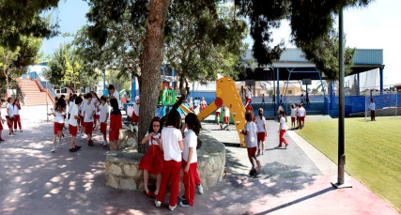

# SUBJECT TEACHER RESPONSIBILITIES

• Lead by example to uphold the school’s mission statement and promote the school’s values of: **CURIOSITY, KINDNESS, ENTHUSIASM, COMMUNITY SPIRIT & PERSEVERANCE**.

• Assist in the planning, preparing and delivering of departmental schemes of work in accordance with the syllabus and with students’ needs and interests.

• Create an effective and stimulating learning environment.

• Mark, test, assess and record in line with school and department policy.

• Use progress data to inform subject planning.

• Complete end of term reports in line with school policy.

• Liaise with Whole School Leaders regarding any problems or concerns over individual students.

• Enforce the school rules in the classroom, the school building and the playground.

• Meet regularly with parents to discuss pupil progress.

• Attend two Saturday morning parent events as well as parent evenings during the year.

• Attend and participate in weekly meetings (Mondays 4.30pm and Thursdays 9.00am).

• Keep abreast of developments within your subject area.

• Undertake all other reasonable duties as requested by Whole School Leadership Team



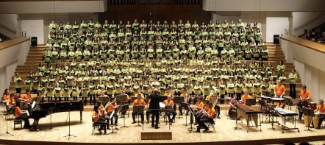

• Be punctual for registration.

• Make effective use of tutor time with your tutor group.

• Check and sign homework diaries every week and ensure that parents have signed them.

• Deliver a tutorial programme and deliver assemblies once per term.

• Ensure the pastoral and academic welfare of students in your care.

• Make regular contact with parents, keeping Whole School Leaders informed at all times.

• Liaise with the school psychologist and Whole School Leaders where appropriate.

• Ensure that students are aware of safety precautions around the school and the fire drill procedure.

• Ensure students follow the correct uniform or dress code rules, sanctioning where necessary.

• Check absences and punctuality through notes from parents and keep up-to-date records.

# FORM TUTOR RESPONSIBILITIES



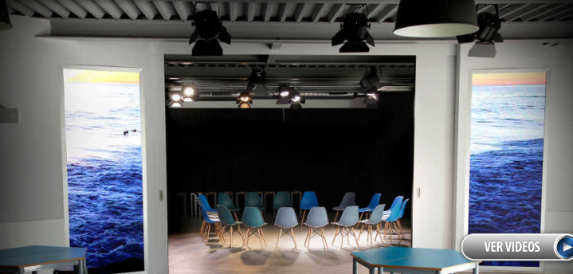



The secondary school including HND operates a 60 period fortnightly timetable with lessons lasting between 45 and 60 minutes. Lessons start at 9.10 a.m. (tutorial period) and finish at 4.30p.m. There is a mid-morning break of half an hour from 11.30-12.00. Lunch is at 2.00pm.

A full-time secondary and HND classroom teacher normally teaches up to 24 periods per week. Additional preparation periods are given for extra responsibilities. Teachers are also expected to cover occasional lessons for absent colleagues.

# THE SECONDARY AND HND SCHOOL DAY

# STAFF WORKING CONDITIONS

At Cambridge House staffing is our priority and is considered our most essential resource; increased staff salaries, staff welfare and improved working conditions are the most important objective of the school in terms of staffing.

Teaching salaries in Spain are set by union agreement on a national scale (known as ´convenio´). This is made up of a base salary (subject to annual review) and obligatory complementary payments. At Cambridge House not only do we fulfill all conditions set out in the convenio agreement, we also have our own internal benefits incentive scheme in order to pay over and above normal Spanish teaching salaries.

All teaching staff have access to immediate advice concerning their salaries and contributions made on their behalf through the Human Resource Manager, Inma Ramirez, who liaises closely with the Senior Leadership Team to ensure that staff are supported and their well-being is ensured.

Employment conditions at Cambridge House are excellent and virtually unrivalled in Spain. While some schools in Spain employ staff for temporary periods of between ten months and two years (not being liable therefore for many of the state contributions incurred), Cambridge House offers a permanent contract (‘contrato fijo indefinido’) to teachers from their first day of employment, with a policy of ensuring that full National Health, social security, tax and pension contributions are made.

The contributions paid guarantee our staff salary security during periods of illness, maternity and paternity leave and full index-linked pensions, which are attractive in comparison to pensions in other

countries. The school also has its own attractive private pension plan which staff can opt into. We work hard to create an attractive financial benefits scheme for all our staff.



We offer the following benefits over and above the set ‘convenio’ salary, which include:

- A flexible performance incentive scheme which allows staff to earn substantially more than the standard teaching salary

- An extended two-month summer holiday period, subject to individual working conditions. Teachers who opt to work during the month of July will receive increased financial benefits

- A free lunch every day

- One free school place for each teacher’s children, which includes registration costs, insurance, class materials and lunch (subject to availability).

- A contributory private pension plan with additional payments towards the plan made by the school and linked to the flexible financial benefits scheme.

- Optional subsidised private medical insurance which covers general illness and dentistry.

- On-site welfare advice and support and help with banking arrangements.

- Fuel and travel contributions in support of school initiatives.

- Excellent career and staff development opportunities.

- Periods of sponsored leave.

- A caring and supportive Senior Leadership and Management Team with a mission “to do what is right” and to offer individualised support to all members of staff.

*Opportunities to increase salary (linked to the flexible performance benefit scheme), including:*

*-employment in support of our own Community College activities;*

*-support to develop individual business opportunities;*

*⋅ support and facilities to enable staff to undertake a variety of development and professional opportunities.*

