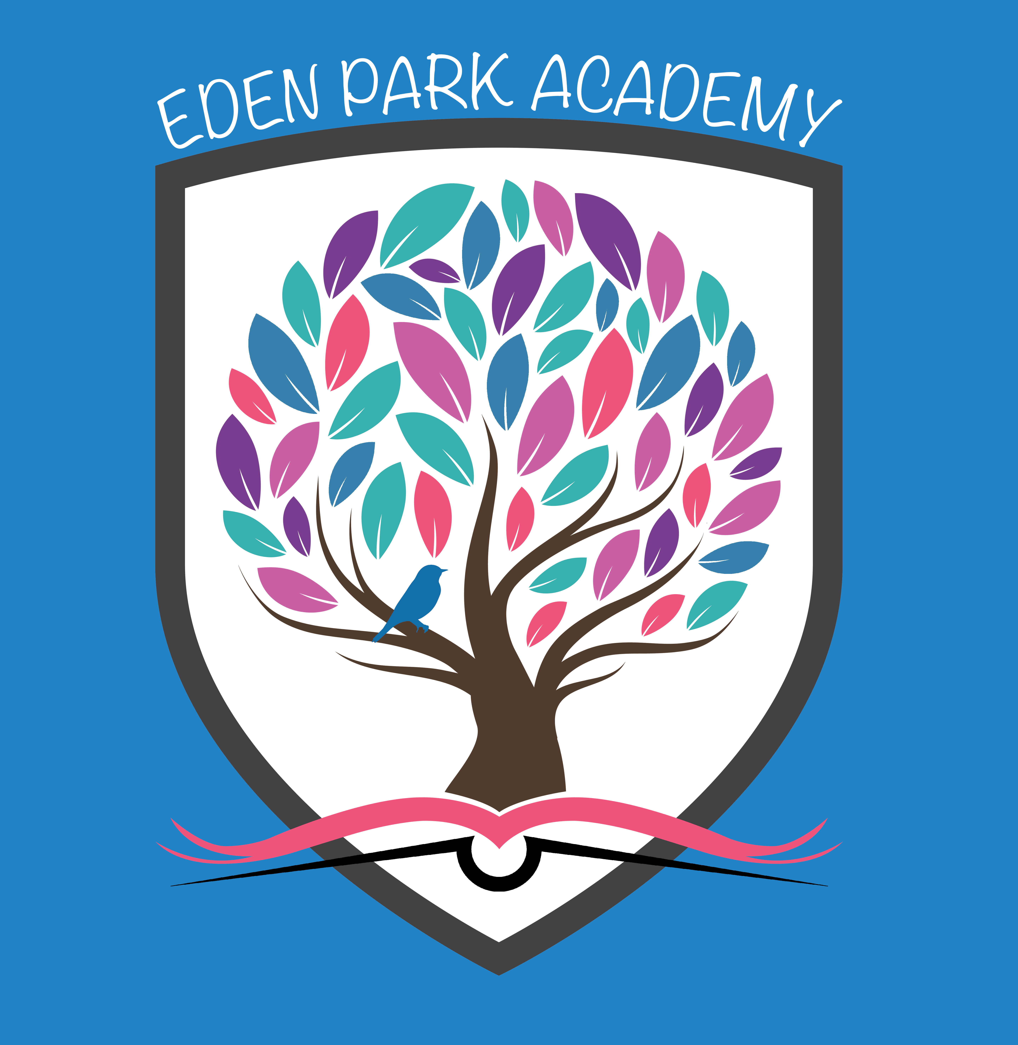

10th October 2018

Head Teacher –Eden Park Primary Academy

Dear Colleague,

Thank you for your interest in the post of Head Teacher of Eden Park Academy. We are here to support any query or question at any stage of this process. Please find attached the supporting documents;-

- Head Teacher Recruitment Information Brochure
- Head Teacher Job Description
- Head Teacher Job Specification
- Head Teacher Job Application form

Visits to the school are welcome and encouraged. For those further away a phone call is encouraged to discuss the post, school and the application process.

Please fill in the application form and address the supporting statement within the application form to Andy Cotton, CEO, outlining the reasons for your interest in the post and responding to the job specification. Please forward the letter and application form by 12th November 2018 noon. Late applications will not be considered. Applications can be forwarded via email to lesley.titmus@tarkatrust.org.uk or in writing to Mrs L.Titmus c/o Newport Community School, Landkey Road, Barnstaple, Devon. EX32 9BW.

Interviews are on 29th and 30th November 2018.

The starting point on the salary range will be discussed and finalised, as part of any formal job offer.
You will be required to show the original documents confirming your professional qualifications, if selected for interview and to successfully undertake a new DBS check prior to confirmation of the job offer. The Tarka Learning Partnership places the utmost priority on child safeguarding. The job will also require evidence of two high quality job references.

If you need further information, please contact Lesley Titmus on 01271 443125 or by email: lesley.titmus@tarkatrust.org.uk I look forward to receiving your application.

Yours sincerely

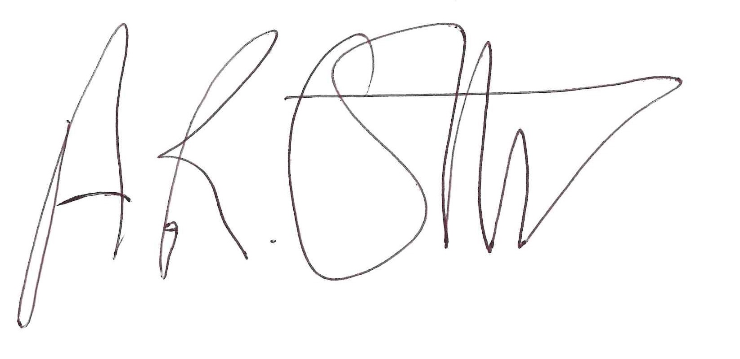

ANDY COTTON
CEO

