Eden Park Academy
Head Teacher

Dear Colleague,
Thank you for your interest in the post of Head Teacher at Eden Park Academy. Please find below information which may support your interest in the advertised post.
Eden Park Academy is a one form entry school in the heart of a community that has undergone change with new housing in recent years. The school serves an area of predominantly social with some private housing close to the centre of Barnstaple.

This post is being advertised at a very exciting time in the development of both Eden Park, formerly known as Forches Cross Primary and Nursery School and the newly formed MAT known as the Tarka Learning Partnership; a local Trust for local schools. Eden Park Academy, Sticklepath Community Primary Academy, Landkey Primary Academy, the Park Community School, Newport Community Primary Academy and a new free school to known as Roundswell Community Primary Academy are forming a North Devon MAT. The Tarka Learning Partnership employs Head Teachers and firmly believes in the purpose and rationale for employing an individual school vision within the Trust This is a time of change for the school and there will be many career opportunities available to staff and learning opportunities for the children in the years ahead. There are several schools actively exploring future membership.

The previous Head Teacher at Eden Park retired in December 2017 after long service and the school currently has an Acting Head Teacher, who will be returning to her former post in the school. The school is fortunate to have a settled team of teachers and support staff, who work hard to support the school’s ethos. This post is a non-teaching role, but the successful candidate is free to choose to teach in whatever capacity they wish.

We know that recruitment of Head Teachers to schools can be challenging and we want to reassure any potential candidates that the Tarka Learning Partnership, the school’s governing body and the staff fully appreciate the need for change and welcome this. Eden Park, as for all schools, needs to evolve and the teachers and support staff will work diligently to embrace the future. The new Head Teacher will lead a strong team of dedicated staff and a group of friendly and engaging children.

School History

Eden Park Academy is a converter Academy, which made the transition to Academy status on 1st July 2018 to work collaboratively with other schools.

Eden Park is situated in Barnstaple, an area which is undergoing housing development. Light industry has been attracted to the area with its close proximity to the Link Road. Several large housing estates have grown up in recent years.
.
We are able to offer the opportunity to work in a school which is at the heart of the community, supported by dedicated staff and a committed local governing body. Visits to the school are encouraged, especially if you are not familiar with the school and community. We firmly believe in supporting teachers and helping them to improve their practice.

What the Community of Eden Park are looking for:-
- The Head teacher of the Eden Park Academy is a visionary leader who inspires and motivates colleagues to provide outstanding teaching and learning.
- The Head teacher engenders respect and trust throughout the school and plans and delivers improvements through effective management and delegation, empowering senior leaders.
- The Head teacher works closely with staff and the governing body to ensure that all children in our inclusive school are eager to learn, reach their full potential and grow as emotionally intelligent individuals.
- The Head teacher has high expectations of themselves as well as colleagues, parents and pupils and is a clear thinker and good communicator.
- The Head teacher is visible, welcoming and friendly.
- Working with the Local Governing Body to provide the leadership and management which enables Eden Park Academy to give every pupil high quality education, and which promotes the highest possible standards of progress and achievement.

- Securing the long-term success of the school by maximising potential through the skills and resources held within the school and by working with the Tarka Learning Partnership.
- Building leadership capacity and developing staff and providing leadership opportunities for staff at all levels.
- Developing a range of family and pupil support services and ensuring that these are integrated in the school and across the primary age range.

“Are you the person who will help us to continue to develop high quality learning and care for all our children?”

Main Duties and Responsibilities
- Developing to a high-level positive links with the local community, including parents and carers.
- Maintaining and raising achievements and standards. Ensure that policies and practices take account of the national, local and school data, inspection and research findings.
- Work with the Local Governing Body to develop and maintain the strategic vision and promote our values and ethos to pupils, staff, Governors, parents and the wider community and ensure that all involved are committed and engaged.
- Translate the vision into agreed objectives and operational improvement plans.
- Create and promote positive strategies ensuring equality.
- Motivate others to create a shared learning culture and positive environment through distributive leadership and an environment which enables everyone to work collaboratively.

- Ensure individual staff accountabilities are clearly defined, understood and agreed and are subject to rigorous and timely review and evaluation.
- Work with the Local Governing Body to enable them to meet their statutory responsibilities.
- Set appropriate priorities for expenditure, allocation of funds and effective administration and control by:-

- Effective management of the school budget
- Ensuring funding and staffing match educational priorities
- Ensuring effective and safe arrangements for the siting and storage of resources and equipment.
- Present coherent, up to date and accurate accounts of the school performance in an appropriate format to the range of audiences including governors, the LA, Ofsted, DfE and others, to allow them to play their role effectively.

Key Accountabilities

Shaping the future
Eden Park is open to a new direction and the staff, pupils and community are open to this direction, but need a visionary Head Teacher to support this. Can you:-

- Demonstrate the vision and values of the school in everyday work and practice. Be willing to innovate, take on new challenges and be a leader in the field of education, especially with regards to research in primary schools.
- Ensure outstanding teaching and learning is at the core of strategic planning and provide inspiration and strong strategic leadership to the teaching team to ensure that the school continues to deliver the highest standards of learning for all.
- Drive a continuous and consistent focus on pupils’ achievement, using data and benchmarks to monitor and evaluate progress, attainment and the quality of provision.
- Communicate and work closely with families to encourage learning at home.
- Ensure policies promote good conduct and behaviour and reinforce the school’s approach to positive behaviour management.
- Ensure that good attendance of staff and pupils is maintained and appropriate and timely action taken when required.
- Ensure that the curriculum is regularly reviewed, evaluated and updated, taking account of local and national initiatives, policies and statutes.
- Combine the outcomes of regular school self-evaluation with external evaluations in order to develop the school.
- Ensure a broad range of extra-curricular activities are offered to provide opportunities for all.
- Promote an exciting and challenging curriculum, inspiring children to learn
- Set high expectations and challenging targets for the school community
- Ensure that differentiated learning opportunities and strategies are in place to support those pupils with additional needs (including EAL, SEN and EBD) and stretch those who are gifted and talented
- Tackle underperformance at all levels
- Create a culture and ethos of challenge and support where all pupils can achieve success and become engaged in their own learning.

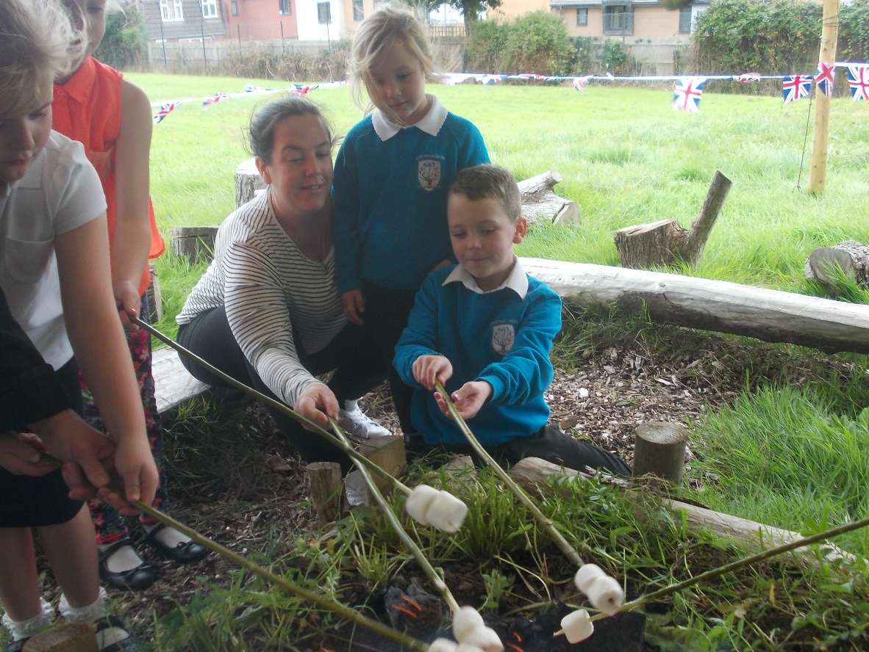

Leading Teaching and Learning
We need our Head Teacher to believe in the importance of a high quality curriculum and the value of teaching and learning. The Head Teacher will:-

  - To lead, motivate, challenge and support staff in order to secure and sustain continuous improvement and a commitment to staff well-being and CPD.
  - Ensure there are effective processes for staff induction, professional development and performance reviews.
  - Treat people fairly and with dignity to maintain a positive school culture.
  - Actively engage with other schools (both Primary and Secondary schools) to support joint learning, share best practice and in the case of Secondary Schools to ensure a secure and happy transition for pupils
  - Promote and maintain a culture of high expectations for self and others
  - Acknowledge the responsibilities and celebrate the achievements of individuals and teams
  - Ensure effective planning, allocation, support and evaluation of work of teams and individuals
  - Regularly review own practice, set personal targets and take responsibility for own development, seeking advice and support
  - Effectively manage own workload and that of others to allow an appropriate work/life balance.
Managing the Organisation
- Manage the schools’ financial and human resources effectively and efficiently to achieve the schools’ educational goals and priorities, and ensure systems are in place for the effective administration and control of school budgets.
- Ensure the ongoing development of an organisational structure which reflects school’s values and enables effective and efficient operations.
- Work with the governing body and senior leaders to ensure evidence-based improvement plans and policies promote continuous school improvement.
- Participate in the recruitment and selection of the highest quality teaching and support staff who are able and willing to contribute to the ethos of the school.
- Work with senior colleagues to retain and deploy staff appropriately
- Develop effective relationships and communications which underpin a professional learning community that enables everyone in the school to achieve.
- Create an inspiring, professional work environment consistent with the school’s values and aspirations.
- Ensure effective team communication mechanisms to ensure that all staff are involved in and kept informed of key priorities and developments.
- Provide effective organisation and management and seek ways of improving organisational structures and functions based on rigorous self-evaluation.
- Use and integrate a range of technologies effectively and efficiently.
- Manage and organise accommodation efficiently and effectively to ensure that all school buildings meet the needs of the curriculum and health and safety regulations.
Strengthening Community Links
  - To value all members of the school community; to celebrate diversity and promote social inclusion.
  - Ensure that parents and pupils are well informed about the school’s direction, priorities, curriculum and pupils’ attainment and progress.
  - To have due regard for safeguarding and promoting the welfare of children and young people and to follow the child protection procedures adopted by the LA and to act as the designated CP officer for the school.
  - To actively promote, implement and monitor equal opportunities across all aspects of the school.
  - Sustain and further develop partnerships with other schools and agencies and within the wider community in order to share expertise and bring mutual benefits to enhance provision and promote positive relationships.
  - Ensure a range of community-based learning experiences
  - Support and engage with the parent support, including the PTA
  - Collaborate with other agencies to ensure pupil and community needs are met. • Create and maintain effective partnerships with parents, Governors and the Local Authority to support and improve pupils’ achievements and personal development
  - Develop effective links with the community to extend the curriculum, enhance teaching and broaden learning opportunities.
  - Build a school culture that takes account of the richness and diversity within the community.
  - Ensure effective supervision and security of the school building, contents and grounds.
  - Ensure any maintenance, repairs or moderations are acted on promptly and in accordance with Health and safety regulations.
  - Maximise the potential of the site to provide stimulating learning environments, sport and play provision and community facilities.
  - Ensure compliance of procedures at all times under the provision of safe systems of work through safe and healthy environments, including information, training and supervision necessary to accomplish those goals.
  - Ensure employees work in compliance with the schools’ Health and Safety policies and under the Health and Safety at Work Act (1974), ensuring the safety of all parties they come into contact with, such as members of the public, in premises or sites controlled by the school.
Above all, we want a Head Teacher who is enthusiastic and committed to leading our school - at the heart of our community – growing together to achieve our very best.

