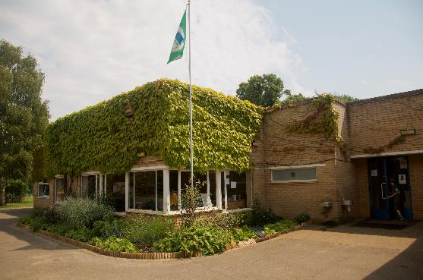
Newnham Croft is a thriving, oversubscribed, happy school of around 230 pupils with a balanced and rich curriculum making the most of its position in the Cambridge city community and its delightfully verdant grounds, wildlife and garden areas and eco and forest school credentials.
Situated in a quiet residential area, at the end of a no through road the outdoor space is very special. It includes a recently-installed natural play structures and a segregated natural play area for Reception and KS1, a large playing field, hard courts, an area of wild scrub woodland used for Forest School teaching, and a productive garden managed by volunteers in conjunction with the children. A variety of green space is readily accessible in the immediate vicinity of the school, including a well-managed park, a local nature reserve and riverside meadows.
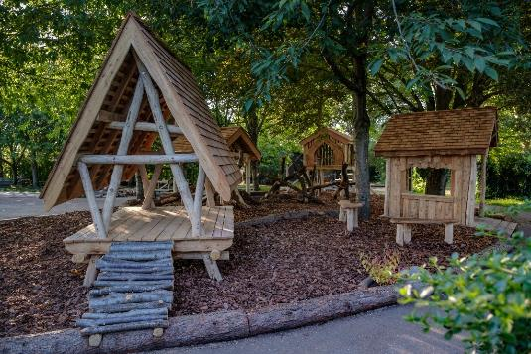
There are well-established relationships with local businesses and residents, whose support ranges from enabling out of classroom learning visits to attending school events. The parent body and the PTA are engaged and supportive. The city and University of Cambridge also provide huge opportunities for curriculum enrichment, across academic, cultural and sporting disciplines. Many locations for out of classroom learning are within walking distance.
We also enjoy having a very active Scout, Guide, Cubs, Brownies, Rainbows and Beaver scout hut sited next to the school as well as a hugely popular nursery and kindergarten and the Newcroft After School and Holiday club using the community room linked to the school. These are independent organisations using parts of the school site by arrangement and along with the breakfast club arranged by the school they are central to the wrap around care the school and linked organisations are able to offer.
Here are a selection of photographs we hope will give you a flavour of the school and its grounds but we sincerely hope you will find an opportunity to visit us so you can see it first-hand. You can also learn more about the school by visiting our website at: http://www.newnhamcroft.cambs.sch.uk.
