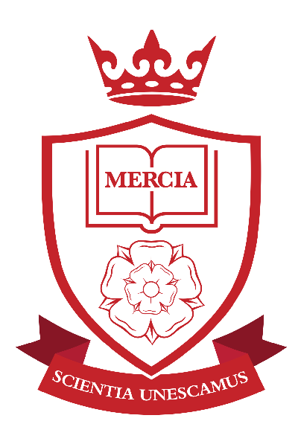

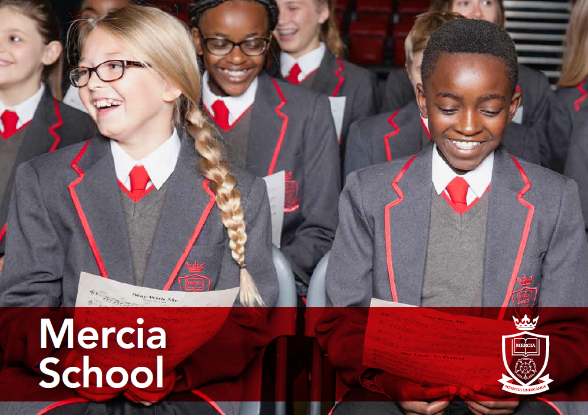
‘Let us be United by Knowledge’

Head of History TLR 2b
Information Pack

School Information
Job Description
Person Specification
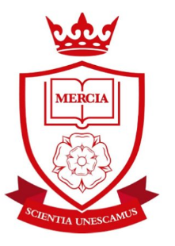
Contents:
- Letter from the Headteacher
- Advert
- Job Description
- Person Specification

‘Let us be United by Knowledge’

Dear Applicant,

Mercia School is a brand new 11-18 school that serves the south-west of Sheffield. The school opened in September 2018 with 120 Year 7 pupils and will grow incrementally for 5 years, until we offer A-level. We have a large catchment area, giving local families an additional choice of school. Mercia School is a traditional school, following the practices of the very best schools in the land. We strive for social mobility and achievement for all.

Mercia School provides all pupils, no matter their background or starting point, a rich and demanding education that inspires them to go on to a top university or a viable alternative. Mercia School is different. The curriculum is academic with a focus on acquisition of knowledge at its heart. Pupils receive high levels of challenge in their studies, which is unrivalled, giving our pupils an advantage over their peers at other local schools.

We passionately believe in promoting the arts, sport, languages and STEM through our thriving elective programme, as part of our extended school day. These experiences coupled with our curriculum, broaden our pupils’ horizons. The character traits our children present are very important to us. Therefore, we give our pupils the opportunities to show commitment, determination, resilience and independence, whilst expecting them to be kind and compassionate to one another. Our children open doors for one another, say ‘please’ and ‘thank you.’ They address teachers with respect. During Family Lunch, they serve one another and show appreciation and gratitude. This is all part of the Mercia way.

I expect that teachers teach from the front with excellent subject knowledge. Our classrooms are arranged in rows with pupils learning things by heart. We value our teachers’ passion for developing their specialism by ensuring they have time and energy to be reflective of their teaching. I anticipate that all teachers at Mercia School will become examiners in their subject area. A whole school team approach to improving practice ensures we have high levels of consistency, which allows us to drill down to the minutiae that matter.

Alongside this, we offer a strong commitment to reducing workload, with staff timetables directed to ensure efficient management of time, allocated CPD time and a robust feedback policy which avoids excessive marking. We do what we can to ensure teachers have time and energy to teach.

Underpinning our ethos is a dedication to high expectations. ‘We sweat the small stuff,’ we do this because we care about our pupils. The little things matter and make the difference in our quest for all our children to be a success in their life. As a result, behaviour at the school is of the highest standard.

As Headteacher, I am excited about the start we have made and I am delighted with the team we have assembled thus far. It is imperative that I continue to build an excellent team of teaching staff that are truly superb in the classroom and are fully committed to building a world-class school for our community. Therefore, recruitment for 2019 starts now.

I am seeking a highly skilled and talented individual, with a thirst to learn, to serve as the school’s Head of History. You will have a chance to help us develop something incredibly special in the department and beyond. This is a once in a career opportunity. You will be required to work diligently with unrivalled passion and work ethic, as we shape our school. You must be ambitious for our children and have a hunger to be the best teacher you can be.

You will love teaching and be excited at the prospect of reflecting and shaping the curriculum, as we deliver truly excellent and challenging lessons for our pupils. As Head of History, you must absolutely believe that every pupil is entitled to a first-class education, no matter their background or ability, achieved through the acquisition of core knowledge.

If this letter has filled you with excitement, I look forward to receiving your application.

I will be holding an Open Day on Monday 17 December 2018. If you would like to take this opportunity to find out more about us, in particular History at Mercia School, please contact Gill Darlow on 0114 5539080 by 1pm on Thursday 13 December 2018.

Closing date for applications is 5pm on Friday 4 January 2019 with interviews expected to take place during the week commencing 14 January 2019. Please send all applications electronically to Gill Darlow at gdarlow@merciaschool.com

Yours sincerely

Mr D F Webster

Mercia School is committed to safeguarding and promoting the welfare of pupils and expects all staff and volunteers to share this commitment. Successful candidates will need to undertake an Enhanced Disclosure via the DBS and/or provide police checks from other countries, where appropriate. Mercia School is an equal opportunities employer.

Dean F Webster
Headteacher Mercia School
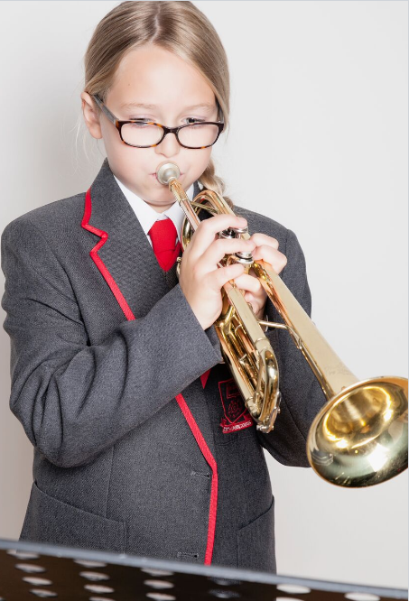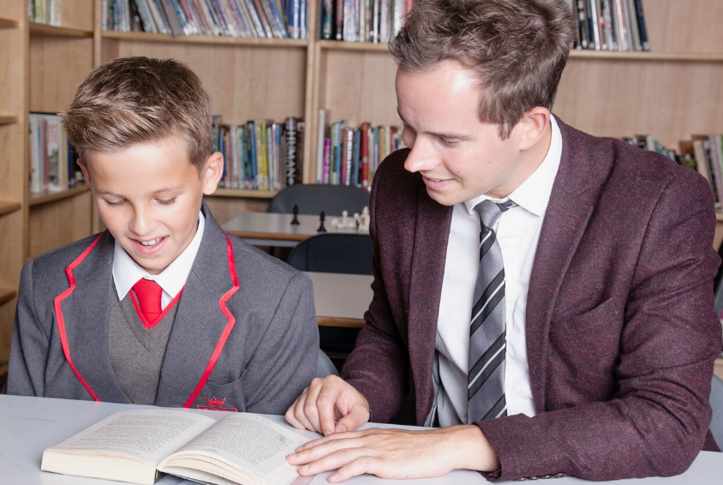
‘Let us be United by Knowledge’
Head of History TLR 2b

Commencement Date: 1 September 2019
We are seeking to appoint an outstanding Head of History, with the skills and knowledge to teach pupils with challenge, passion and commitment.

At Mercia School, lessons are:
- Exceptionally challenging for all pupils, no matter their ability or need.
- Taught in a traditional way that gives pupils time to practise and master content.
- Crucial to raising aspirations so all pupils have a successful career and a happy life.
- Preparing pupils for the challenges at GCSE and A-level, from day one.
- Focussed around historical writing, inference and interpretation. High quality sources will be central in most lessons to create mystery and intrigue.

Your role will be to teach excellent lessons, driving historical literacy, chronology and knowledge with passion and enthusiasm, promoting a love of learning and committing yourself to the vision of the school. You will also contribute to the enrichment programme. We are a small, dedicated team and we want to recruit someone who can help us deliver an unrivalled curriculum.

We welcome applications from talented, ambitious individuals who can dedicate themselves to the implementation of the school’s vision.
www.merciaschool.com

Closing date for applications: Friday 4 January 2019

‘Let us be United by Knowledge’
Job Description
Post title: | Head of History
Responsible to: | Deputy Headteacher
Purpose of the role: | - To deliver the vision of Mercia School without fear or favour, particularly through exemplary leadership of the History Department. This will relate predominantly to the successful delivery of a knowledge rich curriculum taught through traditional, didactic pedagogical approaches  - To drive the standards agenda in History so that every pupil aspires to be the best they can be  - To implement excellent teaching and learning strategies to ensure every student achieves at the highest possible level in History  - To ensure teaching and learning in History is first-class and in line with the Mercia School Teaching and Learning policy, namely a knowledge-based approach with a focus on mastery in History  - To implement the school’s rigorous QA systems and contribute to CPD as directed by the senior team  - To line manage colleagues so that outcomes are excellent across the department  - To work with the Leadership Team in designing a curriculum that is challenging and inspiring  - To consistently drive high standards and expectations throughout the History team and in the school generally  - To build effective networks and partnerships that are pertinent to History, so that Mercia School is innovative whilst staying true to its core values
CORE DUTIES
Strategic Planning: | - To work courageously with the Leadership Team to deliver the vision for the school with particular focus on the History department’s performance and quality  - To ensure units of work in History are challenging and have an abundance of knowledge at their heart which children learn off by heart  - To develop, produce, and maintain, departmental documentation including appropriate schemes of work detailing content, method, and assessment strategies  - To plan and deliver timely History CPD that inspires teachers to plan and implement world-class lessons  - To monitor the work of the department to ensure that all departmental members are consistently applying the policies and procedures of the department  - To ensure the efficient administration of the department through regular departmental meetings. Such meetings are to ensure effective communication of ideas and information among staff in the department and to enable staff to co-operate as a team in planning Professional Development and solving problems  - To create excellent partnerships and networks that aide the design of the History curriculum  - To have attention to detail and strategically plan so that all pupils and groups of pupils achieve equally well in History  - To monitor and react to developments in terms of linguistic pedagogy and research  - To work with the Headteacher on ensuring full staffing throughout the year
Quality Assurance: | - To monitor and evaluate all procedures and processes put in place for managing Teaching and Learning and student achievement in History  - To assist the Leadership Team in maintaining the climate for learning using consistent policies, with particular focus on History
Staffing: | - To promote teamwork and to motivate staff so that we maintain an effective History curriculum, delivered by excellent teachers  - To share and promote departmental student outcomes so that all staff know the children in their classes and therefore plan accordingly  - To drive student outcomes in History, exerting necessary challenge to staff who are not meeting the required standard  - To participate in the interview process for vacancies in History as required
Communication: | - To ensure that staff in the History department are clear on all Mercia School policy. Clarity of instruction must be excellent and departmental heads must reinforce messages without fail  - To ensure that all communication/consultation relating to the History department is appropriate. This includes letters home, social media and contact with any stakeholder
Publicity and Liaison | - To actively promote the school within Sheffield and nationally. This will include participation in national historical competitions and events.  - To contribute to the school liaison and publicity activities, with particular emphasis  - To network within the Trust, city and nationally so that we create an unrivalled talent list, with particular focus on History
Management of Resources: | - To requisition stock needed by the department, to keep stock lists up to date, and to forward to the Leadership Team as required  - To induct new members of staff as required, where appropriate act as a mentor to NQTs/Teach First in line with school policy under the direction of a member of the Leadership Team  - To advise the Leadership Team on the allocation of classes and other timetable requirements for the subject
Additional Duties: | - Assist the Leadership Team in improving the quality of teaching and learning in the school, ensuring the effectiveness of lesson plans and schemes of work including the development of targets for the teaching and learning of basic skills/knowledge within the department.  - Assist the Leadership Team in raising academic standards and raising attainment in the curriculum area across the school and with a cross-curricular dimension  - Assist the Leadership Team to ensure that all pupils receive their entitlement to the full departmental curriculum within a framework of equal opportunities and ensuring regular monitoring and reporting of their progress  - Liaise with Leadership Team on departmental timetable and curriculum matters  - Liaise with Leadership Team with regard to work, behaviour, attendance or other issues involving individual pupils  - Be aware of, and respond to, practice affecting the subject in primary feeder schools and liaise with the Leadership Team regarding primary liaison policy and departmental involvement in that policy
Teaching | - To teach excellent lessons that are in line with the Mercia School Teaching and Learning policy  - To teach History with passion and a reflective attitude  - To inspire other teachers to deliver excellent lessons in the History department  - Be abreast of assessments/examinations at GCSE and A-level so that the curriculum is relevant in History from Year 7 and beyond
OTHER SPECIFIC DUTIES
- To take part in personal professional development
- To observe, without fail, dedicated duties as determined by the Leadership Team
- To participate in staff observations as a part of day-to-day practice. This will include regularly being observed by colleagues and vice versa
- To proudly contribute to an open, honest and candid school climate. We expect candour from all, no exceptions
- To participate in the Family Lunch every day, relishing the opportunity to spend quality time with all of our pupils
- To take part in our House system, as directed by the Headteacher
- Any other delegated roles, as directed by the Deputy Headteacher
The specific responsibilities of the post will be further determined according to the expertise and experience of the successful candidate.

The school will endeavour to make any necessary reasonable adjustments to the job and working environment to enable access to employment opportunities for disabled job applications or continued employment for an employee who develops a disabling condition.

This job description is current at the date as shown, but in conjunction with the post holder, may be changed by the Headteacher to reflect or anticipate changes in the role which are commensurate with the grade and job title.

November 2018

Person Specification

Post title: | Head of History
Qualifications and Training | - Degree in History is essential, 2:1 degree as a minimum is desirable  - Qualified teacher status is essential – not suitable for NQTs  - Recent and relevant professional development relating to knowledge based curricula is desirable | Application Form, References and Interview
Skills and  Knowledge | - Must have highly effective communication skills which engage pupils, parents, staff and the wider community  - Must be able to use/learn traditional pedagogical approaches appropriate to the teaching of History to the highest level  - The ability to teach in a didactic way is essential, pupils must be tested regularly on their spoken and written History. A desire and will to change practice as requested is essential | Application Form, References and Interview
Experience | - Teaching History to a full range of age and ability within a secondary school  - Experience/knowledge of current initiatives relating to achievement and inclusion in History is desirable  - Track record as a successful classroom practitioner (Ofsted criteria) across the secondary school age and ability range  - Track record of exceptional results at GCSE and A-level History is essential  - We welcome existing History examiners, however this is not essential | Application Form, References and Interview
Personal  Qualities | - Must be able to demonstrate the ability to take initiative, lead, motivate, inspire and support the full range of stakeholders to achieve excellence  - Must be ambitious for self and others, showing a powerful commitment to continuous improvement and raising standards within a knowledge-based curriculum  - Must be resilient and optimistic, having a relentless focus on achieving the best for young people and being prepared to develop creative strategies to achieve this  - Must have a clear strategic vision for achievement and inclusion including providing opportunities for learning outside the school day  - Must have the capacity to demonstrate leadership of History. Prior subject leadership is not essential | Application Form, References and Interview

‘Let us be United by Knowledge’

