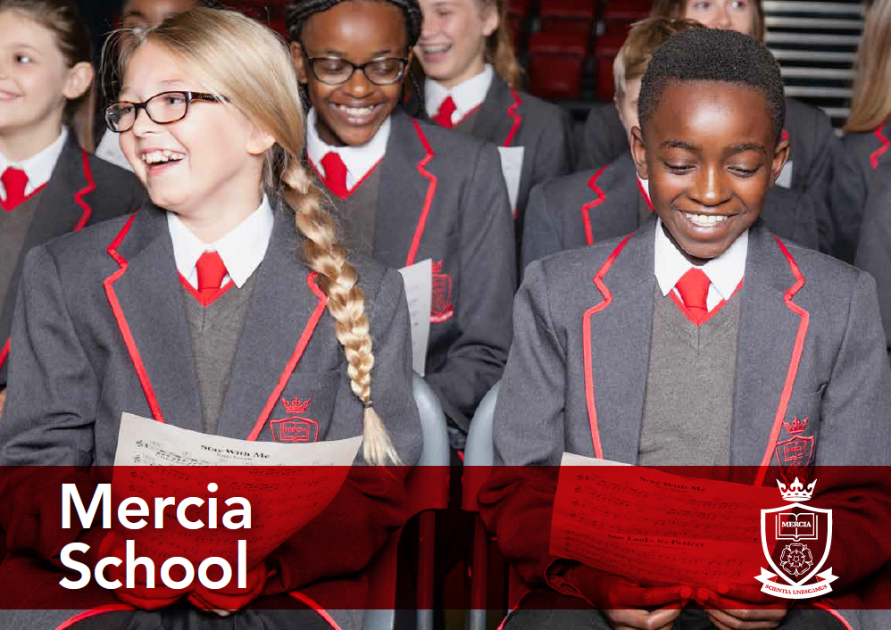
‘Let us be United by Knowledge’

Teacher of English
Information Pack

School Information
Job Description
Person Specification
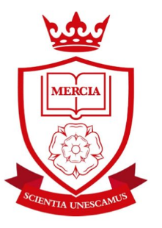
Contents:
- Letter from the Headteacher
- Advert
- Job Description
- Person Specification

‘Let us be United by Knowledge’

Dear Applicant,

Mercia School is a brand new 11-18 school that serves the south-west of Sheffield. The school opened in September 2018 with 120 Year 7 pupils and will grow incrementally for 5 years until we offer A-level. We have a large catchment area, giving local families an additional choice of school. Mercia School is a traditional school, following the practices of the very best schools in the land. We strive for social mobility and achievement for all.

Mercia School provides all pupils, no matter their background or starting point, a rich and demanding education that inspires them to go on to a top university or a viable alternative. Mercia School is different. The curriculum is academic with a focus on acquisition of knowledge at its heart. Pupils receive high levels of challenge in their studies, which is unrivalled, giving our pupils an advantage over their peers at other local schools.

We passionately believe in promoting the arts, sport, languages and STEM through our thriving elective programme, as part of our extended school day. These experiences coupled with our curriculum, broaden our pupils’ horizons. The character traits our children present are very important to us. Therefore, we give our pupils the opportunities to show commitment, determination, resilience and independence, whilst expecting them to be kind and compassionate to one another. Our children open doors for one another, say ‘please’ and ‘thank you.’ They address teachers with respect. During Family Lunch, they serve one another and show appreciation and gratitude. This is all part of the Mercia way.

I expect that teachers teach from the front with excellent subject knowledge. Our classrooms are arranged in rows with pupils learning things by heart. We value our teachers’ passion for developing their specialism by ensuring they have time and energy to be reflective of their teaching. I anticipate that all teachers at Mercia School will become examiners in their subject area. A whole school team approach to improving practice ensures we have high levels of consistency, which allows us to drill down to the minutiae that matter.

Alongside this, we offer a strong commitment to reducing workload, with staff timetables directed to ensure efficient management of time, allocated CPD time and a robust feedback policy which avoids excessive marking. We do what we can to ensure teachers have time and energy to teach.

Underpinning our ethos is a dedication to high expectations. ‘We sweat the small stuff,’ we do this because we care about our pupils. The little things matter and make the difference in our quest for all our children to be a success in their life. As a result, behaviour at the school is of the highest standard.

As Headteacher, I am excited about the start we have made and I am delighted with the team we have assembled thus far. It is imperative that I continue to build an excellent team of teaching staff that are truly superb in the classroom and are fully committed to building a world-class school for our community. Therefore, recruitment for 2019 starts now.

I am seeking a highly skilled and talented individual, with a thirst to learn, to serve as the school’s Teacher of English. You will have a chance to help us develop something incredibly special in the department and beyond. This is a once in a career opportunity. You will be required to work diligently with unrivalled passion and work ethic, as we shape our school. You must be ambitious for our children and have a hunger to be the best teacher you can be.

You will love teaching and be excited at the prospect of reflecting and shaping the curriculum, as we deliver truly excellent and challenging lessons for our pupils. As Teacher of English, you must absolutely believe that every pupil is entitled to a first-class education, no matter their background or ability, achieved through the acquisition of core knowledge.

If this letter has filled you with excitement, I look forward to receiving your application.

I will be holding an Open Day on Monday 17 December 2018. If you would like to take this opportunity to find out more about us, in particular, English at Mercia School, please contact Gill Darlow on 0114 5539080 by 1pm on Thursday 13 December 2018.

Closing date for applications is 5pm on Friday 4 January 2019 with interviews expected to take place during the week commencing 14 January 2019. Please send all applications electronically to Gill Darlow at gdarlow@merciaschool.com

Yours sincerely

Mr D F Webster

Mercia School is committed to safeguarding and promoting the welfare of pupils and expects all staff and volunteers to share this commitment. Successful candidates will need to undertake an Enhanced Disclosure via the DBS and/or provide police checks from other countries, where appropriate. Mercia School is an equal opportunities employer

Dean F Webster
Headteacher Mercia School
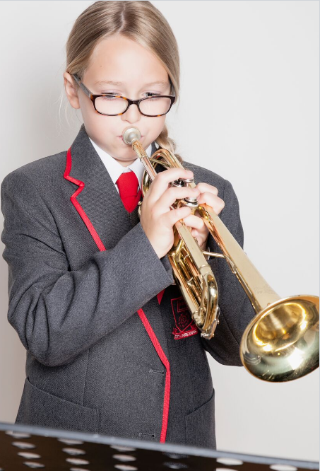

‘Let us be United by Knowledge’
Teacher of English

Commencement Date: 1 September 2019
We are seeking to appoint an outstanding Teacher of English, with the skills and knowledge to teach pupils with challenge, passion and commitment.

At Mercia School, lessons are:
- Exceptionally challenging for all pupils, no matter their ability or need.
- Taught in a traditional way that gives pupils time to practise and master content.
- Crucial to raising aspirations so all pupils have a successful career and a happy life.
- Preparing pupils for the challenges at GCSE and A-level, from day one.
-Purposeful and demanding - recital and developing pupil voice is central to all lessons.

Your role will be to teach excellent lessons, driving literacy and knowledge with passion and enthusiasm, promoting a love of learning and committing yourself to the vision of the school. You will also contribute to the enrichment programme. We are a small, dedicated team and we want to recruit someone who can help us deliver an unrivalled curriculum.

We welcome applications from talented, ambitious individuals who can dedicate themselves to the implementation of the school’s vision.
www.merciaschool.com
Closing date for applications: Friday 4 January 2019
‘Let us be United by Knowledge’
Job Description
Post title: | Teacher of English
Responsible to: | Assistant Headteacher
Purpose of the role: | - To teach designated pupils and undertake associated pastoral and administrative duties as well as other general responsibilities, having full regard for the school’s unique ethos, aims and policies  - To undertake tasks related to the development of the English curriculum and the wider school  - To deliver the vision of Mercia School without fear or favour, particularly through exemplary teaching of English. This will relate predominantly to the successful delivery of a knowledge rich curriculum taught through traditional, didactic pedagogical approaches  - To drive the standards agenda in English so that every pupil aspires to be the best they can be  - To implement excellent teaching and learning strategies to ensure every student achieves at the highest possible level in English  - To ensure teaching and learning in English is first-class and in line with the Mercia School Teaching and Learning policy, namely a knowledge-based approach with a focus on cultural literacy  - To collaborate with the Head of English in designing a curriculum that is challenging and inspiring  - To consistently drive high standards and expectations throughout the school generally  - To build effective networks and partnerships that are pertinent to English, so that Mercia School is innovative whilst staying true to its core values
CORE DUTIES
Teaching and Learning | - To ensure units of work in English are challenging and have an abundance of knowledge, which pupils learn off by heart  - To plan schemes of work for pupils in co-operation with the Head of Department in order to ensure that all pupils are taught to the same exceptional standard  - To produce written records of such planning in accordance with school policy and the instructions of the Head of Department  - To monitor and react to developments in terms of English pedagogy and research.  - To teach excellent lessons that are in line with the Mercia School Teaching and Learning policy  - To teach English with passion and a reflective attitude  - To be abreast of assessments/examinations at GCSE and A-level so that the curriculum is relevant in English from Year 7 and beyond  - To contribute to the provision of a safe and secure learning environment
Professional | - To actively promote the school within Sheffield and nationally. This will include participation in national English competitions and events  - To contribute to the school liaison and publicity activities  - To pursue the aims of the school in a positive manner and promote the school’s knowledge-centric ethos  - To work co-operatively within a whole staff team to achieve continuous improvement with a relentless drive to ensure teaching and learning is of the highest quality  - To consistently implement and maintain the school’s policy on discipline and behaviour  - To support the school’s endeavours to meet the needs of its community  - To contribute to meetings, discussions and management systems necessary to ensure the co-ordination of the work of the school as a whole  - To contribute to the ideas within and the implementation of the School Improvement Plan
OTHER SPECIFIC DUTIES
- To take part in personal professional development
- To observe, without fail, dedicated duties as determined by the Leadership Team
- To participate in staff observations as a part of day-to-day practice. This will include regularly being observed by colleagues and vice versa
- To proudly contribute to an open, honest and candid school climate. We expect candor from all, no exceptions
- To participate in Family Lunch every day, relishing the opportunity to spend quality time with all of our pupils
- To be a committed and excellent Mastery Tutor, delivering rich reading, Mastery Curriculum and fulfilling pastoral duties in line with school policy
- To take part in our House system, as directed by the Headteacher
- Any other delegated roles, as directed by the Headteacher

The specific responsibilities of the post will be further determined according to the expertise and experience of the successful candidate.

The school will endeavour to make any necessary reasonable adjustments to the job and working environment to enable access to employment opportunities for disabled job applications or continued employment for an employee who develops a disabling condition.

This job description is current at the date as shown, but in conjunction with the post holder, may be changed by the Headteacher to reflect or anticipate changes in the role which are commensurate with the grade and job title.

November 2018

Person Specification
Post title: | Teacher of English
Qualifications and Training | - Degree in English is essential (2:1 or above is desirable)  - Qualified teacher status is essential  - Recent and relevant professional development/understanding relating to knowledge-based curricula is desirable | Application Form and Interview
Skills and  Knowledge | - Must have highly effective communication skills which engage pupils, parents, staff, governors and the wider community  - Must be able to use/learn traditional pedagogical approaches appropriate to teaching to the highest level  - The ability to teach in a didactic way is essential  - Knowledge of current initiatives relating to achievement and inclusion in English is desirable  - Subject knowledge to teach to A-level | Application Form, References and Interview
Experience | - Teaching English to a full range of age and ability within a secondary school is desirable but not essential  - We welcome existing subject examiners; however, this is not essential | Application Form, References and Interview
Personal  Qualities | - Must be able to demonstrate the ability to take initiative, lead, motivate, inspire and support the full range of stakeholders to achieve excellence  - Must be ambitious for self and others, showing a powerful commitment to continuous improvement and raising standards within a knowledge-based curriculum  - Must be resilient and optimistic, having a relentless focus on achieving the best for pupils and being prepared to develop creative strategies to achieve this | Application Form, References and Interview

We welcome applications from talented people with clear potential

‘Let us be United by Knowledge’

