Chislehurst
& Sidcup
Grammar School

Full-time Permanent Teacher of Geography

Required for September 2017

Information for Candidates

Our school

The school opened in the Autumn Term of 1931 and has been at three different sites since then. 'Chis & Sid' has been at the current site for over fifty years and has undergone considerable building development, which includes a new Art & Technology block.

Chislehurst and Sidcup Grammar School aims to educate and prepare for life, able students from all backgrounds. This mission is dynamically carried forward within a caring, happy and supportive community. The education that ‘Chis & Sid’ offers develops its students intellectually, emotionally and physically. The ingrained idea of excellence in school life allows students to reach the highest academic, sporting, cultural and aesthetic standards. The special quality of learning in the classroom is equally matched by the richness of teaching that students experience.

Whilst healthy competition is central to the ‘Chis & Sid’ ethos, there are also many opportunities for students to enter into the wider life of the school. Service to the school and community is enthusiastically performed and high levels of leadership and responsibility are actively taken on by students at all levels. There is a supreme belief that building ‘Chis & Sid’s’ tradition of excellence comes not from dwelling on yesterday’s successes but performing tomorrow’s tasks.
The continued success of ‘Chis & Sid’ is matched by an ongoing focus on site development and improvement. Upon extremely attractive grounds, almost unique in the south east of England, a heavy investment programme in new facilities is unfolding. Aside from a range of well resourced specialist teaching areas, the school continues to add new buildings. In 2005, the Jubilee Pavilion was opened and the new Art, Design and Technology building opened in Spring 2007. The construction of the Sidcup Leisure Centre provides yet another development for the school; a modern sports hall further augments ‘Chis & Sid’s’ great sporting tradition. Significant enhancements to the Sixth Form Centre have also provided our Year 12 and 13 students with a dedicated study facility closely attached to the school’s Learning Resource Centre.

Mission, Aims & Values

Mission

Helping the learners of today become the leaders of tomorrow
This school aspires to educate, in partnership with parents and students, inquiring, well informed and compassionate citizens who will go on to make a better world by occupying positions of responsibility and influence.

Aims

- To teach with high expectations, striving to ensure students fulfil their potential in both the academic and complementary curriculum.
- To develop inquiring, knowledgeable, creative and articulate lifelong learners.
- To encourage students in leadership and other positive contributions to the life of the school and wider community.
- To encourage students to adopt healthy, physically active and safe lifestyles.
- To develop students who are both happy and capable of future independence.
- To develop students who will respect others, take responsibility for their own actions and become good citizens.
- To ensure students display self-discipline and responsible behaviour that makes a positive difference to the life of the school.
- To develop excellent working relationships between all those involved in the life of the school.

Values guiding the work of staff and students

- To be excellent role models in all we do.
- To strive to make a positive difference.
- To ensure that health and safety are never at risk.
- To show respect for the environment.
- To be calm, polite and fair in all our relationships.
- To allow no place for any form of aggression or violence.
- To act with open-mindedness, understanding and forgiveness.
- To ensure the needs of the individual and school community are in harmony.
- To show respect for each person's unique role in the life of the school.

Curriculum

The school's curriculum is designed to:
- prepare students for the opportunities, responsibilities and experiences of adult life
- be balanced, broadly based, relevant and differentiated to match student needs, aptitudes and abilities
- promote the spiritual, moral, social, cultural, mental and physical development of each student
Students have equal opportunities to the curriculum at all key stages; where options are available, every effort is made to provide students with the options of their choice. Student progress is assessed and the results recorded and reported to parents.
Year 7: On entry, our students study the full range of traditional subjects in addition to German, French and Latin as part of Key Stage 3.
Year 8: Students continue to study the full range of subjects as in Year 7.
Year 9: Students continue to study the full range of subjects as in Years 7 and 8. The end of Year 9 marks the end of Key Stage 3 and final assessments are made at that point.
Years 10 and 11: All students take GCSE in Mathematics, English Language, English Literature, Biology, Chemistry, Physics, PE, at least one Language subject and RS.
Years 12 to 13: GCE A Level courses are followed by all students in the Sixth Form – it is expected that all students follow at least four courses from the beginning of Year 12. The range of A Levels offered include, Mathematics, Further Mathematics, English, PE, Drama, Music, Music Technology, Chemistry, Physics, Biology, Business Studies, Economics, Psychology, French, German, Classics, Art, Product Design, Food Technology, Computing, ICT, Geography, History, Religious Studies (Philosophy) and Government & Politics.

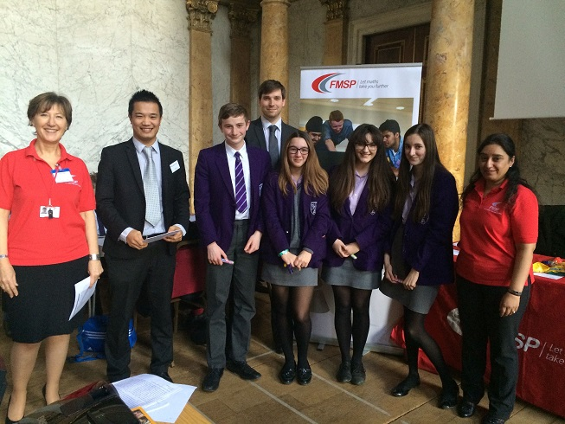
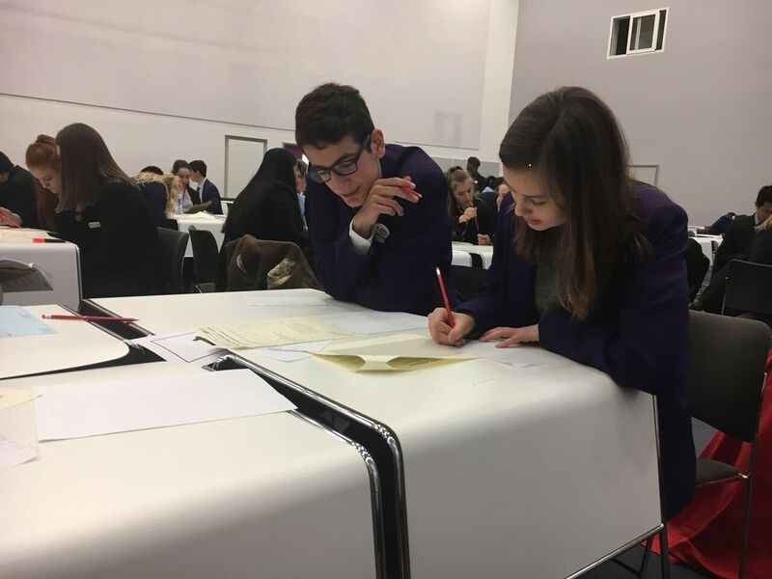

The Department

The department currently consists of three members of staff. Some members of the department have other responsibilities in the School. All Geography lessons are taught in dedicated Humanities classrooms with three dedicated Geography rooms, which includes one classroom with 16 networked computers. Access to the school computer network is via a wireless network with a laptop computer provided by the school. There are excellent reprographic and computer facilities within the school and geography classrooms.

The department’s approach to the teaching of geography is very much focused on developing skills and understanding rather than rote learning of techniques. Opportunities to develop enquiry through fieldwork are offered across the key stages including residential fieldwork for KS5 pupils. We also offer a number of wider Geographical trip options in collaboration with Science and Classics to Switzerland and Italy.

At GCSE we currently follow the AQA syllabus, whilst at A level we follow Edexcel

Recent results in the department have been very good. Over the last three years, 55% to 65% of students achieved A*-A grades in the GCSE examination, 60% to 80% of students achieved A*-B grades in A Level Geography

Every year, a small number of students are successful at pursuing Geography at degree level.

Geography Curriculum Overview

At Chislehurst and Sidcup Grammar School our aim is to inspire in our pupils a curiosity about the world and its people that will remain with them for the rest of their lives. Through this curiosity we aim to help students to engage with the big issues and challenges facing governments, industry and individuals the world over.

Key Stage 3

From Year 7 to 9 pupils study a range of human and physical geography units. Beginning with map skills in Year 7 they are encouraged to develop confidence with key geographical skills and to think like a geographer. The aim is to engage pupils in current debates and issues surrounding such topics as food seasonality and climate change. We endeavour to open their eyes to the varied environments, cultures and issues within our world and equip them with the necessary skills to critically engage in debate and discussion regarding global and local challenges. Through the varied topics we study we aim to develop the intellectual and emotional character of our students enabling them to develop empathy and an understanding of sustainability.

Key Stage 4

We follow the AQA Geography at GCSE, this is a linear course with final examination assessment via three separate papers at the end of Year 11. The course includes a balanced mix of human and physical geography and also gives students the opportunity to develop their skills in geographical writing and analysis. The content builds on topics studied through KS3 and provides students with the opportunity to extend and develop their understanding of the world around them. A key feature of the teaching within geography is to develop problem solving and thinking skills with an active approach to learning, helping students to become effective and independent learners

Subject content:
- Living with the physical environment: The challenge of natural resources
The living world
Physical landscapes of the UK
- Challenges in the human environment: Urban issues and challenges
The changing economic world
The challenge of resource management

Field work and geographical skills are an integral component of the course enabling students to investigate contrasting landscapes through the enquiry process. The specific location of fieldwork will vary year to year depending on the demands of the syllabus.

Key Stage 5

We follow the Edexcel Geography AS and A Level syllabus. These courses offer an engaging and contemporary issues based approach to Geography. Content is framed by enquiry questions that encourage an investigative and evaluative approach to learning. Throughout the course students are encouraged to engage critically with real-world issues and places, and to apply their geographical knowledge, theory and skills to the world around them. Students will grow as independent thinkers and as informed and engaged citizens, who understand the role and importance of geography as a key discipline relevant to understanding the world’s changing people, places and environments. Fieldwork is a compulsory component of both AS and A level Geography delivered through a residential fieldwork course and separate field work days.

AS areas of study
Dynamic landscapes – Tectonic process and hazards / Coastal landscapes and change
Dynamic places – Globalisation / Regenerating places

A Level area of study
Physical systems and sustainability – The water cycle and water security / The carbon cycle and energy security
Human systems and Geopolitics – Superpowers / Migration, Identity and Sovereignty
An independent geographical investigation

Enrichment

The Geography Enrichment programme is thriving in our department and it is considered a very important part of what we do. There are a number of opportunities to develop and extend geographical understanding. Pupils are supported in their development of investigation and enquiry skills through a number of opportunities to undertake fieldwork both in the school grounds and beyond. At Key Stage 3 trips include investigating the clone town nature of Canterbury and the settlement factors of Lullingstone in Year 7 and identifying how humans affect locations in Year 8. At KS 4 trips are directly linked to examination criteria and have in the past included investigating changes along the River Darent, the effectiveness of coastal management and the impact of regeneration in urban environments. Within KS 5 a residential field trip is undertaken to Flatford Mill in Suffolk investigating contrasting locations and the impact of human and physical processes.

To enrich the geographical experiences of students we regularly attend lectures at the Royal Geographical Society. We have also entered the World Wise geography quiz and have been recent winners of our area’s competition, and work with a local primary school enabling KS5 pupils to deliver geography lessons to younger pupils.

Teacher of Geography Job Description

- To plan, prepare and teach lessons as required by the department.
- To set homework and mark written work regularly and ensure that the correct procedures are followed if work is missing, incomplete or late.
- To set, supervise and mark school examinations and course work for public examinations.
- To assess, record and report on the development, progress and attainment of students and to communicate this information to parents via written reports and Parents’ Evenings.
- To provide written information for the UCAS and other similar forms.
- To provide guidance and advice when subject choices are made.
- To review methods of teaching and programmes of work and participate in arrangements for further training and professional development.
- To contribute to departmental extra-curricular activities.
- To consult your line manager about any problems occurring over academic matters, such as aspects of the curriculum or the syllabus for GCSE or A-level.
- To keep records of attendance at lessons as required.
- To keep records of books distributed.
- To encourage as much use as possible of the school libraries and other resources.
- To invigilate and undertake administration associated with public examinations.
- To maintain good order and discipline among students and safeguard their health and safety.
- To consult Head of Learnings, Assistant Heads or Form Tutors about serious discipline problems or any other difficulties students may cause, or may appear to be having.
- To contribute to PSHE and General Studies programmes as required.
- To attend Departmental, Year, Staff, Parents’ and Inset meetings.
- To attend assemblies.
- To provide cover for absent staff, especially within the department, and to carry out other duties as required.
- To act as a Form Tutor if required.
- To adhere to school policy on safeguarding and update training as required.
- To ensure the safeguarding and well-being of children and young people at the school in accordance with school policies.

Person Specification

Skills, qualities and qualification | Essential | Desirable | Method of assessment
A strong academic background and a good honours degree or equivalent in Geography or other related subject | √ |  | Application Form
Teaching qualification | √ |  | Application Form
The ability to teach Geography at KS3, KS4 and A level | √ |  | Application Form  Lesson
A willingness to participate in extra-curricular activities and trips | √ |  | Interview
Very good teaching, communication and interpersonal skills | √ |  | Interview
Strong ICT competence | √ |  | Application Form
Excellent written and spoken English | √ |  | Application Form  Interview
Efficiency and reliability | √ |  | Application Form  Interview
Committed to the safeguarding and well-being of children and young people | √ |  | Interview

Pay scale

- MPS plus Outer London Allowance

Other benefits

- Competitive pay and pension scheme
- Family-friendly working with a childcare voucher scheme
- An Investors in People employer
- Tailored induction programme
- Bluesky professional development scheme with the possibility of funding for additional qualifications.

How to apply:

Further details are available either from the school website www.csgrammar.com (Vacancies) or by emailing jobs@csgrammar.com. Please complete your application form via www.TES.com. CVs alone will not be accepted. Applications will be considered on receipt and interviews may occur at any stage.

If you have any questions, please contact jobs@csgrammar.com

References

Please note that it is our practice to take up references before shortlisting for interview.
Current and previous employers will be contacted as part of the verification process pre-appointment checks.

When an applicant is short-listed, any discrepancies or anomalies in the information provided or issues arising from references will be taken up at interview. Your referees should include your most recent employer. References from relatives or friends are not acceptable.

Safeguarding

Chislehurst and Sidcup Grammar School is committed to safeguarding and promoting the welfare of children and young people. All staff are required, before taking up post, to undertake a criminal record check through the Disclosure and Barring Service (DBS).

Candidates for teaching and support staff posts will be assessed at interview for their suitability to work with children. Appointment is conditional upon at least two satisfactory references, which include specific comments on working with children and young people. All staff at the school have a responsibility to promote and safeguard the welfare of students at the school.

Key Dates:

The school reserves the right to appoint prior to the closing date if a suitable candidate is found.

How to find us

The school is located within a 5-minute walk from Sidcup train station, has local bus services and is close to both the A2 and M25.
