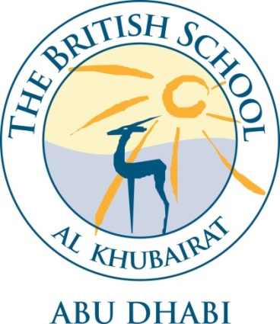

VISION

Building on our unique local heritage, we will provide a world class British education inspiring all our students to exceed expectations.
SAFEGUARDING STATEMENT

The welfare and safety of children who attend the British School Al Khubairat is our paramount concern. We will promote the health, well – being and safety of the pupils in all we do. Our children have the right to protection, regardless of age, gender, ability, race or social background. They have a right to be safe in our school. BSAK expects all its employees and volunteers to share this commitment. The school recognises and understands its responsibilities to work together in partnership with other agencies both here in the UAE and the UK to help children to grow up in a healthy and safe environment. Appointments are subject to satisfactory checks including the enhanced DBS check, Prohibition check and references.
INTRODUCTION

BSAK is committed to safeguarding and promoting the welfare of children, and expects all staff and volunteers to share this commitment. Applicants must be willing to undergo child protection screening appropriate to the post, including DBS checks.
BSAK is an independent British curriculum school for children aged from 3 to 18 years. The school is a member of IAPS, HMC and COBIS.
We recognise that each and every child is unique and we are committed to ensuring that every child develops to their full potential, creating independent, creative, curious, and confident young people, equipped with the values and skills needed for a successful and rewarding life.

JOB DESCRIPTION

Title Biology Teacher

Report to HOD/Headmaster

Collaborates with Secondary Staff

Direct Reports N/A

OBJECTIVE OF ROLE

- Contribute to the effective delivery of teaching and learning in Biology at both GCSE and A Level, to ensure excellent progress and achievement;.
- Promote the role of Biology in the wider life of the school, including through extra-curricular activities;
- Play an active role in developing, sustaining and modelling the skills, attributes and behaviours of a high-performing teaching and learning team.

KEY RESPONSIBILITIES

- Promote excellence in teaching and learning to ensure all children develop to their full potential and are equipped for life beyond school;
- Exemplify best practice in own classroom, and share good practice throughout the department;
- Take part in the regular review and development of schemes of work, keeping up to date with current educational initiatives with your own subject and beyond, ensuring that excellent practice and high standards of teaching and learning are maintained;
- Identify own training needs and attend INSET in consultation with the Head of Department, and disseminate as required;
- Plan effectively, ensuring lessons provide pace, motivation and challenge;
- Set tasks which are imaginative, interesting and demanding;
- Differentiate and extend work as appropriate, working closely with the Learning Support department as required;
- Demonstrate good ICT skills;
- Follow whole school and departmental policies relating to the marking of children’s work, and the assessment, recording and reporting of children’s attainment;
- Maintain a stimulating and meaningful display of children’s work, ensuring that it is regularly updated and relevant to topics being taught;
- Attend departmental meetings as required;
- Maintain classroom discipline, employing sanctions when necessary, in accordance with the school behaviour policy;
- Take registration, in accordance with whole school policy;
- Be responsible for the pastoral provision and support for the pupils in your care;
- Be proactive in communicating with parents regarding both pastoral and academic issues;
- Carry out morning break and lunchtime duties as required;
- Attend and be prepared to lead year group and house assemblies as required;
- Provide lunchtime and co-curricular activities as required;
- Join in with and be supportive of school events and activities generally;
- Be prepared to take part in school trips and visits as required;
- Cover the lessons of absent staff as required;
- Provide work in the case of own absence;
- Teach lessons in non-specialist subject areas as required;
- Develop and maintain good relationships with parents and the local community;
- Attend parents’ evenings as required;
- Undertake any other duties that may reasonably be requested by the Headmaster;

KEY REQUIREMENTS

Bachelor of Science (Biology major) and at least four years relevant teaching experience of Biology as a subject up to A Level or relevant degree, teaching qualification e.g. PGCE and at least two years relevant experience.
Also:-
- Recent Safeguarding training
- Proven successful experience of teaching across the age and ability range and of raising student achievement;
- Proven experience of curriculum development and delivery;
- Experience of monitoring the progress of individuals and cohorts of students.
- To recognise students’ learning needs and to communicate these effectively to other professionals;
- To work effectively in a team, taking the lead when required;
- To manage time effectively.
- Excellent communication skills at all levels orally and in writing
- Excellent ICT skills including some familiarity with school management information systems;
- Good administrative and record-keeping skills
- Proven competence in working - Independently;Under pressure;
- An excellent punctuality and attendance record.
- Commitment to principles and policies of BSAK and understanding of how they apply to teaching and learning;
- Commitment to the community ethos of the school;
- Proven commitment to own continuing professional development.

