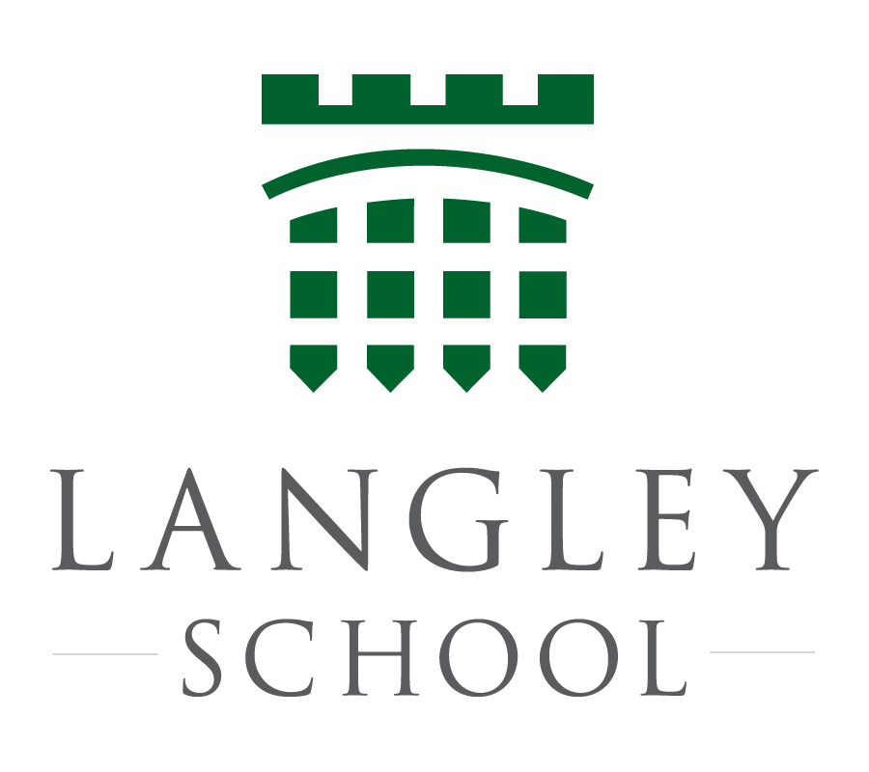

TEACHER OF MATHEMATICS

The successful candidate will:
- Be a reflective practitioner and team player.
- Have a proven track record of raising pupil attainment across all of the key stages.
- Have the ability to plan and deliver innovative lessons that are suitably differentiated to meet the needs of all students.
- Share their passion for Mathematics with their students and fellow teachers.

FURTHER INFORMATION ABOUT THE SCHOOL

Langley School is situated in 100 acres of parkland ten miles south of Norwich. Our current student roll is 511, of which 100 are boarders, 147 in the Sixth form.

Maths is taught in sets of approximately 18 students throughout the School. At A level we offer two sets with approximately 15 in each. A number of students in the sixth form are also prepared for A2 Further Maths. We also prep suitable students for the STEP papers.

This non-selective school caters for a broad range of academic abilities and the Maths department has been remarkably successful in securing 100% pass rate at A level in recent years, and 33% of students have attained a grade A*/A or better at A2 in 2017. This year around 80% of students achieved 9 - 4 grades in GCSE Maths and over 10% of students achieved 9-7 grades. The successful candidate will have experience of teaching to Advanced level. Experience of teaching the Edexcel syllabus at GCE and GCSE is preferred but not essential.

There are currently eight Mathematics teachers in the department. Maths occupies its own block of 6 classrooms, all of which have PCs connected to the School’s network and the internet. Popular software and web based resources used in the department includes ‘Mymaths’ and ‘Supermathsworld’. All classrooms in the school are equipped with Interactive Whiteboards that use Promethean ActivInspire Software. Langley is a well-resourced school with several suites of student PCs that can be booked for individual classes.

The Head of Department, Mr Stuart Goodhew, was appointed in September 2012. If you wish to discuss the post further with Stuart, then please feel free to contact him in school sgoodhew@langleyschool.co.uk

The School also offers a daily programme of sports and activities to which all staff are expected to contribute, according to their interests and expertise. Maths or Science based activities would be welcome as an extension to those gifted in this respect, but any other appropriate and relevant extra-curricular interests are embraced. The salary will be commensurate with qualifications and experience, plus an additional payment above CPS which the school currently enjoys. Boarding accommodation may be available, subject to discussion.

If you feel you would make a significant contribution to this growing, dynamic department, I would be delighted to hear from you.
Mr D Findlay, Headmaster January 2018

