THE GRANGE SCHOOL

Specialising in Business & Enterprise



TEACHER OF BUSINESS STUDIES



THE GRANGE SCHOOL

The Grange School is a well established, friendly school, specialising in Enterprise.
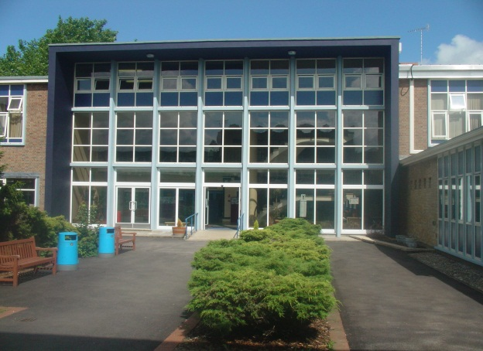
Enterprise is a driving factor throughout learning as evidenced by our Grange Enterprise and Learning Skills (GELS) which are embedded across the curriculum.



We aim to equip all students with the adaptability and flexibility to meet the demands of a rapidly changing world and to promote a sense of responsibility towards others, the school and the wider community. The support and guidance of students is based on a Year system and aims to develop co-operation, involvement and respect in all students.

A broad and balanced curriculum is provided for Years 7 to 9. In Years 10 and 11 all students will study English, Mathematics, Science, PE, RE, ICT/Computing and PSHCE (Personal, Social & Health and Citizenship Education). Students can then choose from a range of additional GCSE, BTEC and vocational courses. We offer a range of traditional and vocational courses at Key Stage 5. The curriculum in all Key Stages is further enhanced through wide ranging extra curricular experiences.

We aim to attract energetic and conscientious staff who have a commitment to the education of our students. The professional development of all staff is an important focus for the school. We strive to create a learning environment which serves the needs of all the members of our diverse and vibrant community.

THE GRANGE SCHOOL

TEACHER OF BUSINESS STUDIES

JOB DESCRIPTION

JOB PURPOSE

To be part of a team which will have an impact on students’ understanding of Business Studies empowering them to achieve highly, both within the curriculum and in their lives beyond school.

DUTIES

- To teach Business Studies to students of all abilities.

- To contribute to the team’s development of an exciting and challenging curriculum which meet the needs of all students.

- To promote and support extra-curricular activities as part of the academic and cultural life of the school.

- To play an integral part in the Achievement structure of the school.

- To foster good relationships with students and with home, including attendance at parent-teacher consultations.

- To support students’ learning by the use of the school’s policies of marking, assessment, record-keeping, reporting and target-setting.

- To attend all relevant meetings.

The Business Studies Department focuses on bringing the world of business into the classroom. Students will learn to appreciate the theory and rationale behind business decision making to gain a deeper knowledge and understanding of business functions and how businesses are created.

There are a wide range of business courses on offer, which aim to meet closely the individual learning needs of each student. These include A-level, Level 3 Technicals, BTEC and GCSE.

THE GRANGE SCHOOL

THE BUSINESS STUDIES DEPARTMENT

STAFF AND STRUCTURE

The Business Studies Department at present consists of five teachers, who also hold a range of additional responsibilities within the school. They form an enthusiastic and very dedicated team who work together in a supportive and friendly atmosphere.

Business Studies is an extremely popular option choice at KS4 and KS5, and courses consistently attract high numbers. At KS3, the Business Studies staff are integral in the delivery of Enterprise lessons.

We require an enthusiastic teacher who is looking to develop their career and contribute to the continued success of the Department.

THE BUSINESS STUDIES DEPARTMENT FACILITIES

There are four designated Business rooms, with internet access. There are a number of interactive whiteboards also available to use.

The school has Specialist Status in Business & Enterprise Education, which means a strong whole school presence of Business and Enterprise across the school. We are looking to appoint a member of the department who will see this as an exciting opportunity to help us continue to drive the subject forward.

EXTRA CURRICULAR

The Grange School recognises the importance of extra-curricular activities as a means of both inspiring and motivating students. As well as revision and coursework clubs, and a range of enterprise activities, we have planned a variety of additional activities that will be of real benefit to students at all levels and of all abilities.

We would be looking for a member of the team who has the drive and enthusiasm to help deliver our extra-curricular offerings and implement the many exciting new developments that are planned.

Candidates are invited to visit the school prior to interview.
Please contact Jenny Bell, PA to the Headteacher, to make an appointment.
The Grange School, Wendover Way, Aylesbury, Bucks, HP21 7NH
Tel: 01296 390900
Fax: 01296 390991
E-mail: office@grange.bucks.sch.uk
www.grange.bucks.sch.uk

