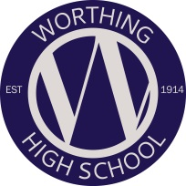
WORTHING HIGH SCHOOL

MFL DEPARTMENT

We are a motivated and supportive team who have a passion for teaching and seeing our students achieve their potential.

Staff and Accommodation

The department consists of five members and is overseen by the Leader of MFL. Most members of staff teach across the age and ability range. Some members of the department also hold responsibility roles outside of the department and all members of the department take responsibility within the department beyond their classroom teaching.

The MFL classrooms are based together and each room is equipped with a SMART board.

The Key Stage 3 Curriculum

In Key Stage 3 we have two groups of dual linguists, both in Year 7, 8 and Year 9 who study French and German. The rest of the students study one MFL (French, German or Spanish) and are taught in mixed ability groups. In our teaching we focus on providing our students with independent learning opportunities and encourage them to use all four skills, (listening, speaking, reading and writing) and incorporate new exam skills from throughout Key Stage 3.

The Key Stage 4 Curriculum

At Key Stage 4 we study the AQA syllabus where students practise the four skills of speaking, writing, reading and listening to prepare them for exams of an equal 25 % weighting at the end of the course. We are newly signed up to the AQA Kerboodle program to complement the curriculum and aid student independent learning.

Curriculum Enrichment

We are committed to offering our students an engaging and enriching curriculum both inside and outside the classroom. Every academic year we organise study trips and various enrichment activities including breakfasts and restaurant trips.

March 2018

