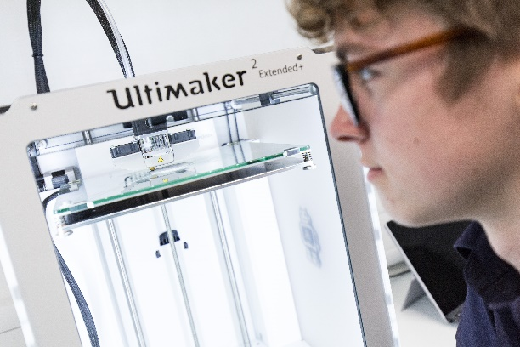

**Candidate Pack**

**Teacher of Exam and Data Manager**

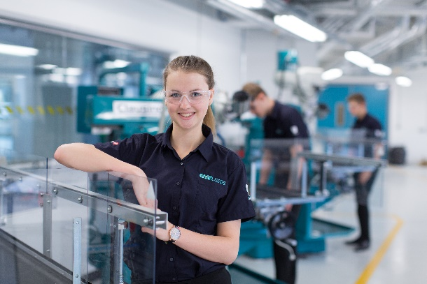UTC Leeds

**Contact - Hayley Stewart**

**Hayley.stewart@utcleeds.co.uk or telephone 0113 353 0140**



**Welcome from UTC Leeds**

UTC Leeds is a new and uniquely different type of school for students of 14 to 18 years who live in the Leeds City Region and which is led by a world class partnership of major employers and the University of Leeds. The UTC seeks to harness the talents and creativity of enthusiastic and able young ‘scientists’ and support them on a journey into the vast range of skilled professions which are available across our nationally vital ‘high-tech’ engineering and manufacturing sector.

Through a learning environment and experience which model the best professional practice in the fields of advanced engineering and manufacturing, the student engineers and applied scientists graduating from UTC Leeds will have the academic qualifications, professional characteristics and personal qualities that render them highly valued employees, researchers, technicians and future leaders in engineering.

UTC Leeds is supported by a partnership which includes among others, the University of Leeds, Agfa, Siemens, and Unilever. It is approved, regulated and funded directly by the Department for Education.

#### We are driven to inspire the next generation of inventors and entrepreneurs. The position of Principal presents a unique opportunity to influence the design of the learning environment, curriculum and organisation of this new UTC, in delivering the Governors’ innovative and forward-looking vision, and we welcome your application for this exciting post.



#### Simon Nadin

Company Director Siemens PLC

#### Graham Cooper

Company Director Agfa Graphics

**Phil Ball**

Company Director Metsa WoodLtd

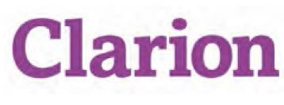**Sponsors**



**About UTC Leeds**

UTC Leeds, is the first school in the area to provide the highest quality academic and vocational education focused specifically on the high level skills and professional capabilities required in the advanced engineering and high- tech manufacturing sector.

Graduates from UTC Leeds will have the skills and qualifications to succeed in 21st Century jobs across the wide range of engineering design applications, including robotics, software development, control systems, medical and environmental engineering,

aeronautical engineering and many more. At 18 years, our students will be qualified to progress to undergraduate degree courses at university or to high quality apprenticeship programmes with approved employers.

Alongside giving ambitious young people an advantage in securing a rewarding career in the lucrative engineering sector, UTC Leeds will make a major contribution to the generation of that essential pool of talent required to sustain and further develop the economic success of our City Region.

**Our Vision**

UTC Leeds will develop in all its students those abilities, values and beliefs that equip them to make a valuable and lifelong contribution as creative scientists and engineers of the 21st Century.

In 2016 UTC Leeds opened its state of the art facilities in Leeds city centre, which at full capacity will support a total of 600 students from across the Leeds City Region.

Our student engineers are nurtured through a stimulating and relevant curriculum, engaging and empowering learning activities, and exposure to leading edge technologies and contemporary engineering challenges.

The challenging learning experience at UTC Leeds is designed to nurture independence, initiative and aspiration.

As a consequence, students leaving UTC Leeds will be recognised as young people with strong ambition and sense of purpose, who drive themselves to learn and achieve, and are guided by a secure framework of personal and social values.

**Building and Location**

The location for UTC Leeds is Sayner Road, Leeds LS10 1LA.

The UTC’s Transport Plan ensures that arrangements are in place for students to attend from across the Leeds City Region, which alongside Leeds, includes Barnsley, Bradford, Calderdale, Craven, Harrogate, Kirklees, Selby, Wakefield and York.

UTC Leeds is the first school of its type in the Leeds City Region specialising in Engineering and Advanced Manufacturing. The University of Leeds and a group of employers from the region including Siemens, Unilever and AGFA sponsor us. Offering a broad range of GCSEs and A levels alongside Technical Qualifications students will achieve outstanding academic success whilst also preparing for the Professional world of Engineering. Our links with the University of Leeds and 60+ employers will allow us to offer unprecedented access to the latest technologies and current employment practices.

An £11 million investment has created a modern, innovative college environment with the capacity to accommodate 600 pupils across the 14 – 19 age range. UTC Leeds offers a superb opportunity for students to study for a minimum of eight qualifications including English, English and science and those achieving the right grades will then have the opportunity to progress on in to our sixth- form.

Recruitment of students at UTC Leeds has been strong and we are now looking to strengthen our team by appointing an inspiring and engaging English practitioner to lead our English department.

This role would suit an excellent English teacher who is looking to join a unique school with a vocational focus. We would be happy to receive applications from existing leaders in English, or those looking for their first role into leading a department. Excellent support will be provided to ensure this person can develop into the role successfully.

As well as working in a contemporary, world class facility you will have access to high quality CPD hosted by our partner sponsors and supporters to ensure you achieve your own career goals and aspirations.

We are very keen to hear from you if you are:

* Inspired by working in a school that attracts young people who are passionate about their own future and have a passion for Mathematics, Science and Engineering
* Excited at the prospect of developing a world class facility for students to gain academic qualifications as well as the skills they will need for life
* Ready to take the next step in your own personal development as a leader in a brand new school where you can have a significant impact on strategic development

**Job Purpose**

**Duties and Responsibilities**

**Training and Assessment Data**

• To ensure all teaching staff are trained in the effective use of data systems and training is updated as appropriate

• To ensure teaching staff are provided with up to date, accurate and clear student performance data which can be easily accessed.

**Examinations**

The post includes the following responsibilities in relation to the management of GCSE, A‐level examinations, Technical qualifications and Applied general:

• oversee the receipt and distribution of mail and email from examination boards;

• respond to requests for information from examination boards, and correspond with the examination boards as appropriate;

• import examination base data into the school database

• oversee the pupil entries and amendments to entries within the school database;

• liaise with external examination candidates;

• produce examination entry files and ensure their dispatch via A2C;

• authorise payments for examination entries

• provide details of charges (e.g. re‐sits, EARs, script returns) to the bursary;

• secure the recruitment and training of a team of paid invigilators who support the invigilation requirements of the school for public examinations;

• log the hours worked by paid invigilators and pass of the details to the Assistant Bursar for salary purposes;

• draw up an examination invigilation timetable in conjunction with Subject Leaders and Assistant Principal;

• resolve any exam clashes and put in place any overnight supervision arrangements (if required);

• oversee the distribution and dispatch of estimated grade sheets, and mark sheets;

• oversee the preparation and submission of Special Consideration online or via form F10;

• liaise with SENco regarding matters related to special examination access arrangements for public examinations and provide such administrative assistance as is required by the Head of Learning Support to support those applications;

• oversee the receipt and checking of examination papers and stationery;

• oversee the receipt and checking of exam papers prior to sealing and posting;

• download and import examination results, and ensure distribution;

• assist the Assistant Principal in the production of consolidated pupil results sheets, subject results sheets and completion of ISC statistical returns;

• maintain a record of outcomes and update the school database, exam statistics and CEM data as required.

• oversee the receipt, checking and distribution of examination certificates;

• complete exam related statistical returns (e.g. FORVUS);

• provide advice to the Principal, Assistant Principal and other colleagues on matters relating to examinations;

• maintain and create pages as ‘guides’ to exam procedures for students, parents and teaching staff.

It is expected that during the examination period the Examinations Officer will be on campus at such times before and after the formal school day that are necessary for the efficient management of the examinations during the public examinations period.  During August it is expected that the Examinations Officer be in school the day prior to and the days of the public release of A‐level and GCSE examination results.

**Additional duties**

* Act with integrity and ensure a high standard of care and safeguarding for all our students.
* Comply with health and safety rules and legislation, ensuring the safety of students and staff at all times.
* Provide a highly visible presence to students and colleagues through the day.
* Attend open evenings, parental events, progress review meetings and other dedicated activities, as required.
* Act in compliance with data protection legislation in respecting the privacy of personal information.
* Comply with the principles of the Freedom of Information Act 2000 in relation to the management of UTC records and information.
* Undertake additional duties as may be reasonably directed by the Principal or line manager where they meet the priorities of the UTC.



**Safeguarding Children and Vulnerable Adults**

### **UTC Leeds has a statutory and moral duty to ensure that the schools functions with a view to safeguarding and promoting the welfare of children and young people studying at the school. The post holder will be required to commit to the school child protection policy and promote a safe environment for children and young people learning within the school.   All posts are subject to enhanced Disclosure and Barring Service check. However, having a criminal record will not necessarily bar you from working with us this will depend on the nature of the position and the circumstances and background of your offences.**

**This school is committed to safeguarding and promoting the wellbeing of children and young people and expects all staff, visitors and volunteers to share this commitment**

**Equality and Diversity**

All employees of UTC Leeds are required to promote equality and diversity in all aspects of the job.  Specifically, the jobholder will be required to support the School to meet the General Equality Duty under the Equality Act 2010 to:

* Eliminate unlawful discrimination, harassment and victimisation and other conduct prohibited by the Act.
* Advance equality of opportunity between people who share a protected characteristic and those who do not.
* Foster good relations between people who share a protected characteristic and those who do not.

The protected characteristics are;  Age, Disability, Gender Reassignment, Marriage/Civil Partnership, Pregnancy/Maternity Leave, Race, Religion or Belief, Sex, Sexual Orientation.

**Health and Safety**

It is the responsibility of all employees to co-operate with the school management in meeting the objectives of providing a healthy and safe place of work. Therefore, all staffmust carry out their work with reasonable care for the health and safety of themselves and other people. Accidents or near misses must be reported and safe working procedures must always be followed.

1. Duties will inevitably develop and change as the work of the school changes to meet the needs of our service. Employees should therefore expect periodic variations to job descriptions, UTC Leeds reserves this right. This job description will be supplemented on a regular basis by individual objectives derived from school strategies.
2. Where an applicant or existing employee is, or becomes, disabled (as defined by the DDA) and informs the College fully of their requirements, reasonable adjustments will be made to the job description wherever possible.