Post Description
We are looking for a graduate teacher of Mathematics with energy, ideas and enthusiasm to join a highly successful department. The school was subject to an OFSTED inspection in March 2014. We were told that students make excellent progress because students enjoy the subject and find staff extremely supportive.
Our department has a good blend of experienced staff and those new to the profession. The OFSTED report commented upon the excellent support and induction programme new teachers to the school receive.
The department is high performing with consistently good results at GCSE and A Level. In 2016, 78% of students secured a C or above at GCSE grade. 45 students completed the A2 in mathematics last summer of which 73% achieved A*-B and 20% achieved the highest A* grade. The department also offers Further Maths with 4 students completing the A2 qualification in 2016 with 2 achieving A* grades. The department, whilst proud of these, is determined to improve even further. Further, there are excellent transition programmes in place with our feeder primary schools.
The Maths Curriculum
Key Stage 3
Each year is split into two halves of 4 or 5 classes, set by ability. Years 8 & 9 have four 50-minute lessons whilst Year 7 have three. MyMaths is used throughout the Key Stage as well as other software and online resources. Rich tasks are used throughout the year to help develop independent learning skills. Various resources are available including individual text books.
Key Stage 4
Our current Key Stage 4 pupils are following the AQA specification for the new 9-1 GCSE Curriculum. Approximately 56% of the students will sit the Higher tier exam this summer. The extra emphasis on ‘Functional Maths’ and ‘Problem solving’ has been embedded in the schemes of work. Key Stage 4 have five 50-minute lessons a week, providing them with ample contact time needed to master the new National Curriculum.
Post-16
We intend to continue to use the AQA board for both Maths and Further Maths in 2017/18 when the new A-Level specifications are introduced. In the past there are usually 3/4 AS Maths groups in Y12 with the 2/3 classes going on to study at A2, although from September students will select 3 A-Level choices to study for the full two years. Six 50-minute periods are allocated in the sixth-form and groups are shared between 2 teachers. Timetable permitting department staff have the opportunity to teach AS/A2 level Maths.
We are extremely proud of the reputation and achievement of Further Maths students. Every year students move to University from John Taylor to study maths or a maths related course.
The Department
The team from September 2017 includes:
The Curriculum Area Leader of Maths is Simon Curzon
Clara Heppleston Assistant CAL
Heather Holmes Assistant CAL
Sherree Bale Head of Sherwood House
Jane Cotterill Lead Teacher (Sixth Form Pastoral)
James May Lead Teacher (STRIPE)
Xzena Hawksworth
Sarah Stevens-Brown
Joanne Barnes
***Teacher Vacancy***
Joining the department from September, Anthony Eagles as full time teacher and Mark Williams as a salaried trainee teacher.

Facilities and Resources
The Maths block is a modern, standalone building with eight specialist teaching rooms, each with a Promethean IWB, and a separate ICT suite which is predominately used by the department. The two other maths rooms are in a cluster of ‘mobile’ buildings nearby. They are quiet, well kept and light. All these rooms have projectors, IWB and most have desktop PCs. The department has use of a number of office areas suitable for planning lessons and marking. One of these areas is used as a social base for the maths staff and helps foster a strong departmental community and positive working atmosphere. The department is well equipped with ActivExpression handsets, graphic calculators, software and textbooks. All teachers in the school have laptops.
The Post
The post has arisen due to a member of staff taking a teaching position in the independent sector.
Person Specification
You should:
- Be an excellent teacher/NQT with the ability to communicate your knowledge to others. Have a passion for your subject and be committed to the principle of life-long learning.
- Have a clear understanding of how assessment for learning, target setting and planning can raise achievement.
- Be aware of current changes to the National Curriculum and its impacts on Mathematics teaching and the challenges we now face.
- Be an effective departmental member with a willingness to take part in discussions on strategies and best practice.
- Be committed to continuing professional development.
- Ability to teach AS/A2 Maths (and/or Further Maths) is desirable.
- Be competent in ICT and prepared to develop this further.
- Be committed to equal opportunities.
- Be positive in outlook, believe in the power of education to improve children’s lives and have a generous spirit.
- In addition, all teachers are required to act as tutors to a form, monitoring and supporting the pupils in their progress through the school.
Dunstall Rd, Barton under Needwood, Staffordshire, DE13 8AZ
T: 01283 239300 F: 01283 239333 E: recruitment@jths.co.uk W: www.jths.co.uk
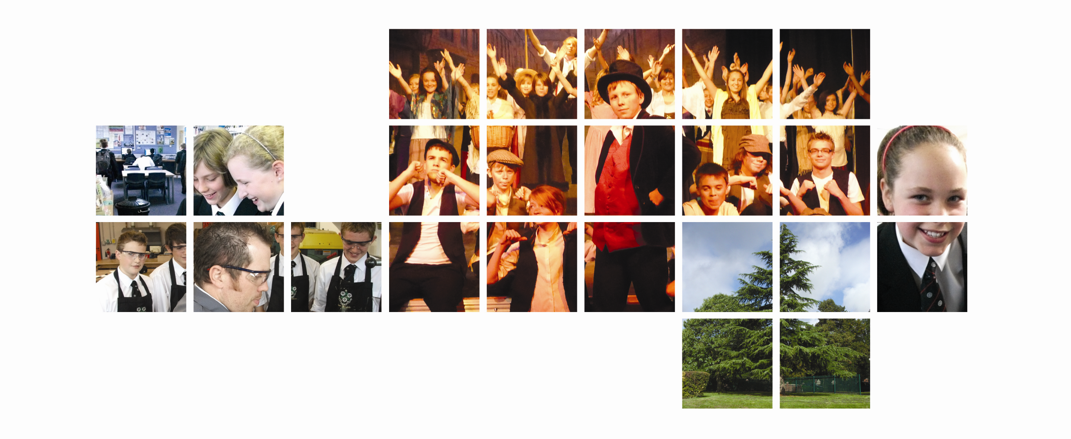
#

Details of the post of
Teacher of mathematics
A Permanent Post starting September 2017
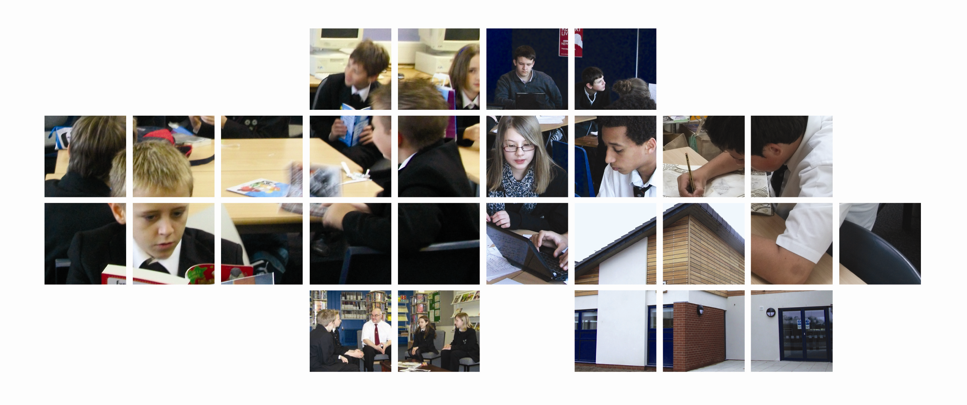

We subscribe to the Equal opportunities policies of the Local Authority as employers. We are also fully committed to implementing child protection procedures and DBS checks.

Please complete the applications form enclosed and send it to us, together with a letter persuading us that you have the experience and potential to fulfil the responsibilities and person specification by 9am on Tuesday 2nd May 2017.

Mike Donoghue

Principal

