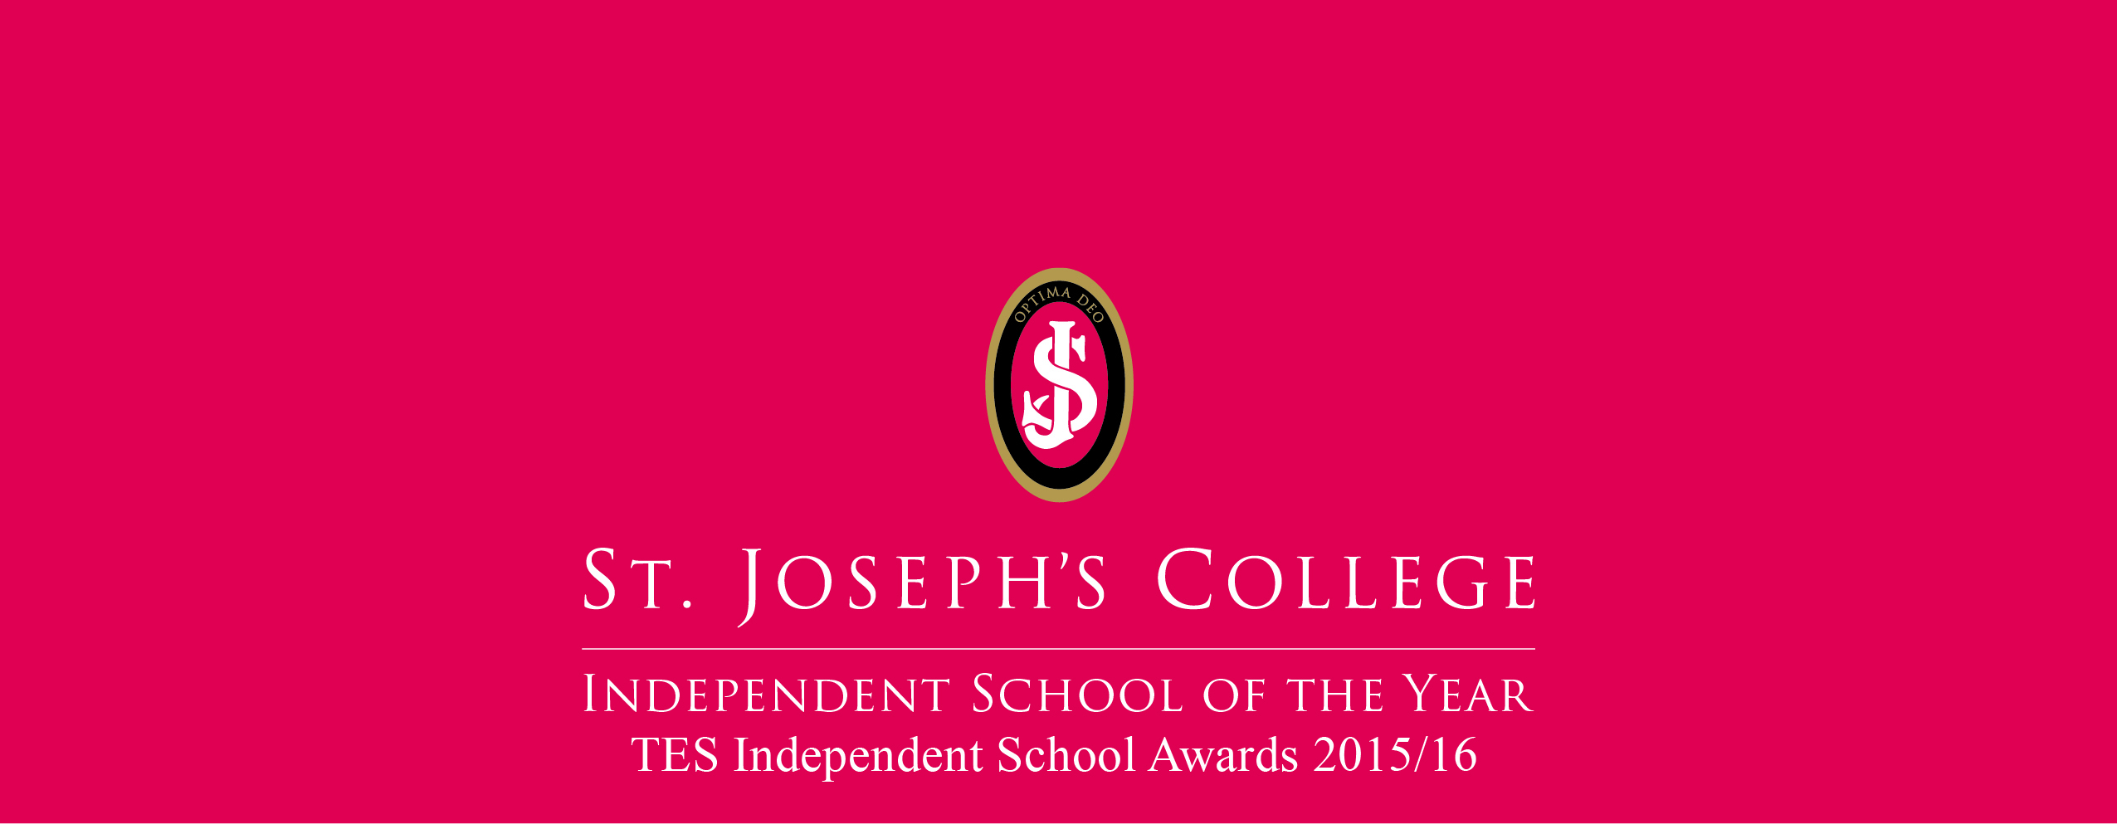

Classroom Assistant
Junior Section

Prep School

Information for Prospective
Members of Staff

Senior School

Information for Candidates
Appointment of a Classroom Assistant

St Joseph’s College is seeking to appoint a Classroom Assistant to join the team in our Junior Section from September 2017.

The post-holder will be responsible in the first instance to the Head of Prep, but also to the Deputy Head who is Head of the Junior Section, and to the Class Teachers in the Junior Section. The post is full time and permanent, from 8am to 4pm during term time and including staff training days.

Applicants should be self-motivated, reliable, a team player and able to use their initiative. A positive and flexible approach and a desire to work with young people are qualities we value highly.

Contents
Duties and Responsibilities page 3
Areas of Responsibility and Key Tasks page 3
Person Specification page 4
Conditions of Service page 5
About the College page 6
Our Mission and Aims page 7
Why St Joseph’s? page 8
Appointment procedure page 10
Interview process page 11
How to find us page 12

Message from the Headmaster, Andrew Colpus

Thank you for your interest in St Joseph’s College. I am delighted that you are considering our school and I trust that this recruitment pack will provide you with the information you require both about the post and the College.

I believe that this is an exciting time to be joining St Joseph’s College. There has been a significant growth in the pupil roll over the last few years and the governors are continually looking to invest in the facilities. The recent development of the College has led it to receive a number of national awards over the last couple of years including the TES Independent School of the Year award 2015/16.

The College seeks to be a school which places an emphasis on providing an all-round education: academic, pastoral, social and spiritual, where pupils develop the attributes of commitment, collaboration, confidence and communication through the various aspects of school life. The College is a very happy place, and colleagues enjoy teaching here.

I hope that you will want to apply for this post. I recognise that much time and thought goes into preparing an application and we, in turn, will give your application serious consideration.
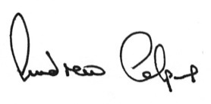
Andrew Colpus
Headmaster

About the Junior Section

At the start of Year 3, pupils move into the Junior Section, with classrooms housed upstairs in the main Prep School building.

Here they build on the work of the Infant Section, and learning is deepened and accelerated as pupils progress and develop. The curriculum is wide-ranging, encouraging each child to achieve his or her full potential.

Teaching is by experienced and dedicated class teachers, supplemented by subject specialists in French, Science, Music and PE. Pupils are also able to take advantage of the Senior School’s facilities, including the Science labs, ICT suites, and Electronics and Food Technology rooms.

Learning outside the classroom steps up another gear in Juniors too, as they experience their first overnight trips away from school. From a couple of days at a Tudor manor in Years 4 and 5, to a week of activities including archery, raft building and initiative courses in Year 6. These visits are always described with great enthusiasm as a highlight of the school year.

Juniors are also encouraged to take on additional responsibilities and to develop their independence and confidence. In Year 6, their increasing maturity is recognised as they become prefects.

Duties and Responsibilities

To be an effective professional who demonstrates high standards of care and support to enable access to learning for all pupils. Members of staff are expected to comply with any reasonable request from a manager to undertake work of a similar level that is not specified in this job description.
Main Requirements
Three qualities are essential:
- You must be a first rate practitioner who has a real passion and enthusiasm for the role and the pupils in your care
- You must be committed to treating each child as an individual
- You must be able to work as part of a team, in a supportive, caring and friendly manner.
In fulfilling the requirements of the post, the applicant should demonstrate essential professional characteristics, and in particular will:
- Inspire trust and confidence in pupils and colleagues
- Build team commitment with colleagues
- Engage and motivate pupils
- Contribute to the College improvement/development planning and promote the learning priorities of the College Development Plan
- Contribute to the development and/or implementation of College policies
- Uphold the values and mission of St Joseph’s College and maintain them both inside and outside the classroom
- Promote the wider aspirations and values of the College

Areas of Responsibility and Key tasks

The main duties and responsibilities are indicated below. Other duties of an appropriate level and nature may also be required, as directed by the Head of Prep.
- Working under the instruction and guidance of the teaching staff to support learning for all pupils
- Working in a variety of settings, e.g. small group work and one-to-one, as well as classroom support
- Assisting the teachers in the management of pupils in and outside the classroom, including in the playground and Dining Hall
- Promoting good pupil behaviour and independence
- Providing clerical and administrative support to the class teachers
- Participating as an active member of the staff team
- Ensuring that all activities are carried out in a safe and secure manner

Other Professional Requirements
- Assisting with the provision of First Aid cover for pupils (First Aid training will be provided)
- Attending relevant meetings and training sessions as required
- Meeting all deadlines reasonably requested
- Adhering to all policies (including Health and Safety and Child Protection) and raising any concerns to the appropriate person

This job description is not necessarily a comprehensive definition of the post. It will normally be reviewed once a year, but it may be subject to modification or amendment at any time after consultation with the holder of the post. The post holder is expected to be flexible and adaptable.

Person Specification for Classroom Assistant

Category | Essential | Preferable
Education, Qualifications and Experience | Interest and experience working with children  A basic awareness of health and safety practices  Some understanding of how children learn | NVQ Level 3 or equivalent  Paediatric First Aid Training
Skills and attributes | Good communication and inter-personal skills  High standards of written and spoken English  Empathy with pupils across the age and ability range  Capacity to deal sensitively with problems raised by pupils  High expectations of pupils | Good computer skills  Ability to diffuse difficult situations using different strategies such as careful listening, sensitive use of humour, praise and recognition  Have particular skills related to guiding children in their learning and play  Ability to use initiative
Personal Characteristics | Self-motivated and reliable with a disciplined work ethic  Ability to establish good working relationships and work well in a team  Excellent role model for pupils  Well organised and resourceful approach to work and have the ability to meet deadlines | Forward thinking approach  Flexible, motivated, able to work unsupervised and an ability to deal with unpredictable situations.
Other Requirements | Fully supportive of the College’s Catholic tradition  Commitment to the ethos of the College  Commitment to the safeguarding and well-being of all pupils | Able to maintain high standards of care and education  Able to promote the image of the College through an articulate and confident approach

Conditions of Service
The hours of work are 8am to 4pm, Monday to Friday, during term time, including training days. The contract for the post is for a total of 41 weeks which includes 5.6 weeks paid leave, including public and bank holidays which you are required to take as they fall during the year.
The rate of pay is £8 per hour. Salary will be paid at the end of each month, being one twelfth of the annual salary based on the number of hours worked per week, including holiday pay entitlement.

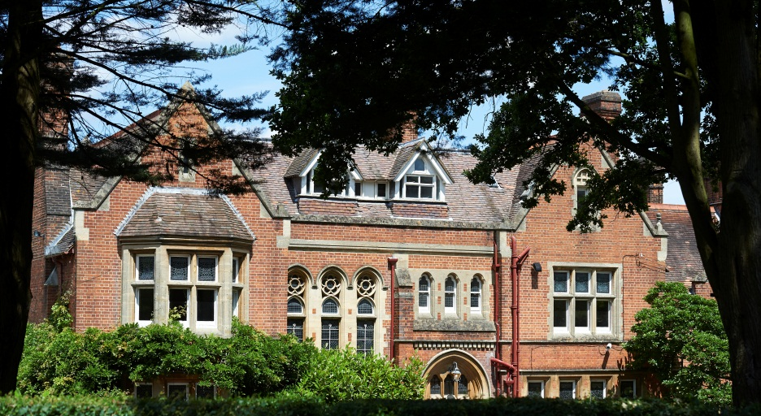

About the College

St Joseph’s College is the leading independent day school for boys and girls aged 3 to 18 in Berkshire. It is fully co-educational and consists of the Senior School (ages 11 to 18) and the Prep School (ages 3 to 11). The Senior School and Prep School are located within a single campus.

Awards
It has won several awards over the last two years including TES Independent School of the Year, Outstanding Progress at the Education Business Awards and Outstanding Leadership Team at the Leadership Awards.

Ethos
St Joseph's is a Catholic school welcoming pupils of every faith or no faith. Pupils are educated in an atmosphere where Christian values and standards are recognised and established. The size of our classes means everyone receives the individual guidance and support they need to achieve their potential. Staff, pupils and parents form strong links, with a focus on both the academic progress and the wellbeing of each pupil. We encourage all pupils to develop an awareness of their own role in society.

Points of Entry
The main points of entry to the school are at age 3, 11, 13 and 16. Entry into the senior school is by formal assessment, and around 60% of applicants to the senior school are from maintained primary schools.

Leavers’ Destinations
The majority of Sixth Form leavers go on to their choice of university, to study a diverse range of subjects. Examination results are strong and improving year on year, however our focus is very much on producing young adults who also have skills for life such as confidence, social skills and a good understanding of the world around them.

Recent Developments
During the past six years the Governors have taken a number of measures to develop the College. In addition to becoming co-educational these include an emphasis on marketing and a substantial investment in facilities, buildings and staff. Consistently rising pupil numbers provide momentum for growth and the confidence to make further investment.

The Future
Looking to the future, St Joseph’s will continue its ambitious plans to enhance and develop the College. However, we will ensure that as we grow, our caring ethos remains at the heart of the College. The warm and friendly nature, together with the way pupils display concern and respect for one another, are often commented upon by visitors and parents. We are proud of this and it is one of the most rewarding aspects of working here.

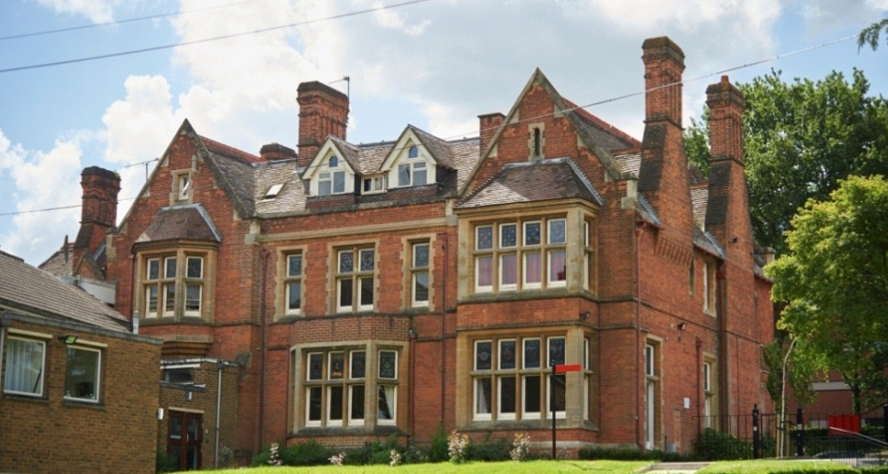

Our Mission and Aims

At St Joseph’s, our mission is to encourage, inspire, challenge and support pupils to fulfil their potential in a community founded on Christian values.

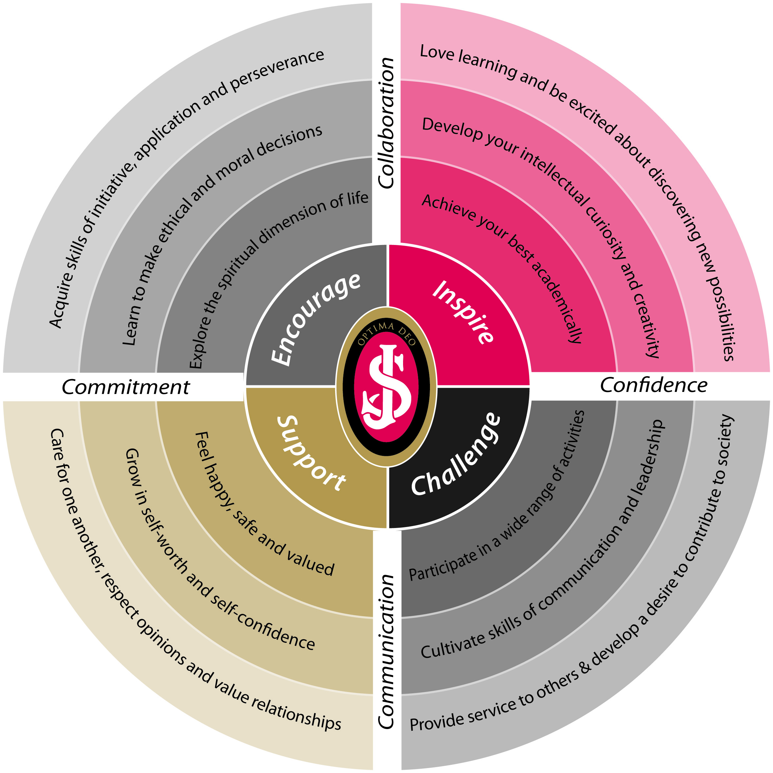

We aim to develop life skills of commitment, collaboration, confidence and communication in each pupil, throughout each of their years at the school.

The College was inspected by ISI in February 2014

The main findings of the report states:
- Attainment is generally high in relation to pupils’ abilities
- The curriculum plan provides pupils with a rich learning experience
- Teachers know their pupils well and offer care, support and guidance which is greatly appreciated by pupils and parents
- The personal development of all pupils throughout the College is excellent
- The relationships between staff and children and amongst the children themselves are friendly and supportive
- The senior leadership team share a clear vision for future development

Why St Joseph’s?

At St Joseph’s we offer:
- A safe and happy environment in which academic and social skills are developed
- Education for boys and girls from age 3 to 18
- A varied curriculum and excellent facilities
- A strong sense of community
- High academic reputation
- Wide range of extra-curricular activities including a strong tradition of music and drama

St Joseph’s is staffed by teachers who combine the best in traditional educational values with a sharp awareness of what is appropriate for pupils who need to be prepared for the twenty-first century. Our pupils are encouraged to be confident, questioning, independent learners, whilst at the same time developing a moral and spiritual sense of purpose in their lives and in their studies.

Salary
The College has its own salary scales, with starting salaries dependent on the experience and qualifications of the successful candidates. Salary scales are reviewed annually by the Governors, to ensure they remain competitive. Annual salary is paid by bank transfer on the last working day of each month, in 12 equal monthly instalments

Non-contractual benefits

Pension
The College participates in the DfE Teachers’ Pension Scheme for teaching staff and a contributory pension for non-teaching staff. Further details are available from the Bursar’s office.

Death in service benefit
In addition to the pension scheme, teachers are entitled to the death in service benefit offered by the Teachers’ Pension Scheme. The College operates a non-contributory group life assurance scheme for support staff.

School fee reduction
Children of teaching staff at St Joseph’s College are eligible for a staff discount on basic tuition fees, subject to passing the entrance assessment where applicable.

Childcare vouchers
St Joseph’s participates in the government’s salary sacrifice childcare voucher scheme. Further details are available from the Bursar’s office.

Eye tests
Members of staff are entitled to a annual eye test.
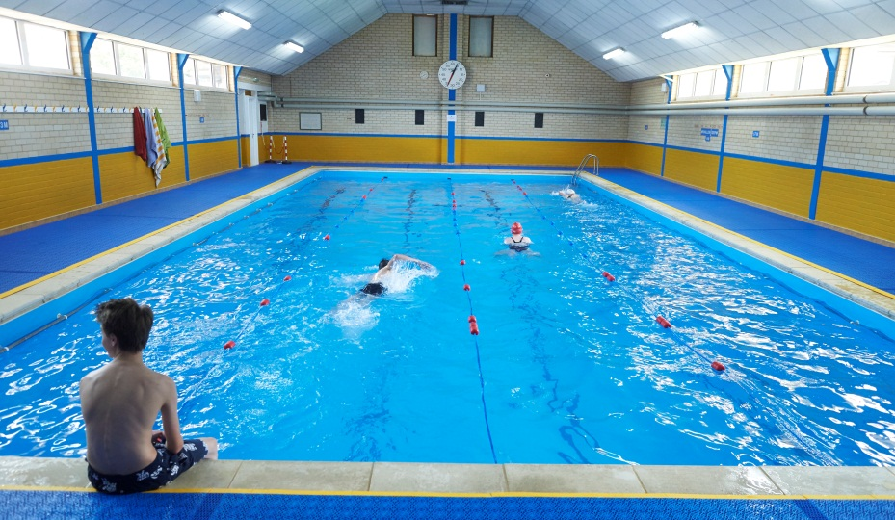

Cycle to work scheme
The school allows staff with an employment contract for 12 months or more to purchase a bicycle through this scheme. Further details are available from the Bursar’s office

Drinks and snacks
Tea, coffee and biscuits are available to all staff at break time, and there is access to hot drinks throughout the day. Snacks and light meals are provided to staff when working later in the evening for school events.

Lunch
Lunch is provided at no cost during term time.

Laptop
Teaching staff are loaned a school laptop to assist with their teaching and administration, and docking stations are available throughout the school.

Use of private vehicle
Subject to a journey being approved by the Bursar or Headmaster, staff can use their private vehicle for school journeys during working hours. The insurance will be under the school’s insurance and staff can claim for mileage.

Car parking
All staff may park in the school car park, subject to the availability of a space. A valid school parking permit must be displayed clearly on the windscreen of any car parked onsite.

Counselling
Staff have access to a 24 hour telephone counselling helpline. In addition, the lay chaplain or visiting school counsellor may be able to see staff.

Legal advice
Staff have access to a 24 hour legal information telephone helpline, covering issues such as consumer rights, debt, tax and personal injury.

Healthcare helpline
A telephone based healthcare support service is available to all staff at no cost.

Swimming pool
Staff are permitted to use the school swimming pool during designated staff swimming sessions.

CPD and training
Professional development is nurtured and encouraged, and the school has a full annual INSET programme. There is strong support for new teaching staff. Newly qualified teachers can undertake their accredited NQT year through the Independent Schools Council programme and a number of members of staff have completed teaching qualifications whilst employed at St Joseph’s.

Staff Room
There is a professional, friendly and supportive Staff Room, together with departmental workspaces throughout the school.

The above non-contractual benefits are currently available to staff. They are at the discretion of the Governors who reserve the right to withdraw them without notice.

Appointment Procedure

- Applications will only be accepted from candidates completing the College Non-Teaching Application Form in full, accompanied by a covering letter.

- The covering letter should illustrate specifically why you think you should be considered for this role, giving clear evidence of how your skills and experience meet the requirements of the role. You should give clear examples, and relate these to the job description and person specification.

- These should be emailed to recruitment@sjcr.org.uk or alternatively sent by post to Mrs Turner, Assistant to the Bursar, St Joseph’s College, Upper Redlands Road, Reading, Berkshire RG1 5JT. Electronic application is encouraged and preferred.

- The closing date for applications is Friday 23 June 2017 and shortlisted candidates are likely to be invited for interview shortly after this date.

- All offers of employment are subject to the receipt of two satisfactory references, one of which must be from your current or most recent employer. For shortlisted applicants for teaching posts, references may be taken up prior to interview.

- St Joseph’s College employs personnel who are best qualified for the post without discrimination in respect of age, disability, race, gender or native origin.

- The College is committed to safeguarding and promoting the welfare of children and young people and expects all staff to share this commitment.

- Successful applicants must undergo child protection screening, including checks with past employers and the Disclosure and Barring Service.

- A copy of the Teaching Staff Application form and the College Recruitment, Selection and Disclosures Policy and Procedures can be found on the College website - www.sjcr.org.uk/417/community/work-with-us
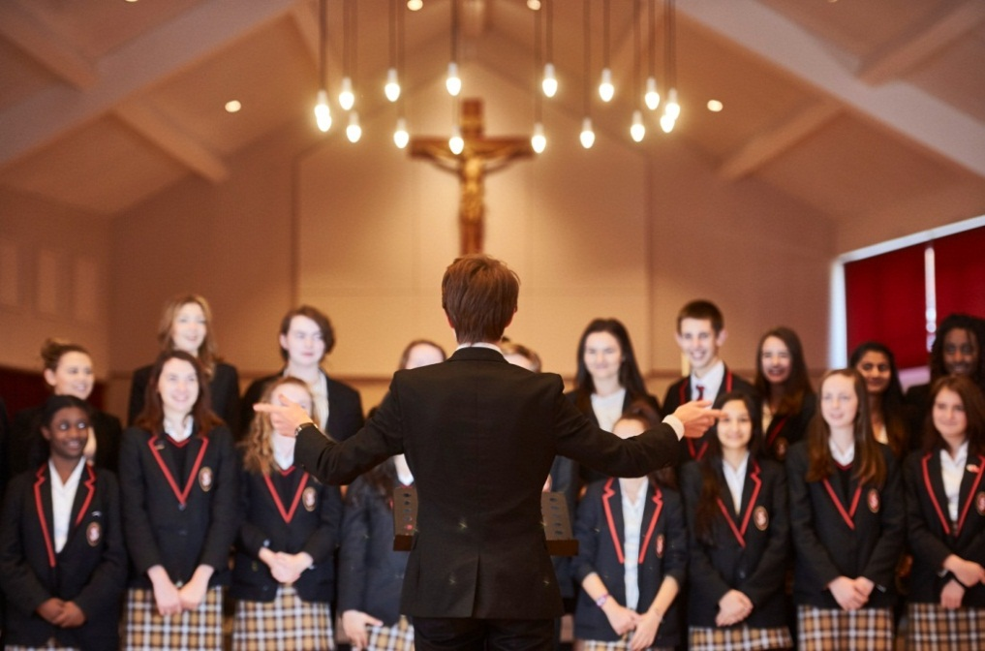

Interview Process

- All candidates invited to interview must bring documents confirming any educational and professional qualifications that are necessary or relevant for the post (e.g. the original or certified copy of certificates, diplomas etc). Where originals or certified copies are not available for the successful candidate, written confirmation of the relevant qualifications must be obtained by the candidate from the awarding body.

- During your visit you should expect to attend a number of interviews with different members of staff. We will also assess your suitability to work with children.

- In addition to formal interviews there will also be an opportunity for shortlisted candidates to tour the College and to meet prospective colleagues.

- If you are invited to interview for a teaching post, you will be required to teach a lesson which will be observed. You will be provided with a brief for the lesson beforehand.

- If you are invited to interview for a non-teaching post, the interview may include other forms of assessment such as administrative tests, a presentation, or a demonstration of relevant practical or other skills.

- The College requests that all candidates invited to interview also bring with them:

- A current driving licence including a photograph or a passport or a full birth certificate
- A utility bill or financial statement issued within the last three months showing the candidate's current name and address
- Where appropriate any documentation evidencing a change of name
- Where the candidate is not a citizen of a country within the European Economic Area or Switzerland, proof of entitlement to work and reside in the UK

Please note that originals of the above are necessary. Photocopies or certified copies are not sufficient.

How to find us

- St Joseph’s College is situated in central Reading, near the University and the Royal Berkshire Hospital. It is close to the M4 (Junction 11) and has excellent transport links

- If travelling by train, the school is approximately 20 minutes’ walk from Reading Station, or alternatively there are a number of local buses that stop close by

- To accurately locate the College entrance at 64 Upper Redlands Road on some GPS satellite navigation systems it may be necessary to use the postcode RG1 5JP

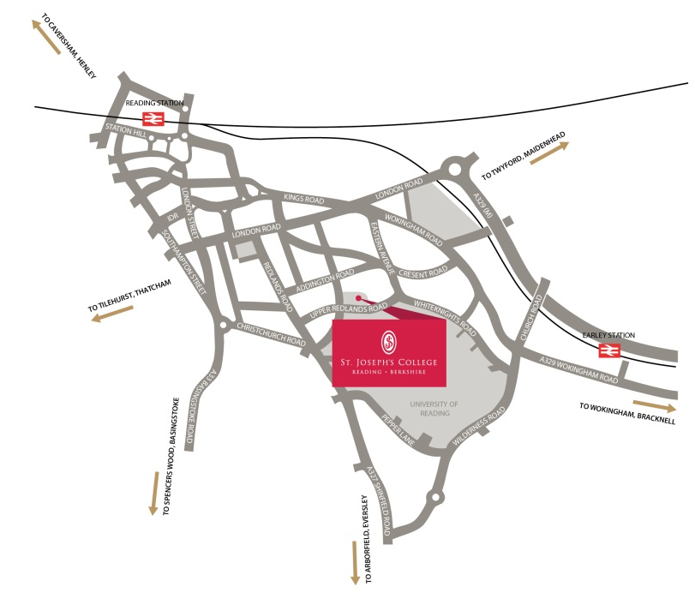
TES independent
School of the Year 2015/16

Outstanding Progress Award Education Business awards 2016

Outstanding Leadership Team Leadership Awards 2016

