THE AREA

The College opened in 1967 and is a mixed 11-16 Foundation School with 761 students on roll. Crookhorn students come from the local communities of Bedhampton, Purbrook and Waterlooville with the majority of youngsters being able to walk to College. Our main feeder schools are Berewood Primary, Mill Hill Primary, Purbrook Junior, Morelands, Queens Inclosure Primary and Springwood Junior. However there is an increasing number of students who come from other local primary schools. Courses for 16+ pupils are also available at Havant South Downs College. 91% of our students go on to one of the local Colleges, 6% into full-time training and employment with the remaining 3% either employed but not currently involved in recognised training, or NEET (1.8% equivalent to two students). The catchment area includes privately owned property and some community housing.

COLLEGE ETHOS

The Four College Cornerstones of Commitment, Responsibility, Respect and Achievement underpin life at our College. These vital principles are part of every aspect of life at the College and over the years have helped transform it to a place where learning has become dynamic, exciting and focused, and where opportunities for personal development have flourished.

We nurture creativity together with sound morals and self-awareness with self-esteem, which, coupled with our academic yet balanced curriculum, enables us to grow confident, young individuals, who are ready to meet the challenges and enjoy the opportunities that life presents. At the heart of Crookhorn is our House system with its emphasis on working together, fostering healthy competition and developing personal interests and positive attitudes.

Teaching and learning is supported by a sophisticated, web-based Learning Management System called ‘itslearning’, which enables and enriches student engagement with their learning.

‘itslearning’ is a digital platform that incorporates a variety of methods for interaction and engagement among students and staff. The key principle is to allow teachers to share resources with students on-line, beyond the confines of the classroom and the text book.

‘itslearning’ also plays an integral part in the completion of homework, to enable the blended classroom concept to become a reality. Homework is set via the platform, and can take a number of forms, from traditional essays to multiple choice quizzes, on-line discussions and watching a clip to prepare for the next lesson.

LOCATION AND BUILDINGS

The College is situated particularly conveniently for the motorway network on the South Coast, in a well-developed area within easy reach of the sea, yet adjacent to the South Downs and the City of Portsmouth. Laid out in spacious, landscaped grounds and housed in well-maintained buildings, it has specialist facilities for science, food technology, textiles, art and design, technology, performing arts and information technology. Classrooms are allocated to the study of English, modern languages, humanities and mathematics. The College has a spacious library, a hall (fully equipped with stage lighting), gymnasium, sports hall and performing arts centre, the latter having been refurbished to include a dance studio.

The sports hall has benefitted from a Sport England grant which was used to install new lighting and flooring. We have floodlit multi use courts which were re-surfaced during summer 2015 and an all-weather playground for student use. The College offers an in-house, fresh food catering service alongside a well-equipped catering facility

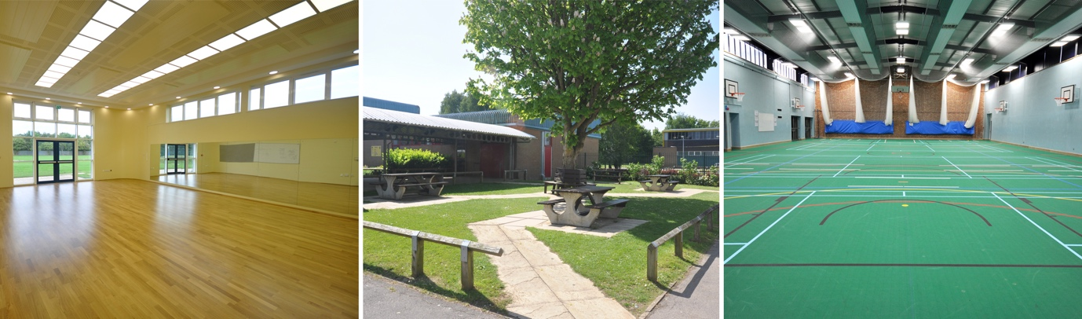

STAFFING

The Headteacher, Mrs Sarah Bennett, is assisted by a five-strong Leadership Group comprising of one Deputy Headteacher, three Assistant Headteachers and an Associate Assistant Headteacher. The College is within Group 6 for salary purposes. The College has a teaching staff of fifty who are supported by a large team of Learning Support Assistants, Study Supervisors and Technicians, as well as administrative, catering and site-maintenance staff.

The College demands the very best of our staff. We set high professional standards and consequently seek to employ only the very best candidates available to us. We believe that all our staff feel that they are part of a team. This ethos is not only amongst departments and colleagues, but, as each and every staff-member is also attached to a House, everyone is part of that wider team and all colleagues are actively encouraged to support their House in activities, competitions and in the general, day-to-day life of the College.

Continuing professional development is valued highly at Crookhorn. Review and development of skills is vigorously supported through appraisal structures and training programmes. As part of the appraisal process, each member of staff has a bespoke individual training plan, in which they are encouraged to identify areas they wish to develop. The College provides a wide range of ‘in-house’ whole day training, disaggregated sessions and seminars as CPD activities, and has a growing library of professional reading resources for staff to access. The College is fully committed to developing a genuine ‘coaching’ culture and all staff are allocated a classroom coach who visits regularly and provides coaching feedback over the academic year.

THE CURRICULUM

At the start of the academic year all students receive their own timetable, which consists of six fifty-minute lessons each day apart from Tuesday, when students complete five lessons and finish College at 2:45pm.
Throughout Years 7 and 8, all students follow a wide range of courses, which offer a broad and balanced curriculum. Although there is an emphasis on the core subjects of English, mathematics and science, the curriculum is designed to give our students a wide range of experience in many of the creative and technical subjects. All students study technology, a modern foreign language, history, geography, Physical Education, computing and each of the creative and performing arts subjects, including drama and dance.
In Years 9, 10 and 11, all students continue to study the core subjects, core PE and Personal, Social and Health Education, which includes Careers and Guidance. In addition, students specialise in their studies by choosing options from a range of subjects, after considering the extensive advice and information offered by the College Careers and Guidance Service. Each student has an individual interview in Years 8 and 9 to help guide them through their selection process. As part of our GCSE options, we offer many exciting and varied courses, such as photography, business studies, engineering and sociology.

On entry to the College students are assigned to a mixed ability vertical tutor group with their own tutor who will normally be with them throughout their College career. Most classes are organised into ability sets based on students’ prior attainment at Key Stage 2 and then testing when they arrive at Crookhorn. The attainment and progress of individual students is monitored very closely by teachers and tutors. Reports are sent to parents between three and five times a year depending on which year group a child is in. Parents are invited into College five times a year to discuss and review their child’s progress with the subject teachers and are also encouraged to attend three progress reviews throughout the year with their tutor.

The College encourages all students to be independent learners and to use our excellent library which allows extensive access to the internet and a wealth of support materials. Throughout the year, curriculum areas organise a number of extra-curricular activities to enrich students’ education. Our active links with Southampton, Chichester and Portsmouth Universities are part of our programme of challenge days, workshops and public performances, which provide further opportunities for students with particular talents and interests to excel.

Homework is an essential and integral part of the learning process both inside and outside of the classroom. It is the responsibility of all staff to ensure homework is used to promote the quality of student’s learning. Homework is most effective when staff are consistent in their approach, parents are supportive of the College practice and students are able to perceive the benefits of their efforts. Homework can be a range of activities and could involve short regular tasks or longer pieces of written work.
Homework will be given at least once a fortnight in the core subjects of English, maths and science, although dependent upon the requirements of the topic being covered, additional homework tasks may be appropriate. There will be times when the core subjects will set ‘Learn It’ tasks which are weekly and will be set via an online platform and these will often be marked online. Regular homework, approximately once every two weeks, will be set in geography, history, computing, RE and MFL. The creative arts, technology and PE will set homework when the teachers feel it is appropriate to the programme of study during each half term. Homework/Study should take approximately sixty minutes per day to complete at KS3. Independent study/reading should also be an expectation at KS3.
All homework will be accessible to the students via their ‘It’s learning’ course page, which parents can access through their child’s account.
We were the first secondary school in Hampshire to achieve the accolade of "Investors in People" accreditation. We have been re-accredited five times since and praised for the staff’s high level of commitment. We were awarded “Investors in Careers” status in 1998 and have been successfully re-accredited every year since. In 2003 we were first awarded the Advanced Healthy School Award which complimented our care of students and the environment, and again have maintained successful re-accreditations since. In August 2008 we received the International Schools Award (re-awarded in 2015) recognising our commitment to broadening student education beyond the boundaries of the College.

RESULTS

GCSE results are very strong, with 60% of students gaining a standard pass in both English and maths. 80% of our students last year gained a standard pass in English, far exceeding the National Average, with 64% achieving the same in maths. Our Attainment 8 figures was 42.15, with many subjects performing extremely well.

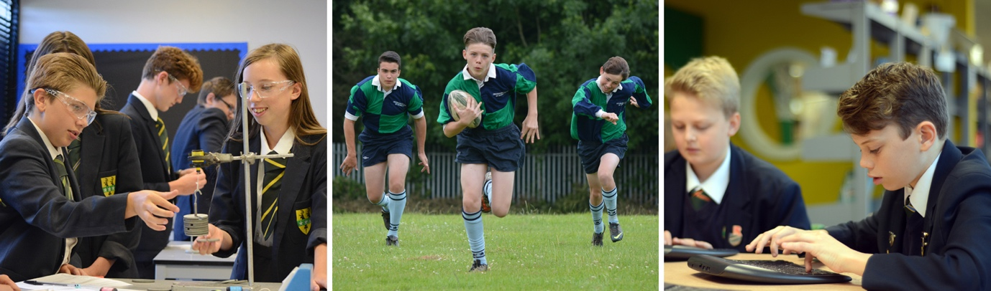

COMMUNITY AND OTHER ACTIVITIES

The College has a wide range of extra-curricular activities which have proven to be both popular and successful. The College operates its own ‘in house’ work experience programme, whereby students in Year 10 spend two weeks with an employer at the end of the Spring Term. This provides our students with a valuable insight into the realities of employment, as well as providing many with relevant, useful skills which are transferrable to further education and careers.

We aim to make our College as open and accessible to all members of our community. As a College we make our facilities available for use to a range of local sports clubs as well as theatre groups and arts and craft societies. Our students benefit from the use of facilities provided through community funding and also from the activities provided.

Breakfast is available from 8.15am daily in the dining room and is popular with staff as well as students! Our library is open each day from 8.30am and facilitates our Homework Club after College. The College aims to provide all our students with extra-curricular access to the library as widely as possible in order to encourage their independent learning and provide additional opportunities for the completion of homework.

We have strong links with local primary schools and regularly host events for Key Stage One and Two children. These include “Professor Cranium’s Cavern of Conundrums”, a literacy, numeracy and science activity for Year 2 children, as well as More and Most Able workshops in photography, science and cooking for Years 5 and Year 6 children. Our teachers work closely with their primary colleagues to develop the pedagogy and understanding of the primary curriculum.

The Duke of Edinburgh Award Scheme as well as the bi-annual ski trip are very popular opportunities for students to excel in outdoor pursuits. During the Duke of Edinburgh Award Scheme, students make a significant commitment to achieving in all four areas of the award including the overnight assessed expeditions to the New Forest.

Our Governors are particularly keen to appoint colleagues who are committed to sustaining this range of opportunities for all our students.

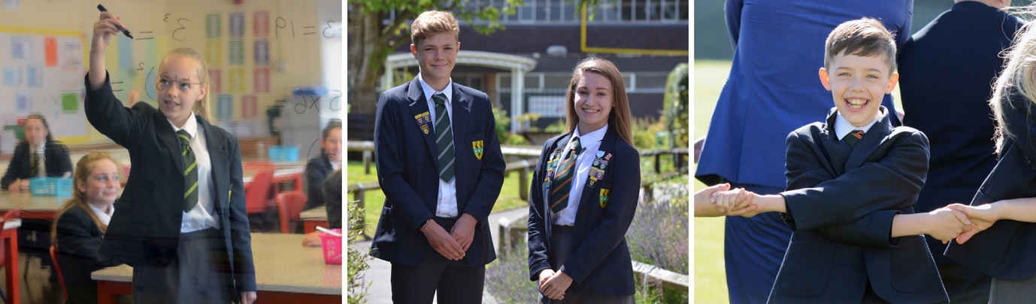

PASTORAL CARE

On entry to the College all staff and students are assigned to one of the four Houses: Arundel, Goodwood, Petworth or Romsey. The house tutor groups are organised on a vertical structure and so have a mix of students from Year 7 to Year 11. The system lends itself to a full collegiate ethos, where mentoring and peer support are central to the development of the individual.

The Houses have a Head of House. The Heads of House are assisted by two Assistant Heads of House, who work across all four Houses. There are a variety of senior student roles within the House, including a House Captain and a Senior House Prefect from Year 11. Other roles available include those of Sports Captain, Events Captain and College Council representatives.

The House system offers a range of opportunities for students to demonstrate their skills, hobbies and interests as well as providing the everyday encouragement to excel academically. This is enhanced by the range of inter-House competitions and the College rewards system.

The individual welfare of the students is undertaken by the closely linked team of House tutors and Heads of House, all of whom are available for discussion of student progress, difficulties and problems. An Assistant Headteacher is responsible for co-ordinating this team and the links to outside agencies such as the Education Inclusion Service, the Educational Psychologist and Education Welfare Services. The College also has a full-time Student Support Manager, supported by an extensive, non-teaching Pastoral team who oversee the wide range of interventions and provision that are required for individual students to ensure their safety, wellbeing and ability to engage with education.

Twice a year all colleagues are involved in “Student Progress Review” sessions with members of their tutor groups. Student progress, behaviour, attendance and achievements are all reviewed and targets for improvement are set. Parental attendance at these sessions is considered extremely important.

The College has a personal, social, careers, citizenship and health education curriculum with a wide range of resources in place to ensure the delivery of a broad pastoral programme. This is taught in dedicated curriculum sessions and reinforced in a programme of assemblies and tutor group activities. The pastoral curriculum in all aspects is specifically designed to enhance the Four Cornerstones, upon which the whole ethos of the College is built.

SAFEGUARDING

All Crookhorn College staff share the responsibility to promote and safeguard the welfare of children and young people for whom they are responsible or with whom they come into contact. In doing so, staff are expected at all times to adhere to and ensure compliance with the College’s Safeguarding Policies and Procedures.

Crookhorn College is committed to safeguarding and promoting the welfare of children and young people and expects all staff, volunteers and other third parties to share this commitment. Safer recruitment practice and pre-employment checks will be undertaken before any appointment is confirmed.

COLLEGE UNIFORM

Students are encouraged to be proud of their uniform, and high standards are set and maintained in how it should be worn. The uniform is specially designed to link with the House system. Each student wears a blazer and has a tie which sports their House colours. For PE, students also wear a t-shirt that corresponds to their House colours. This has proved very popular with the students and gives them a sense of pride in their uniform.

ETHOS AND COMMITMENT

A strong belief in and emphasis on the College Four Cornerstones Commitment, Responsibility, Respect and Achievement underpins everyday life here at Crookhorn College. There is a strong commitment to effective teaching and learning that challenges individuals to achieve their potential. An effective More and Most Able programme links with feeder schools, colleges and universities to provide extended opportunities for students. Excellent learning support for students exists, ensuring that all individuals are able to take advantage of the opportunities presented to them.

Participation in extra-curricular activities forms an integral element of our enrichment programme. Students perform creditably as individuals and teams at House and inter College level. There are opportunities to showcase talent in the creative arts throughout the year. Furthermore annual House competitions serve to raise the profile of all curriculum areas in the challenge to gain prestigious awards in the end of year assembly.

Support from parents is positive at Crookhorn: Parents’ evenings are well attended, College performance audiences are always full and the Parents Association actively supports and raises funds to further the opportunities available in College, as well as donating to local and national charities.

Successful applicants for posts find themselves rapidly welcomed into this hardworking, happy and thriving community from which, in recent years, a number of colleagues have gained promotion to most levels of the profession.

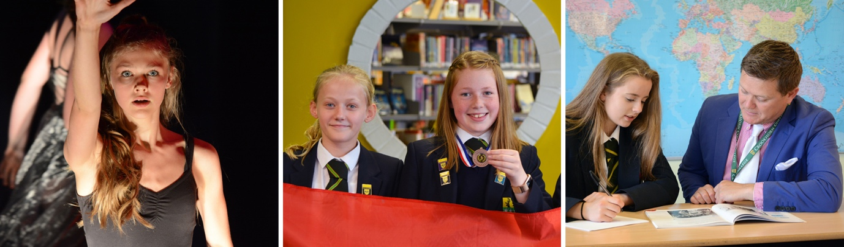

GOVERNING BODY

The Governing Body consists of eighteen Governors, representing the Local Authority, parents and staff as well as co-opted and partnership Governors. They sit on five committees – human resources, finance and estate, student development, student achievement and strategic planning, all meeting on a termly basis.

