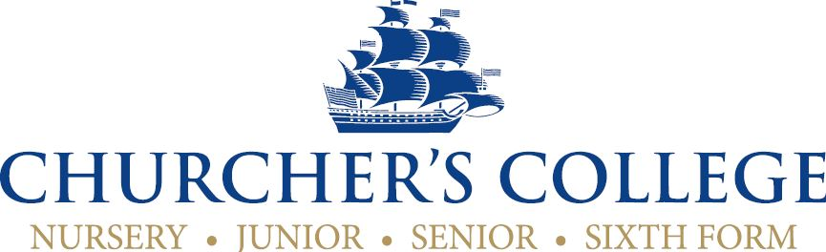

School Librarian (Part time – Term Time)

Background to the school
Churcher’s College is an independent, co-educational, HMC day school, which offers a distinctive education to pupils from the age of 4 to 18. Currently there are over 825 pupils in the Senior School (11-18) in Petersfield, and on another site in Liphook, over 225 pupils in the Junior School and Nursery (3-11). Our aim is to educate and prepare young people in order that they may participate successfully and responsibly in society. We aim to provide a high standard of education for all pupils based upon traditional values and academic standards, personal discipline, and the development of self-confidence. This is accomplished within a caring environment on an open site with the beautiful South Downs as a backdrop.

Background to the role
An enthusiastic individual is required to join the Library staff; this role is essentially a job share and you will be jointly responsible for the smooth and efficient running of the Senior School Library reporting to the Deputy Head Academic.
The main duties of the post will be:
- The smooth running and operation of the College Library facility
    - Instigating programmes which facilitate the use of resources
    - Routine tasks necessary for the smooth, day to day running of the Library
    - Providing and managing resources
    - Cataloguing and ordering of books
    - Operating the circulation system (Oliver by softlink) – using, reserving and returning books.
    - Providing an attractive, stimulating environment by the use of topical displays, posters, etc.
    - Ensuring that the Library stock has been catalogued and kept up to date

  - Assist and supervise pupils in:
    - Using the Library for individual study and ensure the proper use of the Library by students
    - Locating, retrieving, interpreting, evaluating and presenting information.
    - Provide opportunities and activities which encourage independent learning skills
    - Overseeing the Library computer system and pupil use of the IT equipment and network services.
  - Maintaining an effective partnership with teachers to:
    - Identify their curricular requirements and match these to relevant resources
    - Promote and evaluate learning resources and learning skills
    - Order books in conjunction with the Heads of Department to the budget allocated by the Headmaster

Personal Qualities:
- A love of books and reading with the desire to share that with young people
- Approachable and adaptable working style
- Team player
- Able to work alone and use initiative.
- Ability to adjust communication style to differing audiences including a range of pupils.
- Well presented, with welcoming manner
- Strong communication skills both verbal and written
- A passion to help children learn and develop to their potential

Skills and Experience
- Working knowledge of Microsoft Office, including Word, Excel and Outlook
- Experience with Library systems preferred but not essential as training can be given.
- Previous experience working in a school would be beneficial but not essential.
- Some experience working with children or young people.
- Knowledge of current research and referencing techniques would be beneficial but not essential.
Employment Terms:
Location: Churcher’s College Senior School, Ramshill, Petersfield GU31 4AS
Responsible to: Deputy Head Academic
Hours: 12 noon to 17:30 Monday, Tuesday, Thursday and 10am – 17:30 Wednesday and Friday (Term Time only = 35 weeks plus 5 weeks paid holiday)
Pay: £24,500 FTE depending on experience.
Holiday: Five weeks per annum to be taken during the school holidays.
Start date: Oct/Nov 2017
Trial period: Three months
Notice A written notice period of half a term is required for either the Employer or Employee to reasonably terminate the employment Contract.
Pension: The post holder is entitled to join the Local Government Pension Scheme.

To Apply Please complete the application form (available from the website) and send with CV and letter of application to Nicci Kilpatrick, HR Officer, Churcher’s College. Ramshill, Petersfield, Hampshire GU31 4AS, or by email to recruitment@churcherscollege.com.
Vetting/recruitment As a consequence of the Children Act, all staff appointed to positions at Churcher’s College must undergo a DBS check. A copy of the school policy on DBS is available on request.
Two written references will be required and any gaps in employment records will be investigated. It is also necessary for all staff to notify the Headmaster before appointment of any convictions, or other factors which may be relevant to their employment in a school environment.
Churcher’s College is committed to safeguarding and promoting the welfare of the children and young people and expects all staff to share this commitment.
Churcher’s College aims to be a fair employer and is committed to equal opportunities and Churcher’s College does not discriminate against employees on the basis of gender, ethnic origin, disability or age.
Closing date: 12 noon – 25 September 2017 (early applications welcome)
Interviews Will be arranged as soon as possible to facilitate start date.

