Learning Support (LS)Policy

Incorporating Special Educational Needs (SEN), English as an Additional Language (EAL), Learning Difficulty (LD) and Gifted & Talented (G&T)
  - For Ta’allum Schools
POLICY 20
  - Reviewed for 2018-2019

Approvals
The signatures below certify that this Policy has been reviewed and accepted, and demonstrates that the signatories are aware of all the requirements contained herein and are committed to ensuring their provision.
 | Name | Signature | Position | Date
Reviewed by | Sheldon Smith |  | Principal-AJA
Reviewed by | Shuja Uddin |  | Principal- AMAB
Reviewed by | Maha Teema |  | Principal- AMAG
Reviewed by | Neelam Bhatti |  | Head of Learning Support (AJA)
Reviewed by | Amal Atif Ibrahim |  | Head of Learning Support (AMAB & AMAG)
Reviewed by | Najoud Ensaff |  | Consultant - Primary
Reviewed by | Katrina Reece |  | Consultant- Secondary
Reviewed by | Mohammed Abuqadah |  | Consultant- Arabic
Reviewed by | Dr.Mohammad Saefan |  | Education Director
Approved by | Ahmed Al Mannai |  | CEO

Amendment This Policy is reviewed annually to ensure its continuing relevance to the systems and processes that it describes. A record of contextual additions or omissions is given below.
Page no. | Context | Revision | Date
All | Thorough revision of Policy to reflect progression in Learning Support thinking to incorporate SEN, EAL and G&T provision. | Heads of Learning Support, SSIC, PSIC | March 2018

Table of Contents
Ta’allum Vision, Mission and Motto 4
Ta’allum Schools Learners Outcomes 5
Abbreviations 6
Learning Support Vision and Mission 7
Learning Support Policy Aims and Objectives: 8
Procedural Definition of Special Educational Needs (SEN), English as an additional language (EAL), Learning Difficulty (LD) and Gifted & Talented, (G&T) 8
Learning Support Department Program 9
Identification of Learning Support Students 10
Initial School Admissions/ Enrolment Identification (See Appendix A) 10
Enrolled Student Learning Support Identification 10
EYFS 11
Primary 12
Secondary 12
Interventions 12
Individual Education Plans (IEP) 12
Mainstream and Wave 1 Students 13
Individual Educational Plan for Wave 2 and 3 LD students. 13
Progression within Waves: 14
Parental Involvement: 14
Exam Access Arrangements: 14
External Report for Parents of LS Register Students 15
Able and G&T Educational Provision 15
In-Class Provision 16
Out of Class Provision 16
Confidentiality 17
Shadow Teachers (ST’s) 17
Appendix A: Procedures of Enrolment to Learning Support 21
Appendix B: Wave Intervention 22
Appendix C: Common Characteristics of Able & Gifted Individuals 25
Appendix D: LS Timeline & Key Events 26
Appendix E: Request for Learning Support Assessment – Referral Form 29
Appendix F: Examples of EAL support strategies for teachers 30
Educational Achievement 30
Language Development: 30
Social Integration: 30
Appendix G: Roles & Responsibilities 36
Appendix H: Learning Support Parent Meeting Template 39
Appendix I: 5 Stage Model of English as an Additional Language Acquisition 44
Appendix J: Procedure for supporting EAL students Enrolment 45
Appendix K: Learning Support Department Learning Walk Monitoring Tool 46
Appendix L: Learning Support Teacher & Classroom Teacher Conference Notes 47
Appendix M: Shadow Teacher Agreement 48

Ta’allum Vision, Mission and Motto

Ta’allum Group’s Vision
We aspire towards being a progressive institution of learning experiences by offering a quality education based on an Islamic ethos that aims to serve humanity.

Ta’allum Group’s Mission
To establish premier educational institutions which are committed to a unique brand of holistic education.

Our goal is to help every child to learn and acquire Islamic knowledge alongside building a solid foundation in all academic subjects. This will help them develop and gain true Islamic values and thereby make a valuable, correct moral and social contribution to the community in which they live.

Ta’allum Group’s Motto
‘’Creative learners today, our future leaders’ tomorrow”

Ta’allum Schools Learners Outcomes

Academic Achievement and Leadership with Islamic Values are the characteristic hallmarks of our students. Here at Taállum schools we believe that in order to ensure all our students to achieve at the highest level we need to actively support them through curriculum and enrichment in developing the right characteristics. This is what distinguishes our students from other.
Learner Outcome 1 | Our students are Academic
Strand 1:1 | They are lifelong learners
Strand 1:2 | They are creative thinkers
Strand 1:3 | They are bilingual
Strand 1:4 | They are confident
Strand 1:5 | They are innovative
Strand 1:6 | They are independent
Learner Outcome 2 | Our students are Leaders
Strand 2:1 | They have strength of character
Strand 2:2 | They are organised
Strand 2:3 | They are confident
Strand 2:4 | They are responsible
Strand 2:5 | They are future leaders
Learner Outcome 3 | Our students practice and exemplify Islamic values
Strand 3:1 | They adhere to the Five Pillars of Islam
Strand 3:2 | They have good morals
Strand 3:3 | They are polite
Strand 3:4 | They are considerate

Abbreviations

AESN | Additional Educational Support Needs
AJA | Al-Jazeera Academy
AMAB | Al-Maha Academy for Boys
AMAG | Al-Maha Academy for Girls
CAT | Cognitive Ability Test
CTOPP 2 | The Comprehensive Test of Phonological Processing
EAL | English as an Additional Language
ESL  G+T | English as a Second Language  Gifted and Talented
HoD | Head of Department
HoLS  HoS  IEP | Head of Learning Support  Head of School  Individual Educational Plan
JCQ | Joint Council Qualifications
KG | Kindergarten
LD  LS | Learning Difficulties  Learning Support
SEC | Supreme Educational Council
SEN | Special Educational Needs
SENCO | Special Educational Needs Co-Ordinator (Manager)
SMT | Senior Management Team
SNAP | Special Needs Assessment Profile
SPLD | Specific Learning Difficulty
TA/LA  ST  DFE | Teaching Assistant/Learning Assistant  Shadow Teacher  Department For Education (U

Learning Support Vision and Mission

“Schools have a duty to remove the barriers that prevent such students (SEN) from receiving the full range of educational experiences to which they are entitled” (SEC Policy 2009)

Vision
Taállum schools’ approach to Learning Support represents a collaborative effort, involving key stakeholders from the school, family and community in developing an appropriately inclusive educational programme and personalised offering for each student.

We aim to meet the varying needs of all students through awareness of individual needs, adapting and modifying the curriculum where appropriate, and equipping all students with independent learning skills so that they are better able to access the curriculum.

Cultural, Islamic and Tarbeya values are central to our approach.

Mission Statement
Through a structured admissions process, followed by a rigorous system of referrals, assessments and provision expectations, the Learning Support and Academic teams, ensure that student needs are addressed and catered to at all times. This ensures that individual students are supported throughout their educational journeys, securing them opportunities to achieve and become confident members of the wider community.

Accessibility
The Ministry of Education in Qatar (MoE) states that all students deserve the right to participate in all educational experiences. The MoE believes that whenever possible, Special Needs students should be taught in a normal classroom setting and be included in all aspects of school.

Within Ta’allum schools there is provision for students with mobility restrictions i.e. wheel chair users to access all areas within the school via lifts. There are also disability access toilets located at each of the school sites.

Students at Ta’allum will not be restricted access to education due to a physical disability unless there is a medical recommendation for the student to remain away from the school site.

Learning Support Policy Aims and Objectives:

- Ensure high quality, inclusive Learning Support provision to meet the needs of all enrolled students and enable access to a broad, challenging and balanced curriculum which aims to enable all students to achieve their fullest academic and extra-curricular potential
- Ensure that the Learning Support (SEN, LD, G&T, EAL) needs of students are rigorously identified, assessed, provided for, monitored and evaluated at both mainstream and LS Department level
- Make the expectations, roles and responsibilities for all stakeholders, including parents, clear for all LS processes
- Identify the roles and responsibilities of staff in overseeing and providing for a student’s support & enrichment needs
- Enable students and their parents to be involved in all relevant processes and participate in decision-making as appropriate
- Collaborate with community partners in education, health and social care, where appropriate, to provide support
- Ensure students are prepared for the competitive life beyond school, further study and adulthood
- Continuously raise achievement, attainment and deep understanding in all areas, providing opportunities for acceleration and early entry as appropriate

Procedural Definition of Special Educational Needs (SEN), English as an additional language (EAL), Learning Difficulty (LD) and Gifted & Talented, (G&T)

This policy incorporates consideration of the four main areas of Learning Support as detailed:

1) SEN: Ta’allum Schools regard students as SEN if they have a significantly greater difficulty in learning than the majority of students of the same age. They may also have a disability that prevents or hinders them from making use of educational facilities of a kind generally accessed by students of the same age.

2) LD: A student who has a learning difficulty may have neurological-based processing difficulties. These processing difficulties can interfere with learning basic skills such as reading, writing and/or math. They can also interfere with higher-level skills such as organization, time planning, abstract reasoning, long or short-term memory and attention.

3) EAL: The term EAL is used to refer to students who speak English as an additional language, whose native language at home is not English. Some students who speak English as an additional language may be at an early stage of acquiring the language, new to English and even unfamiliar with the Roman alphabet. Some may already speak, understand or to be literate in more than one language.

4) Able and G&T students are defined as:

- An Able Student is one who achieves, or has the ability to achieve, at a level significantly in advance of his/her peer group or significantly above (3 grade boundaries above expectation may be used as a general guideline) than expected for his/her age. This may be in all areas of the curriculum or in one or more specific areas.

- A Gifted Student is one who is in the top 5-10% of the student population of the school or class group and who ‘has the capacity for, or demonstrates high levels of performance in an academic area, such as in English or Mathematics.

- A Talented Student is one who is in the top 5–10% of the student population at the school or class group with a specific practical skill in a non-academic area, for example PE.

(See Appendix C: Common Characteristics of Gifted Individuals for additional guidance)

Learning Support Department Program
Those enrolled specifically in the Learning Support Program for SEN, EAL and LD’s are provided special provisions tailored to their individual needs. The level of support is categorised by the ‘Wave’ (see Appendix B: Wave Intervention). The level of provision offered to students is based on both internal and external observations and assessment information as available. Appendix B illustrates the correlation between need and the level of support offered. Considering each student’s Special Needs and Assessment Profile (SNAP), EAL assessment outcomes and G&T results, the student is placed in one of the Waves. In some cases this may be subject to change based on individual student consideration.

Identification of Learning Support Students

See also: Appendix A: Procedures of Enrolment to Learning Support, Appendix B: Wave Intervention, Appendix C: Common Characteristics of Gifted Individuals, Appendix I: 5 Stage Model of EAL Acquisition, Appendix J: Procedures for supporting EAL student Enrolment.

Initial School Admissions/ Enrolment Identification (See Appendix A)

To ensure identification at the admissions stage, any potential learning support student (including EAL and G&T students), identified through regular entrance screening at the admissions/ school enrolment stage will be referred to the Head of Learning Support.

The HoLS will liaise with the relevant Head of School to agree additional assessment needs (SNAP, EAL or teacher assessments etc.) and/or approve student enrolment and ensure awareness and communication of needs upon entry.

Any student who is assessed at Stage A (new to English) or early Stage B (early acquisition) of EAL must be admitted to Learning Support if they are accepted for enrolment (See: Appendix I – 5 Stage Model of EAL Acquisition).

The above will be documented using the Confirmation for Accepting LS Students template - see: Appendix D.

NB. The admission of students with profound needs ceased from Sept 2015.

Enrolled Student Learning Support Identification

All academic staff are required to proactively monitor their students and refer any students of concern to the Head of Learning Support for assessment via their direct line manager and Head of School. The below process applies alongside the Request for LS Assessment referral form contained in Appendix E.

NB. This form may also be used by parents who are requesting a LS assessment.

14 days from referral (1)
Within 48 hours following assessment
Confirmation for referral within 72 hours from HOS
Conducted 72 hours following parent confirmation
Student observation completed within 72 hours of referralerral receipt
Obtained within 48 hours of observation

EYFS
In EYFS, baseline assessments are conducted in the first six weeks of the academic year in collaboration with teachers and co-ordinators to determine the age band at which students are working in the Prime Areas of learning. If, during EYFS, students are identified as having particular needs, these will be accommodated through support from the teaching assistant and teacher, and through a modified curriculum. In some instances, where appropriate, a shadow teacher will work with the student.

The Head of EYFS will liaise with the Head of Learning Support to ensure that support provided to students, including that provided by a shadow teacher, is meeting students’ needs, and that students enter Primary School having achieved a good level of development and are adequately prepared for the challenges of new learning.

Primary

In the Primary school, baseline assessments are carried out in September. Concern sheets are completed by classroom teachers and referred to Year Leaders for discussion and approval by the Head of Primary. If students are judged to have particular LS needs, they will be referred to Learning Support for an assessment. In some instances, a shadow teacher may work with the student. The Head of Primary and Primary co-ordinators will liaise with the Head of Learning Support to ensure that support is provided and that the student’s learning needs are met.

Secondary

In the Secondary school, baseline assessments are carried out in September. Concern sheets are completed by subject teachers and sent directly to the Head of Learning Support for assessment - after approval by Heads of Subject and the Head of Secondary.

In some instances, a shadow teacher may work with the student. The subject teacher, Heads of Department & Heads of Secondary will liaise with the Head of Learning Support to ensure that support is provided to the student and that their learning needs are met.

Interventions

Ta’allum schools will implement a whole school approach to embed LS interventions and enhance individual student attainment and learning:

This will incorporate:
- Early diagnosis and focused intervention for Literacy, Numeracy and Arabic difficulties
- Effective diagnostic assessment & use of best practice diagnostic tools
- Individualised, student centred approach to intervention
- Incorporation of evidence-based strategies for effective LS teaching

Students with English as an additional language (EAL) constitute the vast majority of Ta’allum students. It is expected that all teachers will willingly undertake CPD on catering for EAL in the mainstream classroom, maintain and develop their awareness of appropriate strategies, resources and tools, and incorporate these in all learning experiences.
An EAL resource box is to be available in all mainstream Primary classes to support students with EAL needs.

Individual Education Plans (IEP):

All students on the Learning Support register will have an IEP which records targets and strategies to address specific needs and help the student progress and optimise their achievement. IEP’s will be reviewed by Learning Support teachers four times per academic year, in consultation with Classroom/ Subject Teachers, Parents and Shadow teachers as applicable. Heads of School and relevant Heads of Department/ Year Leaders will be provided copies.

IEP’s are a working document developed by the LS teacher with input and support from relevant academic staff. The IEP identifies:

- 2-5 short term targets set to meet the individual student’s needs – reviewed 4 times per academic year and shared with parents, academic staff and students (where appropriate)
- Suggested teaching strategies to be used
- The provision to be implemented
- When and how frequently the plan is to be reviewed
- Achievement/ progress towards Targets and Outcomes
- Only what is additional to or different from the differentiated, mainstream curriculum provision.
- Parents (and students) have the opportunity to attend formal parent meetings twice yearly, to discuss their student’s progress.

Mainstream and Wave 1 Students
Class and subject teachers will address the needs of all mainstream and Wave 1 students through appropriate, individualised and group differentiation in mainstream classes.

Once a student is classified and enrolled in the LS support program, the following guidelines apply:

Individual Educational Plan for Wave 2 and 3 LD students.
An IEP (Individual Education Plan) will be developed by the support teacher in consultation with the student (applies to upper KS2 and secondary students only), parents, and relevant teachers. In Primary, the IEP will be developed by the support teacher in consultation with the home room teacher and parent. A decision will be made at this point, based on the evidence available, as to whether the student will receive individual support from the Learning Support team. The IEP will be reviewed and updated in line with mid and end of semester reporting. Students and parents will be invited to contribute to the target setting and review process.

If the school has evidence that a student is making insufficient progress despite significant support and intervention at Wave 3, then it may be necessary to seek further advice and support from outside professionals (e.g. Rumailah Hospital).

Progression within Waves:

Learning Support Student progress will be tracked and documented on an on-going basis. The tracking will serve as an additional measure to determine academic growth and/or identify further assistance required to meet student needs.

The decision to move a student between waves will be led by the Head of Learning Support and will include feedback from subject/ classroom teachers, year leaders (Primary), Heads of Department (Secondary) and Heads of School as a minimum. Decisions will be based on the following considerations:

- Progress towards and achievement of IEP targets
- Progress in class tasks/ activities and assessments
- Perceived ability to independently self-manage within the mainstream classroom

Finalising the change between Waves will be agreed and communicated with parents and evidenced using Appendix H: LS Parent Meeting Template. The Learning Support Register (including SIMS) will be updated and all relevant staff, including SMT will be informed.

Parental Involvement:

Parents are encouraged to participate in the learning and development of their child. Parent meetings will take place formally in both semesters, following the IEP and assessment timelines to ensure informed discussions.

Informal, regular communication will take place throughout the semester with the Head of Learning Support, Classroom/ Subject teacher and Learning Support Teacher to ensure parents are kept informed of their child’s progress and support requirements.

Where necessary, schools will support parents in contacting external agencies when their child requires more intensive support, or a service that the school is unable to provide. (Appendix H: Learning Support Parent Meeting template will be used to record these communications).

Exam Access Arrangements:

Based on best practice and the MOE guidelines, students registered in Learning Support (Wave 2 and 3) may require some alternative arrangements (accommodations) to enable them to equitably access assessment activities. These may include:

- additional time
- the use of assistive technology to overcome severe print-related barriers
- the use of a reader when reading is not being assessed
- the use of a scribe when writing is not being assessed
- the use of a calculator when computation is not being assessed
- modified test papers
- small group setting
- rest breaks
- prompts to keep students on task

When Wave 3 and Rainbow students are registered in Learning Support they can be provided with access arrangements and will be accredited a passing grade – which must be clearly identified in SIMS as a Wave 3 pass. The progression and retention rules will not normally be applied to Learning Support Wave 3 students, though this may be subject to review on a case by case basis. Some severe Wave 3 students may be able to sit the modified assessment.

Wave 3 and Rainbow students with a profound learning need will complete modified exams suited to their needs and level in English, Math and Arabic subjects only. HoLS will oversee assessment adaptations with HOS.

Wave 2 students will sit standardized assessments which will be moderated/ differentiated appropriately. HoLS will oversee assessment adaptations with HOS.

The Heads of Primary and Secondary will agree with the Head of Learning Support the additional time and provision for student access arrangements. The additional time may be up to 25% extra and will be consistently applied for all students within the same Wave.

External Report for Parents of LS Register Students (End of Semester and Academic Year)

The class/ subject teacher is responsible for writing the student’s report compiling input from all relevant staff. The reports will inform parents of progress made by the student, as well as targets and recommendations to progress learning. This report will be distributed to parents at the end of each semester, in line with mainstream timelines.

At end of year reporting, HoLS will also provide an overview of Wave 3 student progress.

Able and G&T Educational Provision

Educational provision for Able and Gifted & Talented students will predominantly take place within the frameworks of the curriculum subjects and be overseen by Heads of Department in Secondary, Subject Coordinators, Primary Co-ordinators and Heads of School - with oversight from the Heads of Learning Support.

There will also be planned opportunities to study topics and subjects outside of these frameworks, both within lessons and through extra-curricular provision. This will comprise a combination of differentiation, enrichment, extension and acceleration that occurs as both in-class provision and out-of-school activities.

G&T students will be provided with IEPs, which will be implemented and reviewed in line with LS expectations.

In-Class Provision

Schemes of work, medium term plans and teacher lesson plans will include specific details of levels of differentiation, which may include (as appropriate):
- tasks which demand higher order cognitive and intellectual skills to challenge students
- access to advanced resources and materials that support the level of challenge
- More complex and open-ended tasks
- Flexible learning strategies
- the incorporation of higher order questioning and opportunities for students to develop metacognitive skills
- Curriculum acceleration

A range of student grouping strategies will also be used, as appropriate, to maximise student learning. These may include:
- Setting for certain subjects
- ‘clusters’ of identified students in mixed-ability classes to enable students to study concepts and skills with like peers

Out of Class Provision

A range of extra and co-curricular provision will be planned that offers extension and enrichment to students in their area(s) of ability and/or interest. This will enable them to examine subjects in greater depth and to explore additional subjects. This provision will be overseen by Heads of School and may include:

- after-school clubs, breakfast clubs and lunchtime clubs
- weekend classes/schools
- focused visits to artistic events, athletic opportunities, exhibitions
- study support to develop organisational and thinking skills
- master classes offered by external agencies and institutions
- school and community competitions

Confidentiality

At Ta’allum Schools we ensure that discretion and confidentiality are applied to all Learning Support student data and information.

Students who are enrolled in Wave 2 & 3 within Learning Support will have an individual student file which will be filed in a safe location. The student’s file will include professional assessment reports, school reports, assessment data and other pertinent information. The student file will be stored for at least 2 years after s/he has left the school, unless requested to be released to parents.

Shadow Teachers (ST’s)
ST’s are primarily responsible for supporting profound Wave 3 students at all times during the school day. It is the responsibility of the parents to recruit an appropriate ST following all Child Protection, Safeguarding and Recruitment expectations. The Principal and Head of School, with the HR department, will approve and sign off all ST’s to confirm approval to commence employment and satisfactory compliance.
ST’s need to have attained a minimum qualification of high school diploma and must not be the student’s nanny. The ST will be interviewed by the Head of School and Principal following initial screening by the Head of Learning Support. All recruitment documents must be forwarded, reviewed and approved as compliant by the Principal, HOS and Head of School HR before the ST can commence student support.
Documents required for the ST (all originals to be sighted & copies to be filed in Shadow Teacher’s HR File):
- Current, up to date CV with all periods accounted for
- Copy of high school diploma or equivalent
- Copies of Police Checks from all previous countries of residence
- Background checks to be completed
- Valid RP
- Copy of the passport
- Completed Interview Assessment Form signed by Head of School and Principal
- Signed Shadow Teacher Agreement (Appendix M)
- Any other documents referred to in the Shadow Teacher Agreement (Appendix M)

For severe LS cases, and after consultation and approval by the Head of School, Principal and Head of Learning Support, the parent may request to employ a shadow teacher for Health and Safety purposes. This employment remains the sole responsibility of the parents and the arrangement may be rescinded at any stage if it is proving unsatisfactory to the school.

Appendix A: Procedures of Enrolment to Learning Support
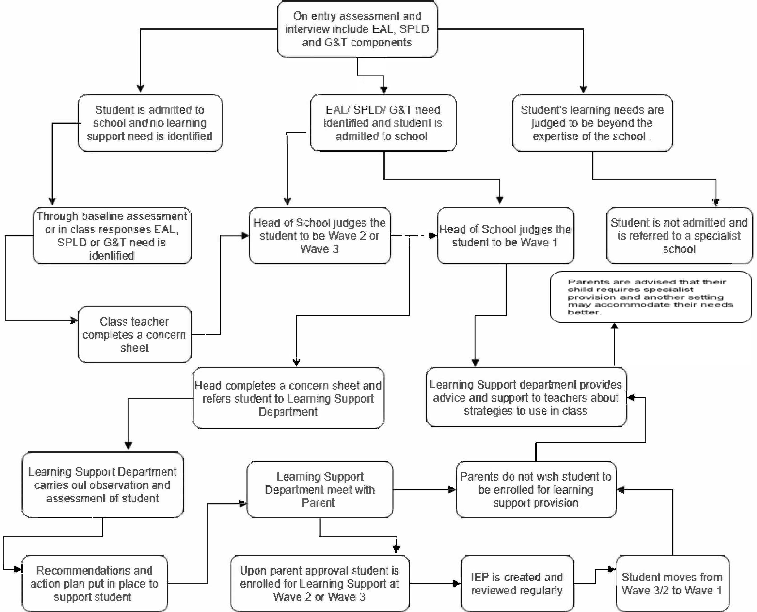

Appendix B: Wave Intervention
WAVE 1 (SEN, LD, EAL)  The student will not be added to the Learning Support register  Differentiation for the student will be clearly identified on class/ subject teacher planning  No Additional Fees | This wave is for students who when tested require a level of differentiation, but do not qualify to be enrolled for Learning Support.  - They require mainstream classroom adjustments, along with structured teaching strategies.  - These students can function in the classroom with differentiated tasks.  - The Learning Support department can provide consultation to the mainstream classroom teacher regarding differentiation for Wave 1 students.
WAVE 2 (SEN, LD, EAL)  Inclusion/withdrawal  Learning Support register.  Extra Fees Apply | This wave is for mild to moderate cases. The students in this wave are in need of focused support.  - The student can better function inside the classroom when provided with appropriate Learning Support sessions and effective mainstream strategies.  - In consultation with all relevant teaching staff, the Learning Support department develops an IEP and oversees implementation.  - The LS specialist will support the student in class as well as out of class based on the timetable created for each student.  - Students in this wave will sit the same mainstream exams, however may be provided with special access arrangements, e.g. to be able to sit exams in a small setting and/ or be provided extra time depending on the approval of Head of School.

EAL WAVE 2  Inclusion  EAL Register  Extra Fees Apply | - If a student is judged to be working at Stage A (new to English) level or Lower Stage B (acquisition level) in the initial EAL assessment (see Appendices I and J), upon the agreement of parents, he/she will be enrolled in the Learning Support Department program under Wave 2 and extra fees will apply.
WAVE 3 (SEN, LD, EAL)  Inclusion/withdrawal | This wave is for students with severe learning difficulties and SEN.  These students require additional, one to one support in the mainstream classroom.

Learning Support register. Extra fees Apply | - Students receive a detailed IEP which is implemented during remedial sessions in the Learning Support Department setting using modified mainstream lesson plans  - They may complete modified exams in the Learning Support Centre and will be provided special consideration access arrangements for all assessments.  - Some Wave 3 students may require their own shadow teacher to assist them individually during school time. Shadow teachers are employed by the parents following strict guidelines.
WAVE 3  RAINBOW STUDENTS | These students have profound and severe learning difficulties and SEN, certificated medically and assessed externally by an authorized body, and cannot be adequately catered to in the mainstream classroom, either with or without intensive learning support and withdrawal.  - As of 2015, these students will not be admitted to Ta’allum Schools, however assistance and guidance will be provided to ensure that parents are supported to find the best educational setting to cater to their student’s needs.
ABLE, TALENTED AND GIFTED STUDENTS | Where a student is identified as Able, Gifted or Talented, they will be added to the G&T register/s overseen by the Head of Learning Support and Head of School collectively.  - G&T students will receive an IEP overseen by the HoLS through HOS. These will be reviewed and revised in line with Wave 2 students.  - These students will be provided appropriately challenging, differentiated curriculum and tasks in the mainstream to enable them to progress at an accelerated rate, in line with their ability.  - Extra-curricular activities & programs, both within school and the wider community, will be developed and implemented to further meet the needs of these students
The above is a guideline to inform decisions based on student need and the corresponding level of support offered. Considering the student’s Special Needs and Assessment Profile (SNAP), EAL assessment outcomes and G&T results, the student is placed in one of the Waves.
In some cases this will be subject to change based on individual student consideration.

Appendix C: Common Characteristics of Able & Gifted Individuals

When reflecting on able and gifted students, the following factors should be considered alongside anecdotal observations and performance data – both of which may not necessarily accurately reflect true student ability.
Able and gifted students are very diverse and not all exhibit all characteristics all of the time. However, there are common characteristics that many able and gifted individuals share:
- Unusual alertness, even in infancy
- Rapid learner; puts thoughts together quickly
- Excellent memory
- Unusually large vocabulary and complex sentence structure for age
- Advanced comprehension of word nuances, metaphors and abstract ideas
- Enjoys solving problems, especially with numbers and puzzles
- Often self-taught reading and writing skills as preschooler
- Deep, intense feelings and reactions
- Highly sensitive
- Thinking is abstract, complex, logical, and insightful
- Idealism and sense of justice at early age
- Concern with social and political issues and injustices
- Longer attention span and intense concentration
- Preoccupied with own thoughts—daydreamer
- Learn basic skills quickly and with little practice
- Asks probing questions
- Wide range of interests (or extreme focus in one area)
- Highly developed curiosity
- Interest in experimenting and doing things differently
- Puts ideas or things together that are not typical
- Keen and/or unusual sense of humor
- Desire to organize people/things through games or complex schemas
- Vivid imaginations (and imaginary playmates when in preschool)
Adapted from: https://www.nagc.org/resources-publications/resources/my-student-gifted/common-characteristics-gifted-individuals

Appendix D: LS Timeline & Key Events
Month | Key Event | Details & Responsibility
Feb/March | Entry assessments, interviews and enrolments | - Academy Registrar with oversight from HOS as necessary
September | Academic year begins – Baseline Assessments &  Identification of all SEN, EAL, Able & G&T groupings | - Baseline Assessments conducted & analysed by mid semester (HOS)  - LS Concern sheets completed, approved by HOS and forwarded to LS  - Able & G&T students identified for all subject areas (HOS)
October | Literacy and Numeracy profile assessments  Parent Meetings & LS enrolment  IEP writing & implementation  SNAP assessments for all LS students | - LS with support from HOS as necessary
November | Mid-term assessments - adaptations for Wave 3  - Access arrangements for Wave 2 & 3  Data analysis & review of LS Register, including Able & G&T  Parent Teacher Meetings | - HoLS to oversee with HOS  - HOS & HoLS  - HOS & HoLS
December | IEP Review | - HoLS with HOS
January | Semester 1 Exams  - adaptations for Wave 3  - Access arrangements for Wave 2 & 3 | - HoLS to oversee with HOS
February | Literacy & Numeracy Assessment – 2nd completed  Data analysis & review of LS Register, including Able & G&T  S1 Reports  IEP review & refine | - HoLS  - HOS & HoLS  - HOS with HoLS input  - HoLS & HOS (G&T students)
March | Mid-term assessments - adaptations for Wave 3  - Access arrangements for Wave 2 & 3  Data analysis & review of LS Register, including Able & G&T  Parent Teacher Meetings | - HoLS to oversee with HOS  - HOS & HoLS  - HOS & HoLS
April | Parent Teacher Meetings | - HOS & HoLS
May | 2nd SNAP assessment  IEP final review | - HoLS  - HoLS & HOS (G&T students)
June | Semester 2 Exams  - adaptations for Wave 3  - Access arrangements for Wave 2 & 3  End of Year reports | - HoLS to oversee with HOS  - HOS & HoLS input & comment for WAVE 3 students

Appendix E: Request for Learning Support Assessment – Referral Form

Student Name: | Date of Birth:
Year & Class: | Date Form Completed:
Name of Teacher Completing Form:
Baseline score English:
Baseline score Math:
Cause for Concern:

Student History:

Parent Information:
Have these concerns been discussed with the parents at any stage? □ Yes □ No
If yes, summarise key points for consideration, including specific dates.

Classroom Strategies:
- What action has been taken through curriculum differentiation to address the needs?
- If the area of concern relates to behaviour, emotional and social development, summarise behaviour management strategies already used.
- Attach at least two (2) student work samples.

Signature of Teacher:

Signature of Head of Department/ Year Leader (Confirming agreement that the student concern/ issue LS):

Signature of Head of School: (Confirming agreement that the student concern/ issue LS):

Learning Support Recommendation:

Signature of HoLS:

Appendix F: Examples of EAL support strategies for teachers

EAL Strategies:

There are three considerations for evaluating EAL student progress:

Educational Achievement: refers to the student’s academic progress throughout their school career. This is measured by classroom participation, achievements in curriculum tests, exams and project work.

Language Development: focuses on the development of the students’ mastery of all components of English language, including as the medium for learning specific subject matter.

Social Integration: the academic and social participation of the student in all school activities. Levels of participation affect the student’s sense of belonging and identity with the school community, their ability to make friends and work with their peers.

Specific strategies for Literacy

(tick as appropriate) | Strategy | Explanation
 | Talk  Opportunities for talk should be planned | - A ‘silent’ period is often a stage of development in learning EAL and a studentStudentstudent should not be forced to respond  - It is normal for understanding to surpass verbal output in the early stages.  - Create activities for scaffolded talk  - Use paired discussion, preferably in first language if possible, before commencing written work
 | Collaborative Activities Plan for regular collaboration with peers | - Group tasks facilitate involvement, belonging and the need to experiment with language in order to complete a task  - Language is modelled by peers  - If studentStudentstudents have been taught how to work collaboratively, the group creates a non- threatening environment for learning
 | Use of first language  Encourage regular transfer between first language and English | - Show that the studentStudentstudent’s first language is valued, fostering self-respect and motivation  - Learn a few simple phrases, numbers, colours  - Provide opportunities for studentStudentstudents to work in same language groups and pairs  - If students are literate in first language encourage them to continue reading and writing  - Make bilingual books  - Bilingual displays  - Listen to bilingual taped stories  - Read bilingual books  - Use home and community languages in drama and role play  - Ask parents, staff and community members to give bilingual support in the classroom

(tick as appropriate) | Strategy | Explanation
 | Language awareness  Foster awareness and knowledge of language | - Gain a simple understanding of the student’s first language, simple phrases, basic script form and syntactical differences  - Students should be asked to think about their ‘language stories’, of their experience of becoming bilingual  - Teach students about the varieties of language within and between countries  - Study the difference between written and spoken English, between different registers, codes and dialects of spoken English  - Know appropriate use of English in different situations  - Explain the use of synonyms, idioms, derivations and nuances in both English and first language
 | Parental involvement  Develop parents’ ability to support and reinforce the school’s work from home and create an open dialogue for the school to become better informed about  the studentStudentstudent’s development | - Use interpreter or bilingual Language Assistant at meetings, especially the initial meeting  - Visit student at home with an interpreter  - Advise parents how to support their student’s  language development bilingually, for example, sharing picture books in first language  - Give clear guidance about the British education system and the curriculum

- Table 3: Specific Strategies for Literacy
Allow studentStudentstudents to communicate with you in any way they can, especially when they initiate talk and in response to open-ended questions.
Teaching Strategies | Examples of activities
Teach survival English first so that the student can express needs e.g. drink | - Demonstrate classroom vocabulary e.g. pencil, paper, table, chair  - Use picture cards  - Use ICT, e.g. Clicker 4
Value home language | - Ask the student for equivalent words to those you are teaching. This will boost self-esteem and help him/her to remember the English vocabulary  - Use dual language picture dictionaries,
Teach more nouns, trying to link them into current class learning | - Use visual and contextual clues  - Examples: parts of the body; clothes; places; people  - Picture lotto  - Picture snap  - Sorting activities, e.g. by colour, shape or size  - Matching activities  - Illustrated dominoes
Teach some key verbs | - Start with activities they will need to understand, such as sit, stand, walk and run  - It could be practically demonstrated, with a question and response: “Can you ……….?” “Yes I can ………….”  - Use picture cards  - Use ICT, e.g. Clicker 4
Model colloquial phrases, giving an opportunity to repeat them in a variety of contexts | - This is a…..  - What’s this?  - What colour is it?  - How many …..have you got?  - Can I have a blue pencil please?
Talk using full sentences | - Ask open ended questions to give studentStudentstudents an opportunity to respond at their own level  - Only insist on whole phrases some of the time, as it may be discouraging to beginner bilinguals  - Picture sequencing: sorting unsequenced pictures and re-telling the story
Plan for opportunities for talk (especially important to maintain this for more advanced learners) | - Use first hand experience as a stimulus for talk  - Create activities for scaffolded talk  - Use collaborative group work  - Play paired games, e.g. matching and sorting

Teaching Strategies | Examples of activities
Letter formation | - Lower case and letter sounds (phonemes) first  - Describe the pen movement to form the letters  - Try to supervise “copy writing” until letter formation is secure
Words | - Labelling pictures and diagrams  - Matching activities  - Students maintain a glossary of new or keywords and phrases to revise both in school and at home. These may be kept bilingually where students are literate in first language. Glossaries may be in picture format and may be subject specific, for example, science equipment. Learn key words bilingually in advance.  - Pre-teach keywords prior to a new unit or individual lesson  - Display key words and phrases around the classroom, in English and bilingually  - Reinforce and test key words during starters and plenaries
Sentence construction | - Visual clues to support writing  - Matching sentences or paragraphs to a sequence or set of pictures. Pictures may be pasted into a workbook, with written sentences.  - Provide students with word cards, which they use to construct sentences  - Writing sentences using choice tables, where there are a number of possible responses to choose from to complete a sentence. This could be matching halves of different sentences.  - Re-writing sentences by changing underlined words  - Writing sentences based on a modelled answer, providing structure and setting standards of expectation  - Cloze procedures, filling gaps in sentences  - Substitution tables; writing frames  - Word banks; prompt cards  - Phoneme Mats  - Big Write pyramids and prompts  - Use ICT, e.g. Cloze Pro

Specific strategies for Mathematics
These strategies provide guidance on the induction of early stage EAL students, planning for a unit of work and for the parts of individual lessons.

- Table 4: Specific Strategies for Mathematics
- Induction of Early Stage EAL Studentss

- The following basic teaching strategies should be carried out early stage studentss with EAL:

Teaching Strategy – Age Appropriate | Examples of Activities
Familiarise students with:  - number names and scripts  - systems (place value) and notation e.g. use of decimal point/comma or space/comma | - Use numerical system from student’s culture as the starting point  - Oral games, rhymes and songs for repetition  - Number jigsaws/squares  - Matching activities (oral and/or written)
Familiarise students with words describing position | - Games/activities to reinforce e.g. first, fourth, last e.g. discussion about races (athletics, horse races)  - Games/activities to reinforce e.g. ‘inside’, ‘outside’, ‘opposite’
Teach students to tell the time (12 & 24 hour), days, months, years & seasons | - Use pictures of the school day, with written times and clock faces, use a digital camera to record the student’s own class timetable  - Teach using bilingual word lists
By Key Stage 3, students should be familiar with the four rules | - Ensure that students are familiar with addition, subtraction, multiplication and division

Appendix G: Roles & Responsibilities

Principals | - Are responsible for ensuring the full implementation of the Learning Support Policy within their Academy.  - Conduct Shadow Teacher interviews with HOS and sign off  - Ensure all HR procedures and formalities are completed for Shadow Teachers before they commence student support
Heads of School | - HOS are responsible for overseeing and ensuring that the Learning Support provision, within mainstream classes, extra and co-curricular, and for specific Learning Support interventions - for all identified student groups and individual students, is implemented, monitored and in line with the expectations of the LS Policy and international best practice.  - HOS line manage and work collaboratively with the Heads of Learning Support to meet all requirements. They are ultimately responsible for all aspects of Learning Support provision within their school section.  - Ensure maintenance and regular review (at key assessment points as a minimum) of student differentiation registers for all classes and subjects  - Ensure differentiated planning identifies specific student groups and names of students as per differentiation registers  - Conduct Shadow Teacher interviews with Principal and sign off  - Ensure all HR procedures and formalities are completed for Shadow Teachers before they commence student support
Heads of Learning Support | Maintain a thorough and comprehensive understanding of the LS Policy and work collaboratively with HOS to ensure implementation, monitoring and oversight.  Some specific areas of responsibility are:  Overseeing the day to day operation of the school’s learning support provision.  - Contribute to the annual review of the Learning Support Policy  - Ensure and co-ordinate registers and provision for all Learning Support students - including Able and G&T  - Manage Learning Support teachers, teaching assistants and shadow teachers.  - With HOS guidance, oversee all Learning Support student records & processes – including G&T, SIMS evidencing and oversight.  - Communicate and liaise with parents of WAVE 2 & 3 students  - Ensure IEP monitoring and review as per timelines (as a minimum)  - Contribute to in-service training of staff for identified needs  - Liaise with external agencies including support and educational psychology services, health and social services, and voluntary bodies.
KS1-KS2 Coordinators | - Work collaboratively with the Head of Learning Support to agree curriculum content to be covered.  - Liaise between the Learning Support teachers and the homeroom teachers.  - Meet weekly with the Head of Learning Support to review registers and to ensure that appropriate differentiation is in place for all LS students – including Able & G&T.
Primary & Secondary Year Leaders | - Oversee and provide pastoral and academic support for all students, maintaining a specific awareness of LS Student needs – including Able & G&T.  - Provide support for behavioural management
Head of School Human Resources | - Ensure a personal file for all Shadow Teachers is opened and maintained at all expiry dates  - Ensure all parties sign the Shadow Teacher Agreement (Appendix M) between the Academy, Parent and Shadow Teacher  - Provide a specific list to the Shadow Teacher of what they are and are not allowed to do (Provided by the Head of School and signed by Shadow teacher)  - Ensure to file an Interview assessment form – ( confirming that the Shadow Teacher has been interviewed by Head of School & Principal - both to sign  - Ensure to file an updated CV with details of all prior work experiences  - Ensure to conduct and file Police Checks  - Ensure to conduct and file proper background checks  - Ensure that the Shadow Teacher has not been terminated from prior service through disciplinary action  - Ensure all other related documents in Shadow Teacher Agreement (Appendix M) are obtained and filed

Appendix H: Learning Support Parent Meeting Template

Student name: |  | Date:
Parent name: |  | Location of meeting:
Present in the meeting:
Topics discussed

Actions

File | Email | Verbal | Copied

Staff name ___________________________________________
Signature ____________________________________________ Date_________________
Parent: ______________________________________________
Signature_____________________________________________ Date _________________

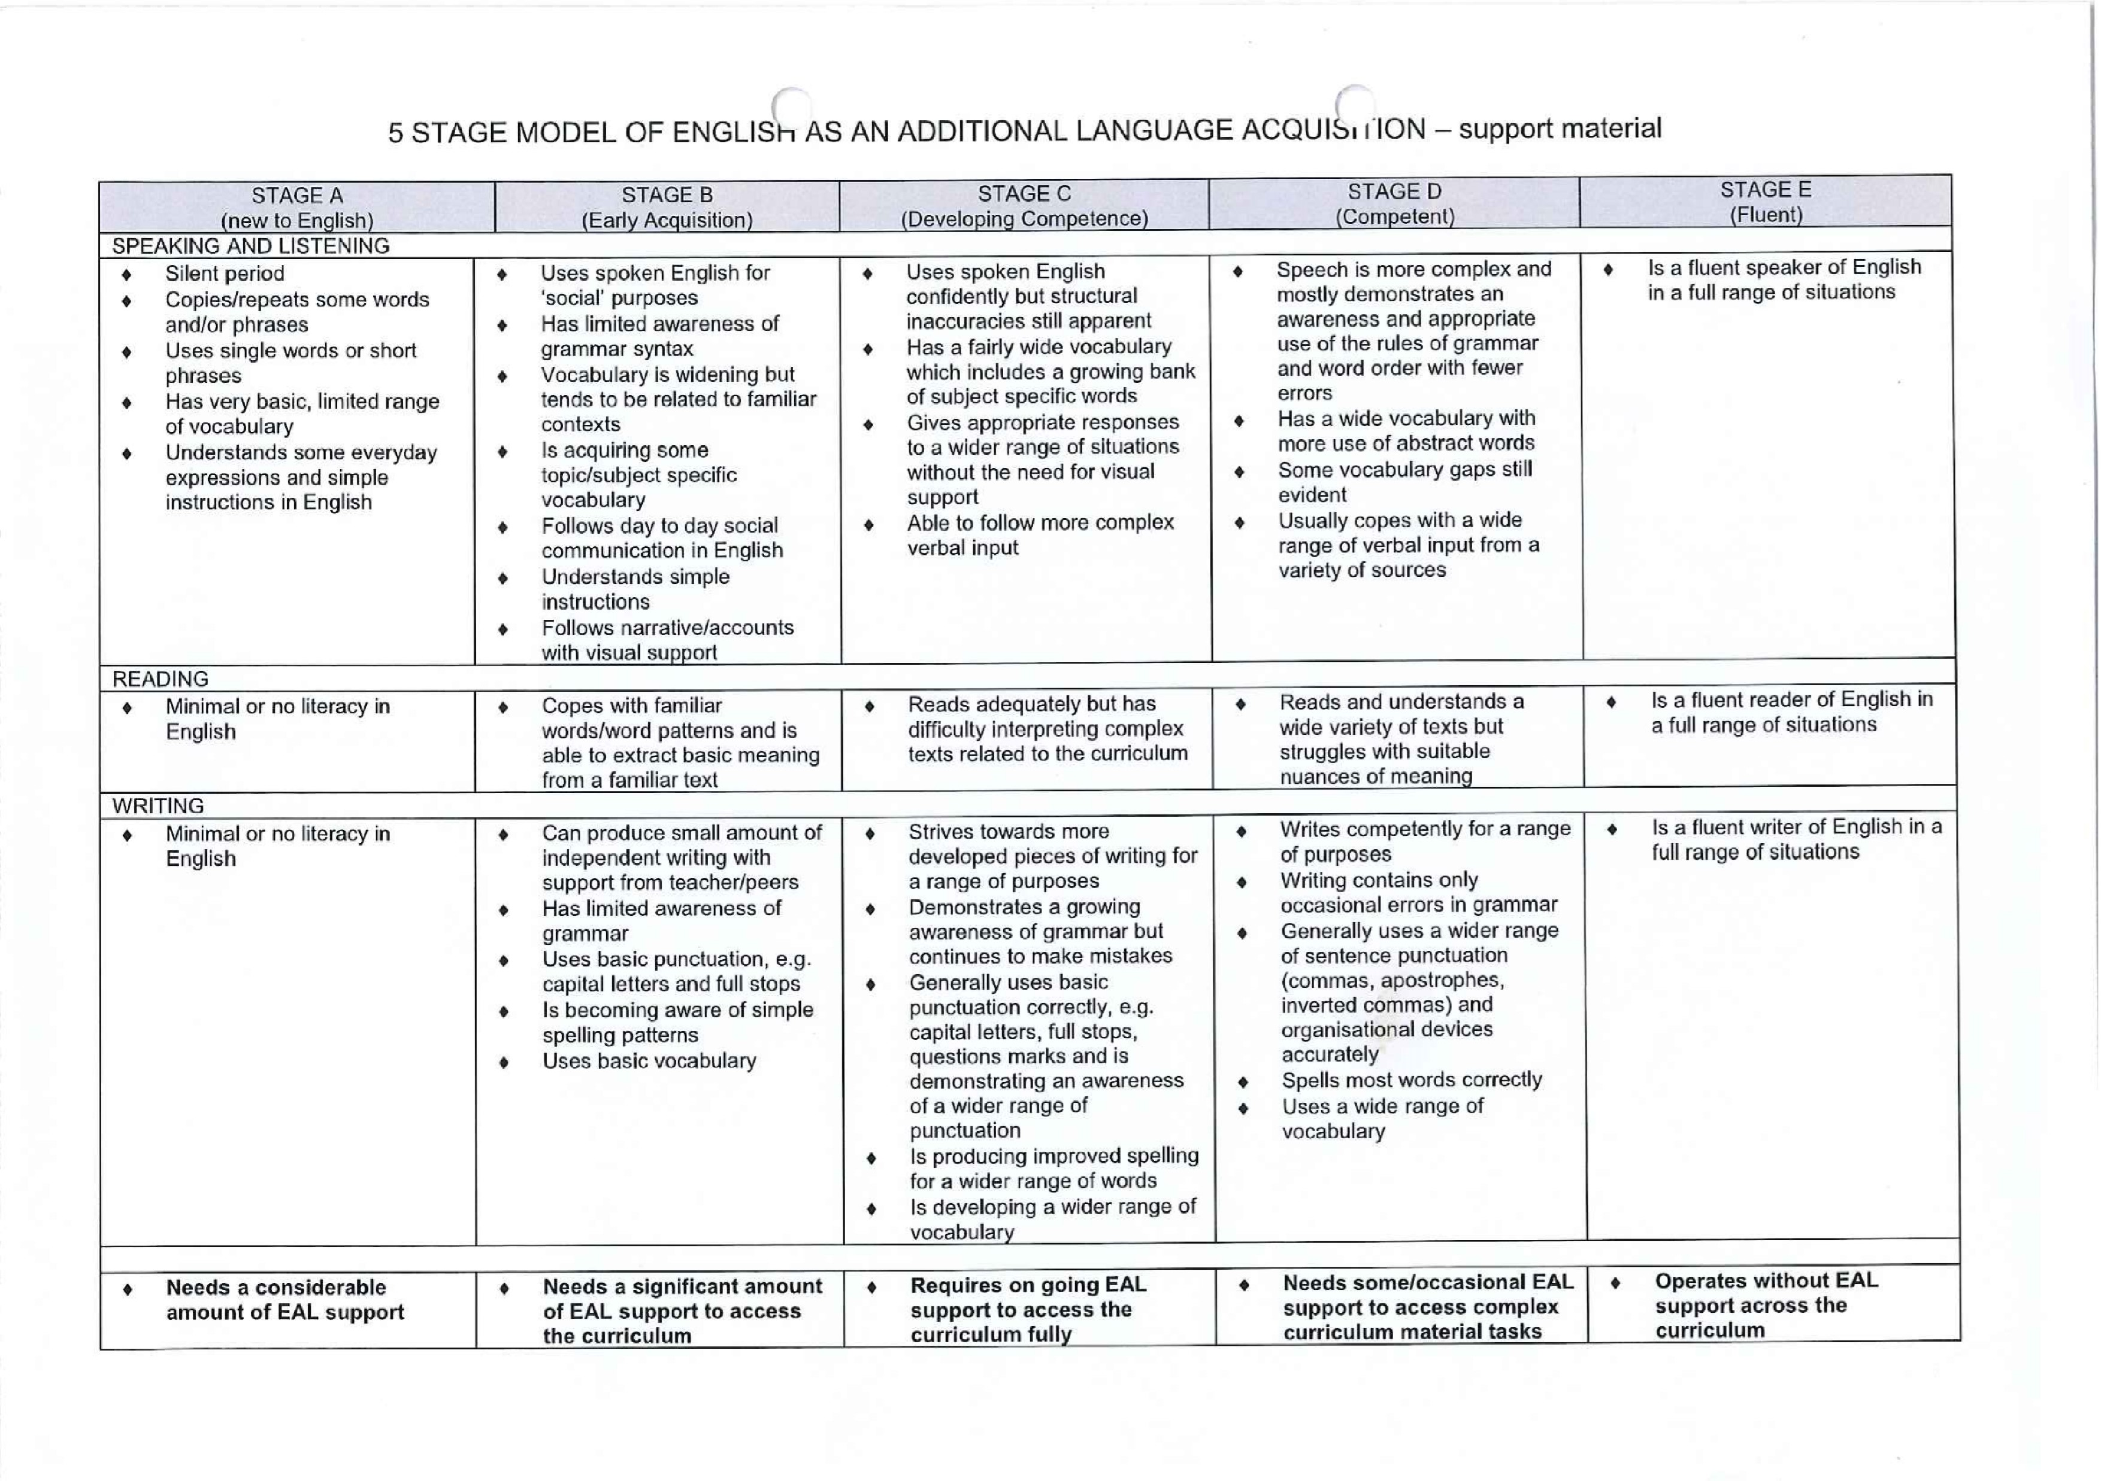

Appendix I: 5 Stage Model of English as an Additional Language Acquisition

Appendix J: Procedure for supporting EAL students Enrolment
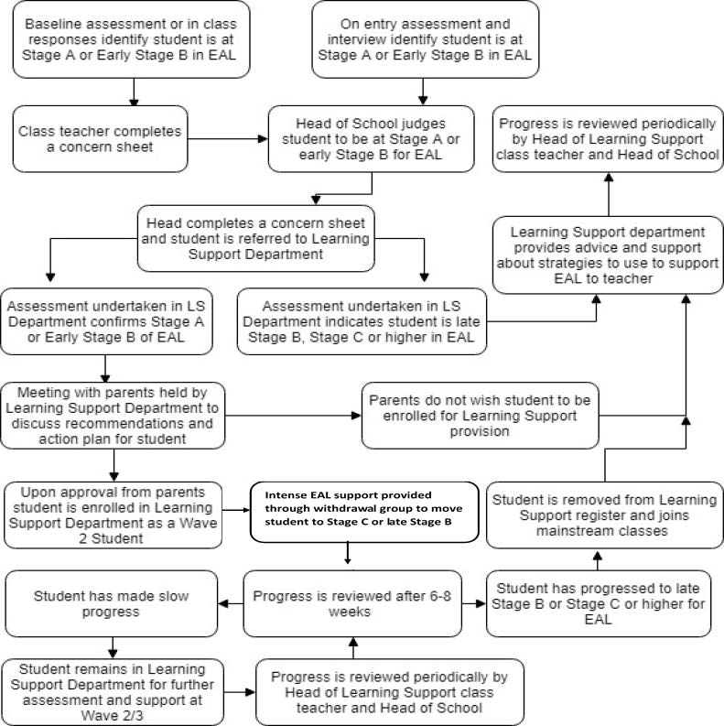

Appendix K: Learning Support Department Learning Walk Monitoring Tool
Learning Walk by (Print Name) Date:-

Week | Weekly Lesson  Plan available  or x | LO clearly displayed & discussed  or x | Success Criteria  clearly explained  or x |  | Appropriate planning available – including identifying differentiation with specific student names  or x | Key Vocabulary clearly displayed  or x | Student books marked up  to date  Yes / No or Partly
Learning Support Teacher
Sunday
Monday

Tuesday
Wednesday
Thursday
Areas of Strength Areas for Development

Appendix L: Learning Support Teacher & Classroom Teacher Conference Notes

Student/ren:  Year Group: | Date:  Contact details:
Reason for meeting:
Information Sharing Problem solving Review Handover Planning
Topics Discussed:

Actions

Teacher Name:  Teacher Signature: | Learning Support Teacher Name:  Learning Support Teacher Signature:

Appendix M: Shadow Teacher Agreement

This agreement is made and entered into effect at / / and between:
1. FIRST PARTY: The Academy - (Ta’allum Group’s Entity - Al Jazeera Academy)
Address: First Floor, GSSG Building, Doha, State of Qatar
PO Box: 4219
Contact # +974 44915416
2. SECOND PARTY: The Parents – ( Name Here )
Address:
PO Box:
Contact # +974
3. THIRD PARTY: The Shadow Teacher - ( Name Here )
Address:
PO Box:
Contact # +974
With a permanent address of all the parties in Doha, State of Qatar.
Place of Work for the Shadow Teacher: ( Name and Class )
Agreement Start Date: ( )
Agreement End Date: ( )
Third Party’s Presence Hours Per Day : ( )
Third Party’s Presence Days Per Week: ( )
Third Party’s Time In and Time Out: ( Time In ) ( Time Out )
Other Terms and Conditions
- Second Party has requested and approved for the Third Party to provide extra support as a Shadow Teacher to his Son/Daughter namely ______________ in the Class ________, at above agreed place with the First Party

- Second Party takes full responsibility of the Third Party’s action(s) with the concerned student.

- Second Party agrees and understands that he/she shall bear all the costs involved in this agreement and shall deal directly with Third Party for salary payment or any other related payments related to this agreement.

- Third Party agrees and understands that the First Party does not have any financial responsibility/obligation, neither will Third Party claim any compensation, either during this agreement and or upon/after its expiry or termination by either party. All compensation matters are dealt with directly by the Second and Third party, First Party is completely exempted from it.

- Second Party agrees that First Party has the right to terminate this agreement at any time with immediate effect without mentioning any reason by giving written notice. Second party may also terminate this agreement by giving three working days’ advance written notice to the First Party.

- This agreement expires at the dates mentioned above and is not renewed by default. Should a further support be required to provide to the concerned student, second part shall initiate the request and a new agreement be signed by all the Parties.

- Second Party hereby undertakes the below that:
- The Third Party has obtained the minimum of a Bachelor’s Qualification and has no restrictions in any country which prevent them from working with Children
- The Third Party possesses a clean record of behavior/Police clearance from Home country and Qatar
- The Third Party will abide by instructions given to her/him by the First Party or legal representative of the First Party
- The Third party shall work with the highest levels of professionalism, honesty and integrity
- The Third Party will abide by all Policies and Procedures of the First Party

- During the course of this agreement, Third Party will come across information about the Academy, both the Second Party and Third Party undertakes that the information will be kept confidential during the agreement and or upon and after termination of this agreement.

- During the course of this agreement, Third Party will come across in contact with Children, both the Second Party and Third Party undertakes that he/she will not indulge with any activity with other Children.

- Second Party hereby agrees to provide the below documents to First Party, prior to the commencement date of this agreement. In case of failure of the Second Party to fulfill this responsible, First Party will be obliged to cease the commencement of this contact with immediate effect: -
- Valid Qatar’s Residence Permit copy of the Second and Third Party
- Valid Passport Copy of the Second and Third Party
- Police Clearance of the Third Party
- Updated CV of the Third Party
- Educational Certificates of the Third Party
- Experience Certificates of the Third Party proving his/her past experience
- No Objection Letter from the Third Party’s Sponsor to work with First Party as Shadow Teacher on the request of the Second Party
- Two Reference Letters of the Third Party from his/her previous Employer (one must be from last Employer and direct line manager)
- Any other document that First Party may deem necessary during the period of this agreement, Second Party will be obliged to provide the same

- Second Party understands and agrees that granting permission to work to Third Party as is per discretion of the First Party and Third party will undergo a recruitment process as per the First Party procedures.

- Second and Third Party agrees that they have been given a detailed Description which details the scope of support Third Party will be giving the concerned Student – and both have read/understood it and will abide by it.

- This agreement does not constitute any employment relationship between the First Party and Third Party as Third Party will only be available as support for the concerned student with consent of the Second Party.

- This agreement is governed by related Laws of the State of Qatar. The Qatari courts shall have an exclusive jurisdiction to hear any dispute arising out of or in relation to this agreement.

- The Second and Third Party certifies that he/she has read and fully understood the terms and conditions of this agreement and acknowledges that he/she has received a copy of the same. Furthermore, they also acknowledge that by signing this agreement, all previous negotiations, agreements or undertaking, whether oral or in writing, is hereby superseded.

- This Agreement has been issued in three original copies, one to be kept by each party, who now sign as accepting and understanding all terms of agreement herein.

For and on Behalf of Ta’allum Group

First Party Second Party Third Party
Dated: Dated: Dated:

