TEACHER OF SCIENCE

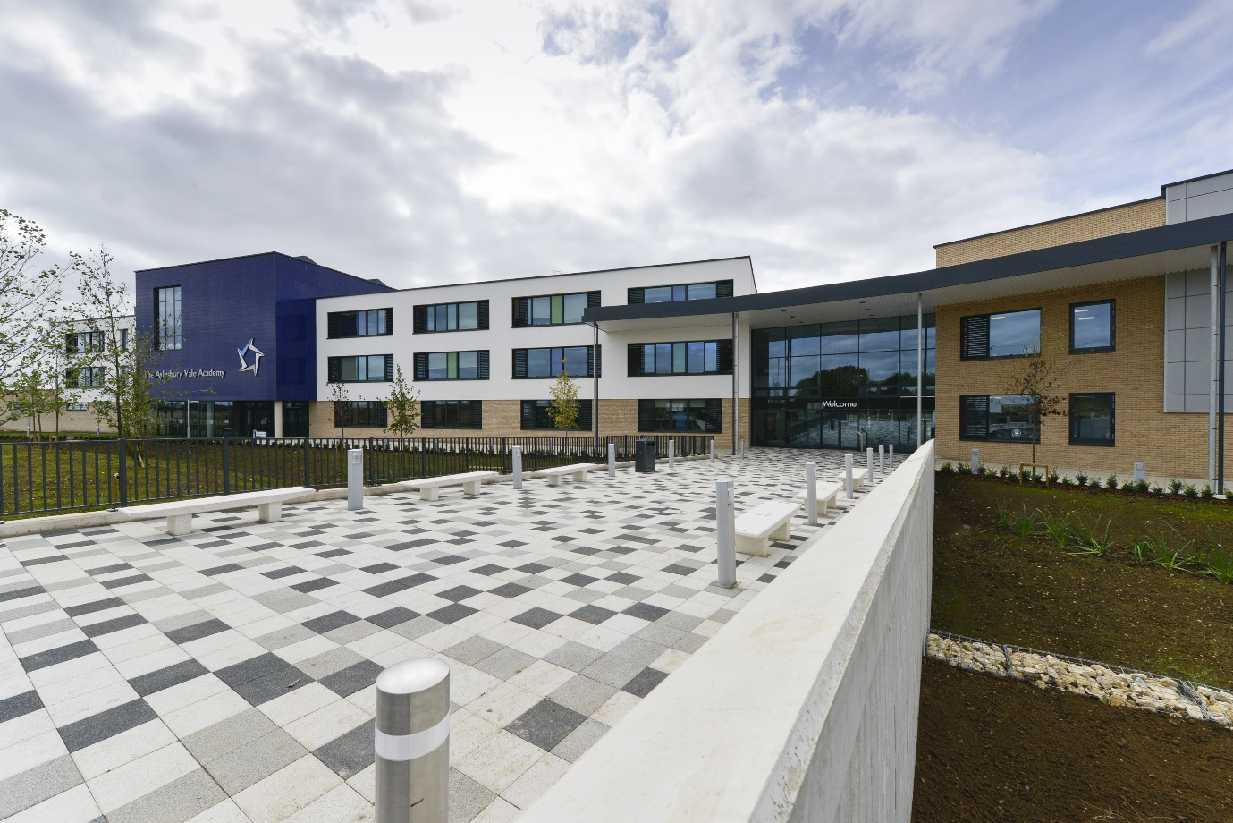

ETHOS AND AIMS OF AYLESBURY VALE ACADEMY

Ethos

The school aims to provide a supportive, stimulating and secure environment where high standards of learning and personal responsibility are expected and achieved and where every member of the school community is respected and valued.

We believe that, as young people and adults, we are constantly learning. Our aim is to include, engage and challenge individuals within a stimulating environment to prepare them as responsible good citizens.

As a community, we have identified a set of core values that, as a Church of England Academy, guide and influence everything we do. These are:

faith, respect, equality, aspiration, creativity and service

Aims

1 To provide the environment, stimulus and opportunities which will encourage and enable very individual
to discover and fulfil their potential.

2 To enable each individual to develop confidence and self-esteem and to encourage self-reliance, self-
discipline and corporate responsibility both in school and in the wider community.

3 To develop each student’s capacity to take responsibility for his/her own learning and to work
constructively as a member of a group or a team.

4 To provide opportunities for each student to participate in and enjoy a range of cultural, creative,
practical, physical and social activities and to develop their knowledge and skills in these areas. To
provide opportunities for moral and spiritual development.

5 To ensure that each student leaves school with qualifications and achievements commensurate with
his/her ability, with the knowledge, skills, attitudes and values which will provide the confidence to lead a fulfilled and responsible life and with an awareness that learning in a lifelong process.

6 To educate all students through a broad and balanced curriculum which will prepare them effectively
for adult life in a multicultural society and an interdependent, changing world.

SCIENCE DEPARTMENT
The Science Department comprises of 6 teachers with a wide range of experience in teaching Science along with 2 Science Technicians. We currently follow the Exploring Science Key Stage 3 curriculum with the majority of students going on to take AQA GSCE Science at Key Stage 4. At Key Stage 4, we also offer AQA Triple Science and Edexcel BTEC in Applied Science. At Key Stage 5, we currently offer AQA Biology A Level and hope to expand on this offer over the next few years. With all the curriculum changes currently taking place, this is an exciting time to join this growing department and all teachers will have the opportunity to have a positive impact on the development and implementation of the new Science curriculum.

Being part of the new build for Aylesbury Vale Academy, each teacher has their own dedicated Science laboratory which is fully equipped with an interactive whiteboard, data projector and visualiser as well as also being able to access class sets of laptops. Outside of lessons, we currently run a Science Club as well as a variety of different revision sessions for Key Stage 4 and 5 students. Our students also have the opportunity to go and help out with the younger students at Berryfields Primary during the annual Science Week.

Strong Science team containing members of SLT.

JOB DESCRIPTION

GENERAL DESCRIPTION OF THE POST

The holder of this post is expected to carry out the professional duties of a teacher as described below.

Meet the Professional Standards for Teachers and actively support the vision, ethos and policies of the Academy.

Accountable to: Curriculum Leader

MAIN PURPOSE

To ensure all students reach their potential through delivery of high quality teaching and learning alongside effective monitoring, assessment and target setting.

DUTIES AND RESPONSIBILITIES:

- Encourage and enable all students to achieve the highest possible standards of learning by:

- Setting and sharing clear aims, goals and purposes
- Planning, conducting, reviewing and evaluating learning experiences with regard to continuity and progression content, activities, resources, feedback.
- Making sure the learning environment in the teaching space is stimulating, well organised, attractive, safe and secure.
- Ensuring that the best possible quality resources are used.
- Ensuring that a variety of teaching methods and styles are used with students.
- Making sure that all students have an equal opportunity to succeed.
- Undertaking accurate, relevant and regular assessment, recording and reporting of achievement.
- Deploying support staff and other adults effectively in the classroom, involving them, where appropriate in the planning and management of students’ learning.
- Secure a high standard of student behaviour in the classroom by establishing appropriate and high expectations and dealing with inappropriate behaviour in the context of the Behaviour Policy of the Academy.
- Support team commitment, through collaborative planning and by sharing good practice to create a stimulating learning environment for teaching and learning.
- Evaluate your own teaching critically and use this to improve your effectiveness. Take responsibility for drafting performance management objectives and ensuring agreed evidence is available for review against agreed criteria. Take a positive attitude to professional development.
- Comply with the Academy’s Health and Safety policy, to undertake risk assessments as appropriate.

